Conical Objects
Conical Objects
A Conical object is a three-dimensional geometric shape that has a circular base and a pointed top. The word comes from the Greek word “Konos”, meaning cone. Those types of objects can be seen around in nature such as pine trees, and seashells to even shapes like an ice cream cone.

Conical shapes are very common in engineering and architecture as they serve many benefits. One main advantage is the ability to distribute weight evenly across its base, making it extremely stable and convenient for use. Those shapes are very stable as they are implemented in elevated buildings such as lighthouses or even wind turbines.

The three-dimensional geometric shape is formed by a set of points formed from a fixed point called, the apex. As seen in the figure below, the base of the cone is a circle, while the surface of the cone is curved, extending from the base to the apex. Speaking more technically, the base is the flat circular surface at the end of the cone, while the axis is the straight line passing through the apex and the center of the base which is the longest line segment in the cone. Other properties of the conical shape include the height which is the distance from the apex to the centre of the base. However, the slant height is the distance from any point on the circumference of the base to the apex.

As Conical objects come in different forms and types, here are the most common…
Right Cone: The axis is perpendicular to the base
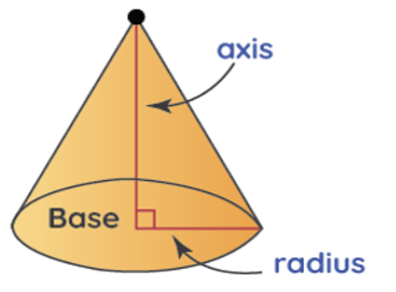
Oblique Cone: The axis is not perpendicular to the base
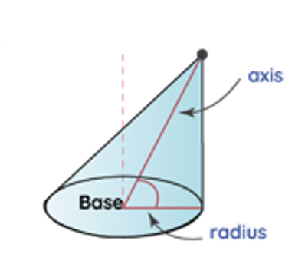

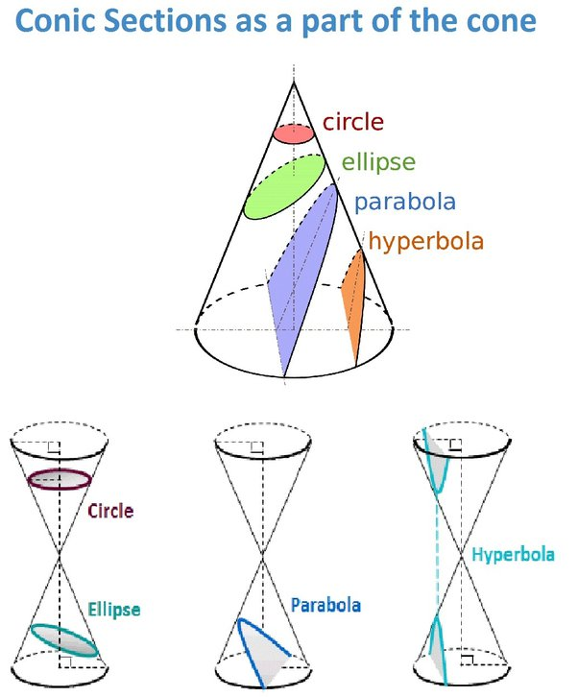
Circular Cone: A cone with a circular base

Elliptical Cone: Cone with an elliptical base

Calculating the Surface Area:
The surface area of a cone can be calculated using the formula:
A= πr (r+l)
Where…
- A = Surface area,
- r = Radius of the base,
- l = Slant height

Calculating the Volume:
The volume of a cone can be calculated using the formula: 1/3πr²h
Where…
- V= Volume
- r= Radius of the base
- h= Height

References
Conical: Definitions and examples - club Z! tutoring. clubztutoring. (n.d.). https://clubztutoring.com/ed-resources/math/conical-definitions-examples-6-7-3/
Does a given parabola define one cone, or is there a set of cones ... (n.d.). https://www.quora.com/Does-a-given-parabola-define-one-cone-or-is-there-a-set-of-cones-defined-by-the-given-Parabola
Right circular cone- formula, properties, definition, examples. Cuemath. (n.d.). https://www.cuemath.com/geometry/right-circular-cone/

