Inertial Measurement Units
IMUs, short for Inertial Measuring Units, are little sensors which are being used more and more in various electronic devices around us such as cell phones, gaming consoles, robots and more and more. They are a combination of accelerometers and gyroscopes used to give us complete understanding of a device’s acceleration, speed and orientation.

The accelerometers are used mainly to measure the acceleration (then tilt). Accelerometers measure the acceleration in three axes (x, y, z) as the distance travelled can be calculated by double integration, however, due to accumulated error, distance results are often unreliable. While Gyroscopes are used to measure the angular velocity (then orientation) Three gyroscopes measure the angle velocities (𝜔₁, 𝜔₂, 𝜔₃) in the body frame.

A device that belongs to the IMU class is MPU-6050, these devices are able to measure the acceleration, inertia and other parameters. The MPU-6050 is used in multiple different applications such as…
- Phones and electronic devices: Used to determine the orientation of the device to switch between portraits and landscape modes
- Game Controllers: Games like WII or VR sets use IMU to detect level and motion
- Robotics: It's common to use it to establish position control and velocity

One of the key components of the MPU-6050 is an accelerometer which was talked about earlier, the MPU-6050 uses this to measure its acceleration. Acceleration has a common unit which is the G-force. One G-force on Earth is about 9.9 meters per second squared. This is important to understand as the accelerometer needs to take into account its static acceleration and consider it whilst making calculations. The MPU-6050 is a triple-axis accelerometer, which means that the device senses acceleration on an X, Y, and Z axis.

Another key factor in the MPU-6050 is the Gyroscope. The gyroscope consists of a wheel mounted that spins rapidly on its axis, moving in any possible direction. It also contains a MEMS, which is a Micro Electro Mechanical System. Its job is to produce voltage when rotating.

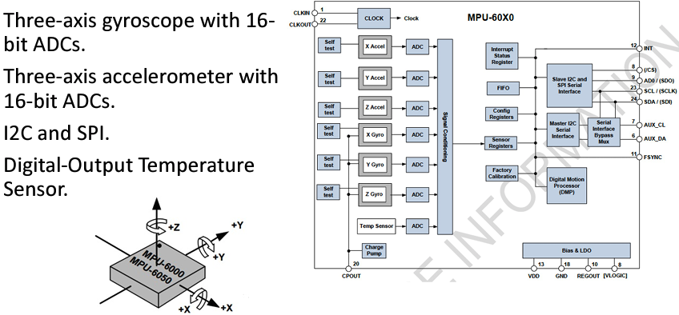

MPU-6050 sensor also offers versatility beyond its built-in capabilities through its ability to interface with external sensors through a secondary I2C bus. This feature prompts upon connecting a magnetometer to measure magnetic fields along the 3 axes, thereby expanding the sensor’s Degrees of Freedom (DoF) from 6 to 9.

References
Gu, D. (2023, March). Proprioceptive sensors and Odometry. Unit 3 . Colchester; in CTC.1.04.
Publisher Name DroneBot Workshop Publisher Logo. (n.d.). Build a digital level with MPU-6050 and Arduino. DroneBot Workshop. https://dronebotworkshop.com/mpu-6050-level/

