**Name :OMAR AHMED OMAR**

**ID :20140180**

**Group: 3 IS_DS**

1. **A manufacturing Plant produces two types of products (Prod-A and Prod-B).**

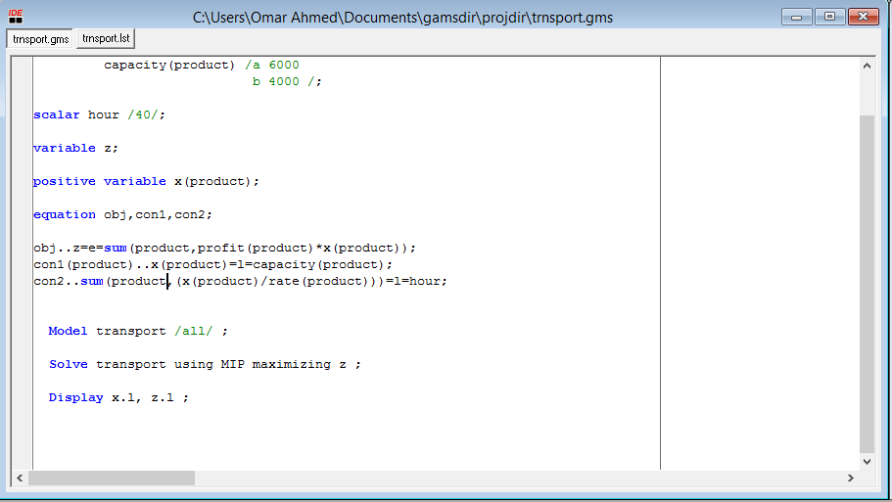

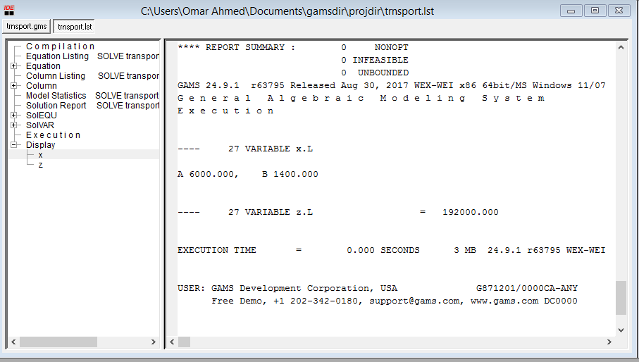

*Decrease Hours by 50%:

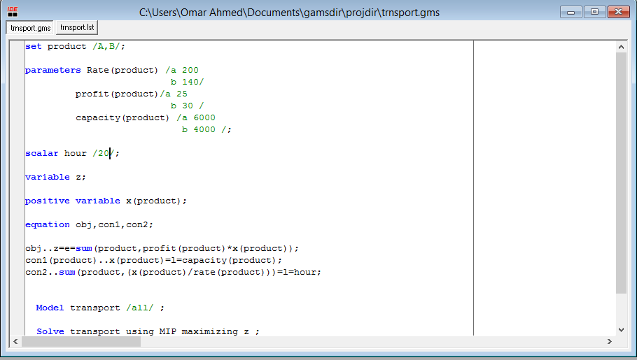

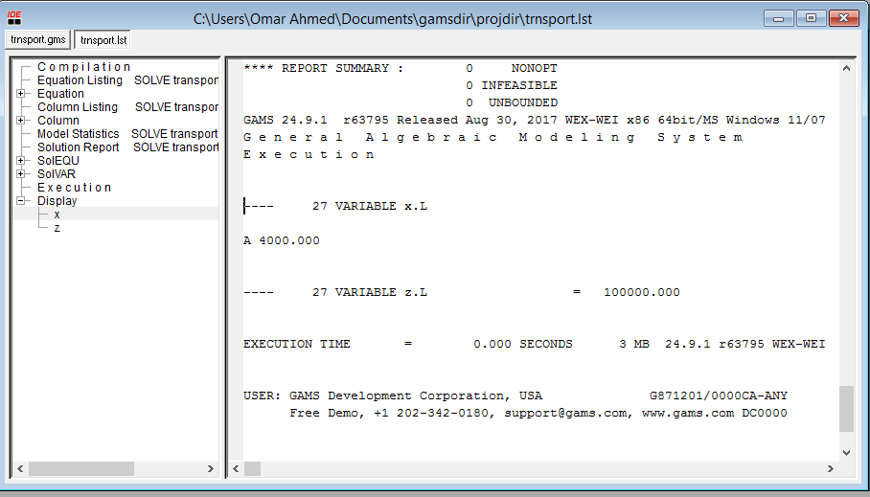

*Increase Hours by 50%:

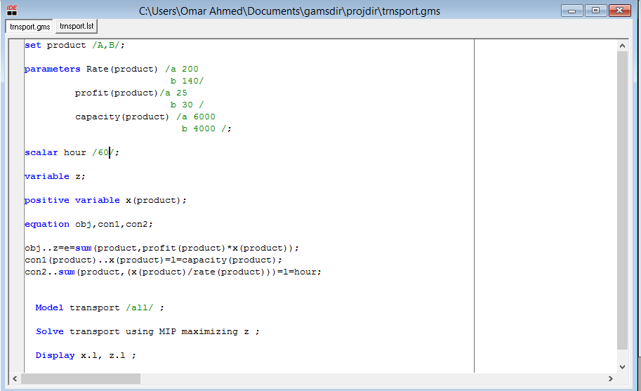

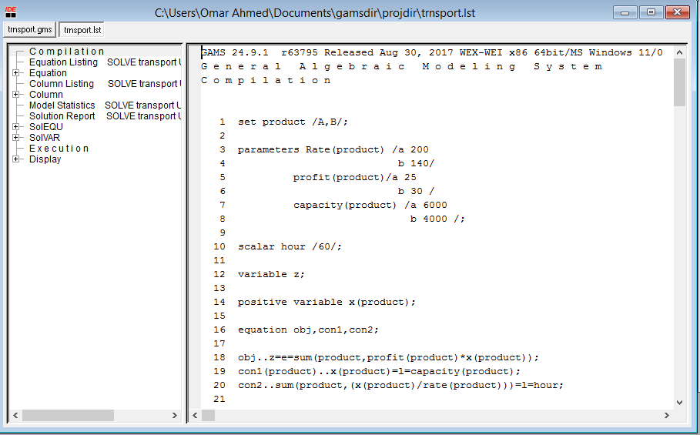

The suggestion is to increase hours.

*decrease Product of A by 25%:

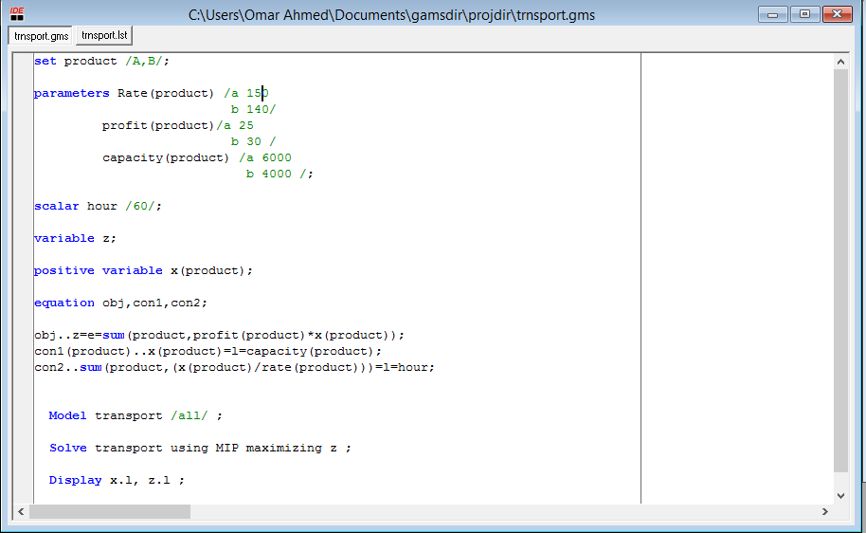

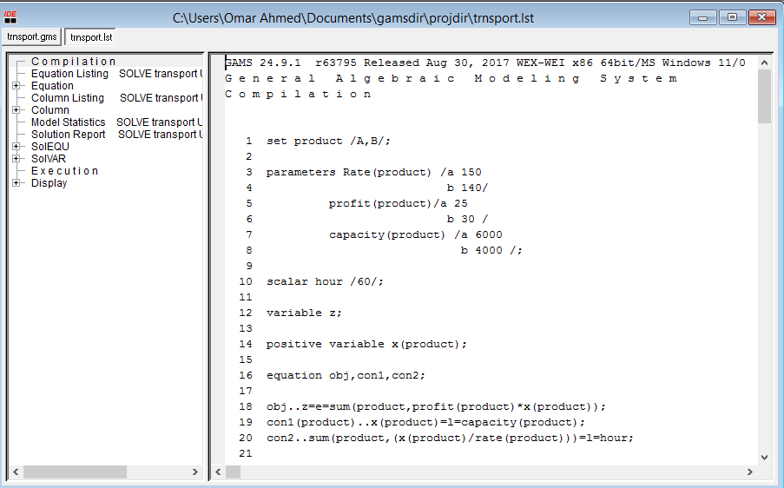

*Increase Product of A by 25%:

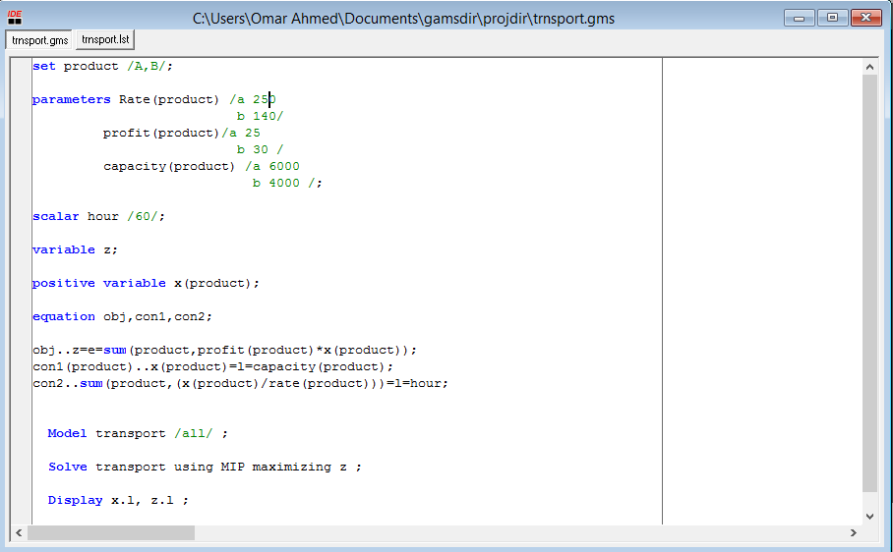

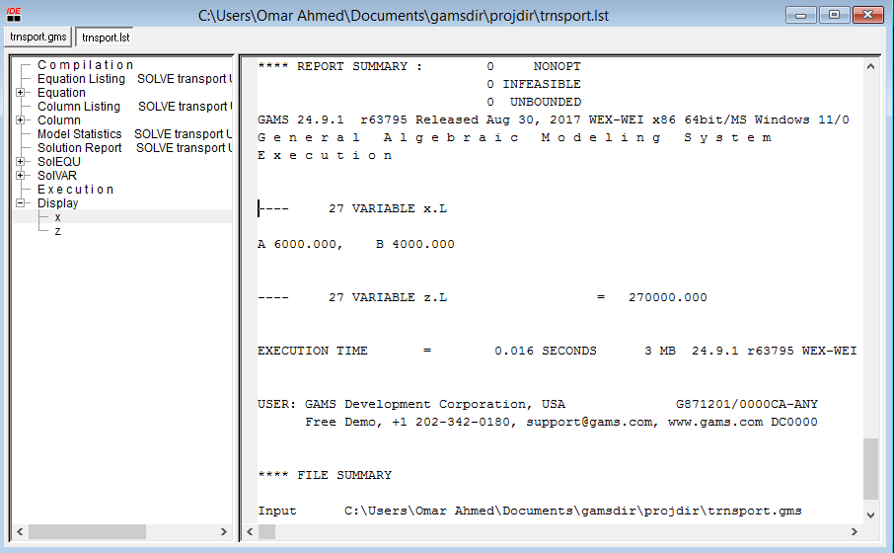

The suggestion is to increase the rate of the product A.

*Decrease Product of Production Capacity of A by 50%:

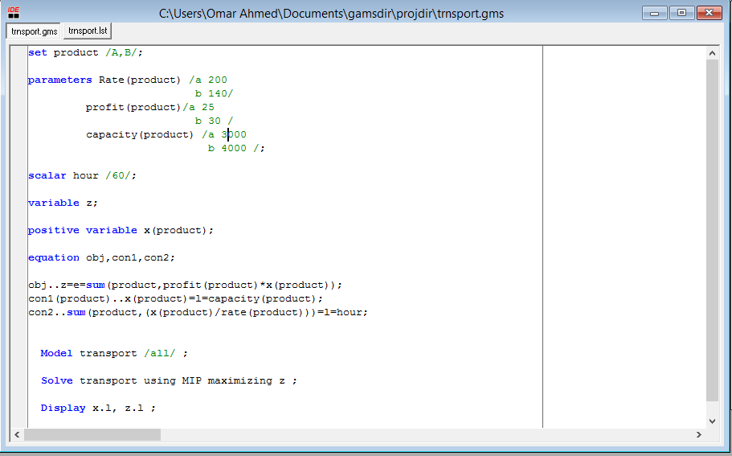



*Increase Product of Production Capacity of A by 50%:

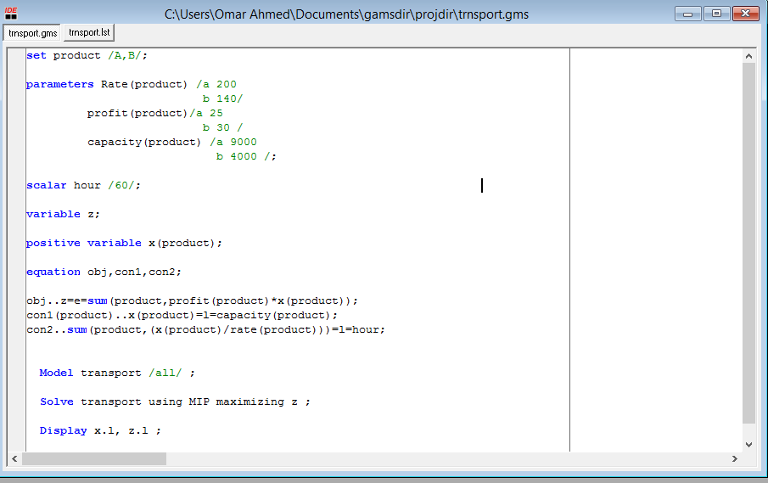

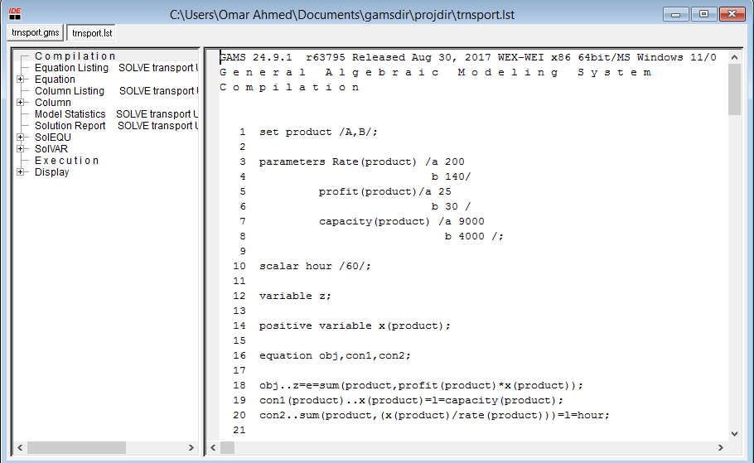

**B-Assuming that the manager of the manufacturing plant decided to add one product to the production mix (Prod-C).**

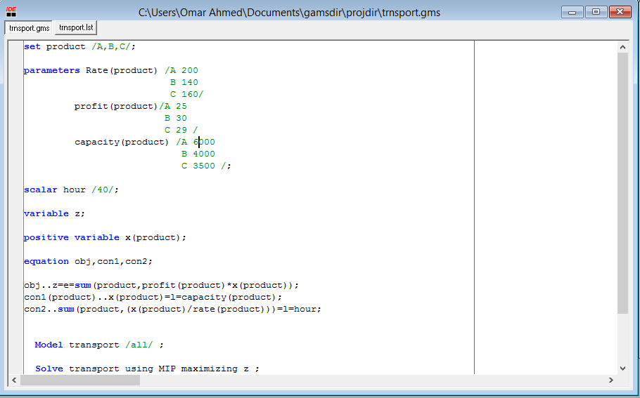

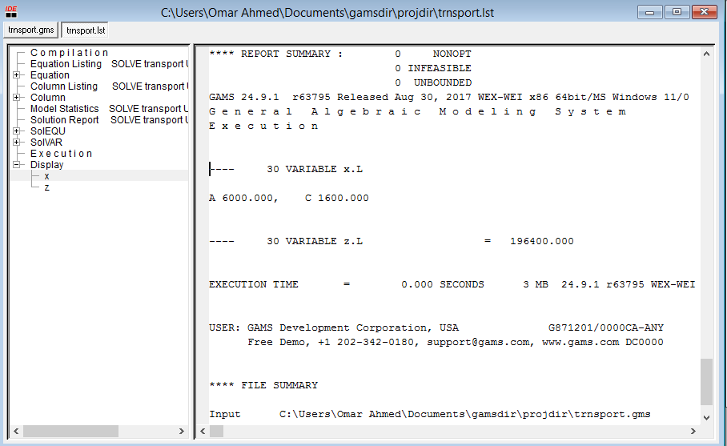

*Decrease Hours by 50% (PartB):

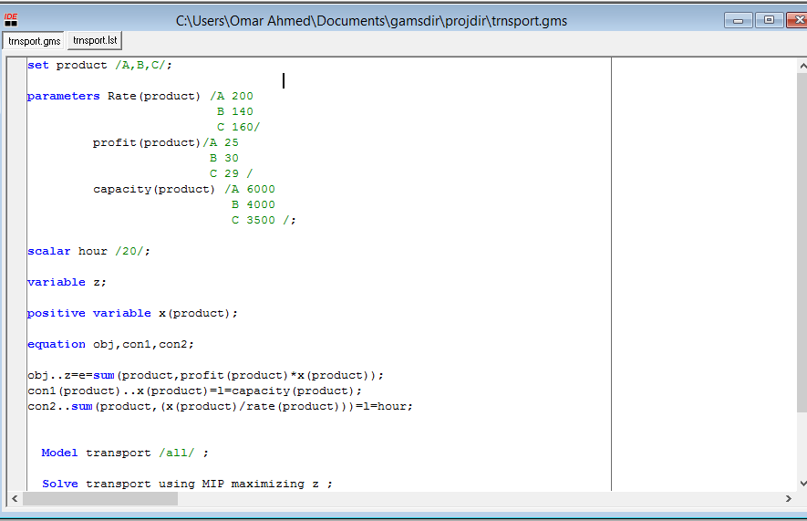

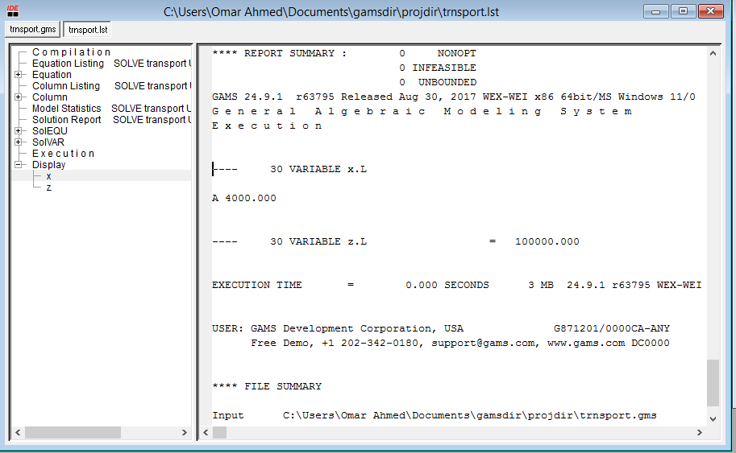

*Inecrease Hours by 50% (PartB):

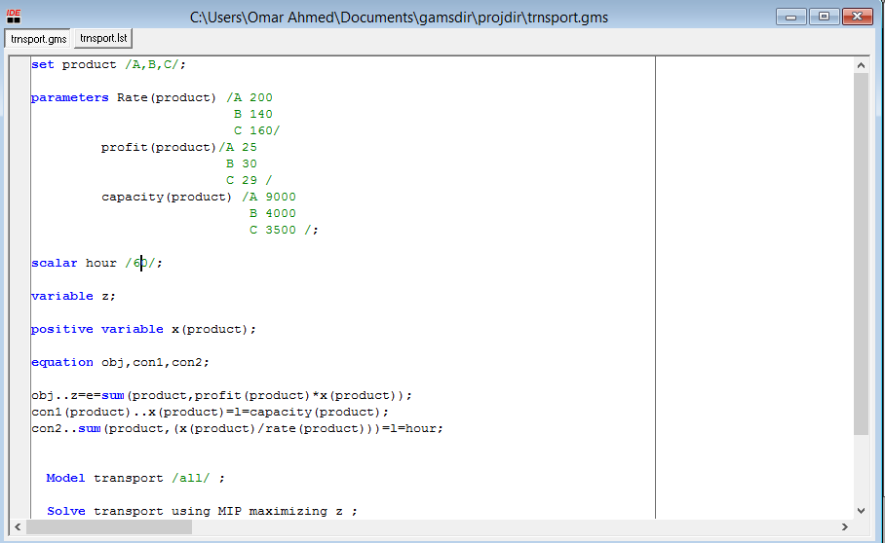

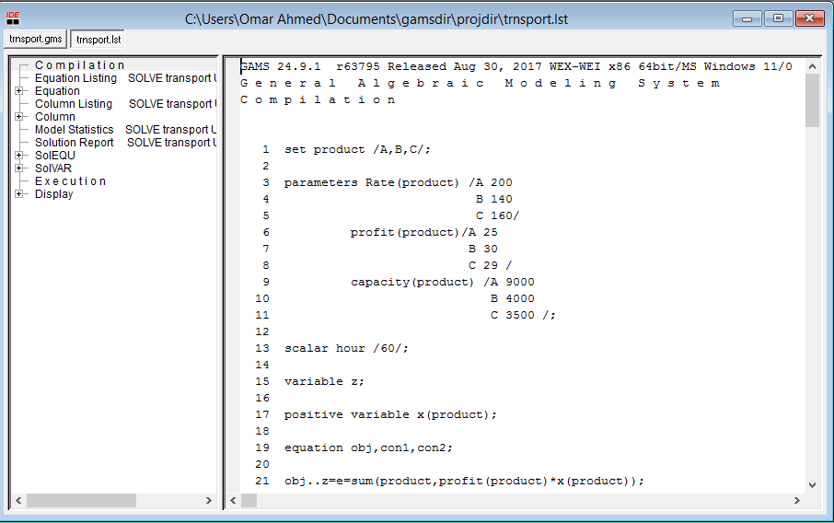

3-Suggest alternative policy measures and analyse the impact

Decreasing the value of the production rate by 25% of the Product A decrease the objective function.

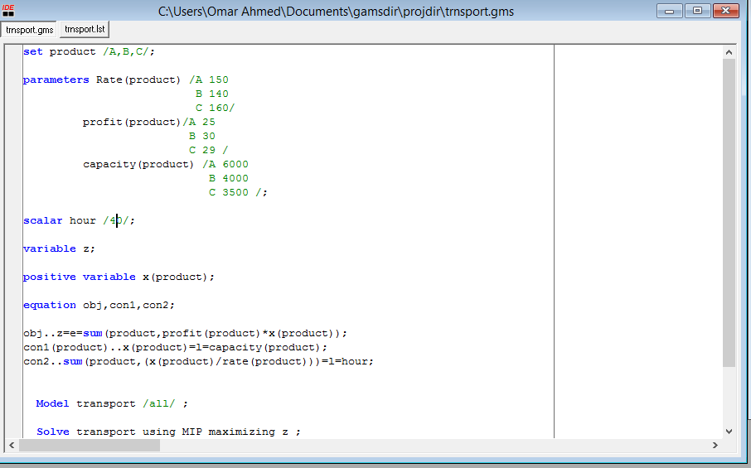

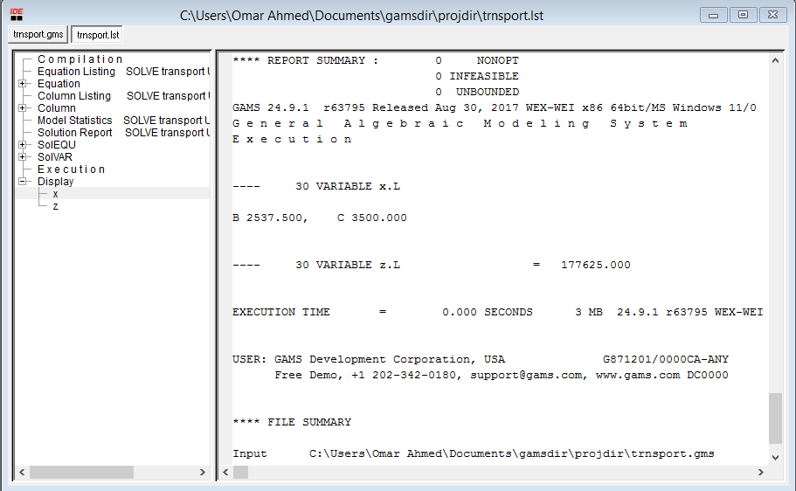

Increasing the value of the production rate by 25% of the Product A decrease the objective function.

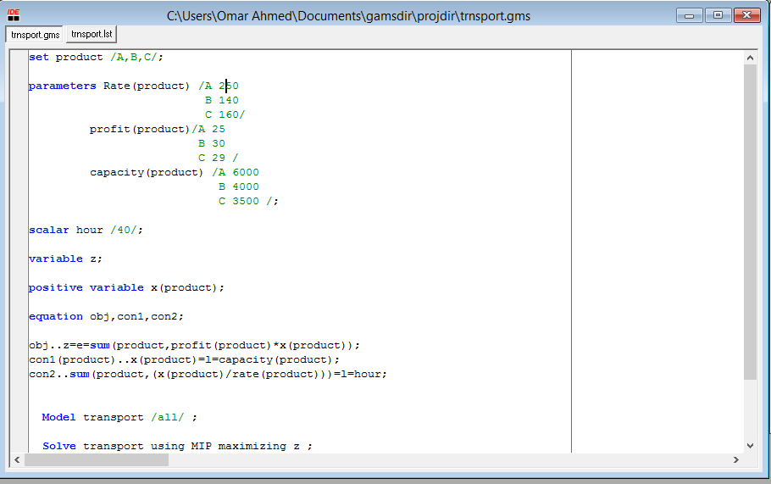

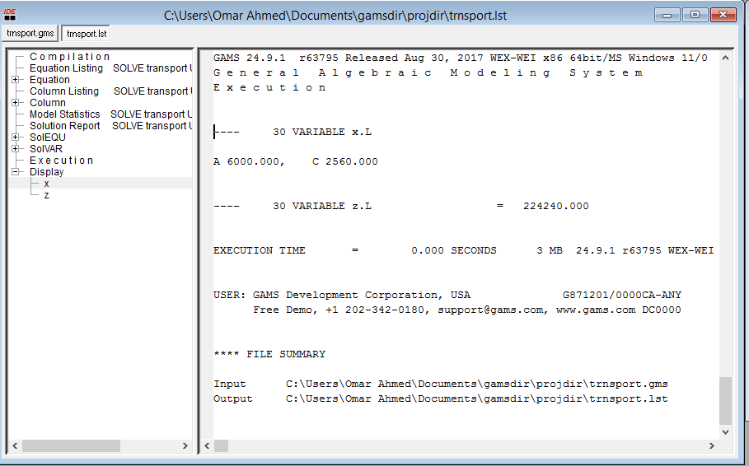

*Decrease Product of Production Capacity of A by 50%:

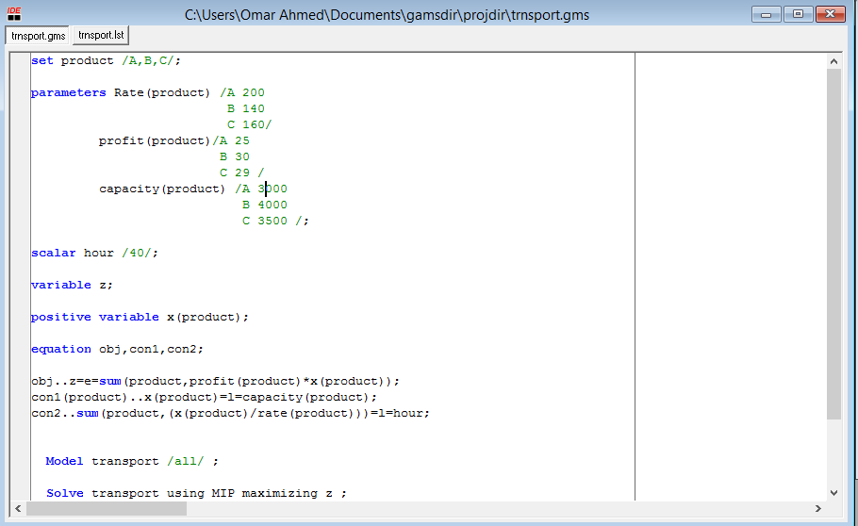

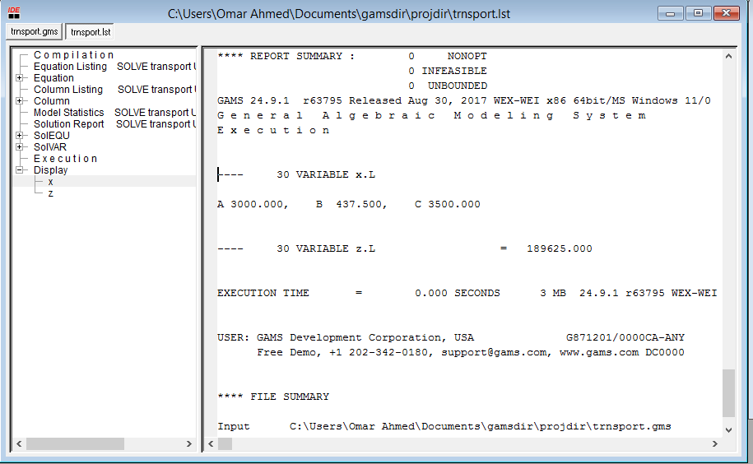

*Increase Product of Production Capacity of A by 50%:

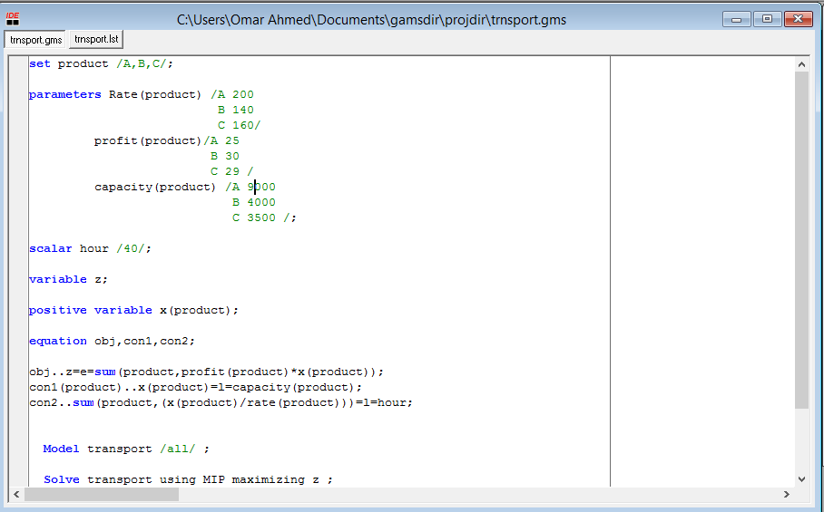

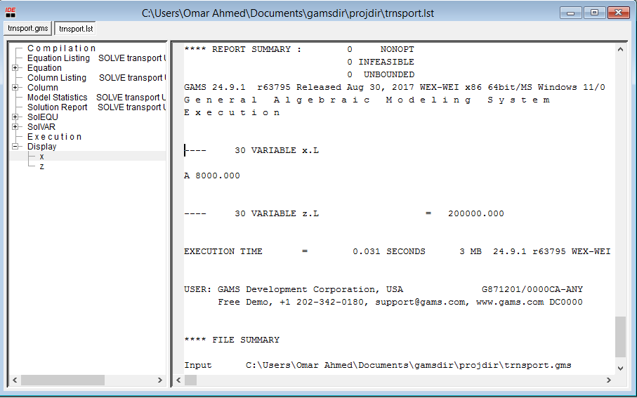

C) **Assuming that the production manager decided – for technical reasons to add**

**Lower bounds (in tonnes) on the production of the three products**

