Cairo University  
Faculty of Computers and Information



**CS251**

**Software Engineering I**

Project Name

Software Design

Team names

Omar ahmed

Hoda gamal

Mostafa Mohamed

Ezzat hany

12/2016

Contents

Team 3

Document Purpose and Audience 3

System Models 3

I. Class diagrams 4

II. Sequence diagrams 7

Class - Sequence Usage Table 10

Ownership Report 11

# Team

|  |  |  |  |
| --- | --- | --- | --- |
| **ID** | **Name** | **Email** | **Mobile** |
| 20140180 | Omar ahmed | Omarbadry28@gmail.com | 01151475706 |
| 20140301 | Hoda gamal | Hodagamal10.hg@gmail.com | 01151601669 |
| 20140270 | Mostafa Mohamed | Mustafalotfy48@gmail.com | 01125206371 |
| 20140173 | Ezzat hani | Ezzathany8@gmail.com | 01122148138 |

# Document Purpose and Audience

**Document purpose**

The purpose of this document is: designing the class diagrams and sequence diagrams with the class - sequence usage table of the educational game platform which we have specified its software recruitments in phase 1.

**Audience**

The audience includes system developers, system designers and the organization that might market for the project.

# System Models

## I. Class diagrams

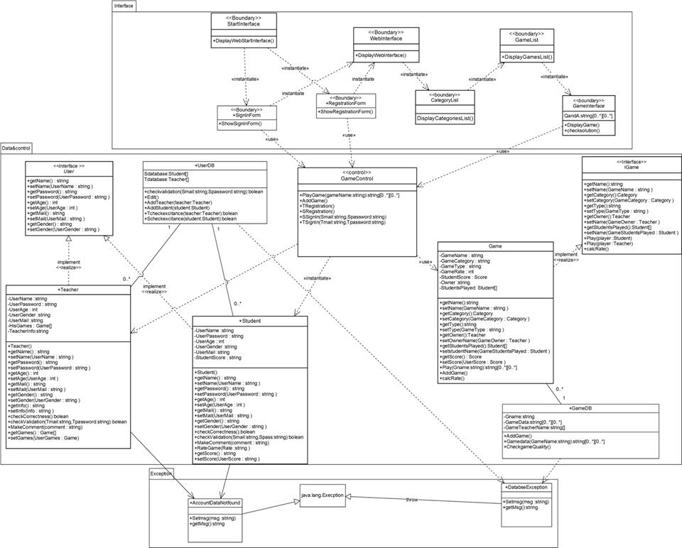

|  |  |  |
| --- | --- | --- |
| **Class ID** | **Class Name** | **Description & Responsibility** |
| 1 | Control | Has the functions that user can do and connect between boundaries  And the entities |
| 2 | User | Has abstract functions of student and teacher classes |
| 3 | student | Has the data wanted to be saved from the user (student) and has the  Function that we need to confirm the data we collect |
| 4 | Teacher | Has the data wanted to be saved from the user (Teacher) and has the Function that we need to confirm the data we collect |
| 5 | UserDB | Has the data of the user (student , teacher),check validation data and save data |
| 6 | Game | Has the data wanted to be saved about the game and has function that control the game |
| 7 | gameDB | Has the data of the game add and check quality of the game |
| 8 | IGame | Has abstract functions of class game |
| 9 | StartInterface | It`s boundary class display start web interface to user |
| 10 | Sign in form | Display sign in form to user that contain the data we need to collect  From user (mail,password) |
| 11 | Registration | Display sign in form to user that contain the data we need to collect  From user |
| 12 | Category list | Show the categories of the game |
| 13 | Game list | Show the name of the games uploaded to the website |
| 14 | Game interface | Display the game to the user and check solution |
| 15 | Web interface | Show web interface that has list of the website |
| 16 | Account data not found | Has the exception when the data of the user not found |
| 17 | Database exception | Has exception when error happens in the database |

## 

## II. Sequence diagrams

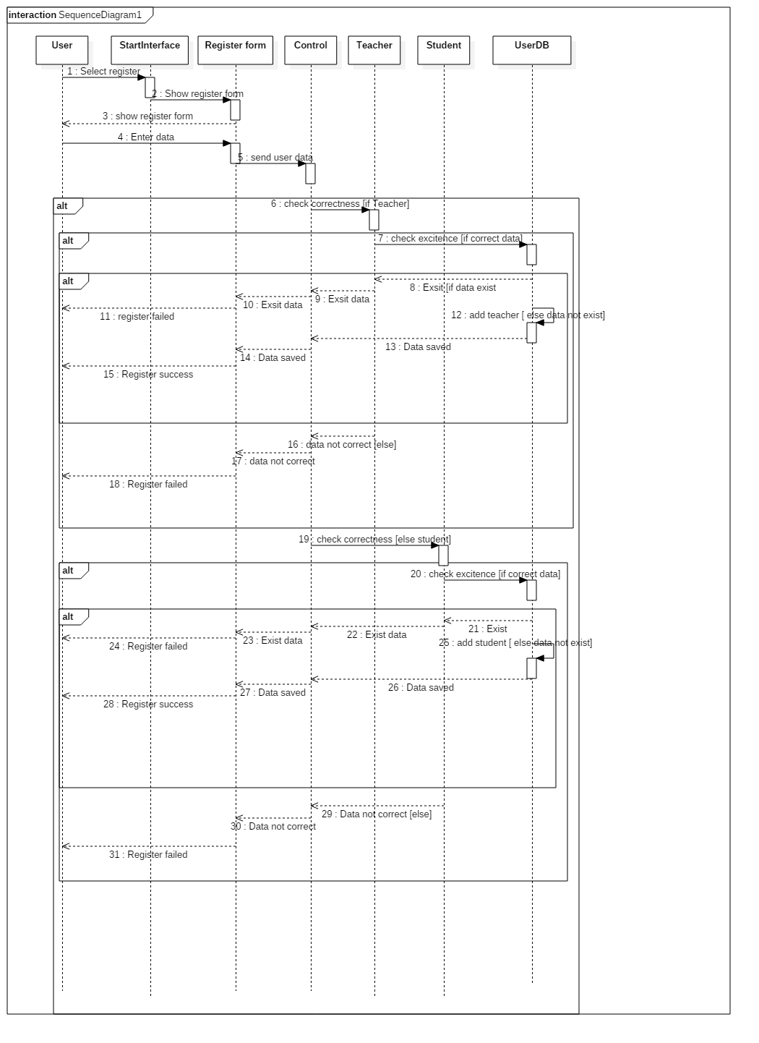

Registration (as a student or as a teacher)

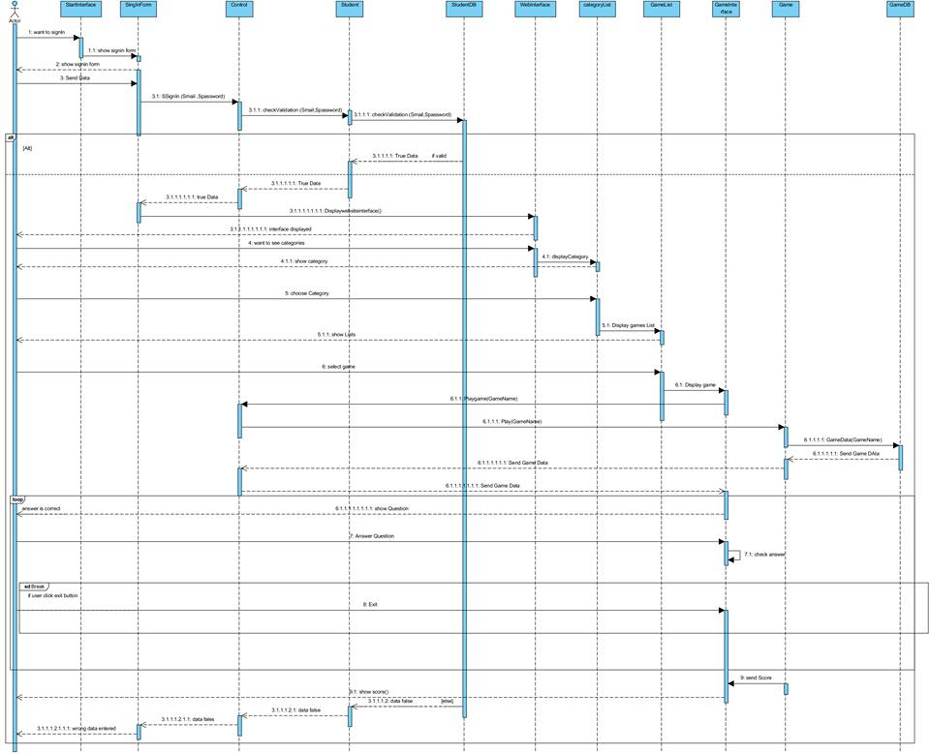

Play game (as a student)

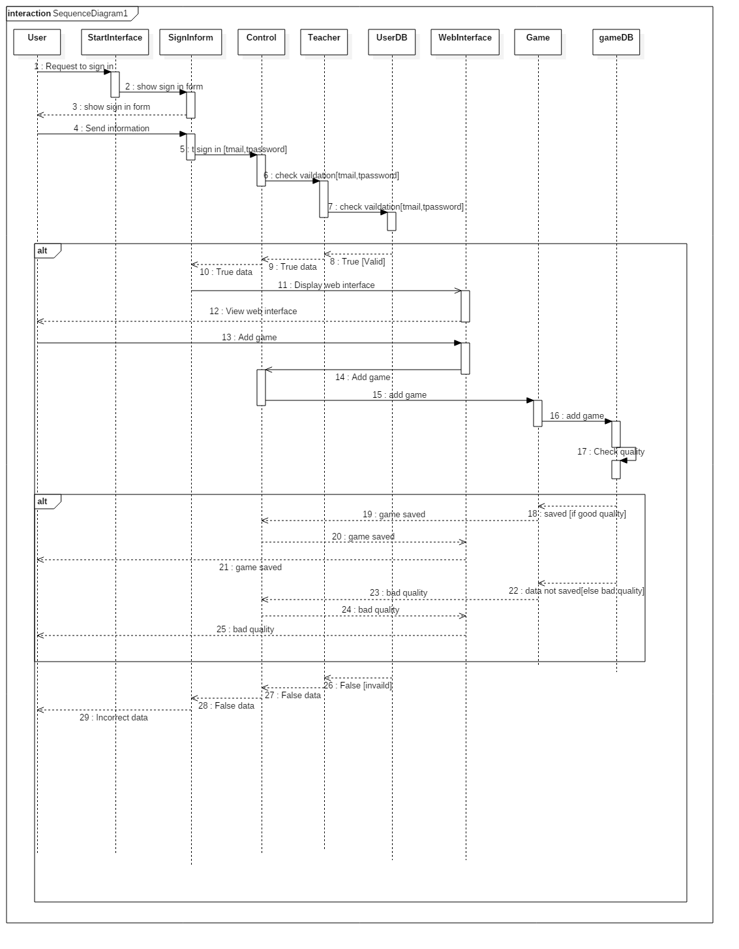

Add game (as a teacher)

### Class - Sequence Usage Table

|  |  |  |
| --- | --- | --- |
| Class Name | Sequance |  |
| Control | 1,2,3 | PlayGame,AddGame,  Tregistration,Sregistration,SsignIn,TSignIn |
| User | __ abstract class |  |
| student | 1,2 | getName,setName,getPassword,setPassword  ,getAge,setAge,getMail,setMail,getGender,  setGender,checkCorrectness,checkValidation |
| Teacher | 1,3 | getName,setName,getPassword,setPassword  ,getAge,setAge,getMail,setMail,getGender,  setGender,checkCorrectness,checkValidation, |
| UserDB | 1,3 | getName,setName,getPassword,setPassword  ,getAge,setAge,getMail,setMail,getGender,  setGender,checkCorrectness,checkValidation,  setGame |
| Game | 2,3 | getName,setName,setOwnerName,getStudentsPlayed,setstudentName,getScore,setScore,Play,AddGame,calcRate |
| gameDB | 2,3 | AddGame,Gamedata,CheckgameQuality |
| IGame | __ abstract class |  |
| StartInterface | 1,2,3 | DisplayWebStartInterface |
| SignInForm | 2,3 | ShowSignInForm |
| RegistrationForm | 1 | ShowRegistrationForm |
| Categorylist | 2 | DisplayCategoriesList |
| Gamelist | 2 | DisplayGamesList |
| Gameinterface | 2 | DisplayGame,checksolution |
| Webinterface | 2,3 | DisplayWebInterface |

## 

## 

## 

## 

## 

## 

## 

## 

Ownership Report

|  |
| --- |
| we have participated all together in every point in this document. |