
A Project Report On

DriveSense(Vehicle Service Tracker)

Submitted in partial fulfillment of the requirement for the award of the degree

Master of Computer Applications
(MCA)

Academic Year 2025 – 27

Nehang Majethiya (92500584120)
Mustafa Malvi (92500584101)
Priyarajsinh Rana (92500584118)

Internal Guide

Dr. Vivek Gondalia


Rajkot-Morbi Road, At &PO :Gauridad, Rajkot 360 003. Gujarat. India.


Faculty of Computer Applications (FoCA)


This is to certify that the project work entitled

DriveSense(Vehicle Service Tracker)

submitted in partial fulfillment of the requirement for the award of the degree of
Master of Computer Applications (MCA) of the

Marwadi University

is a result of the bonafide work carried out by
Nehang Majethiya (92500584120)
Mustafa Malvi (92500584101)
Priyarajsinh Rana (92500584118)

during the academic year 2025-26

Faculty Guide HOD Dean

DECLARATION

We hereby declare that this project work entitled DriveSense is a record done by us.

We also declare that the matter embodied in this project is genuine work done by us and has not been submitted whether to this University or to any other
University / Institute for the fulfillment of the requirement of any course of study.

Place:
Date:

Nehang Majethiya (92500584120) Signature:___________
Mustafa malvi (92500584101) Signature:___________
Priyarajsinh Rana (92500584118) Signature:___________

ACKNOWLEDGEMENT

It is indeed a great pleasure to express our thanks and gratitude to all those who helped us. No serious and lasting achievement or success one can ever achieve without the help of friendly guidance and co-operation of so many people involved in the work.

We are very thankful to our guide Dr. Vivek Gondalia , the person who makes us to follow the right steps during our project work. We express our deep sense of gratitude to for his /her guidance, suggestions and expertise at every stage. A part from that his/her valuable and expertise suggestion during documentation of our report indeed help us a lot.

Thanks to our friend and colleague who have been a source of inspiration and motivation that helped to us during our project work.

We are heartily thankful to the Dean of our department Dr. R. Sridaran for giving us an opportunity to work over this project and for their end-less and great support to all other people who directly or indirectly supported and help us to fulfil our task.

Nehang Majethiya (92500584120) Signature:___________
Mustafa Malvi (92500584101) Signature:___________
Priyarajsinh Rana (92500584118) Signature:___________

CONTENTS

Chapters | Particulars | Page No.
1 | Introduction | 1
2 | Preamble | 3
3 | Review of Literature | 5
4 | Technical Description | 7
4.1 | Hardware Requirements | 7
4.2 | Software Requirements | 7
4.3 | Technologies Used | 7
4.4 | System Architecture Overview | 8
5 | System Design and Development | 9
5.1 | Algorithm | 9
5.2 | Flowchart | 10
5.3 | Data Flow Diagram | 11
5.4 | Class Diagram | 12
5.5 | Use Case Diagram | 13
5.6 | Sequence Diagram | 14
5.7 | Activity Diagram | 15
5.8 | State Diagram | 16
5.9 | Database Design | 17
5.10 | Menu Design | 18
5.11 | Screen Design | 19
6 | System Testing | 28
7 | Conclusion | 34
8 | Future Scope | 35
9 | Bibliography | 37

FIGURE INDEX

Sr. No. | Figure No. | Particulars | Page No.
1 | 5.1 | Algorithm | 9
2 | 5.2 | Flow chart | 10
3 | 5.3 | Data Flow Diagram (Level 0) | 11
4 | 5.4 | Class Diagram | 12
5 | 5.5 | Use Case Diagram | 13
6 | 5.6 | Sequence Diagram | 14
7 | 5.7 | Activity Diagram | 15
8 | 5.8 | State Diagram | 16
9 | 5.9 | Database Design | 17
10 | 5.10 | Relationship diagram | 18
11 | 5.11.1 | Home Dashboard Screen | 19-20
12 | 5.11.2 | Emergency Assistance Dialog | 21
13 | 5.11.3 | Vehicle List Screen | 22
14 | 5.11.4 | Add Vehicle Screen | 23
15 | 5.11.5 | Service History Screen | 24
16 | 5.11.6 | Add Service Entry Screen | 25
19 | 5.11.7 | Fuel History Screen | 26
20 | 5.11.8 | Add Fuel Entry Screen | 27

TABLE INDEX

Sr. No. | Table No. | Particulars | Page No.
1 | Table 6.1 | Vehicle Management Test Cases | 30
2 | Table 6.2 | Fuel and Mileage Test Cases | 31
3 | Table 6.3 | Service Tracking Test Cases | 31
4 | Table 6.4 | Emergency Module Test Cases | 32
5 | Table 6.5 | Dashboard and UI Test Cases | 32

Introduction
DriveSense is an Android-based mobile application developed to simplify and enhance vehicle management for everyday users. In real-world scenarios, individuals often neglect regular vehicle maintenance, fail to monitor fuel consumption, and lose track of service schedules. This results in reduced vehicle performance, higher maintenance costs, and unexpected breakdowns.
To address these challenges, DriveSense provides a centralized platform where users can manage all vehicle-related activities efficiently. The application allows users to add and manage multiple vehicles, record fuel entries, and maintain detailed service histories. By organizing this information in a structured manner, the system ensures that users always have access to accurate and up-to-date vehicle data.
A key strength of the application lies in its intelligent features. DriveSense automatically calculates mileage based on fuel logs, helping users understand the efficiency of their vehicle. It also provides service reminders based on distance traveled, ensuring timely maintenance. Additionally, the application includes usage-based predictions, which estimate when the next service will be required based on average daily usage patterns.
The system is designed as a single-user, offline application using an SQLite database. This approach ensures fast performance, data security, and complete independence from internet connectivity. All data is stored locally on the device, making the application reliable and accessible at all times.

To further enhance practicality, DriveSense includes an emergency assistance feature. In case of vehicle issues, users can quickly access options to call a mechanic or locate nearby service centers using Google Maps integration. This adds real-world value and improves user safety.
The application also focuses on user experience by providing a clean, intuitive, and modern interface. Features such as quick actions, smart defaults, and minimal input requirements reduce manual effort and make the system easy to use even for non-technical users.
The primary objective of DriveSense is to improve vehicle maintenance awareness, reduce manual tracking effort, and provide meaningful insights through data-driven features. By combining simplicity with smart functionality, the application transforms routine vehicle management into an efficient and user-friendly process.

Preamble
The DriveSense application is designed using a modular approach, where each module is responsible for a specific functionality. This structure improves maintainability, scalability, and clarity of the system. The major modules of the application are described below:

1. Vehicle Management Module
This module handles all operations related to vehicles. It allows users to add new vehicles, edit existing details, and delete vehicles when required. It stores essential information such as vehicle name, registration number, type (car, bike, scooter), model, and current odometer reading. This module acts as the core of the system, as all other modules are linked to the selected (active) vehicle.

2. Service Tracking Module
The Service Tracking Module enables users to maintain a complete record of vehicle servicing. Users can log service details including service date, kilometer reading at the time of service, cost incurred, and additional notes. This module helps users keep track of maintenance history and ensures timely servicing of the vehicle.

3. Fuel Tracking Module
This module is responsible for recording fuel-related data. Users can add fuel entries by specifying the amount, fuel quantity, and odometer reading. Based on this data, the system supports mileage calculation and helps users monitor fuel efficiency over time. It also assists in analyzing fuel expenses.

4. Analytics Module
The Analytics Module provides intelligent insights by processing stored data. It performs calculations such as average mileage, total expenses, and service reminders based on predefined intervals. It also supports usage-based predictions by estimating future service requirements based on driving patterns. This module enhances decision-making and improves vehicle management efficiency.

5. Emergency Module
The Emergency Module adds real-world usability to the application. It provides quick access to emergency assistance by allowing users to call a mechanic directly or locate nearby service centers using Google Maps. This feature ensures user safety and convenience during unexpected situations.

Review of Literature
Several mobile applications such as Fuelio and Drivvo provide functionalities for fuel tracking, mileage calculation, and expense management. These applications allow users to record fuel entries, monitor fuel efficiency, and analyze vehicle-related expenses over time. They offer basic analytics and graphical insights, which help users understand their fuel consumption patterns.
However, most existing systems primarily focus on data storage and basic analysis. They often require continuous manual input, which can be time-consuming and inconvenient for users. Additionally, many applications depend on internet connectivity for synchronization, backup, or account management, making them less reliable in offline scenarios.
Another limitation of these systems is the lack of intelligent features such as usage-based predictions and simplified input mechanisms. Users are required to enter complete details for every operation, and there is minimal support for reducing repetitive data entry. Furthermore, multi-vehicle management in many applications is not streamlined, requiring users to manually select or switch between vehicles frequently.
DriveSense addresses these limitations by introducing a more user-centric and efficient approach. The application is designed as an offline-first system using SQLite, ensuring fast performance and data privacy without relying on internet connectivity. It incorporates a smart input system that reduces manual effort by providing default values and quick actions.

A key innovation in DriveSense is the Active Vehicle System, which allows users to select a single active vehicle, automatically linking all fuel and service records to it. This significantly simplifies multi-vehicle management. Additionally, the application includes intelligent features such as interval-based mileage calculation and usage-based service prediction, which provide more accurate and meaningful insights compared to traditional methods.
By combining simplicity, intelligent processing, and offline functionality, DriveSense offers a more practical and user-friendly solution for vehicle management compared to existing applications.

Technical Description

Hardware Requirements
The application is designed to run efficiently on standard Android devices without requiring high-end hardware. The minimum hardware requirements are as follows:
- Android Smartphone with Android OS (version 6.0 or above recommended)
- Minimum 4GB RAM for smooth performance
- Basic storage space for application installation and local database

Software Requirements
The development and execution of the DriveSense application require the following software tools and technologies:
- Android Studio: Integrated Development Environment (IDE) used for designing, coding, testing, and debugging the application.
- Java Development Kit (JDK): Used for writing and compiling the application logic in Java.
- Android SDK: Provides necessary libraries, APIs, and tools required for Android app development.
- SQLite Database: Used for local data storage, enabling offline functionality and fast data access.

Technologies Used
- Programming Language: Java
- User Interface: XML layouts using Material Design principles
- Database Management: SQLite (local database)
- State Management: SharedPreferences (for Active Vehicle system)
- API/Integration: Google Maps via Intent for emergency feature

System Architecture Overview
The application follows a modular and structured architecture:
- Frontend (UI Layer): Built using XML layouts and Activities to handle user interaction
- Backend Logic Layer: Implemented in Java classes for handling calculations, validations, and business logic
- Database Layer: Managed using SQLite through a DatabaseHelper class for CRUD operations
- State Management Layer: Managed using SharedPreferences to store active vehicle data
This architecture ensures clear separation of concerns, better maintainability, and efficient performance of the application.

System Design
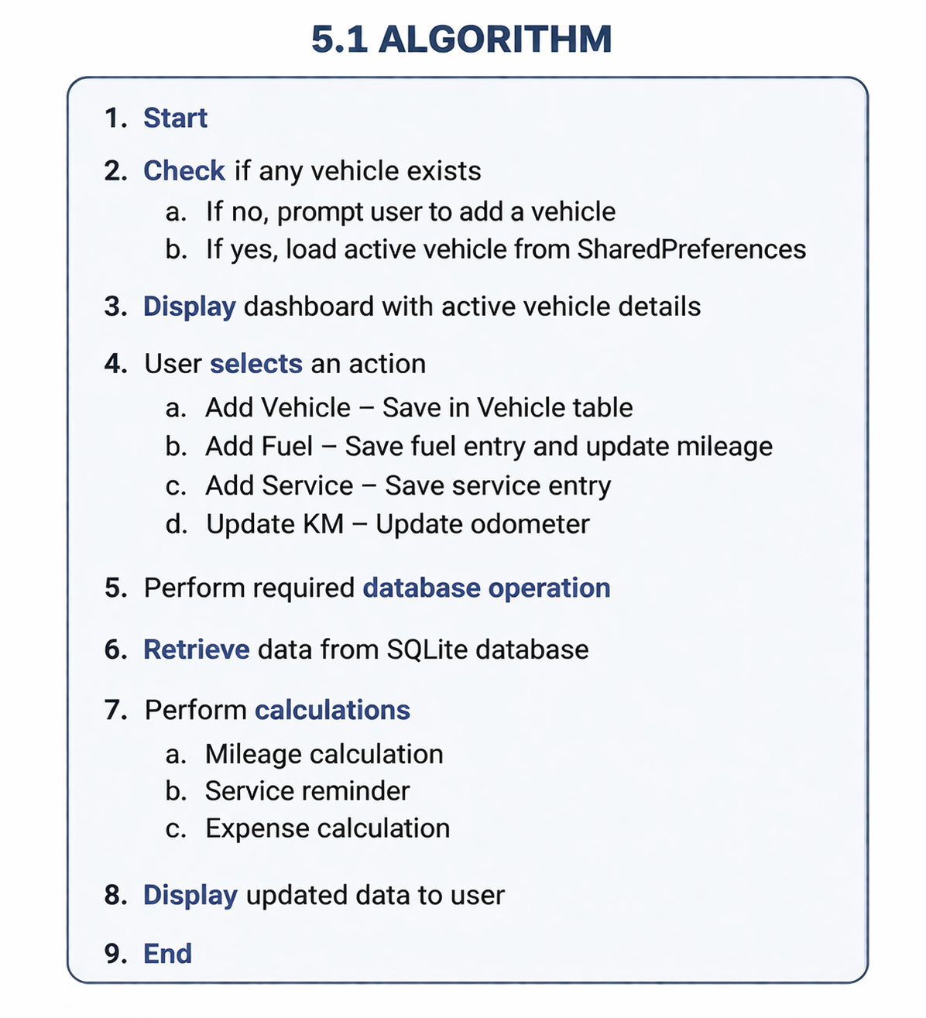
Figure 5.1
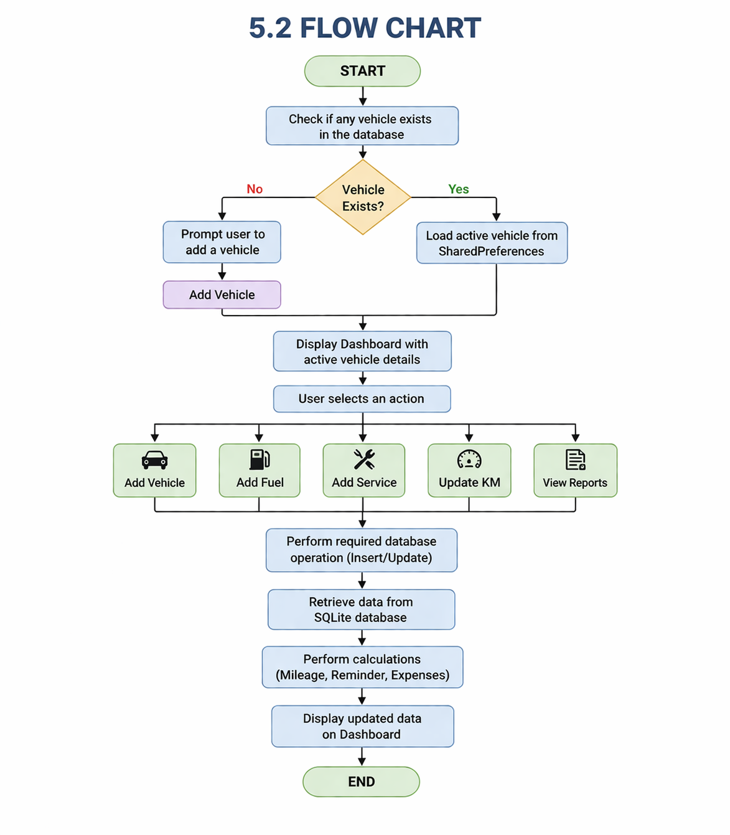 Figure 5.2

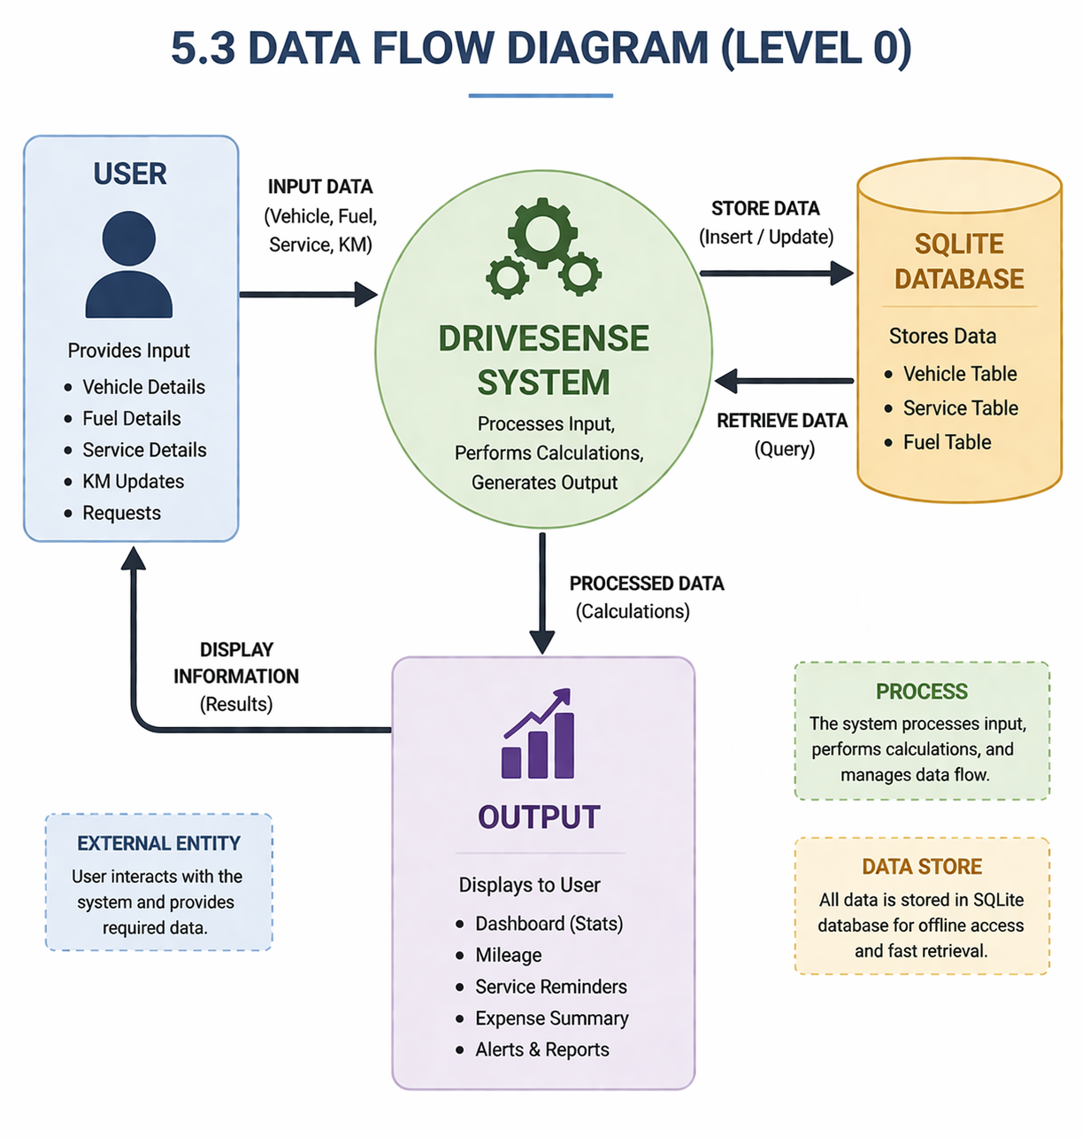 Figure 5.3

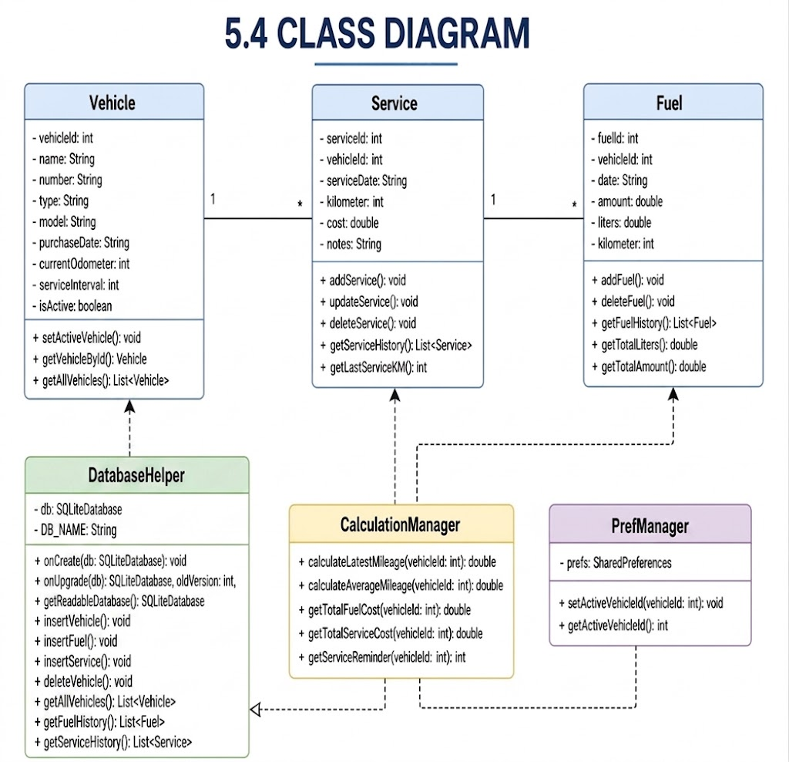
Figure 5.4

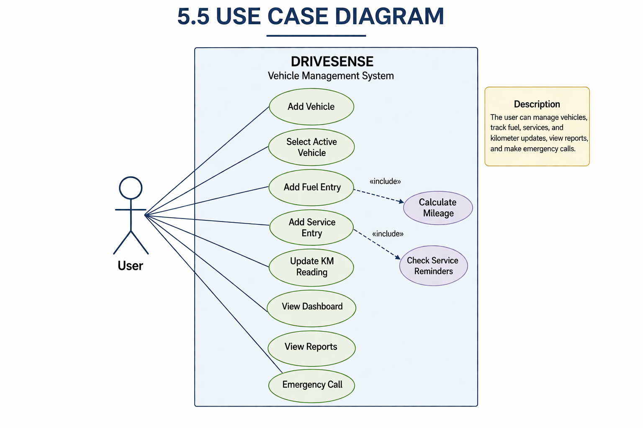
Figure 5.5
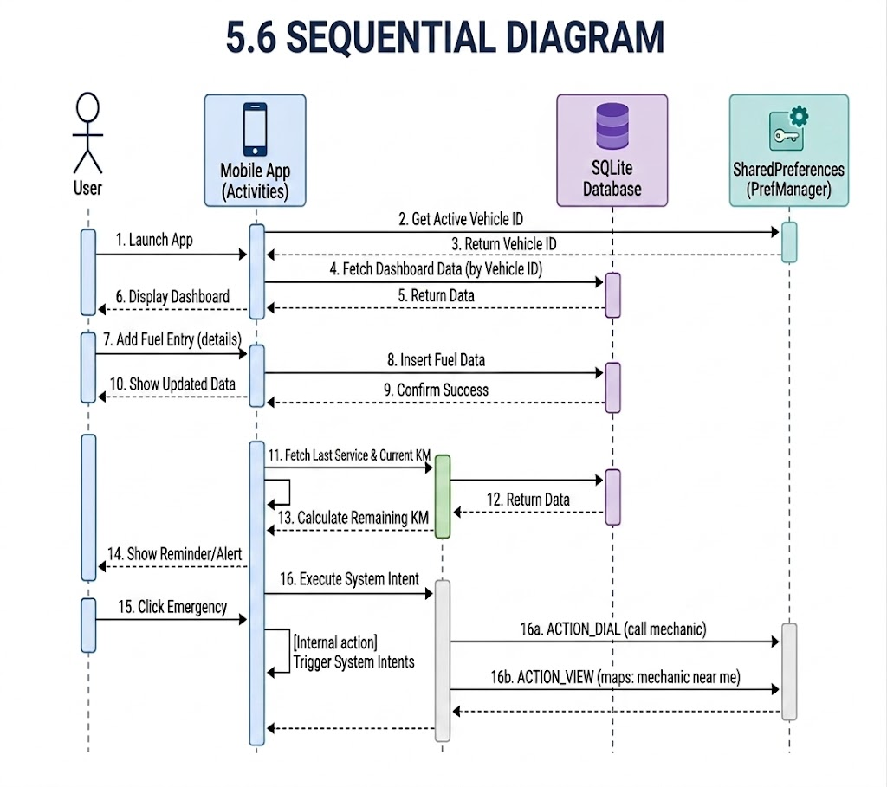
Figure 5.6

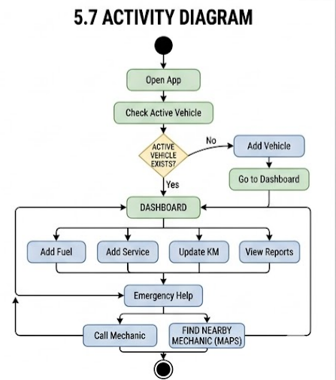
Figure 5.7
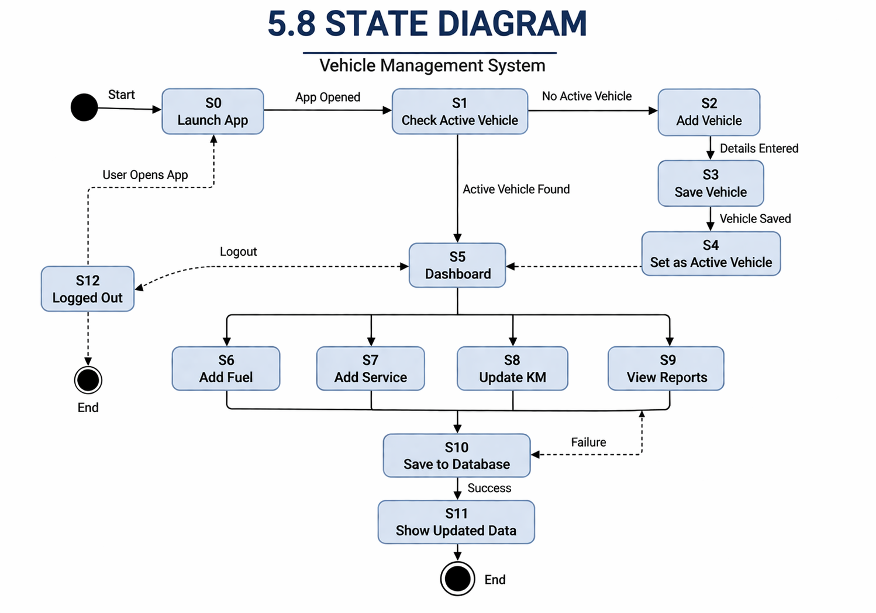
Figure 5.8

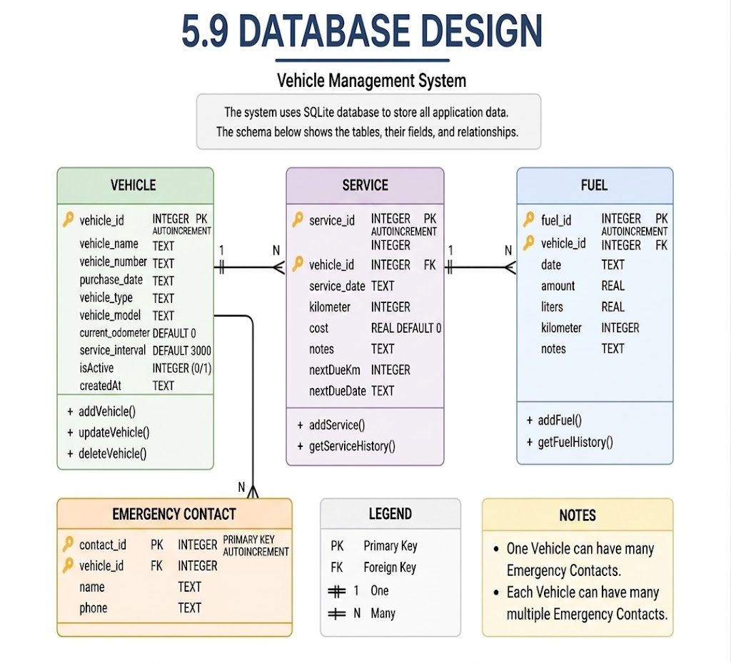
Figure 5.9

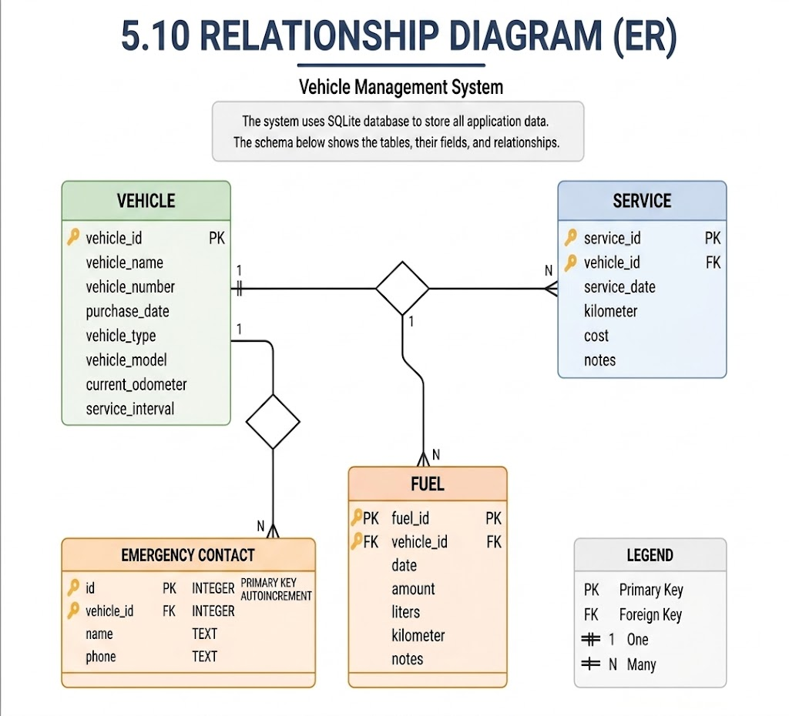
Figure 5.10

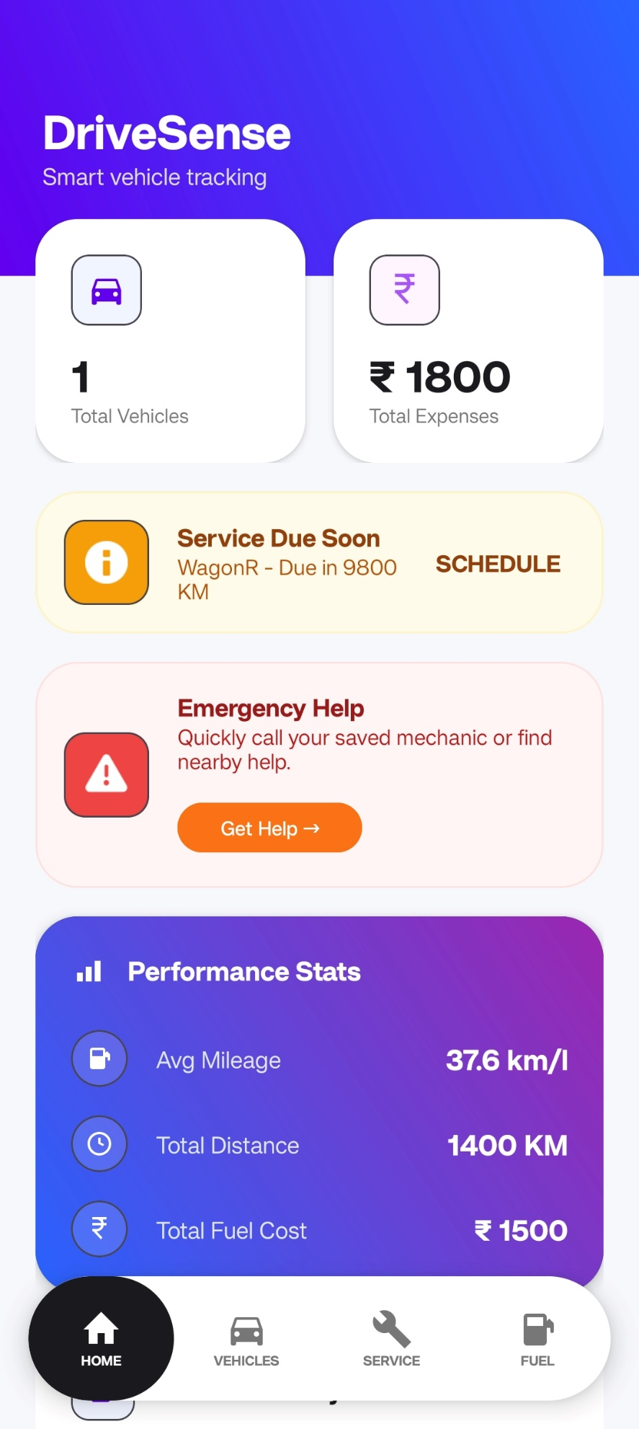
MENU DESIGN/SCREEN DESIGN
Figure 5.11.1
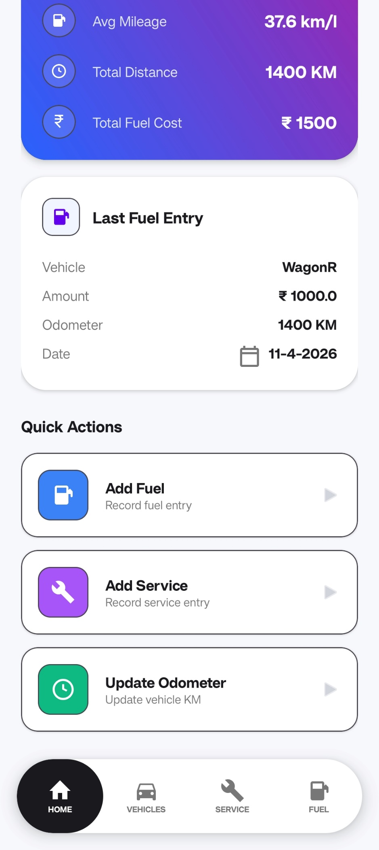
Figure 5.11.1
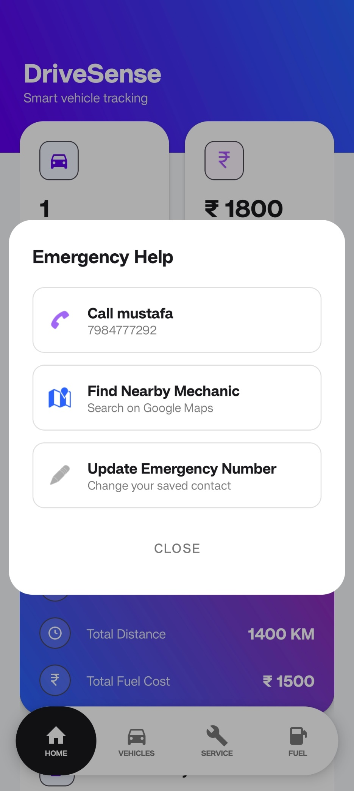
Figure 5.11.2
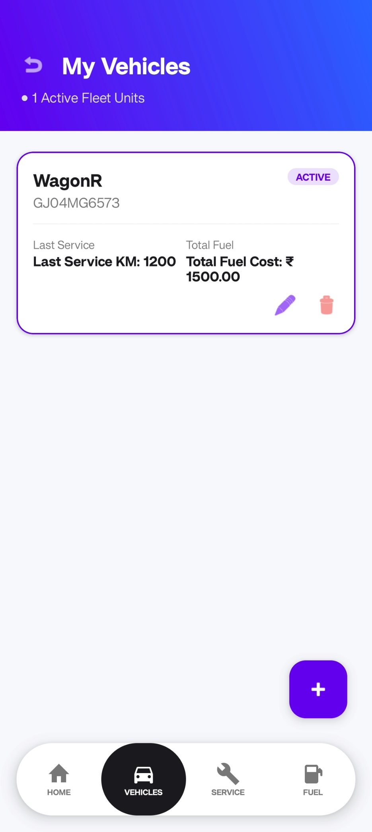
Figure 5.11.3
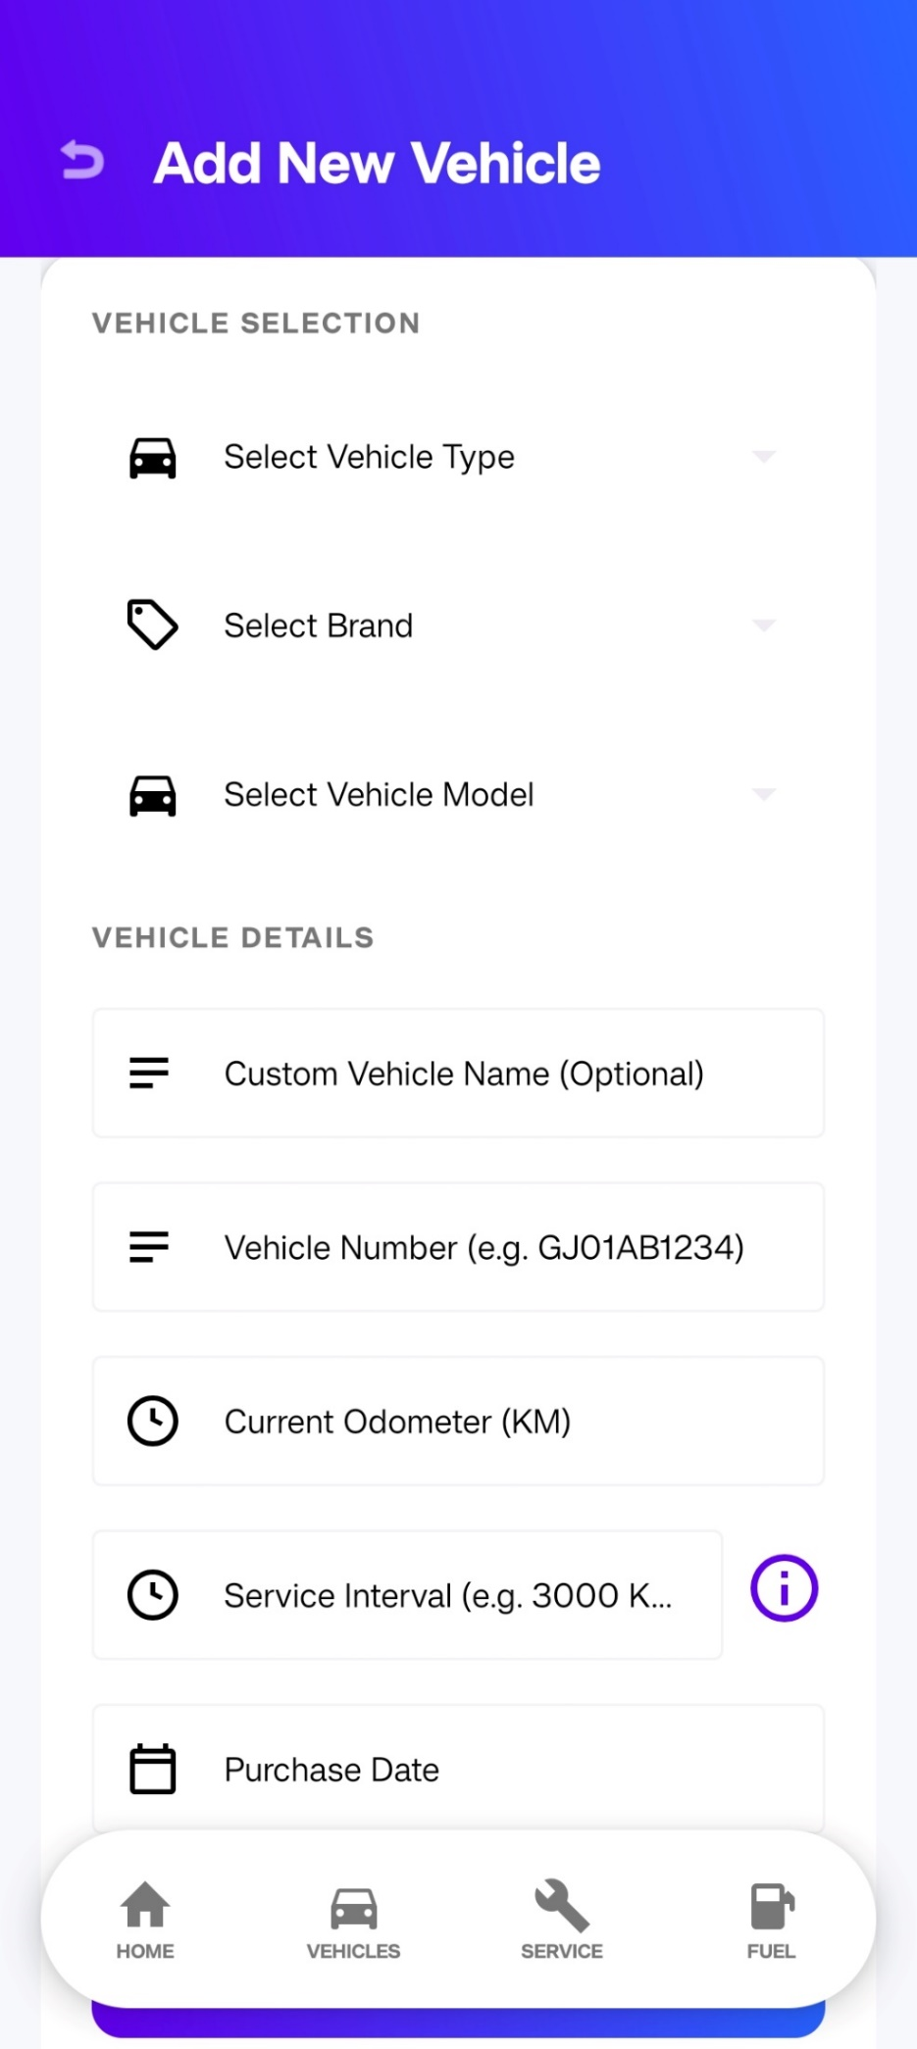
Figure 5.11.4
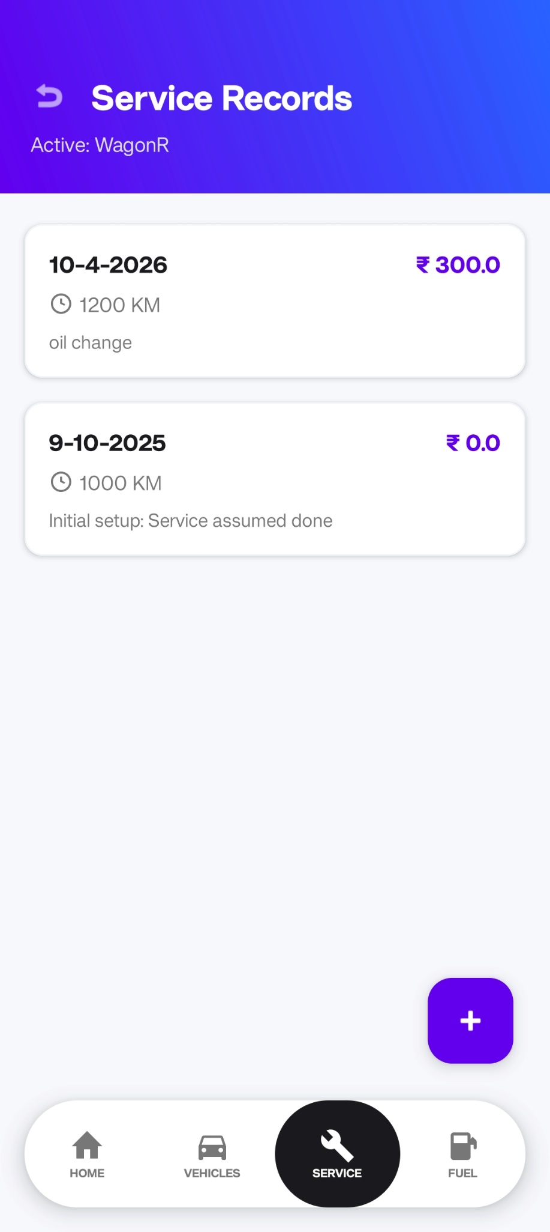
Figure 5.11.5
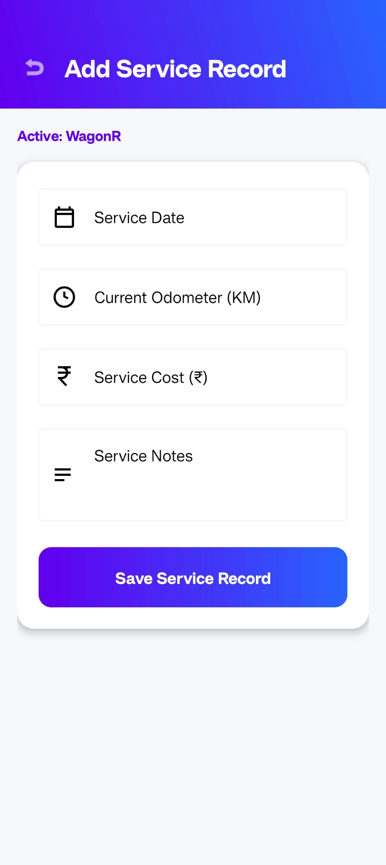
Figure 5.11.6
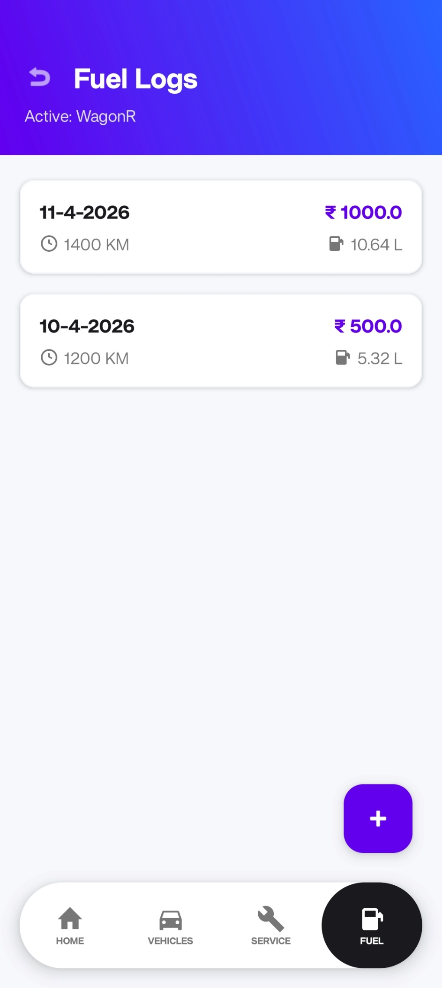
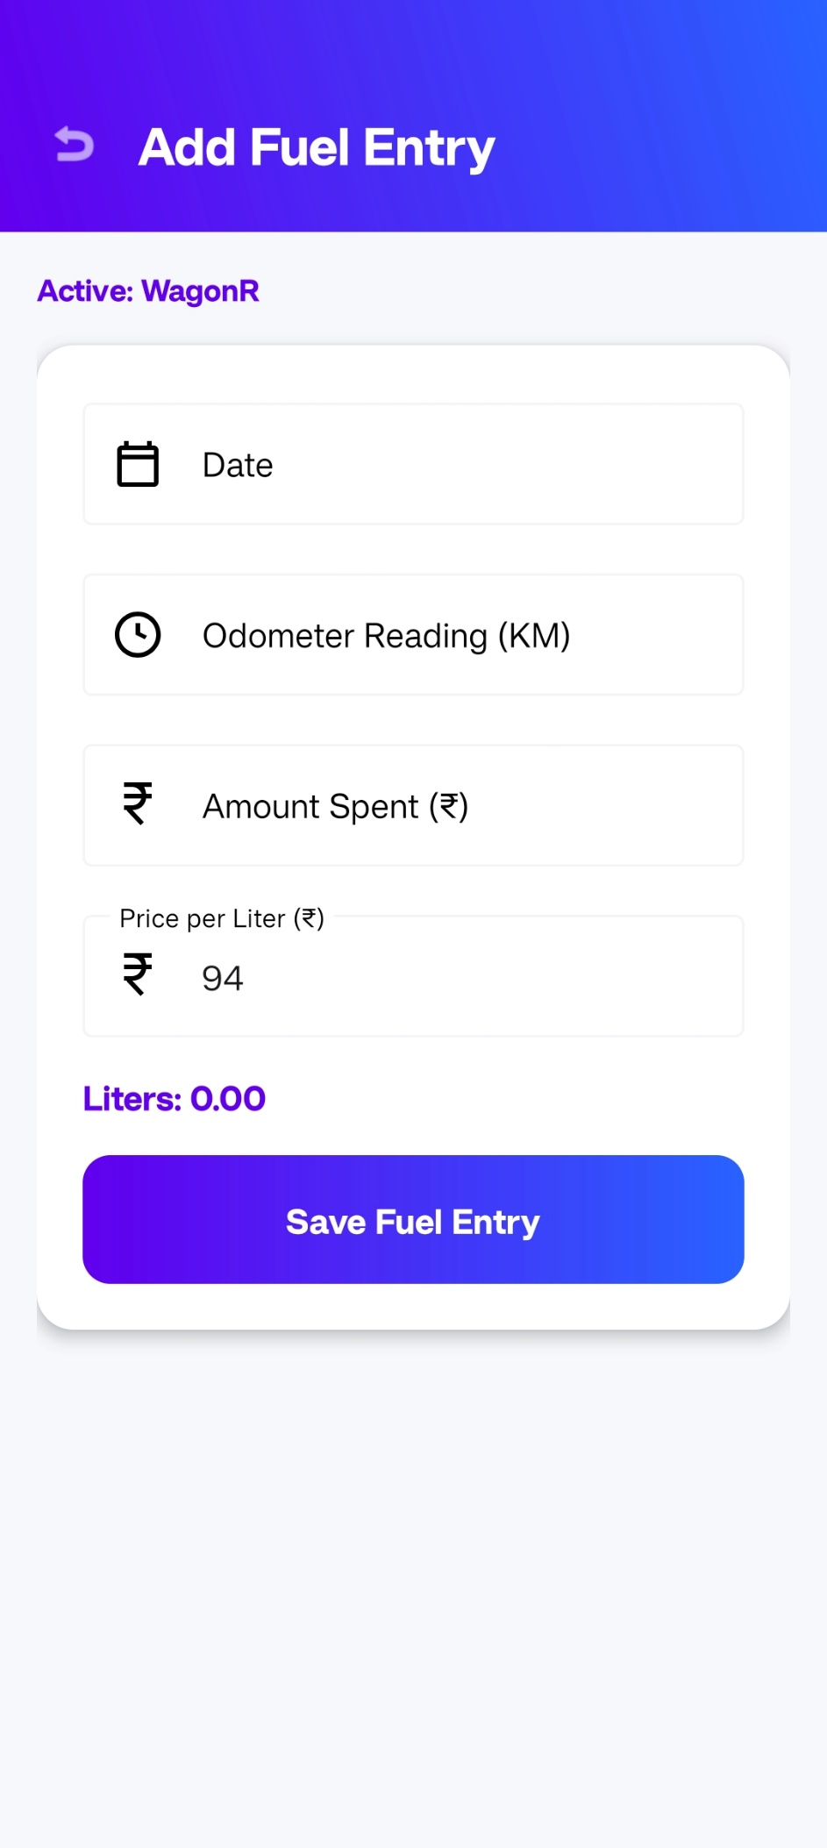
Figure 5.11.7
Figure 5.11.8

System Testing
System testing is performed to ensure that the DriveSense application functions correctly, meets user requirements, and is free from major defects. It involves testing the complete application as a whole, including all modules and their interactions.

- Testing Objectives
The primary objectives of system testing are:
- To verify that all features work as expected
- To ensure proper interaction between different modules
- To identify and fix bugs or errors
- To validate user inputs and system responses
- To ensure data consistency and accuracy

- Types of Testing Performed

- Functional Testing
Functional testing was conducted to verify that each feature of the application works according to the requirements.
- Adding, editing, and deleting vehicles
- Recording fuel entries and calculating mileage
- Logging service details and viewing history
- Displaying dashboard data correctly
- Emergency feature (call and maps) working properly
- Unit Testing
Individual components such as DatabaseHelper methods, mileage calculation logic, and input validation functions were tested separately to ensure correctness.
- Integration Testing
Integration testing was performed to verify that different modules work together properly. For example:
- Fuel entry updates odometer and affects mileage calculation
- Service entry updates service reminders
- Active vehicle selection affects all related data
- User Interface Testing
UI testing ensured that:
- Layouts are properly aligned
- Buttons and inputs work correctly
- Navigation between screens is smooth
- No crashes occur during user interaction
- Validation Testing
Input validation was tested to ensure:
- No empty fields are accepted
- Kilometer values do not decrease
- Negative values are not allowed
- Division by zero is prevented in calculations

- Test Cases

Category 1: Vehicle Management Test Cases

Test Case ID | Module | Test Scenario | Input / Action | Expected Output | Actual Output | Result
TC01 | Vehicle Management | Add New Vehicle | Enter all vehicle details and click Save | Vehicle added and appears in list | Vehicle added successfully | Pass
TC02 | Vehicle Management | Validation Check | Leave required fields empty | Error message displayed | Error message shown | Pass
TC03 | Vehicle Management | Active Selection | Select another vehicle | Active vehicle updated | Active vehicle updated correctly | Pass
TC04 | Vehicle Management | Delete Vehicle | Delete vehicle with logs | Vehicle and related logs deleted | Data deleted successfully | Pass

Table 6.1

Category 2: Fuel & Mileage Test Cases

Test Case ID | Module | Test Scenario | Input / Action | Expected Output | Actual Output | Result
TC05 | Fuel Module | Auto Calculation | Enter mount = 500, Price = 100 | Liters= 5.00 L calculated | Correct liters calculated | Pass
TC06 | Fuel Module | Mileage Calculation | Add two fuel logs with KM difference | Correct mileage displayed | Mileage calculated correctly | Pass
TC07 | Fuel Module | Single Entry Case | Add only one fuel log | Mileage = 0.0 km/l | Mileage shown as 0.0 | Pass
TC08 | Fuel Module | Invalid KM Input | Enter KM lower than previous | Error or ignored input | Validation handled correctly | Pass
Table 6.2

Category 3: Service Tracking Test Cases

Test Case ID | Module | Test Scenario | Input / Action | Expected Output | Actual Output | Result
TC09 | Service Module | Add Service Record | Enter service at 5000 KM with cost | Expense updated | Expense updated correctly | Pass
TC10 | Service Module | Service Reminder | KM near service interval | "Due Soon" message shown | Reminder displayed correctly | Pass
TC11 | Service Module | Overdue Alert | KM exceeds interval | "Overdue" warning shown | Warning displayed correctly | Pass
Table 6.3

Category 4: Emergency Assistance Test Cases

Test Case ID | Module | Test Scenario | Input / Action | Expected Output | Actual Output | Result
TC12 | Emergency Module | Phone Validation | Enter invalid phone number | Error message displayed | Validation works correctly | Pass
TC13 | Emergency Module | Call Mechanic | Tap call button | Dialer opens | Dialer opened successfully | Pass
TC14 | Emergency Module | Find Mechanic | Tap map option | Google Maps opens | Maps opened correctly | Pass
Table 6.4

Category 5: Dashboard & UI Test Cases

Test Case ID | Module | Test Scenario | Input / Action | Expected Output | Actual Output | Result
TC15 | Dashboard | Odometer Sync | Add fuel entry with KM | Dashboard updates KM | KM updated correctly | Pass
TC16 | UI Navigation | Screen Switching | Navigate between screens | Smooth transition | Navigation smooth | Pass
TC17 | Dashboard | Empty State | Remove all vehicles | Show empty state message | Message displayed correctly | Pass
Table 6.5

- Results
All modules of the DriveSense application were tested successfully. The system performs reliably under normal usage conditions. All major functionalities such as vehicle management, fuel tracking, service logging, and emergency assistance work as intended.
No critical bugs were found during testing, and minor issues were resolved during development.

- Conclusion of Testing
The testing process confirms that the application is stable, user-friendly, and functionally accurate. The system meets all specified requirements and is ready for deployment.

Conclusion
The DriveSense application was successfully developed as a smart, efficient, and user-friendly vehicle service tracking system. The project effectively addresses a common real-world problem of managing vehicle maintenance, fuel records, and service schedules in a structured and reliable manner.
The application provides essential functionalities such as vehicle management, fuel tracking, and service logging, along with advanced features like accurate mileage calculation, service reminders, and usage-based predictions. The implementation of the Active Vehicle System simplifies multi-vehicle management by automatically linking all operations to the selected vehicle. Additionally, the Smart Input System reduces manual effort by minimizing repetitive data entry, thereby improving overall user experience.
The system was designed as an offline-first application using SQLite, ensuring fast performance, data security, and complete independence from internet connectivity. This makes the application reliable and accessible under all conditions. All modules were thoroughly tested and verified to function correctly across different scenarios, ensuring system stability and accuracy.
Overall, DriveSense demonstrates the practical application of Android development concepts, database management, and logical problem-solving techniques. The project not only fulfills academic requirements but also provides a strong and scalable foundation for future enhancements and potential real-world deployment.

Future Scope
The DriveSense application provides a strong foundation for vehicle maintenance tracking; however, several enhancements can be implemented in the future to improve its functionality, scalability, and real-world usability.
One major enhancement is the integration of cloud-based storage, such as Firebase, which would allow users to synchronize their data across multiple devices and prevent data loss. This would also enable features like user authentication and secure data backup.
Another important improvement is the implementation of push notifications using AlarmManager or Firebase Cloud Messaging. This would allow the system to notify users about upcoming service schedules, overdue maintenance, and important updates even when the application is not actively in use.
The application can also be extended with advanced analytics and data visualization, including charts and graphs for fuel consumption, mileage trends, and expense analysis. This would help users better understand their vehicle performance and make informed decisions.
Integration with GPS and location services can further enhance the emergency feature by providing real-time navigation to nearby service centers and mechanics. This would improve the practicality and usefulness of the application during critical situations.
Another potential enhancement is the use of AI-based prediction models to provide more accurate maintenance recommendations based on user driving behavior and historical data. This would make the system more intelligent and adaptive.
Additional features such as document storage (for insurance and vehicle papers), multi-user support, and dark mode UI can also be considered to improve user experience and application versatility.
Overall, these enhancements can transform DriveSense from a standalone offline application into a comprehensive, intelligent, and scalable vehicle management system suitable for real-world deployment.

Bibliography
The following references were used during the development of the DriveSense application:

Online References
- Android Developers. Android Developer Documentation.
Available at: https://developer.android.com
- SQLite. SQLite Official Documentation.
Available at: https://www.sqlite.org/docs.html
- Stack Overflow. Programming Q&A Community.
Available at: https://stackoverflow.com
- GeeksforGeeks. Computer Science and Programming Tutorials.
Available at: https://www.geeksforgeeks.org
- W3Schools. Web Development and Programming Tutorials.
Available at: https://www.w3schools.com
- YouTube. Android Development Tutorials and Guides.

Offline References
- MCA Course Materials and Academic Notes
- Faculty Guidance and Classroom Lectures
These references were used to understand Android development concepts, database management using SQLite, user interface design, and problem-solving approaches during the implementation of the project.

