Implementing a Retinex Algorithm for Low-Light Image Enhancement Using CNN and U-Net Architectures

Author: Mustafa Melih Dönmez

Abstract — Low-light image enhancement is a challenging task in image processing, crucial for applications such as surveillance, photography, and autonomous driving. This paper investigates the application of Retinex theory for enhancing low-light images using deep learning approaches. Two architectures are proposed and compared: (1) a CNN-based model that dynamically predicts optimal Retinex parameters for each image, and (2) a U-Net-based model that performs enhancement after fixed multi-scale Retinex preprocessing. Both models were trained on the LOLv1 dataset. Evaluations were conducted using Structural Similarity Index (SSIM) and loss metrics. The U-Net model achieved significantly better performance, suggesting that fixed Retinex preprocessing followed by deep enhancement yields superior results over adaptive parameter prediction.
Keywords — Retinex, low-light image enhancement, convolutional neural network, U-Net, SSIM, deep learning.

Introduction
Low-light conditions severely degrade image quality, resulting in poor contrast, loss of detail, and color distortion. This hampers the performance of higher-level vision tasks such as object detection and tracking. Enhancing such images is vital for real-world applications in security surveillance, autonomous navigation, and medical imaging.
The Retinex theory, introduced by Land and McCann, models how the human visual system perceives color under varying lighting conditions. It attempts to separate the reflectance (true color and texture) from the illumination. Traditionally, algorithms such as Single-Scale Retinex (SSR) or Multi-Scale Retinex (MSR) were used with fixed Gaussian filters. However, fixed parameters often fail to generalize across varying scenes.
To address this, deep learning methods can be integrated with Retinex theory for dynamic or learned enhancement. In this work, we implement:
- A CNN-based model that learns to predict optimal parameters for Retinex enhancement on a per-image basis.
- A U-Net model that applies fixed Retinex preprocessing and learns to map enhanced inputs to clean outputs.
The aim is to compare the effectiveness of these two approaches in enhancing low-light images both quantitatively (loss and SSIM) and qualitatively (visual quality).

Materials and Methods

Dataset
The LOLv1 dataset (Low-Light Dataset) from Kaggle is used, consisting of 485 low-light and corresponding normal-light images. The dataset is split into two directories:
our485/low/ – low-light images
our485/high/ – ground truth enhanced images
Data was resized to 256×256 and normalized. PyTorch’s DataLoader was used to batch images during training.

Retinex Theory
The Retinex model enhances an image I(x, y) by computing:
R(x, y) = log I(x, y) - log [G_σ * I(x, y)]
where:
- I(x,y)I(x, y)I(x,y) is the input image
- G_σ is a Gaussian kernel with standard deviation σ\sigmaσ
- * denotes convolution
For multi-scale Retinex (MSR), outputs from different sigma values (e.g., 15, 80, 250) are averaged. Further color restoration and normalization is applied:
MSRCR=G⋅[MSR+β⋅(log(αI)−log(∑I))]
where α,β,G are tunable parameters for contrast and color correction.

CNN Based Retinex Model
This model includes:
- A feature encoder that processes the input and predicts Retinex parameters (σ1,σ2,σ3,α,β,G)
- Application of multi-scale Retinex using the predicted parameters
- A post-enhancement CNN that refines the enhanced image output
The CNN allows dynamic adaptation of enhancement parameters for each input image, which can be beneficial in scenes with widely varying lighting.

U-Net Based Retinex Model
The second approach uses fixed Retinex parameters (e.g., [15, 80, 250]) to preprocess the input image, followed by a U-Net architecture. U-Net comprises:
- Encoder: convolutional blocks with downsampling
- Bottleneck: latent representation
- Decoder: upsampling with skip connections for spatial detail preservation
This model leverages Retinex theory to standardize inputs and uses the deep U-Net structure to enhance them further.

Loss Function
We define a combined loss:
L_combined = 0.5 × L1 Loss + 0.5 × (1−SSIM)
- L1 loss ensures pixel-wise accuracy
- SSIM loss ensures perceptual similarity
Both models were trained using Adam optimizer, learning rate 5×10⁻⁵, and batch size of 8 over 120 epochs.

Experimental Results

Model | Final Loss | Final SSIM
CNN | 0.212 | 0.712
U-Net | 0.103 | 0.829
- U-Net achieved significantly lower loss and higher SSIM.
- Loss and SSIM curves show smoother convergence for U-Net.

Loss Comparison

CNN Initial Loss: 0.272 → Final Loss: 0.212
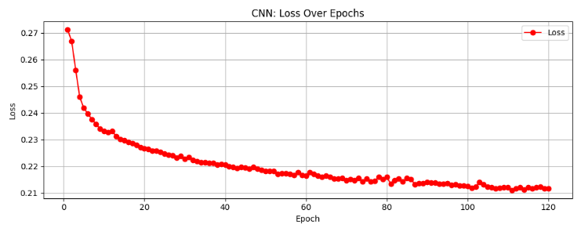

U-Net Initial Loss: 0.270 → Final Loss: 0.103
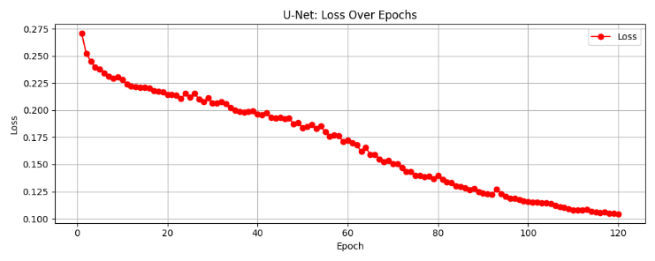

SSIM Comparison

CNN Initial SSIM: 0.637 → Final SSIM: 0.712
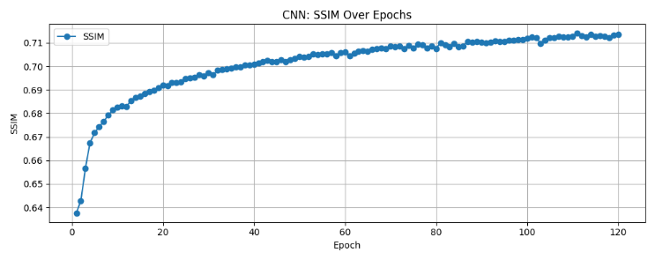

U-Net Initial SSIM: 0.640 → Final SSIM: 0.829

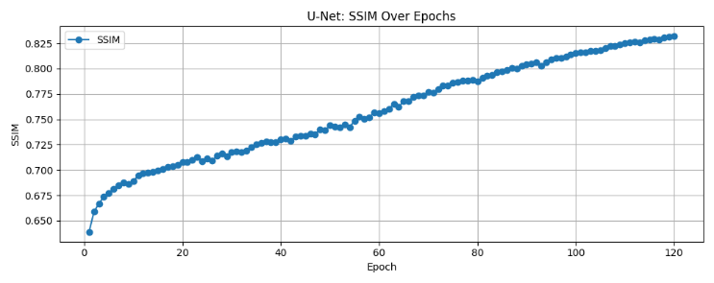

Visual Comparison
Visual outputs were evaluated for 5 test images. Observations:
- CNN enhances brightness but sometimes introduces noise.
- U-Net produces sharper, natural-looking results, especially in shadowed regions.

Retinex Algorithm using CNN:
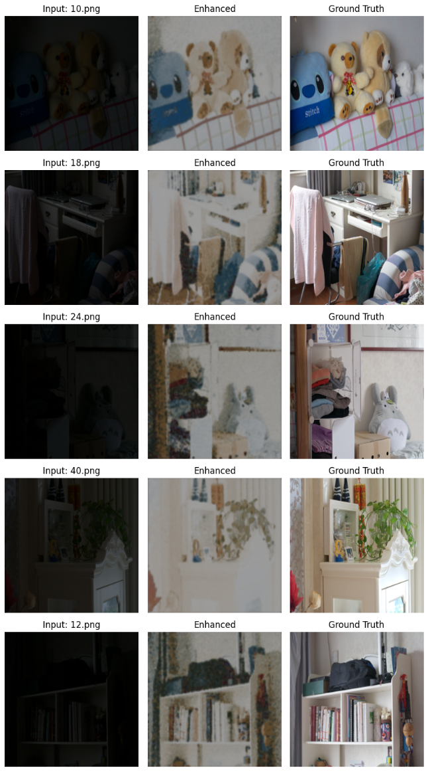

Retinex Algorithm using U-Net:
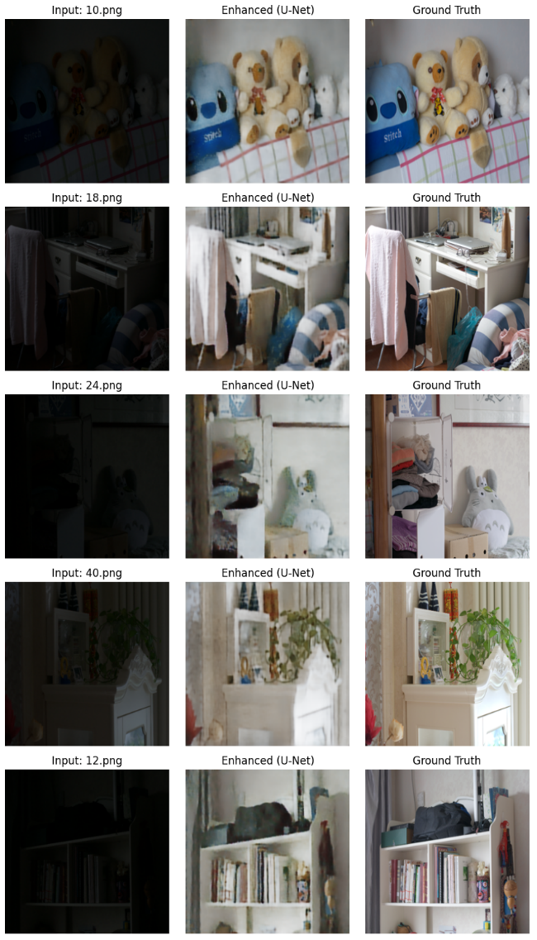

Conclusions
This study explored the integration of Retinex theory with deep learning for low-light image enhancement. The CNN model dynamically learns optimal Retinex parameters, while the U-Net applies fixed preprocessing and learns enhancement mappings.
Findings:
- Both models improve image quality under low-light.
- U-Net outperforms CNN in terms of perceptual quality (SSIM) and loss.
- Fixed Retinex preprocessing simplifies training and generalizes better.
Future Work:
- Explore perceptual loss (e.g., VGG-based)
- Test on real-world datasets (night driving, surveillance)
- Optimize models for mobile deployment

Acknowledgements
Some parts of this study, including data loading and plotting, were supported using AI tools (ChatGPT-4o) to automate and format code and figures. No direct model tuning was done using these tools.

References
- Land, E. H. (1977). The retinex theory of color vision. Scientific american, 237(6), 108-129.
- Wei, C., Wang, W., Yang, W., & Liu, J. (2018). Deep retinex decomposition for low-light enhancement. arXiv preprint arXiv:1808.04560.
- Li, H., Xu, Z., Taylor, G., Studer, C., & Goldstein, T. (2018). Visualizing the loss landscape of neural nets. Advances in neural information processing systems, 31.
- Kaggle Dataset: https://www.kaggle.com/datasets/soumikrakshit/lol-dataset

