SQL INJECTION ATTACK ASSIGNMENT 1

MUSTAFA NOOR

22-10287

INFORMATION SECURITY SEC -A

Github link: https: //github.com/MustafaN435/Comp421-22-10287-SECA.git

**WHAT I DID IN THE ASSIGNMENT:**

I performed the SQL injection attack on a vulnerable website called “vulnweb.com”. In which I took the URL and performed the attack using SQL Map. Here the aim for my attack was to exploit the password from the admin. In which the result I got was the username for the admin and his password.

The order of my commands is as follows:



This command gave me the names of the databases. Its result is :







Through this command I selected a database whose tables I wanted to fetch. It told me that there are 8 tables in the database “acuart”. The result is as follows :

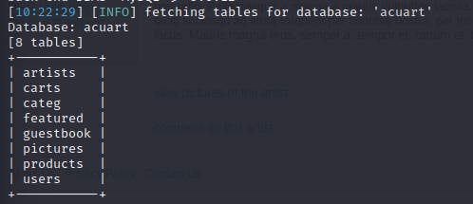





Then, using this command I fetched the columns in the users table. Which gave me the following results;

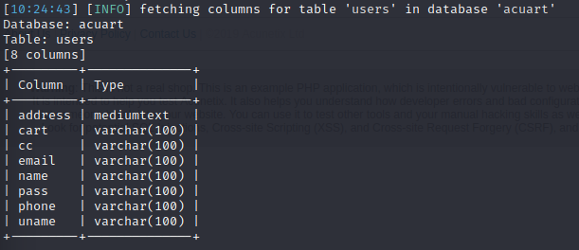





This is the command by which I get the “uname” (username) of the admin.

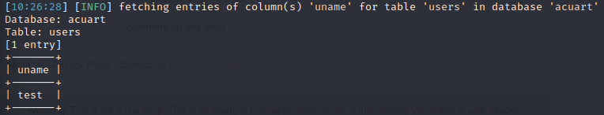

And his password from the following command,



Its result is :

