M Huzaifa Farooq | lab#05 | 2024F-BIT-075
Lab Task 1:
Translate the linear search algorithm into a program which either find the location LOC where ITEM appears in ARRAY or return LOC=0
Code:
#include<iostream>
usingnamespace std;
int main()
{
constint arrSize = 10;
int arr[arrSize] = { 21, 99, 150, 212, 320, 420, 510, 603, 834 , 911 }; int item = 603;
int loc = 0;
for (int i = 0; i < arrSize; i++) {
if (arr[i] == item) {
loc = i + 1;
break;
} | }
if (loc != 0) {
cout <<"Item "<< item <<" found at location "<< loc << endl; }
else {
} | } | cout <<"Item not found in the array."<< endl;
Output:
Sir Syed University of Engineering and | 1
Technology

M Huzaifa Farooq | lab#05 | 2024F-BIT-075
Lab Task 2:
Translate binary search and insertion algorithm into a program which finds either the location LOC where ITEM appears in ARRAY or the location LOC where ITEM should be inserted into ARRAY. (For object 3, 4, and 5 take an array of 10 elements given below)
Code:
#include<iostream>
usingnamespace std;
int main()
{
constint ArrSize = 10;
int arr[ArrSize] = { 3, 5, 8, 12, 15, 18, 20, 25, 30, 35 }; int item;
cout <<"Enter item to search: ";
cin >> item;
int beg = 0;
int end = ArrSize - 1;
int loc = -1;
while (beg <= end)
{ | int mid = (beg + end) / 2;
if (arr[mid] == item) {
loc = mid + 1;
break;
}
elseif (item < arr[mid]) {
} | end = mid - 1;
else {
beg = mid + 1;
}
}
if (loc != -1) {
cout <<"Item "<< item <<" found at location "<< loc << endl; }
else {
cout <<"Item not found in the array."<< endl;
} | } | cout <<"Item should be inserted at location "<< beg + 1 << endl;
Output:
Sir Syed University of Engineering and | 2
Technology

M Huzaifa Farooq | lab#05 | 2024F-BIT-075
Lab Task 3:
Write a program which uses Binary Search to search the elements52, and 33 and print it.
Code:
#include<iostream>
usingnamespace std;
int main() {
constint n = 10;
int arr[n] = { 11, 22, 33, 36, 45, 52, 57, 60, 64, 78 };
int items[2] = { 52, 33 };
for (int k = 0; k < 2; k++) {
int item = items[k];
int beg = 0;
int end = n - 1;
int loc = -1;
while (beg <= end) {
int mid = (beg + end) / 2;
if (arr[mid] == item) {
} | loc = mid;  break;
elseif (item < arr[mid]) {
end = mid - 1;
}
else {
beg = mid + 1;
} | }
if (loc != -1) {
cout << item <<" found at index "<< loc << endl; }
else {
} | } | } | cout << item <<" not found"<< endl;
Output:
Sir Syed University of Engineering and | 3
Technology

M Huzaifa Farooq | lab#05 | 2024F-BIT-075
Lab Task 4:
Write a program which uses Binary Search to search the elements 45 and 78 and delete it. NUMBERS= [11,22,33,36,45,52,57,60,64,78]
Code:
#include<iostream>
usingnamespace std;
int main()
{ | constint arrSIze = 10;  int arr[arrSIze] = { 11, 22, 33, 36, 45, 52, 57, 60, 64, 78 }; int n = arrSIze;  int items[2] = { 45, 78 };
for (int k = 0; k < 2; k++)
{ | int item = items[k];
int beg = 0, end = n - 1;
int loc = -1;
while (beg <= end)
{ | int mid = (beg + end) / 2;
if (arr[mid] == item)
{
loc = mid;
break;
}
elseif (item < arr[mid])
{
} | end = mid - 1;
else
{
} | } | beg = mid + 1;
if (loc != -1)
{
for (int i = loc; i < n - 1; i++)
{
arr[i] = arr[i + 1];
}
n--;
} | }
cout <<"Updated Array: ";
for (int i = 0; i < n; i++)
{
cout << arr[i] <<" ";
} | }  cout << endl;
Output:
Sir Syed University of Engineering and | 4
Technology

M Huzaifa Farooq | lab#03 | 2024F-BIT-075
Lab Task 1:
Summarize the time and space complexity of algorithms and list the key differences in a table.
SUMMARY:
Time Complexity: Time complexity reveals how the quantity of operations an algorithm performs expands as the input volume (n) increases. It illustrates the scaling behavior of runtime with growing data size, instead of tracking real-world seconds.
Space Complexity: Space complexity denotes the volume of memory an algorithm utilizes in proportion to the input scale (n). This covers storage for input data, output results, auxiliary variables, and stack space from recursive calls or function invocations.
DIFFERENCES BETWEEN SPACE AND TIME COMPLEXITY:
Aspect | Time Complexity | Space Complexity
Definition | Indicates how the execution duration of an algorithm  expands as the input volume increases. | Shows the quantity of  memory an algorithm  demands as the input scale grows.
Focus | Runtime performance or processing speed. | Memory consumption or storage needs.
Measurement | Number of fundamental  operations or computational steps performed. | Volume of memory units  (variables, bytes, or auxiliary space) utilized.
Main Concern | CPU efficiency or processor workload. | Memory (RAM or storage) availability.
Optimization Goal | Minimize the duration required for completion. | Decrease the overall memory footprint.
Types | Best case, average case, worst case (e.g., O(1), O(log n),  O(n), O(n²)) | Usually denoted in similar fashion (e.g., O(1), O(n), O(n²)).

Sir Syed University of Engineering and | 1
Technology

M Huzaifa Farooq | lab#03 | 2024F-BIT-075
Lab Task 2:
Determine, for the typical algorithms that you use to perform calculations by hand, the running
time to do the following:
a. Add two N-digit integers.
b. Multiply two N-digit integers.
c. Divide two N-digit integers.
a. Addition of Two N-Digit Numbers:
Process: Sum corresponding digits from the least significant position toward the most significant, propagating any carry to the following position.
Explanation: A single addition is needed per digit pair; hence the total effort rises linearly with the count of digits.
Time Complexity: O(N)
b. Multiplication of Two N-Digit Numbers:
Process: Compute the product of every digit from the first number with each digit of the second, then combine all intermediate products (similar to manual long multiplication).
Explanation: Each digit in one operand pairs with every digit in the other, producing
approximately N×N individual multiplications.
Time Complexity: O(N²)
c. Division of Two N-Digit Numbers:
Process: Apply classic long division by repeatedly subtracting scaled versions of the divisor from the current remainder and appending the next digit.
Explanation: Every iteration performs comparisons and subtractions that may span up to N digits, yielding around N² elementary operations overall.
Time Complexity: O(N²)
SUMMARY TABLE:
Operation | Running Time (Big-O)
Addition of two N-digit integers | O(n)
Multiplication of two N-digit integer | O(n2)
Division of two N-digit integers | O(n2)

Sir Syed University of Engineering and | 2
Technology

M Huzaifa Farooq | lab#03 | 2024F-BIT-075
Lab Task 3:
Describe all cases of algorithm analysis (BEST, WORST & AVERAGE CASES).
For a sequential search of an array a[0..n] with n elements write the comparison of these cases.
Cases of Algorithm Analysis:
Algorithm analysis is the technique used to evaluate how efficient an algorithm performs. It is typically expressed through three scenarios:
•Best Case: The situation in which the algorithm requires the least amount of time to
complete.
•Worst Case: The scenario where the algorithm demands the maximum possible time to finish execution. ·
•Average Case: The anticipated runtime of the algorithm when operating on ordinary or randomly distributed inputs.
SEQUENTIAL SEARCH:
Case | Condition | Number of  Comparisons | Time Complexity | Explanation
Best Case | The target element K is positioned at the very start of the array. | 1 | O(1) | The search  terminates  instantly after the first check.
Worst Case | The target element K is located at the end of the array or is absent entirely. | N | O(n) | Every element in the array needs to be examined  before reaching a conclusion.
Average Case | The target element K can appear in any random position  with equal  likelihood. | (n+1)/2 | O(n) | On average,  roughly half of the elements are  inspected before  locating K.

Sir Syed University of Engineering and | 3
Technology

M Huzaifa Farooq | lab#04 | 2024F-BIT-075
Lab Task 1:
Write the program for the Bubble Sort algorithm and explain its time complexity, advantages, and disadvantages.
Code:
#include<iostream>
usingnamespace std;
int main()
{
int arr[10];
for (int i = 0; i < 10; i++) {
cout <<"arr["<< i <<"]= ";
cin >> arr[i];
}
for (int i = 0; i < 10 - 1; i++) {
for (int j = 0; j < 10 - i - 1; j++) { if (arr[j] > arr[j + 1]) {
int temp = arr[j];
arr[j] = arr[j + 1];
arr[j + 1] = temp;
} | }
}
cout <<"\nSorted Array: ";
for (int i = 0; i < 10; i++) {
cout << arr[i] <<" ";
}
}
Output:
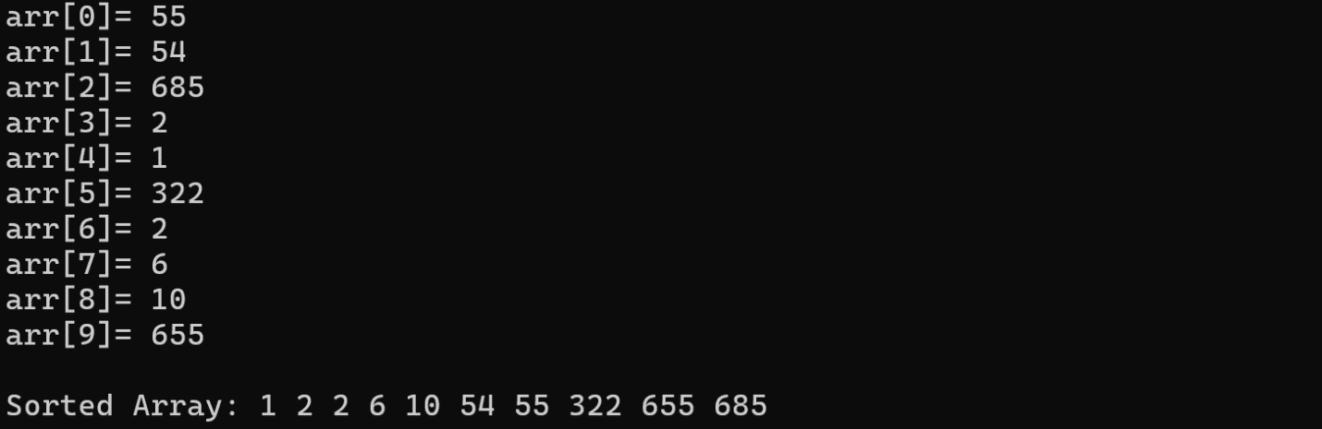
Sir Syed University of Engineering and | 1
Technology

M Huzaifa Farooq | lab#04 | 2024F-BIT-075
Lab Task 2:
Write the program for the Selection Sort algorithm and explain its time complexity, advantages, and disadvantages.
Code:
#include<iostream>
usingnamespace std;
int main() {
int arr[10];
for (int i = 0; i < 10; i++) {
cout <<"arr["<< i <<"]= ";
} | cin >> arr[i];
for (int i = 0; i < 10 - 1; i++) {
int minIndex = i;
for (int j = i + 1; j < 10; j++) {
if (arr[j] < arr[minIndex]) {
} | } | minIndex = j;
int temp = arr[i];
arr[i] = arr[minIndex];
arr[minIndex] = temp;
}
cout <<"\nSorted Array: ";
for (int i = 0; i < 10; i++) {
cout << arr[i] <<" ";
} | }
Output:
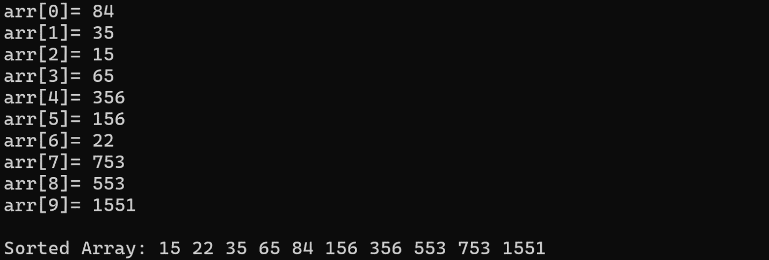
Sir Syed University of Engineering and | 2
Technology

M Huzaifa Farooq | lab#04 | 2024F-BIT-075
Lab Task 3:
Write the program for the Insertion Sort algorithm and explain its time complexity, advantages, and disadvantages.
Code:
#include<iostream>
usingnamespace std;
int main() {
int arr[10];
for (int i = 0; i < 10; i++) {
cout <<"arr["<< i <<"]= ";
} | cin >> arr[i];
for (int i = 1; i < 10; i++) {
int key = arr[i];
int j = i - 1;
while (j >= 0 && arr[j] > key) {
arr[j + 1] = arr[j];
j--;
}
} | arr[j + 1] = key;
cout <<"\nSorted Array: ";
for (int i = 0; i < 10; i++) {
} | cout << arr[i] <<" ";
}
Output:
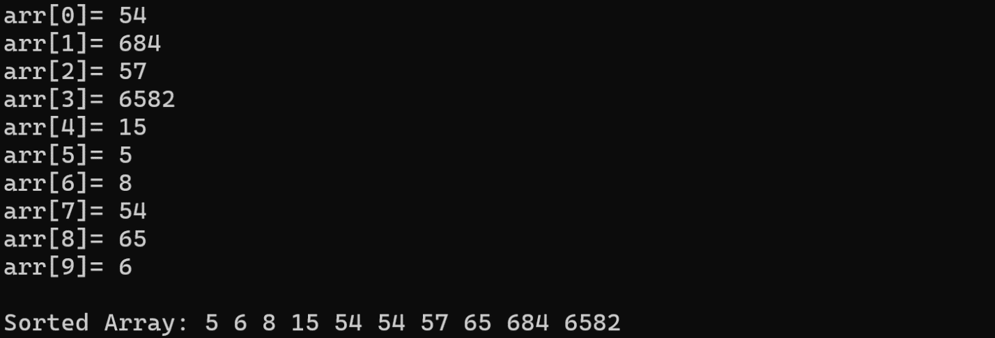
Sir Syed University of Engineering and | 3
Technology

