Task # 01:
Write a C++ code that will implement the Binary Search Trees using Arrays.

CODE:
int main() {
int tree[50];
for (int i = 0; i < 50; i++) { tree[i] = -1;
}
int n, x;
cout << "Enter number of nodes: "; cin >> n;

for (int k = 0; k < n; k++) { cin >> x;
int i = 1;
while (tree[i] != -1) {
if (x < tree[i]) { i = 2 * i;
}
else {
i = 2 * i + 1;
}
}
tree[i] = x;
}
cout << "BST stored in array:\n"; for (int i = 1; i < 50; i++) {
if (tree[i] != -1) {
cout << "Index " << i << " : " << tree[i] << endl;
}
}
}

OUTPUT :
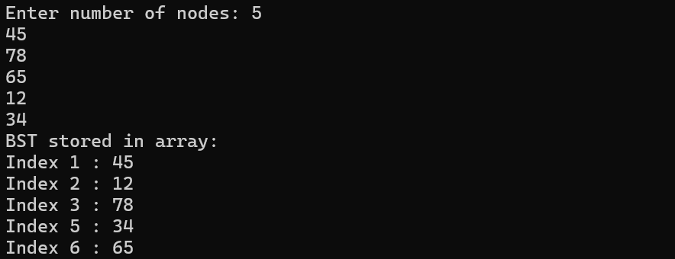

Task # 02:
Write a C++ code that will implement the Binary Search Trees using Linked List.

CODE :
struct ode {
int data; ode* left; ode* right;
};
int main() {
ode* root = ULL; int n, x;
cout << "Enter number of nodes: "; cin >> n;
for (int i = 0; i < n; i++) { cin >> x;
ode* node = new ode(); node->data = x;
node->left = ULL; node->right = ULL; if (root == ULL) {
root = node;
}
else {
ode* current = root; while (true) {
if (x < current->data) {
if (current->left == ULL) { current->left = node; break;
}
current = current->left;
}
else {
if (current->right == ULL) { current->right = node; break;
}
current = current->right;
}
}
}
}

ode* stack[50]; int top = -1;
ode* current = root;
cout << "\nBST elements: ";
while (current != ULL || top != -1) { while (current != ULL) {
stack[++top] = current; current = current->left;
}

current = stack[top--];
cout << current->data << " ";

current = current->right;
}

}

OUTPUT:
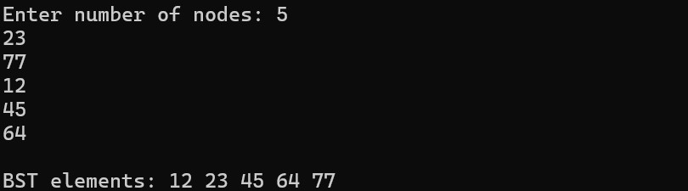

Task # 03:
Write a C++ code that will implement the Searching of a node in BST.

CODE:
int main() {
int tree[50];
for (int i = 0; i < 50; i++) tree[i] = -1;
int n, x, key;
cout << "Enter number of nodes: "; cin >> n;
for (int k = 0; k < n; k++) { cin >> x;
int i = 1;
while (i < 50 fifi tree[i] != -1) { if (x < tree[i]) {
i = 2 * i;
}
else {
i = 2 * i + 1;
}
}

if (i < 50)
tree[i] = x;
}
cout << "Enter value to search: "; cin >> key;
int i = 1;
while (i < 50 fifi tree[i] != -1) { if (key == tree[i]) {
cout << "ode found at index " << i;
}
else if (key < tree[i]) { i = 2 * i;
}
else {
i = 2 * i + 1;
}
}
cout << "ode not found";

}

OUTPUT:
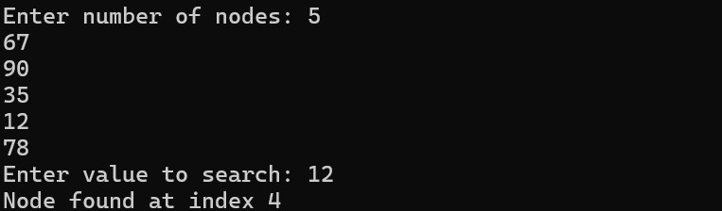

Task # 04:
Write a C++ code that will implement the Insertion of a node in BST.

CODE:
int main() {
int tree[50];
for (int i = 0; i < 50; i++) { tree[i] = -1;
}
//Insertion
int n, x;
cout << "Enter number of nodes: "; cin >> n;

for (int k = 0; k < n; k++) { cin >> x;
int i = 1;
while (tree[i] != -1) {
if (x < tree[i]) { i = 2 * i;
}
else {
i = 2 * i + 1;
}
}
tree[i] = x;
}
cout << "BST stored in array:\n"; for (int i = 1; i < 50; i++) {
if (tree[i] != -1) {
cout << "Index " << i << " : " << tree[i] << endl;
}
}
}

OUTPUT:


Task # 05:
Write a C++ code that will implement the deletion of a node in BST.

CODE:
int main() {
int tree[50];
for (int i = 0; i < 50; i++) tree[i] = -1;
int n, x, key;
cout << "Enter number of nodes: "; cin >> n;
//ISERT
for (int k = 0; k < n; k++) { cin >> x;
int i = 1;
while (i < 50 fifi tree[i] != -1) { if (x < tree[i])
i = 2 * i;
else
}

i = 2 * i + 1;
if (i < 50)
tree[i] = x;
}
//DELETE
cout << "Enter value to delete: "; cin >> key;
int i = 1;
while (i < 50 fifi tree[i] != -1 fifi tree[i] != key) { if (key < tree[i])
i = 2 * i; else
i = 2 * i + 1;
}
if (i >= 50 || tree[i] == -1) { cout << "ode not found"; return 0;
}
// Case 1: Leaf node
if ((2 * i >= 50 || tree[2 * i] == -1) fifi
(2 * i + 1 >= 50 || tree[2 * i + 1] == -1)) {
tree[i] = -1;
}
// Case 2: One child
else if (2 * i < 50 fifi tree[2 * i] != -1) { tree[i] = tree[2 * i];
tree[2 * i] = -1;
}
else if (2 * i + 1 < 50 fifi tree[2 * i + 1] != -1) { tree[i] = tree[2 * i + 1];
tree[2 * i + 1] = -1;
}
cout << "ode deleted successfully\n";
//DISflLAY
cout << "BST after deletion:\n"; for (int j = 1; j < 50; j++) {
if (tree[j] != -1)
cout << "Index " << j << " : " << tree[j] << endl;
}

OUTPUT:
