Lab Task 1:
Write a C++ program to implement a queue using an array with enqueue and dequeue operations. Find the top element of the queue and check if the queue is
empty, full or not.

CODE:
#define SIZE 5 int main() {
int queue[SIZE];
int front = -1, rear = -1;

// EQUEUE operations int x;

// Insert 10
x = 10;
if (rear == SIZE - 1)
cout << "Queue is Full\n"; else {
if (front == -1) front = 0; rear++;
queue[rear] = x;
cout << x << " inserted\n";
}

// Insert 20
x = 20;
if (rear == SIZE - 1)
cout << "Queue is Full\n"; else {
if (front == -1) front = 0; rear++;
queue[rear] = x;
cout << x << " inserted\n";
}

// Insert 30
x = 30;
if (rear == SIZE - 1)
cout << "Queue is Full\n"; else {
if (front == -1) front = 0; rear++;
queue[rear] = x;
cout << x << " inserted\n";
}

// Insert 40
x = 40;
if (rear == SIZE - 1)
cout << "Queue is Full\n"; else {
if (front == -1) front = 0; rear++;
queue[rear] = x;
cout << x << " inserted\n";
}

// Insert 50
x = 50;
if (rear == SIZE - 1)
cout << "Queue is Full\n"; else {
if (front == -1) front = 0; rear++;
queue[rear] = x;
cout << x << " inserted\n";
}

// FROT element if (front != -1)
cout << "Front element: " << queue[front] << endl;

// CECK STATUS
if (front == -1)
cout << "Queue is Empty\n"; else if (rear == SIZE - 1)
cout << "Queue is Full\n";
else
cout << "Queue is either Empty nor Full\n";

// DEQUEUE
if (front == -1)
cout << "Queue is Empty\n"; else {
cout << queue[front] << " removed\n"; front++;
if (front > rear) front = rear = -1;
}

// FROT element after dequeue if (front != -1)
cout << "Front element: " << queue[front] << endl;

}

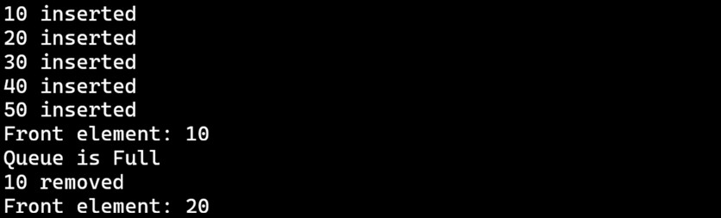
OUTPUT :

Task # 02:
Write a C++ program using (a) arrays(b)linked list to reverse the elements of a queue.

CODE (A):
int main() {
int queue[5] = { 46, 70, 12, 66, 24 };
int n = 5;
cout << "Elements of Queue:\n"; for (int i = 0; i < 5; i++) {
cout << queue[i] << " ";
}
cout << endl;
// Reverse the queue
for (int i = 0; i < n / 2; i++) { int temp = queue[i];
queue[i] = queue[n - i - 1]; queue[n - i - 1] = temp;
}

cout << "Reversed Queue:\n"; for (int i = 0; i < n; i++)
cout << queue[i] << " ";

}

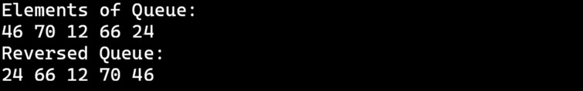
OUTPUT (A):

CODE (B):
struct ode {
int data; ode* next;
};

int main() {
ode* front = ULL;

// Enqueue elements
int data[] = { 46, 70, 12, 66, 24 };
int n = 5;

for (int i = 0; i < n; i++) { ode* temp = new ode(); temp->data = data[i]; temp->next = ULL;

if (front == ULL) { front = temp;
}
else {
ode* p = front;
while (p->next != ULL) p = p->next;
p->next = temp;
}
}

// Display queue before reversing cout << "Queue before reversing:\n"; ode* t = front;
while (t != ULL) {
cout << t->data << " "; t = t->next;
}
cout << endl;

// Reverse the queue ode* prev = ULL; ode* current = front; ode* next = ULL;

while (current != ULL) { next = current->next; current->next = prev; prev = current; current = next;
}
front = prev;

// Display queue after reversing
cout << "\nQueue after reversing:\n"; t = front;
while (t != ULL) {
cout << t->data << " "; t = t->next;
}
cout << endl;
}

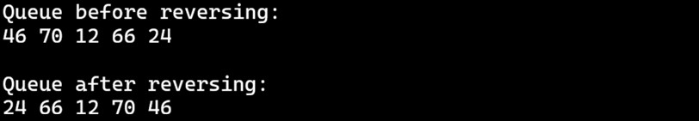
OUTPUT (B):

Task # 03:
Write a C++ program using (a) arrays(b)linked list to remove a given element from a queue.

CODE (A):
int main() {
int queue[5] = { 46, 70, 12, 66, 24 };
int n = 5;
int key = 5; // element to remove

cout << "Queue before removal:\n"; for (int i = 0; i < n; i++)
cout << queue[i] << " ";

// Remove the element
for (int i = 0; i < n; i++) { if (queue[i] == key) {
for (int j = i; j < n - 1; j++) queue[j] = queue[j + 1];
n--;
break;
}
}

cout << "\n\nQueue after removing " << key << ":\n"; for (int i = 0; i < n; i++)
cout << queue[i] << " ";

}

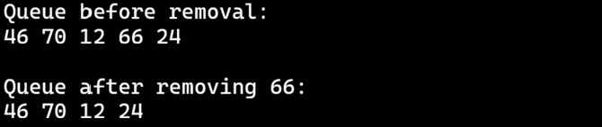
OUTPUT (A):

CODE (B):
struct ode {
int data; ode* next;
};

int main() {
ode* front = ULL;

// Enqueue elements
int data[] = { 46, 70, 12, 66, 24 };
int n = 5;

for (int i = 0; i < n; i++) { ode* temp = new ode(); temp->data = data[i]; temp->next = ULL;

if (front == ULL) { front = temp;
}
else {
ode* p = front;
while (p->next != ULL) p = p->next;
p->next = temp;
}
}

// Display queue before removal cout << "Queue before removal:\n"; ode* t = front;
while (t != ULL) {
cout << t->data << " "; t = t->next;
}
cout << endl;

// Remove element 66 ode* temp = front; ode* prev = ULL;

// If first element is 66
if (temp != ULL fifi temp->data == 66) { front = temp->next;
delete temp;
}
else {
while (temp != ULL fifi temp->data != 66) { prev = temp;
temp = temp->next;
}

if (temp != ULL) {
prev->next = temp->next; delete temp;
}
}

// Display queue after removal
cout << "\nQueue after removal:\n"; t = front;
while (t != ULL) {
cout << t->data << " "; t = t->next;
}
cout << endl;
}

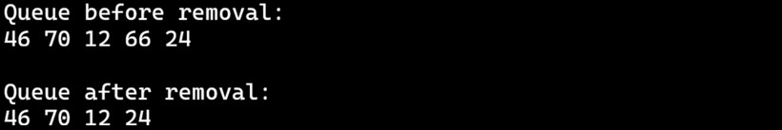
OUTPUT (B):

Task # 04:
Write a C++ program using (a) arrays(b)linked list to find the position of an element in a queue.

CODE (A):
int main() {
int queue[5] = { 46, 70, 12, 66, 24 };
int n = 5;
int key = 66; // element to find int position = -1;

cout << "Queue elements:\n"; for (int i = 0; i < n; i++)
cout << queue[i] << " ";

// Find position
for (int i = 0; i < n; i++) { if (queue[i] == key) {
position = i + 1; // position starts from 1 break;
}
}

cout << "\n\nElement " << key << " position: "; if (position != -1)
cout << position;

else

}

cout << "ot Found";

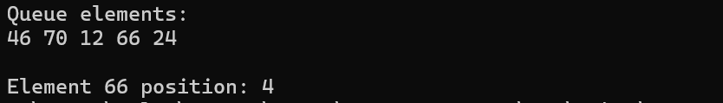
OUTPUT (A):

CODE (B):
struct ode {
int data; ode* next;
};

int main() {
ode* front = ULL; ode* temp;
ode* p;

// Enqueue 10
temp = new ode(); temp->data = 10; temp->next = ULL; front = temp;

// Enqueue 20
temp = new ode(); temp->data = 20; temp->next = ULL; p = front;
while (p->next != ULL) p = p->next;
p->next = temp;

// Enqueue 30
temp = new ode(); temp->data = 30; temp->next = ULL; p = front;
while (p->next != ULL) p = p->next;
p->next = temp;

// Enqueue 40
temp = new ode(); temp->data = 40; temp->next = ULL; p = front;
while (p->next != ULL) p = p->next;
p->next = temp;

// Display queue
cout << "Queue elements:\n"; p = front;
while (p != ULL) {
cout << p->data << " "; p = p->next;
}

// Find position of element 30 int key = 30;
int pos = 1; int found = -1; p = front;
while (p != ULL) {
if (p->data == key) { found = pos; break;
}
p = p->next; pos++;
}

cout << "\n\nElement 30 position: "; if (found != -1)
cout << found;

else

}

cout << "ot Found";

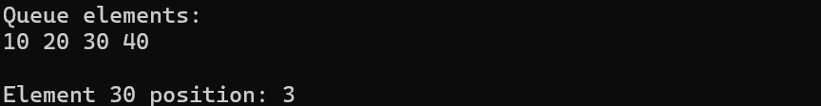
OUTPUT (B):

Task # 05:
Write a C++ program using (a) arrays(b)linked list to sort the elements of a queue.

CODE (A):
int main() {
int queue[5] = { 46, 70, 12, 66, 24 };
int n = 5;

cout << "Queue before sorting:\n"; for (int i = 0; i < n; i++)
cout << queue[i] << " ";

// Sort using simple bubble sort for (int i = 0; i < n - 1; i++) {
for (int j = 0; j < n - i - 1; j++) { if (queue[j] > queue[j + 1]) {
int temp = queue[j]; queue[j] = queue[j + 1]; queue[j + 1] = temp;
}
}
}

cout << "\n\nQueue after sorting:\n"; for (int i = 0; i < n; i++)
cout << queue[i] << " ";
}

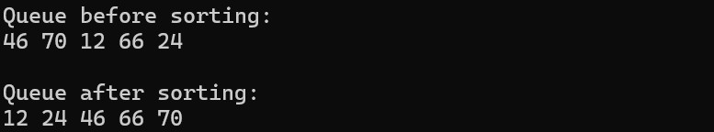
OUTPUT (A):

CODE (B):
struct ode {
int data; ode* next;
};

int main() {
ode* front = ULL;

// -------- EQUEUE OflERATIOS -------- int values[5] = { 46, 70, 12, 66, 24 };

for (int k = 0; k < 5; k++) { ode* temp = new ode(); temp->data = values[k]; temp->next = ULL;

if (front == ULL) { front = temp;
}
else {
ode* p = front;
while (p->next != ULL) p = p->next;
p->next = temp;
}
}

// -------- DISflLAY BEFORE SORTIG --------
cout << "Queue before sorting:\n"; ode* t = front;
while (t != ULL) {
cout << t->data << " "; t = t->next;
}

// -------- SORTIG (BUBBLE SORT) --------
ode* i; ode* j;
for (i = front; i != ULL; i = i->next) {
for (j = i->next; j != ULL; j = j->next) { if (i->data > j->data) {
int temp = i->data;
i->data = j->data;
j->data = temp;
}
}
}

// -------- DISflLAY AFTER SORTIG --------
cout << "\n\nQueue after sorting:\n"; t = front;
while (t != ULL) {
cout << t->data << " "; t = t->next;
}
}
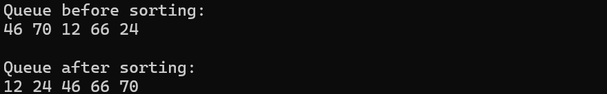
OUTPUT (B):

