Lab Task 1:
Write a C++ program using (a) arrays (b) linked list to implement a stack using
an array with push and pop operations. Find the top element of the stack and check
if the stack is empty or not.

Code:
#include <iostream>
#include <iostream>
using namespace std;

#define SIZE 10
int arr[SIZE];
int topA = -1;

// Stack Using Array
bool arrayEmptyShown = false;

bool isEmptyArray() {
return (topA == -1);
}

void pushArray(int x) {
arr[++topA] = x;
}

void popArray() {
if (isEmptyArray()) {
if (!arrayEmptyShown) {
cout << "Array Stack Empty\n";
arrayEmptyShown = true;
}
}
else {
cout << "After poped from stack!\n";
topA--;
}
}

void topArray() {
if (isEmptyArray()) {
if (!arrayEmptyShown) {
cout << "Array Stack Empty\n";
arrayEmptyShown = true;
}
}
else {
cout << "Array Stack Top: " << arr[topA] << endl;
}
}

// Stack Using Linked List
struct Node {
int data;
Node* next;

Node(int value) {
data = value;
next = NULL;
}
};

Node* topL = NULL;
bool ListEmptyShown = false;

bool isEmptyList() {
return (topL == NULL);
}

void pushList(int x) {
Node* n = new Node(x);
n->next = topL;
topL = n;
}

void popList() {
if (isEmptyList()) {
if (!ListEmptyShown) {
cout << "Linked List Stack Empty\n";
ListEmptyShown = true;
}
}
else {
cout << "After poped from stack!\n";
Node* temp = topL;
topL = topL->next;
delete temp;
}
}

void topList() {
if (isEmptyList()) {
if (!ListEmptyShown) {
cout << "Linked List Stack Empty\n";
ListEmptyShown = true;
}
}
else {
cout << "Linked List Stack Top: " << topL->data << endl;
}
}

int main() {
// ARRAY STACK
int no_of_Ele, Element;
cout << "Enter number of Elements: ";
cin >> no_of_Ele;

while (no_of_Ele > SIZE) {
cout << "Invalid input! Stack size limit is " << SIZE << endl << "Please enter number of elements again: ";
cin >> no_of_Ele;
}

for (int i = 0; i < no_of_Ele; i++) {
cout << "Element " << i + 1 << ": ";
cin >> Element;
pushArray(Element);
}
cout << endl;
topArray();
popArray();
topArray();
popArray();
topArray();
popArray();
topArray();
cout << endl;
// LINKED LIST STACK
int no_of_Nodes, Nodes;
cout << "Enter number of Nodes: ";
cin >> no_of_Nodes;

for (int i = 0; i < no_of_Nodes; i++) {
cout << "Node " << i + 1 << ": ";
cin >> Nodes;
pushList(Nodes);
}
cout << endl;
topList();
popList();
topList();
popList();
topList();
popList();
topList();
}

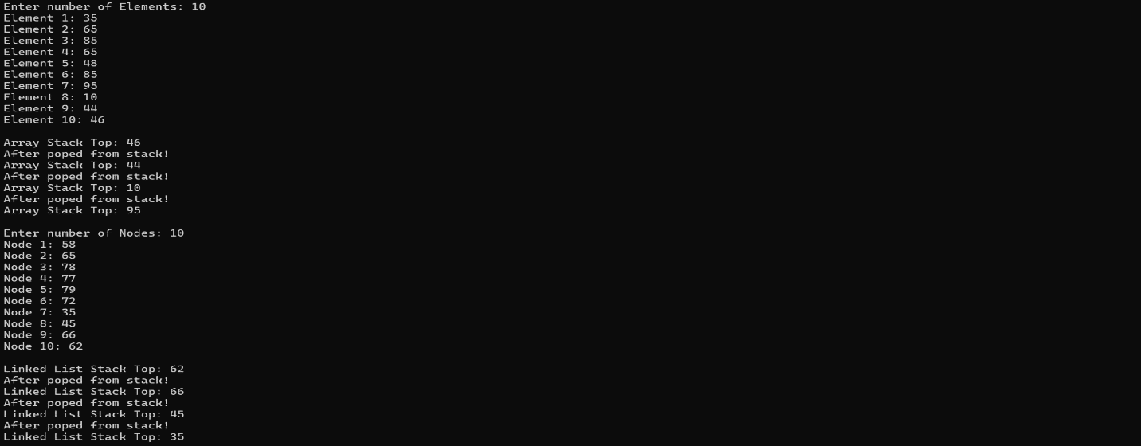
Ouput:

Lab Task 2:
Write a C++ program to implement a stack using (a) arrays(b)linked list with
push and pop operations. Check if the stack is full.

Code:
#include <iostream>
using namespace std;

// STACK USING
#define SIZE 5
int arr[SIZE];
int topA = -1;

bool isArrayFull() {
return (topA == SIZE - 1);
}

bool isArrayEmpty() {
return (topA == -1);
}

void pushArray(int value) {
if (isArrayFull()) {
cout << "Array Stack is Full\n";
}
else {
arr[++topA] = value;
cout << value << " pushed into Array Stack\n";
}
}

void popArray() {
if (isArrayEmpty()) {
cout << "Array Stack is Empty\n";
}
else {
cout << arr[topA--] << " popped from Array Stack\n";
}
}

// STACK USING LINKED LIST
struct Node {
int data;
Node* next;
Node(int value) {
data = value;
next = NULL;
}
};

Node* topL = NULL;

bool isListEmpty() {
return (topL == NULL);
}

void pushList(int x) {
Node* newNode = new Node(x);

if (newNode == NULL) {
cout << "Linked List Stack is Full (Memory Full)\n";
return;
}

newNode->next = topL;
topL = newNode;

cout << x << " pushed into Linked List Stack\n";
}

void popList() {
if (isListEmpty()) {
cout << "Linked List Stack is Empty\n";
}
else {
Node* temp = topL;
cout << temp->data << " popped from Linked List Stack\n";
topL = topL->next;
delete temp;
}
}

int main() {

cout << "STACK USING ARRAY:\n";
popArray(); // empty check

pushArray(10);
pushArray(20);
pushArray(30);
pushArray(40);
pushArray(50);
pushArray(60); // full check

popArray();
popArray();

cout << "\nSTACK USING LINKED LIST:\n";
pushList(100);
pushList(200);
pushList(300);

popList();
popList();
popList();
popList(); // empty check

return 0;
}

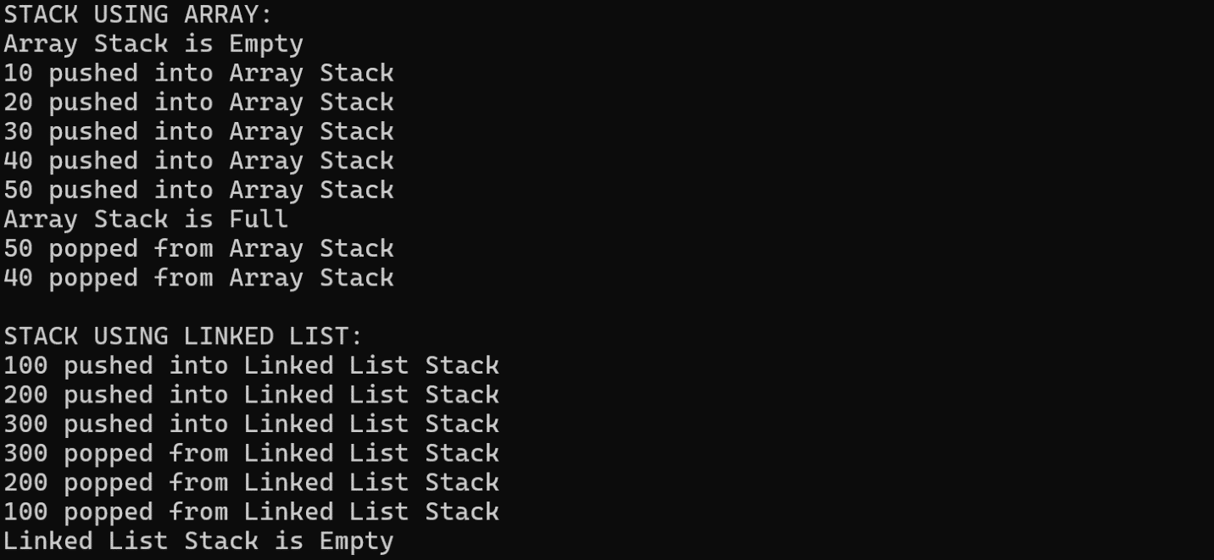
Ouput:

Lab Task 3:
Write a C++ program to sort a given stack (using an array) using another stack.
Input some elements onto the stack:
Stack elements: 0 1 5 2 4 7
Sort the elements in the stack:
Display the sorted elements of the stack:
Stack elements: 0 1 2 4 5 7
Remove two elements:
Stack elements: 2 4 5 7
Input two more elements
Stack elements: 10 -1 2 4 5 7
Sort the elements in the stack:
Display the sorted elements of the stack:
Stack elements: -1 2 4 5 7 10

Code:
#include <iostream>
using namespace std;

#define SIZE 30

int s1[SIZE], s2[SIZE];
int top1 = -1, top2 = -1;

void push1(int x) {
s1[++top1] = x;
}

int pop1() {
return s1[top1--];
}

void push2(int x) {
s2[++top2] = x;
}

int pop2() {
return s2[top2--];
}

void sortStack() {
while (top1 != -1) {
int temp = pop1();

while (top2 != -1 && s2[top2] < temp) {
push1(pop2());
}
push2(temp);
}

while (top2 != -1) {
push1(pop2());
}
}

void display() {
for (int i = 0; i <= top1; i++)
cout << s1[i] << " ";
cout << endl;
}

int main() {
push1(12);
push1(3);
push1(45);
push1(7);
push1(19);
push1(1);
push1(30);
push1(25);
push1(8);
push1(14);

cout << "Stack elements:\n";
display();

sortStack();
cout << "Sorted stack:\n";
display();

pop1();
pop1();
cout << "After removing two elements:\n";
display();

push1(50);
push1(-5);
cout << "After adding two elements:\n";
display();

sortStack();
cout << "Sorted stack again:\n";
display();
}

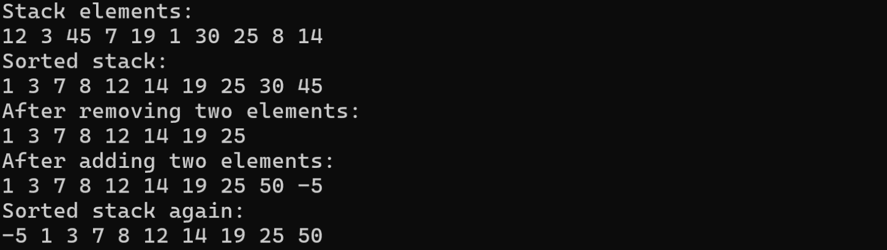
Ouput:
Lab Task 4:
Write a C++ program using (a) arrays (b)linked list that reverses the stack
(using an array) elements.

Code:
#include <iostream>
using namespace std;

struct Node
{
int data;
Node* prev;
Node* next;

Node(int val)
{
data = val;
prev = NULL;
next = NULL;
}
};

int main()
{
// Stack Reverse using Array
#define SIZE 10
int stack[SIZE];
int top = -1;

cout << "ARRAY STACK\n";
cout << "Enter 10 elements:\n";

for (int i = 0; i < SIZE; i++)
{
cout << "Element " << i + 1 << ": ";
cin >> stack[++top];
}

cout << "Reversed Stack (Array):\n";
for (int i = top; i >= 0; i--)
{
cout << stack[i] << " ";
}

cout << "\n\n";

// Stack Reverse using Doubly Linked List
Node* topDLL = NULL;

cout << "DOUBLY LINKED LIST STACK\n";
cout << "Enter 10 elements:\n";

for (int i = 0; i < SIZE; i++)
{
int val;
cout << "Elements " << i + 1 << ": ";
cin >> val;

Node* temp = new Node(val);

if (topDLL != NULL)
{
topDLL->next = temp;
temp->prev = topDLL;
}

topDLL = temp;
}

Node* bottom = topDLL;
while (bottom->prev != NULL)
{
bottom = bottom->prev;
}

Node* curr = bottom;
Node* tempPtr = NULL;

while (curr != NULL)
{
tempPtr = curr->prev;
curr->prev = curr->next;
curr->next = tempPtr;

if (curr->prev == NULL)
{
topDLL = curr;
}

curr = curr->prev;
}

cout << "Reversed Stack (Doubly Linked List):\n";
curr = topDLL;
while (curr != NULL)
{
cout << curr->data << " ";
curr = curr->next;
}
cout << endl;
}

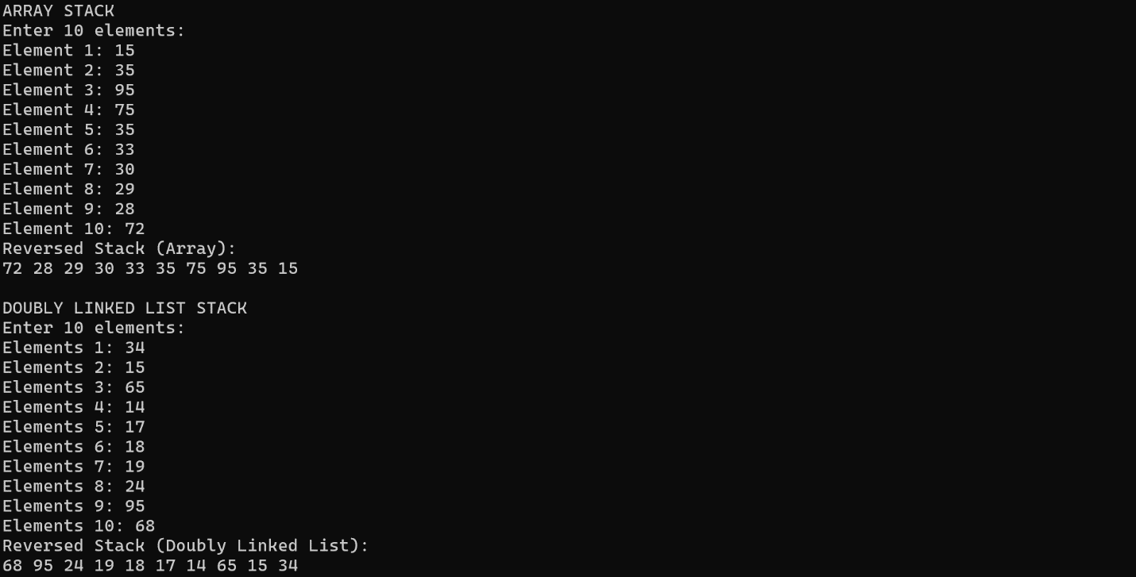
Ouput:

Lab Task 5:
Write a C++ program using (a) arrays (b)linked list to find and remove the
lowest element in a stack.

Code:
#include <iostream>
using namespace std;

#define SIZE 10
struct Node
{
int data;
Node* next;
Node(int value) {
data = value;
next = NULL;
}
};

int main()
{
// STACK USING ARRAY
int stack[SIZE];
int top = -1;

cout << "ARRAY STACK\n";
cout << "Enter 10 elements:\n";

for (int i = 0; i < SIZE; i++) {
cout << "Elements " << i + 1 << ": ";
cin >> stack[++top];
}

int min = stack[0];
int minIndex = 0;

for (int i = 1; i <= top; i++) {
if (stack[i] < min){
min = stack[i];
minIndex = i;
}
}

cout << "Lowest element: " << min << endl;

for (int i = minIndex; i < top; i++) {
stack[i] = stack[i + 1];
}
top--;

cout << "Stack after removing lowest element:\n";
for (int i = top; i >= 0; i--) {
cout << stack[i] << " ";
}
cout << "\n\n";

// STACK USING LINKED LIST
Node* topLL = NULL;

cout << "LINKED LIST STACK\n";
cout << "Enter 10 elements:\n";

for (int i = 0; i < SIZE; i++) {
int val;
cout << "Elements " << i + 1 << ": ";
cin >> val;

Node* temp = new Node(val);
temp->next = topLL;
topLL = temp;
}

Node* curr = topLL;
int minLL = curr->data;

while (curr != NULL) {
if (curr->data < minLL) {
minLL = curr->data;
}
curr = curr->next;
}

cout << "Lowest element: " << minLL << endl;

curr = topLL;
Node* prev = NULL;

while (curr != NULL) {
if (curr->data == minLL) {
if (prev == NULL) {
topLL = curr->next;
}
else {
prev->next = curr->next;
}

delete curr;
break;
}
prev = curr;
curr = curr->next;
}

cout << "Stack after removing lowest element:\n";
curr = topLL;
while (curr != NULL) {
cout << curr->data << " ";
curr = curr->next;
}

}

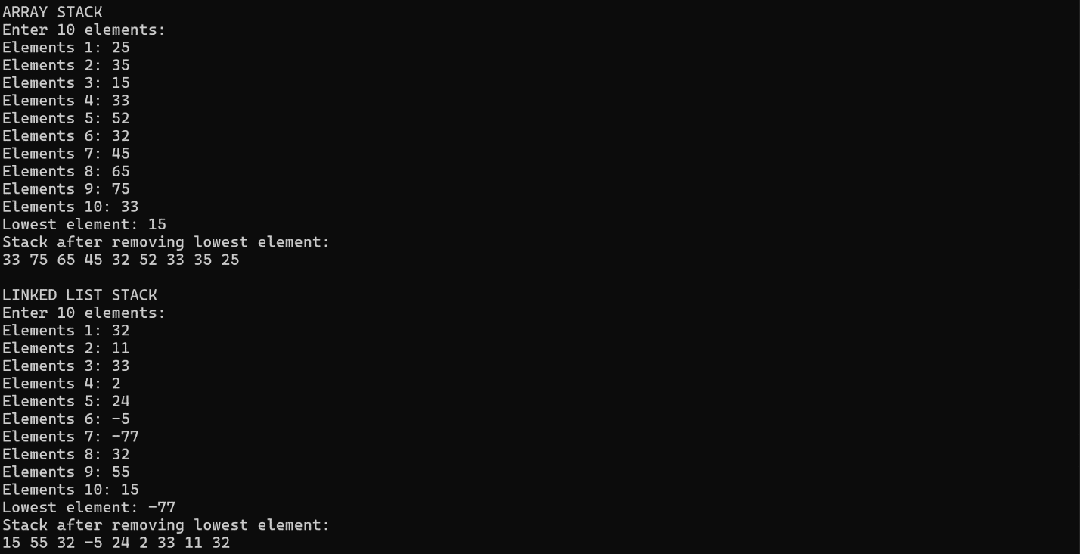
Ouput:

