Write a program that constructs a multi-linked list from a two-dimensional array with any size and then traverse multi-linked list to determine whether the matrix is a scalar matrix or not.

A scalar matrix is basically a square matrix whose all diagonal elements are equal and all other elements means off diagonal elements are zero.

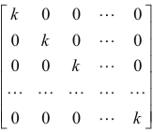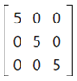

Don’t take any input from the user. Assign the matrix in the code.

Examples:
int[][] matrix = {{55,0,0,0,0},{0,55,0,0,0},{0,0,55,0,0},{0,0,0,55,0},{0,0,0,0,55}}
Output: true

int[][] matrix = {{18,0,0,0},{0,18,0,0},{0,0,18,0},{0,0,0,18}}
Output: true

int[][] matrix =
{{6,0,0,0,0,0},{0,6,0,0,0,0},{0,0,6,0,0,5},{0,0,0,6,0,0},{0,0,0,0,6,0},{0,0,0,0,0,6}}
Output: false

int[][] matrix =
{{6,0,0,0,0,0},{0,6,0,0,0,0},{0,0,6,0,0,0},{0,0,0,6,0,0},{0,0,0,0,7,0},{0,0,0,0,0,6}}
Output: false

Example:

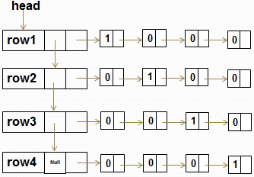

Output: True

