**תרגיל 1:**

**יש לבחור סיפור הצלחה של הטמעת ענן, ולנתח אותו לפי הקריטריונים הבאים:**

We decided to pick netflix as an example for out answer

1. **האם נעשה שימוש בענן פרטי/ציבורי/היברידי?**

Netflix is using a public cloud , specifically AMS for its cloud server

1. **מודל שירות – SAAS/PAAS/IAAS**

Netflix uses a IAAS since it is a subscription based service , a user pays monthly where there is a tier for payment ,the higher the price the better the service is .

1. **הציעו שלוש מטריקות לבדיקת הצלחת ההטמעה. נמקו במשפט קצר כל הצעה.**
2. **Scalability:** Measure the ability to handle peak demand without performance degradation.
3. **Cost Efficiency:** Assess cost savings compared to traditional infrastructure models.
4. **Reliability and Availability:** Ensure uninterrupted service delivery and minimal downtime**.**
5. **האם הייתם מציעים לארגון ענן אחר? מודל אחר? התיחסו למסקנות הסיפור.**

For netflix using a different model other then a public one is very difficult since its a show/movie streaming service it is kinda stuck with being a public model to allow as many user from anywhere to be able to access it .

As for the cloud service it self instead of AWS we could use Microsoft Azure cloud service ,in my opinion it is very similar in usage and services ,but with Microsoft Azure also has a higher compatibility with microsoft product ,it also has a hybrid cloud capability that can allow netflix to transform into a hybrid model if they wish to do so in the future

**תרגיל 2:-**

1**.רשמו את שם האתר שנבחר, ופסקה קצרה של הסבר והקשר (קונטקסט).**

VMware Workstation Player , it is a virtualization software that allows users to run multiple operating systems on a single physical machine. It's commonly used for testing, development, and educational purposes.

2. **בצעו ראיון קצר עם דמות מרכזית (אמיתית) המייצגת משתמש במערכת. הגדירו את הפרסונה.ציירו empathy map.**

we're interviewing Sarah - a software developer who frequently uses VMware Workstation Player for her development projects.

Interviewer: Can you tell us about your experience with VMware Workstation Player?

Sarah: Absolutely! VMware Workstation Player has been an invaluable tool for me in my software development work. It allows me to create and run virtual machines effortlessly, which is essential for testing my applications across different operating systems and environments.

Interviewer: How does VMware Workstation Player benefit your development workflow?

Sarah: Well, it provides a sandboxed environment where I can safely test new software configurations without risking my main system. This flexibility saves me time and resources, as I can quickly spin up new virtual machines to experiment with different setups or troubleshoot compatibility issues.

Interviewer: What features of VMware Workstation Player do you find most useful?

Sarah: One feature I really appreciate is the snapshot functionality. Being able to capture the state of a virtual machine at a specific moment and revert back to it if something goes wrong is incredibly handy. Also, the ability to share virtual machines with colleagues or clients simplifies collaboration and ensures everyone is working with the same setup.

Interviewer: Thank you for sharing your insights, Sarah. It sounds like VMware Workstation Player plays a crucial role in your development toolkit.

Sarah: Absolutely, it's indispensable for my work, and I highly recommend it to anyone in the software development field.

|  |  |
| --- | --- |
| **Sarah Thompson** | |
|  | **Name: Sarah Thompson**  **Title: Senior Software Developer**  **Industry: Technology (Software Development)**  **Age: 35**  **Education: Bachelor’s degree in computer science** |
| **Goals: Enhance productivity, ensure software compatibility, stay updated with technology.**  **Challenges: Time constraints, compatibility testing, learning curve.**  **How we help: Streamline workflow with sandboxed environment, simplify compatibility testing with virtual machines, offer resources for continuous learning and support.** | |

**Empathy Map:-**

|  |  |
| --- | --- |
| **THINKS:**  ·  **Prioritizes efficiency in software development.**  · **Seeks tools to simplify compatibility testing.**  · **Values staying updated with the latest technology trends.** | **DOES:**  ·  **Utilizes virtualization software for testing and**  **development.**  · **Actively seeks out new tools and resources for learning.**  · **Focuses on meeting project deadlines.** |
| **FEELS:**  ·  **Frustrated by time constraints and compatibility**  **issues.**  · **Motivated by opportunities for skill advancement.**  · **Confident when equipped with effective tools and resources** | **SAYS:**  ·  **"We need to ensure compatibility across all**  **platforms."**  · **"I'm excited to explore this new technology."**  · **"Time is of the essence; let's streamline our workflow."** |

**3. בצעו תהליך של divergent thinking. רשמו את כל הרעיונות שעלו.**

1. Integration with cloud storage for seamless backup and sharing of VM
2. Gamification elements to make learning and using the software more engaging and fun
3. Collaboration features that allows multiple user to work on VMs at the same time
4. Marketplace for sharing pre-made VMs Templated and environments

4. **בצעו תהליך של convergent thinking. רשמו את כל השיפורים שעלו**.

1. Focus on enhancing performance and optimization of virtual machines for faster execution.
2. Develop specialized editions tailored for specific industries or use cases such software development, cybersecurity or education.
3. Offer a subscription-based model with pricing plans based on usage and features
4. Expand costumer support resources,including forums and responsive technical support.
5. Conduct regular updates and patches to address security vulnerabilities and ensure stability .

5**.רשמו 5 דרישות פונקציונליות מרכזיות ו-5 דרישות לא פונקציונליות מרכזיות.**

Functional Requirements:-

1. to create, edit, Ability and manage virtual machines with various operating systems.
2. Support for snapshotting, allowing users to capture and restore the state of virtual machines.
3. Compatibility with a wide range of hardware configurations to ensure seamless performance.
4. Integration with networking features for configuring network settings within virtual environments.
5. Secure authentication mechanisms to control access to virtual machines and sensitive data.

Non-functional Requirements:-

1. Performance: Ensure efficient resource utilization and minimal overhead in running virtual machines.
2. Reliability: Guarantee high availability and stability of virtualization software, minimizing downtime.
3. Scalability: Enable the system to handle a growing number of virtual machines and users without degradation in performance.
4. Usability: Provide a user-friendly interface and intuitive controls to enhance user experience and productivity.
5. Security: Implement robust security measures to protect against unauthorized access, data breaches, and malware threats within virtual environments.

6. הציגו תרשים USE CASE של האתר.

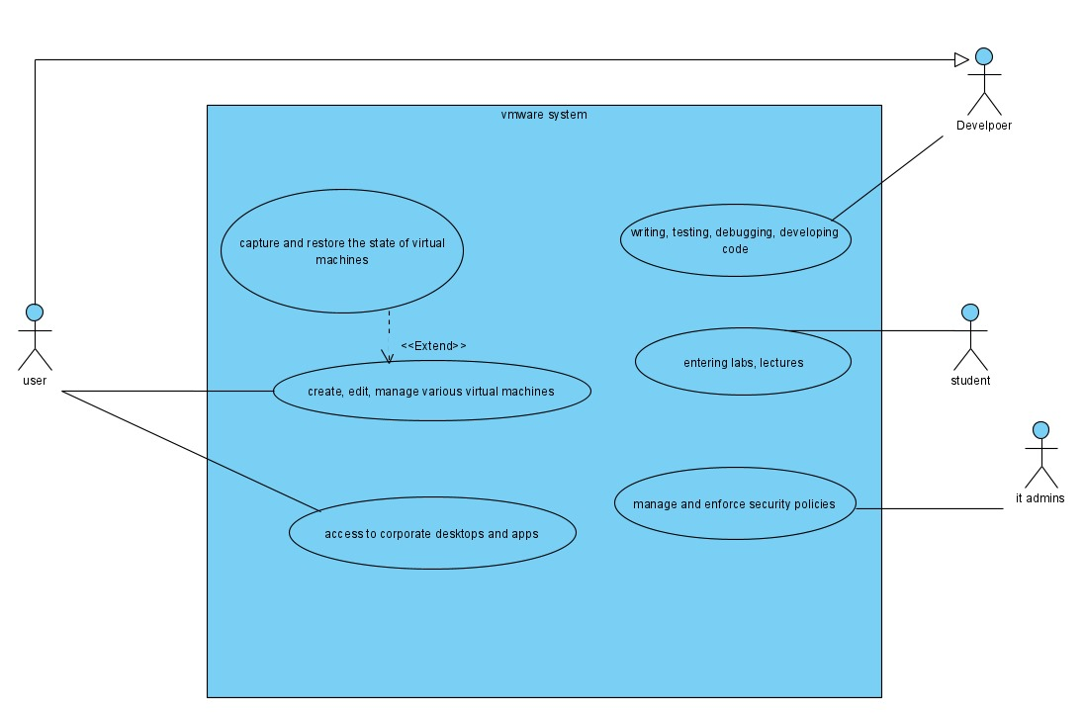

7. ציירו אב טיפוס מנייר והסבירו את כל האלמנטים המרכזיים בו.

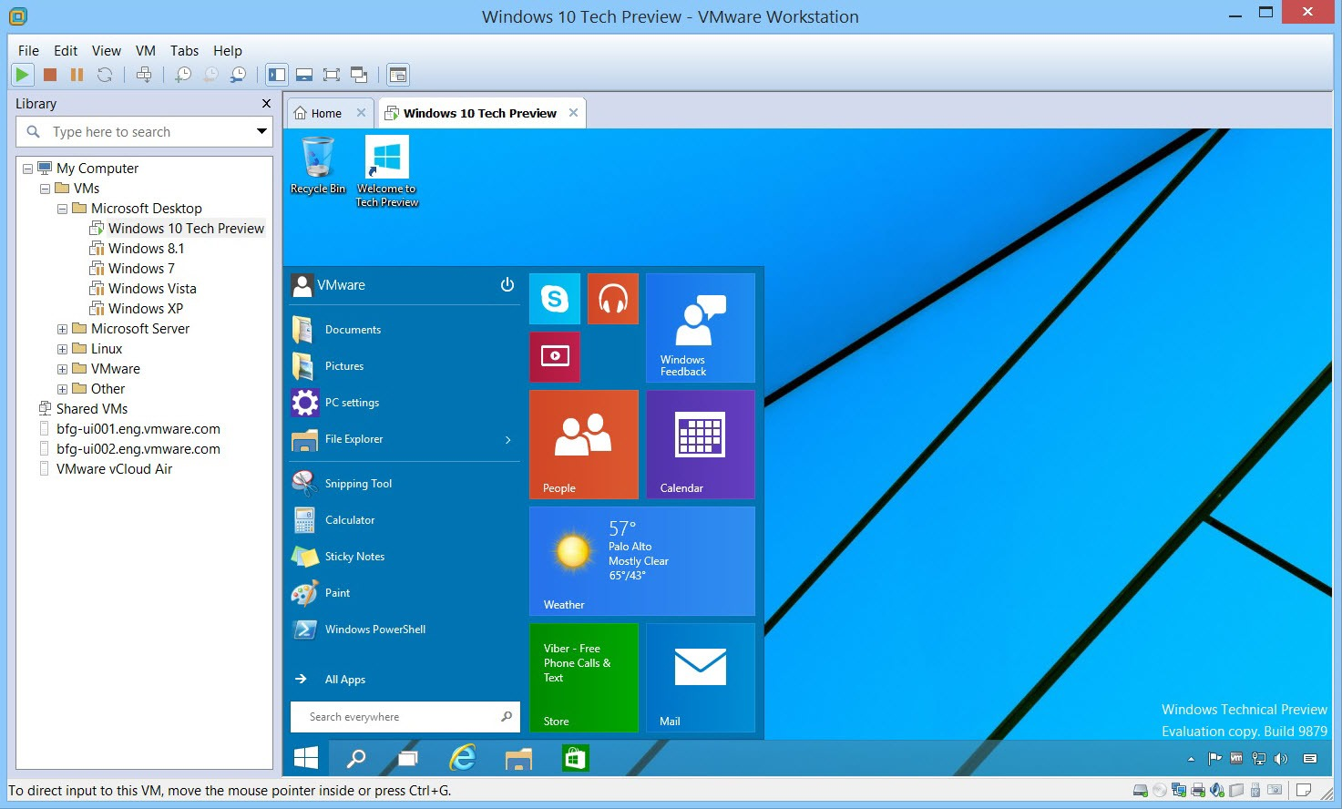

Here you can access different VMs from your library and you can have multiple VMs running at the same time

There is also a place for shared VMs that u can access it