Report on COVID-19 Data Analysis Program


National University of Computer and Emerging Sciences

COURSE: Programming for Business (CS2016)
SECTION: 1D
DATE: 3 Dec, 2024
SUBMITTED TO: Ms. Iman Ilyas
SUBMITTED BY:
Imtanan Mujahid (24L-5594)
Muhammad Sarmed (24L-5530)
Mustafa Tashfeen (24L-5592)
Suhaib Raza (24L-5635)

Contents
Report on COVID-19 Data Analysis Program 1
1.1 Introduction 3
1.2 Libraries 3
2.1 Used for data manipulation and analysis. 3
2.2 NumPy 3
2.3 Matplotlib 4
2.4 Seaborn 4
3.1 Working of Each Module 4
3.1.1 load data Module 4
3.1.2 Importing Required pandas 4
3.1.3 Defining the Function 4
3.1.4 Reading the File 4
3.1.5 Error Handling 5
3.2 clean data Module 5
3.2.1 Handling Missing Province/State Entries 5
3.2.2 Handling Missing Numeric Data 5
3.2.3 Removing Duplicate Rows 6
3.2.4 Confirmation Message 6
3.3 explore data Module 6
3.3.1 Displaying Sample Rows 6
3.3.2 Dataset Summary 6
3.3.3 Identifying Missing Values 6
3.3.4 Statistical Summary 7
3.4 analyze global trend Module 7
3.4.1 Extracting Numeric Data 7
3.4.2 Summing Cases Across Regions 7
3.4.3 Converting Results to Time Series 7
3.4.4 Printing the Result 8
3.5 analyze_top_countries Module 8
3.5.1 Grouping Data by Country 8
3.5.2 Calculating Total Cases Per Country 8
3.5.3 Sorting and Selecting Top N Countries 8
3.5.4 Printing the Result 9
3.6 plot_global_trend Module 9
3.6.1 Configuring the Plot 9
3.6.2 Plotting the Data 9
3.6.3 Adding Labels and Titles 10
3.6.4 Displaying the Plot 10
3.7 plot top countries Module 10
3.7.1 Configuring the Plot 10
3.7.2 Adding Titles and Labels 10
3.7.3 Displaying the Plot 10
3.8 calculate statistics Module 11
3.8.1 Mean Calculation 11
3.8.2 Median Calculation 11
3.8.3 Standard Deviation 11
3.8.4 Min and Max Values 11
4.1 Conclusion 11

1.1 Introduction
Examining large data sets, like global COVID-19 time-series data, is key to finding patterns and good decision-making. This program in Python handles and flaunts that data in an intelligible way. The report breaks this program down into easily digestible components to ensure things remain lucid and describe how all the functions work and why they do so.

1.2 Libraries
So, you will need here four major Python libraries: Pandas, NumPy, Matplotlib and Seaborn. Each one is actually pretty critical at different steps of the procedure like data dealing, doing some maths thing, and a little pretty visualizing thing.

2.1 Used for data manipulation and analysis.
- Use in the Program:
  - Loads data from CSV files into a DataFrame (pd.read_csv()).
  - Handles missing values (fillna()) and removes duplicates (drop_duplicates()).
  - Provides functions for exploring the dataset (info(), describe()).

2.2 NumPy
- Purpose: Numerical computing and working with large arrays.
- Use in the Program:
  - Efficiently handles numerical data with functions like np.sum(), np.mean(), np.std().
  - Used for aggregating daily cases globally and performing statistical calculations.

2.3 Matplotlib
- Purpose: Used for visualization (creating static plots and charts).
- Use in the Program:
  - Creates line plots for global COVID-19 trends (plt.plot()).
  - Adds titles, labels, and legends to plots for clarity (plt.title(), plt.xlabel(), plt.ylabel()).

2.4 Seaborn
- Purpose: Enhanced statistical data visualization based on Matplotlib.
- Use in the Program:
  - Creates attractive bar plots for displaying the top countries by total COVID-19 cases (sns.barplot()).
  - Provides color palettes for better presentation.

3.1 Working of Each Module

3.1.1 load data Module
This is responsible for loading the dataset from a file and converting it into one Pandas Data Frame. It makes a code strong by implementing error handling and validation.

3.1.2 Importing Required pandas
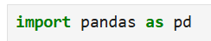
- Purpose: Pandas is allowing us to work efficiently with structured data. It Simplifies the loading of datasets from various formats like CSV, Excel, and SQL and Provides powerful tools for filtering, grouping, and summarizing data.

3.1.3 Defining the Function
- Explanation:
  - A def function is used to make it easier for the person to repeat this code further down the line making it efficient. In the brackets we have the parameter “file_path” which means we are taking the path of the file from the user as input

3.1.4 Reading the File
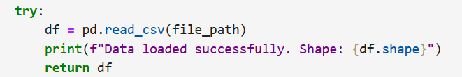
- Purpose:
  - Reads the CSV file into a DataFrame using pd.read_csv().and prints the dataset’s shape (df.shape) to confirm successful loading.
- Why read_csv()?
  - Efficiently handles large datasets and automatically infers column names, data types, and delimiters, reducing setup time.
- Example:
  - A file containing COVID-19 data with columns like Province/State, Country/Region, and daily case counts will be converted into a tabular format.

3.1.5 Error Handling
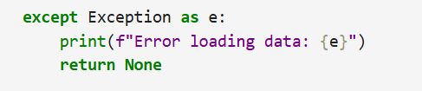
• Purpose:
- Catches potential errors, such as file not found, incorrect file format, or read permissions issues and ensures the program does not crash unexpectedly.

3.2 clean data Module
This module allows the dataset to ensure data quality. Cleaning data is essential to avoid errors or misleading results in subsequent analysis.

3.2.1 Handling Missing Province/State Entries
- Purpose:
  - Replaces missing values in the Province/State column with "Unknown."
  - Ensures no critical information is lost, especially for regional analysis.
- Why Replace with "Unknown"?
  - Retains the data rows for these entries while acknowledging incomplete information.
- Potential Issue:
  - If a large percentage of entries are labeled "Unknown," it could signal data collection issues.

3.2.2 Handling Missing Numeric Data
- Purpose:
  - Replaces missing numeric values with zeros to avoid affecting calculations like sums or averages.
  - Uses apply() for efficient column-wise operations.
- Why Replace with 0?
  - Zero indicates no cases reported, which aligns with real-world assumptions in this context.
- Alternatives:
  - Use the column mean or median as a replacement if zeros might introduce bias.
  - Interpolate missing values for time-series data.

3.2.3 Removing Duplicate Rows
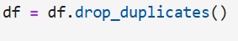
- Purpose:
  - Eliminates duplicate entries, ensuring each row represents unique information.
- Example:
  - If two rows for Italy on the same date exist, it might double-count cases unless duplicates are removed.

3.2.4 Confirmation Message
- Purpose:
  - Notifies the user that cleaning is complete, building confidence in the dataset’s readiness.

3.3 explore data Module
This module offers a quick overview of the dataset, highlighting its structure, content, and potential anomalies.

3.3.1 Displaying Sample Rows
- Purpose:
  - Prints the first five rows of the dataset, providing a snapshot of its contents.
- Why Inspect head()?
  - Verifies that column names, data types, and values are as expected.
- Potential Issues:
  - Columns might have inconsistent or misaligned data.

3.3.2 Dataset Summary
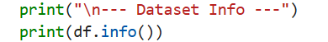
- Purpose:
  - Displays column names, data types, and non-null counts.
  - Helps identify missing data and improper types (e.g., dates stored as strings).
- Key Metric:
  - Memory usage (memory_usage) can guide optimization (e.g., using float32 instead of float64).

3.3.3 Identifying Missing Values
- Purpose:
  - Summarizes missing values per column.
- Why Check for Missing Values?
  - Missing data may indicate issues with collection methods.

3.3.4 Statistical Summary
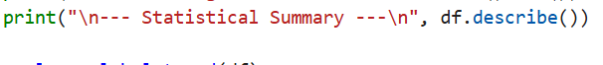
- Purpose:
  - Computes metrics like mean, standard deviation, and min/max values for numeric columns.
  - Provides a high-level overview of data distribution.

3.4 analyze global trend Module
This module calculates the global trend of confirmed COVID-19 cases by summing daily case data across all regions. It transforms raw regional data into a global time series.

3.4.1 Extracting Numeric Data
- Purpose:
  - Extracts all columns starting from the 5th column (daily case counts) and converts them to a NumPy array for efficient computating.

- Key Point:
  - The first four columns (Province/State, Country/Region, Lat, Long) are skipped since they contain metadata, not case data.

3.4.2 Summing Cases Across Regions
- Purpose:
  - Calculates the total daily cases globally by summing rows for each column (date) and we use this because each row represents a specific region's data. Summing them aggregates data across all regions.

3.4.3 Converting Results to Time Series
- Purpose:
  - Converts the numpy array into a Pandas Series with dates as the index.
  - Ensures compatibility with Pandas operations and it is used to Make it easier to handle date-based operations, such as indexing or filtering specific time ranges.

3.4.4 Printing the Result
• Purpose:
- Displays the first few values of the global trend, verifying correctness.

• Example Output:
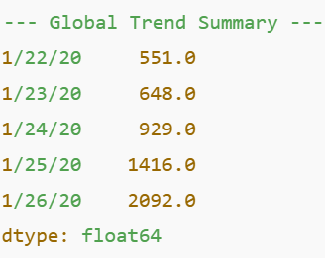

3.5 analyze_top_countries Module
This module identifies the top N countries with the highest total confirmed cases, providing insights into the most affected regions.

3.5.1 Grouping Data by Country
- Purpose:
  - Groups data by the Country/Region column, aggregating case counts for all regions within a country.
- Key Consideration:
  - Numeric columns (case counts) are summed automatically, while non-numeric columns are ignored.

3.5.2 Calculating Total Cases Per Country
- Purpose:
  - Sums daily case counts across all dates for each country.
  - Produces a single total for each country, simplifying comparisons.

3.5.3 Sorting and Selecting Top N Countries
- Purpose:
  - Sorts countries by total cases in descending order.
  - Selects the top N countries (e.g., 5 most affected countries).

3.5.4 Printing the Result
• Purpose:
- Displays the results for verification.
• Example Output:
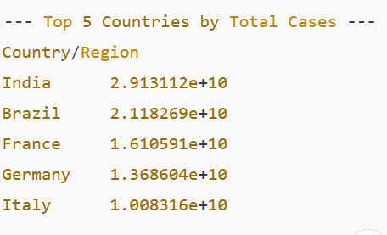

3.6 plot_global_trend Module
This module visualizes the global trend of confirmed cases over time using a line plot.

3.6.1 Configuring the Plot
- Purpose:
  - Sets the plot size for better readability, especially for long time-series data.

3.6.2 Plotting the Data
- Purpose:
  - Creates a line plot of the global trend, with dates on the x-axis and case counts on the y-axis.
- Why Use a Line Plot?
  - Ideal for visualizing trends over time.

3.6.3 Adding Labels and Titles
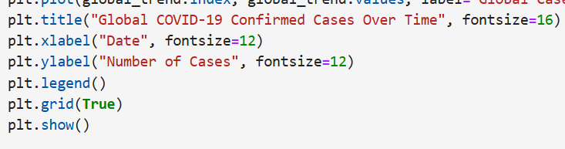
- Purpose:
  - Titles and labels make the plot informative and professional.
  - The legend identifies the data series (e.g., "Global Cases").

3.6.4 Displaying the Plot

- Purpose:
  - Renders the plot, allowing users to visually interpret the data.

3.7 plot top countries Module
This module visualizes the total confirmed cases for the top N countries using a bar plot.

3.7.1 Configuring the Plot
- Purpose:
  - Creates a horizontal bar plot using Seaborn for aesthetic visualizations.
  - Bars represent total cases, while the y-axis lists country names.

3.7.2 Adding Titles and Labels
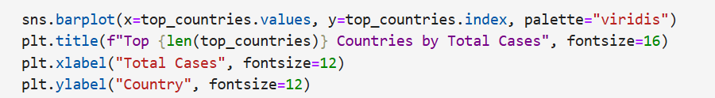
- Purpose:
  - Titles and labels provide context for the plot.

3.7.3 Displaying the Plot

Purpose:
- Renders the plot for analysis.

3.8 calculate statistics Module
This module computes basic statistics, such as mean, median, standard deviation, minimum, and maximum values for daily case counts.

3.8.1 Mean Calculation
- Purpose:
  - Computes the average daily cases across all regions.

3.8.2 Median Calculation
- Purpose:
  - Finds the middle value for daily cases, which is less affected by outliers.

3.8.3 Standard Deviation

- Purpose:
  - Measures the spread of daily case counts, indicating variability.

3.8.4 Min and Max Values
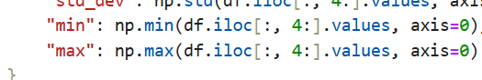
- Purpose:
  - Identifies the lowest and highest daily case counts, respectively.

4.1 Conclusion
So, with COVID-19, every module and its parts make everything run smoothly and help with data analysis and visualization. It really shows how crucial modularity, error-handling, and visualization are for making a program strong and easy to use.

