Software Requirements Specification
for
Community Management System
Prepared by
Ahmed Mustafa, Haziq Naeem, Muneeb-ul-Islam
NUCES ISLAMABAD
20-3-2025

- Table of Contents
Introduction
1.1 Purpose
1.2 Document Conventions
1.3 Intended Audience and Reading Suggestions
1.4 Product Scope
1.5 References
- Overall Description
2.1 Product Perspective
2.2 Product Functions
2.3 User Classes and Characteristics
2.4 Operating Environment
2.5 Design and Implementation Constraints
2.6 User Documentation
2.7 Assumptions and Dependencies
- External Interface Requirements
3.1 User Interfaces
3.2 Hardware Interfaces
3.3 Software Interfaces
3.4 Communications Interfaces
- System Features
- Nonfunctional Requirements
5.1 Product Requirements
5.2 Organizational Requirements
5.3 External Requirements
- Use Case Diagram & User Stories
6.1 Use Case Diagram
6.2 User Stories with Pre/Post Conditions
- Sequence Diagrams
- Class Diagram
- Product Backlog
- Sprint Backlog
- Meeting Minutes
- Version Control & Contribution Evidence

1. Introduction

1.1 Purpose
The Communi3y is Community Management System (CMS) that is a web-based application designed to streamline property management, public service requests, digital booking, facility reservations, and incident reporting within a community.

1.2 Document Conventions
This document follows the IEEE SRS template format.

1.3 Intended Audience and Reading Suggestions
- Developers & Database Administrators – Understand system functionalities.
- Project Managers & Scrum Masters – Track development milestones.
- Residents & Admins – Comprehend system capabilities.

1.4 Product Scope
The system provides digital solutions to manage properties, request public services, participate in digital voting, reserve community facilities, and report incidents. The backend will be implemented using Next.js, Node.js, and MySQL.

1.5 References
- IEEE 830-1998 Software Requirements Specification Standard.
- Project Diagrams: Use Case Diagram, Sequence Diagram, Class Diagram.

2. Overall Description

2.1 Product Perspective
This system is a standalone web-based application that digitalizes community management operations, replacing manual processes.

2.2 Product Functions
- Property Registration
- Public Service Requests
- Digital Voting System
- Recreation Facility Reservation
- Crime & Incident Reporting

2.3 User Classes and Characteristics
- Residents – Property owners or tenants accessing services.
- Admins – Management personnel handling operations.

2.4 Operating Environment
- Web-based system accessible via modern browsers.
- Hosted on a local server infrastructure.
- Uses Html, CSS and React(if applicable at the end of sprint 3) (Frontend), Node.js (Backend), MySQL (Database).

2.5 Design and Implementation Constraints
- The system should be deployed on a MySQL database.
- Must follow security protocols for data encryption and access control.

2.6 User Documentation
- User Manual (for residents & admins)
- API Documentation (for developers)

2.7 Assumptions and Dependencies
- Reliable internet connection for cloud-based functionality.
- Compliance with local property laws for registration validation.

3. External Interface Requirements

3.1 User Interfaces
- Web-based UI developed using HTML, CSS and REACT.js (applicable at the end of sprint 3).
- Interactive forms for property registration, voting, and service requests.

3.2 Hardware Interfaces
- Deployable on standard server hardware.
- Must support cloud hosting for scalability.

3.3 Software Interfaces
- Integration with MySQL database.
- Node.js for backend operations.

3.4 Communications Interfaces
- Email & SMS notifications for critical updates.
- Secure HTTPS for data transmissions.

4. System Features
- 4.1 User Stories & Acceptance Criteria
Here are the User Stories with Acceptance Criteria following the format in your attached image (Story Card Format):

- 1. Register Property
User Story:
As a resident, I want to register my property in the system so that I can be recognized as a property owner and access related services.
Acceptance Criteria:
And I know I am done when:
- I can input property details and upload necessary documents.
- The system validates and accepts my registration request.
- I receive a confirmation notification upon successful registration.

- 2. Manage Resident Data
User Story:
As an admin, I want to add, update, and manage resident information so that records remain accurate and up to date.
Acceptance Criteria:
And I know I am done when:
- I can view, edit, and delete resident profiles.
- Changes made reflect immediately in the database.
- A confirmation message is shown after each update.

- 3. Make Payment
User Story:
As a resident, I want to pay society fees, utility bills, and other charges so that I can fulfill my financial obligations.
Acceptance Criteria:
And I know I am done when:
- I can select a bill and choose a payment method.
- Payment is processed securely and a digital receipt is generated.
- The payment status updates in my account dashboard.

- 4. Track & Update Payments
User Story:
As an admin, I want to monitor and update residents’ payment records so that I can ensure financial accuracy.
Acceptance Criteria:
And I know I am done when:
- I can view all payment histories per resident.
- I can manually edit and update payment status.
- All changes are logged with a timestamp.

- 5. Manage Bills
User Story:
As an admin, I want to generate, adjust, and send utility and maintenance bills so that residents receive accurate billing.
Acceptance Criteria:
And I know I am done when:
- I can create and adjust bill details (amount, due date, etc.).
- Bills are assigned correctly to each resident.
- A notification is sent to the resident’s dashboard/email.

- 6. Book Parking & Reserve Facility
User Story:
As a resident, I want to book parking spots and recreation facilities so that I can use shared community resources.
Acceptance Criteria:
And I know I am done when:
- I can view available parking/facilities.
- I can book a slot for a specific time/date.
- I receive confirmation and the resource is marked as reserved.

- 7. Submit Maintenance Request
User Story:
As a resident, I want to request maintenance services so that property issues can be resolved.
Acceptance Criteria:
And I know I am done when:
- I can describe the issue and attach supporting media (photo/video).
- The request is logged and visible in my request history.
- I receive a ticket number and status tracking option.

- 8. Schedule Infrastructure Maintenance
User Story:
As an admin, I want to schedule and oversee maintenance for public infrastructure so that the community remains well-maintained.
Acceptance Criteria:
And I know I am done when:
- I can create a maintenance task with schedule and location.
- The task is assigned to a maintenance team.
- Progress and completion status can be tracked.

- 9. Manage Event RSVPs
User Story:
As a resident, I want to RSVP for events so that I can participate in community activities.
Acceptance Criteria:
And I know I am done when:
- I can view upcoming events and RSVP.
- My attendance status updates instantly.
- I receive an event reminder or pass.

- 10. Send & Receive Notifications
User Story:
As an admin, I want to send important notifications so that residents stay informed.
Acceptance Criteria:
And I know I am done when:
- I can draft and send messages to all or selected residents.
- Notifications appear in residents’ dashboards or inboxes.
- Sent notifications are logged with timestamp and audience.

- 11. Request Public Service
User Story:
As a resident, I want to request services like garbage collection so that community needs are met.
Acceptance Criteria:
And I know I am done when:
- I can submit a service request with location and description.
- A request ticket is generated.
- I receive confirmation and can track status.

- 12. Report Crime or Incident
User Story:
As a resident, I want to report crimes or incidents so that authorities can respond accordingly.
Acceptance Criteria:
And I know I am done when:
- I can report an incident with details and location.
- The system assigns it to the concerned department.
- I receive a response acknowledgment.

- 13. Submit Public Feedback
User Story:
As a resident, I want to provide feedback on community services so that improvements can be made.
Acceptance Criteria:
And I know I am done when:
- I can write and submit feedback easily.
- My feedback is acknowledged.
- The admin panel shows cumulative feedback analytics.

- 14. Digital Voting
User Story:
As a resident, I want to participate in digital voting so that I can have a say in community decisions.
Acceptance Criteria:
And I know I am done when:
- I can view open polls and vote.
- My vote is submitted anonymously.
- The system shows vote completion confirmation.

- 15. Manage Institutes & Healthcare
User Story:
As an admin, I want to oversee educational and healthcare facilities so that community members receive quality services.
Acceptance Criteria:
And I know I am done when:
- I can add/edit institute profiles.
- I can assign and manage healthcare service schedules.
- Updates are reflected in the community portal.

Would you like these filled into a template like your uploaded image (in a Word or PDF document)?
- .

5. Nonfunctional Requirements

5.1 Product Requirements
- The system should support 1000+ concurrent users.
- Should process real-time transactions.

5.2 Organizational Requirements
- Uses Agile methodology for iterative development.

5.3 External Requirements
- Should comply with GDPR & local property laws.

6. Use Case Diagram & User Stories
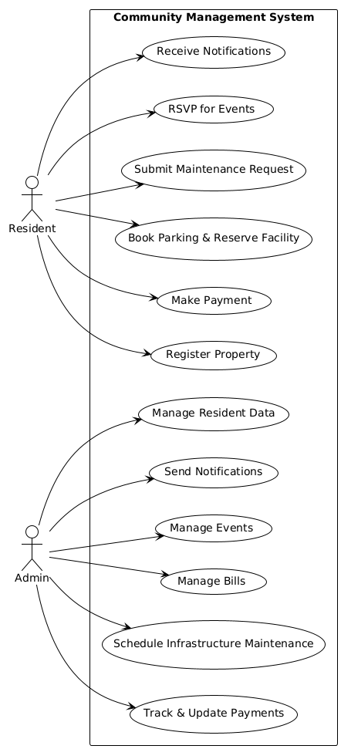

7. Sequence Diagrams
- Three key activities visualized.
- 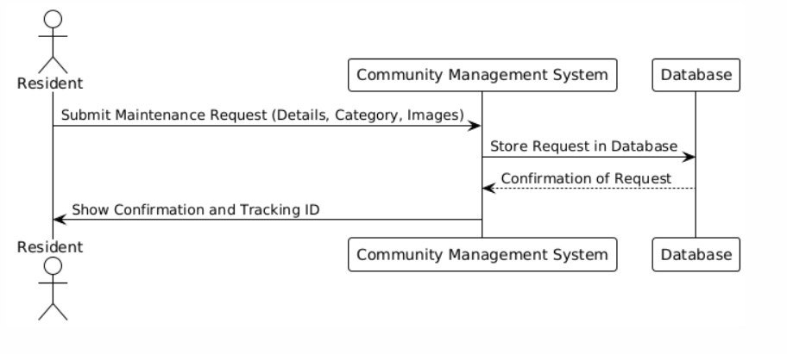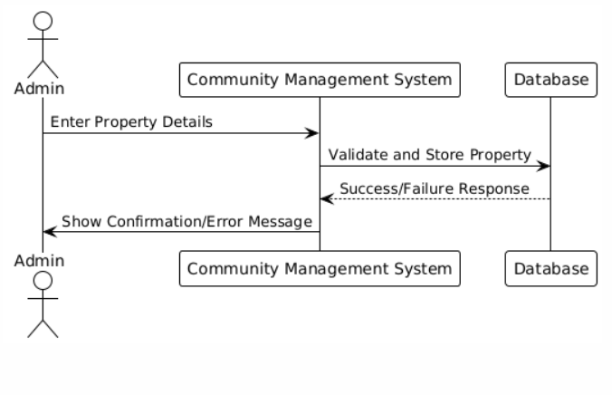
- 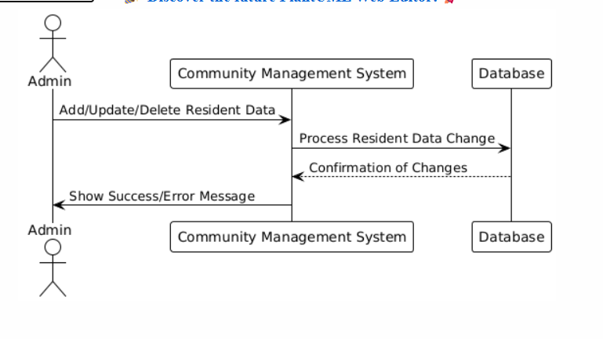

8. Class Diagram

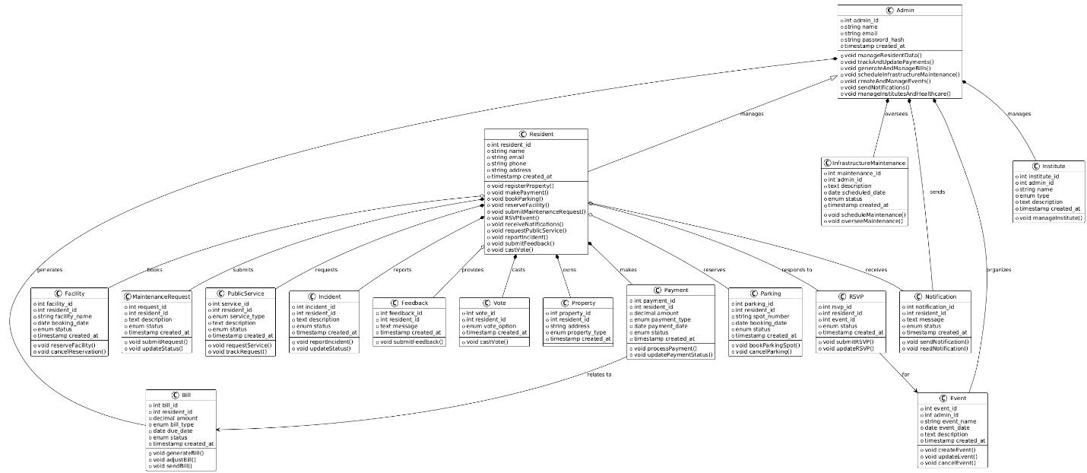

9. Product Backlog

The product backlog includes all user stories prioritized based on their importance.
User Story | Priority
Register Property | High
Manage Resident Data | High
Make Payment | High
Track & Update Payments | High
Manage Bills | High
Book Parking & Reserve Facility | Medium
Submit Maintenance Request | Medium
Schedule Infrastructure Maintenance | Medium
RSVP & Manage Events | Low
Send & Receive Notifications | Low

10. Sprint Backlog

Sprint 1 Backlog
User Story | Assigned To | Tasks | Milestones
Register Property | Haziq | Database schema, API, UI | March 16: Backend,  March 18: UI,  March 20: Testing
Manage Resident Data | Muneeb | Schema, API, UI | March 15: API,  March 17: UI,  March 19: Testing
Make Payment | Ahmed | Payment API, UI, Security | March 16: Backend,  March 18: UI  March 20: Security
Track & Update Payments | Haziq | Database, Admin panel, Notifications | March 17: Backend  March 19: Testing
Manage Bills | Muneeb | Billing system, API, UI | March 15: Backend  March 18: UI  March 20: Testing

Sprint 2 Backlog (Subset of User Stories)
User Story | Assigned To | Tasks | Milestones
Book Parking & Reserve Facility | Ahmed | Reservation System, UI, API | March 19: Backend  March 200: UI  March 21: Testing
Submit Maintenance Request | Haziq | Request submission, File uploads, Status tracking | March 21: Backend,  March 21: UI,  March 21: Testing
Schedule Infrastructure Maintenance | Muneeb | Admin scheduling UI, Notifications | March 22: Backend,  March 22: UI  March 22: Testing

11. Meeting Minutes

Project: Communi3y – Community Management System (CMS)
Meeting Title: Functional and Technical Requirements Review
Date: 15 MARCH 2025
Time: 8:30 pm
Location: Virtual
Chairperson: Muneeb ul Islam, Product Owner
Recorder: Ahmed Mustafa, Scrum Master
Attendees:
- Ahmed (Developer, Scrum Master)
- Muneeb (Developer, Product Owner)
- Haziq (Developer, Scrum Team)

a. Agenda
- Review of SRS Document
- Clarification of Roles & Responsibilities
- Discussion on Sprint 1 and Sprint 2 Backlog
- Confirmation of Design Artifacts (Use Case, Sequence, Class Diagrams)
- Roadmap Review and Action Items

b. Meeting Notes:
- Reviewed the document and project purpose: A web-based CMS designed to facilitate digital community management (property registration, service requests, incident reporting, etc.).
- Reiterated the use of IEEE SRS format and audience scope (Developers, Admins, Residents).
- Confirmed product scope: Includes digital voting, payment, reservations, and feedback systems.
- Technologies finalized:
  - Frontend: HTML, CSS, React.js (planned post-Sprint 3)
  - Backend: Node.js
  - Database: MySQL
- Two main user classes: Residents and Admins
- System will be hosted locally but must support cloud scalability.

C. Sprint Planning
- Sprint 1 Stories Reviewed:
  - Register Property, Manage Resident Data, Make Payment, Track Payments, Manage Bills
  - Tasks assigned with clear milestones. Developers confirmed task deadlines.
- Sprint 2 Stories Reviewed:
  - Book Parking, Submit Maintenance Request, Schedule Infrastructure Maintenance
  - Emphasis placed on testing and UI readiness by March 22.

d. Non-Functional & Compliance Requirements
- Agreed on:
  - System must support 1000+ concurrent users
  - Real-time transaction capability

e. Decisions Made
- React.js integration will be postponed until end of Sprint 3, meanwhile use HTML and CSS for testing the frontend purposes.
- Documentation (User Manual & API Docs) to be created alongside system features.
- Working on Backend using Node.js and MySQL for database.
- Digital voting and feedback systems and other user stories marked for Sprint 3 due to lower priority.

- Action Items
Action Item | Responsible | Deadline
Update Class and Sequence Diagrams | Haziq, Ahmed | March 15
Begin Sprint 2 Development | All Devs | March 19
Finalize UI/UX designs | Ahmed | March 22
Backend and DB setup | Muneeb. Haziq | March 16

Next Meeting: 15 April 2025
Objective: Review Sprint 3 progress and initial testing feedback.

12. Version Control & Contribution Evidence
- https://github.com/Mustafaahmed10/SE_Project
- https://trello.com/b/CmcUFss2/community-managment-system
- ScreenSHots:
- 