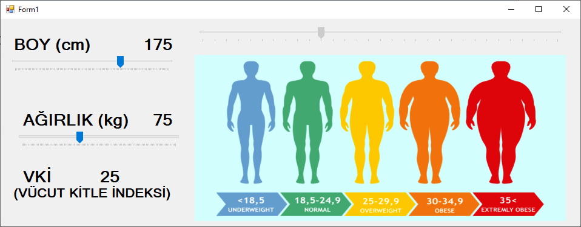

using System;
using System.Collections.Generic;
using System.ComponentModel;
using System.Data;
using System.Drawing;
using System.Linq;
using System.Text;
using System.Threading.Tasks;
using System.Windows.Forms;

namespace WindowsFormsApplication85
{
public partial class Form1 : Form
{
double boy=1, kilo=75, vki=25;

public Form1()
{
InitializeComponent();
}

private void trackBar1_Scroll(object sender, EventArgs e)
{
hesapla();
}

private void trackBar2_Scroll(object sender, EventArgs e)
{
hesapla();
}

private void hesapla()
{
boy =trackBar1.Value;

label1.Text = boy.ToString("N0");
kilo = trackBar2.Value;
label2.Text = kilo.ToString();
vki = kilo*10000 / boy / boy;
label5.Text = vki.ToString("N2");

try
{

trackBar3.Value = Convert.ToInt16(vki);
}
catch { };
}
}
}

