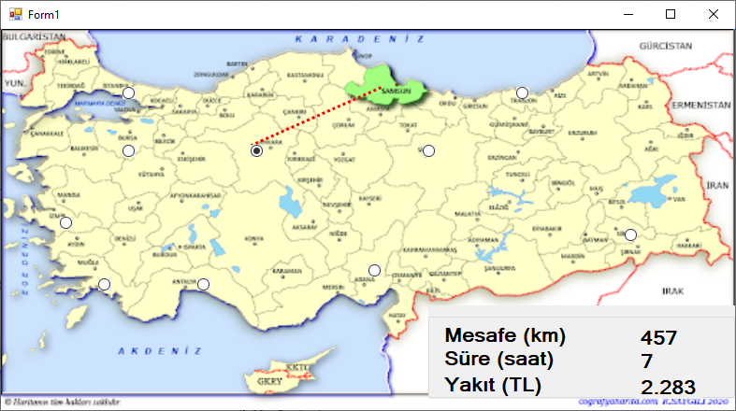

using System;
using System.Collections.Generic;
using System.ComponentModel;
using System.Data;
using System.Drawing;
using System.Linq;
using System.Text;
using System.Threading.Tasks;
using System.Windows.Forms;
using Microsoft.VisualBasic.PowerPacks; // bu satırı ekle

namespace WindowsFormsApplication84
{
public partial class Form1 : Form
{
double farkx, farky, mesafe,saat,yakit;
public Form1()
{
InitializeComponent();
}

private void radioButton2_CheckedChanged(object sender, EventArgs e)
{
lineShape1.X2 = radioButton2.Left;
lineShape1.Y2 = radioButton2.Top;
}

private void Form1_Load(object sender, EventArgs e)
{
lineShape1.X1 = radioButton1.Left;
lineShape1.Y1 = radioButton1.Top;

}

private void lineShape1_Click(object sender, EventArgs e)
{

}

private void lineShape1_EnabledChanged(object sender, EventArgs e)
{

}

private void lineShape1_EndPointChanged(object sender, EventArgs e)
{
farkx = lineShape1.X1 - lineShape1.X2;
farky = lineShape1.Y1 - lineShape1.Y2;
mesafe = Math.Sqrt(farkx * farkx + farky * farky);
mesafe = mesafe * 3;
saat = mesafe / 70;
yakit = mesafe * 5;
label1.Text = mesafe.ToString("N0");
label2.Text = saat.ToString("N0");
label3.Text = yakit.ToString("N0");

}

private void radioButton9_CheckedChanged(object sender, EventArgs e)
{
lineShape1.X2 = radioButton9.Left;
lineShape1.Y2 = radioButton9.Top;
}

private void radioButton10_CheckedChanged(object sender, EventArgs e)
{
lineShape1.X2 = radioButton10.Left;
lineShape1.Y2 = radioButton10.Top;
}

private void radioButton8_CheckedChanged(object sender, EventArgs e)
{
lineShape1.X2 = radioButton8.Left;
lineShape1.Y2 = radioButton8.Top;
}

private void radioButton6_CheckedChanged(object sender, EventArgs e)
{
lineShape1.X2 = radioButton6.Left;
lineShape1.Y2 = radioButton6.Top;
}

private void radioButton7_CheckedChanged(object sender, EventArgs e)
{
lineShape1.X2 = radioButton7.Left;
lineShape1.Y2 = radioButton7.Top;
}

private void radioButton4_CheckedChanged(object sender, EventArgs e)
{
lineShape1.X2 = radioButton4.Left;
lineShape1.Y2 = radioButton4.Top;
}

private void radioButton11_CheckedChanged(object sender, EventArgs e)
{
lineShape1.X2 = radioButton11.Left;
lineShape1.Y2 = radioButton11.Top;
}

private void radioButton5_CheckedChanged(object sender, EventArgs e)
{
lineShape1.X2 = radioButton5.Left;
lineShape1.Y2 = radioButton5.Top;
}

private void radioButton3_CheckedChanged(object sender, EventArgs e)
{
lineShape1.X2 = radioButton3.Left;
lineShape1.Y2 = radioButton3.Top;
}
}
}

