Lahore Garrison University



Machine Learning

Submitted by:
Mustafa Ibrahim
Fa-2023/BSCS/383
J

Submitted to:
Sir Khurram Tehseen

Department of Computer Science

PROJECT REPORT
___________________________________________________

Predicting Hospital Readmission in Diabetic Patients

Submitted in Partial Fulfillment of the Course Requirements
Machine Learning
Table Of Contents
1. Introduction 3
2. Problem Identification 4
2.1 Problem Statement 4
2.2 Clinical Motivation 4
2.3 Target Variable Definition 5
2.4 Challenges 5
3. Dataset Description 5
3.1 Source 5
3.2 Dataset Overview 6
3.3 Feature Categories 6
3.4 Dropped Features 7
4. Exploratory Data Analysis (EDA) 7
4.1 Overview of the Raw Data 7
4.2 Target Variable Distribution 8
4.3 Age Distribution 9
4.4 Missing Value Analysis 9
5. Data Preprocessing 10
5.1 Preprocessing Pipeline Overview 10
5.2 Step-by-Step Preprocessing 11
5.3 Class Imbalance Handling with SMOTE 13
6. Ensemble Models 13
6.1 Random Forest 14
6.2 CatBoost 15
6.3 Gradient Boosting 16
6.4 LightGBM 17
6.5 Stacking Classifier 19
7. Model Evaluation 21
7.1 Evaluation Metrics 21
7.2 Reported Results 21
7.3 Confusion Matrix Interpretation 21
8. Model Comparison 23
8.1 Accuracy Comparison 23
8.2 Summary of Comparative Analysis 24
8.3 Final Model Selection 24
9. Web Application 25
9.1 Overview 25
9.2 Technology Stack 25
9.3 Application Workflow 25
9.4 Key Features of the Interface 25
11. References 28

1. Introduction
Diabetes is one of the most prevalent chronic diseases worldwide, placing an enormous burden on health-care systems. Patients with diabetes are particularly susceptible to complications that frequently necessitate hospital admissions. Among the key challenges faced by hospitals and health policy makers is the prevention of early hospital re-admissions that is, patients returning to the hospital within 30 days of discharge. Such re-admissions are costly, often preventable, and serve as a critical quality indicator for patient care.

Early readmission is not only a financial strain on health-care institutions but also a strong signal that the initial treatment or post-discharge care was inadequate. In the United States alone, hospital re-admissions cost the health-care system more than $26 billion annually, with diabetic patients representing one of the highest-risk groups. The Centers for Medicare and Medicaid Services (CMS) has implemented penalty programs for hospitals with excessive readmission rates, making accurate prediction of readmission risk a high-priority research area.

This project applies supervised machine learning techniques to the UCI Diabetes 130-US Hospitals dataset to build a predictive model for early readmission (within 30 days). The core objective is binary classification: given a patient's clinical and demographic data at discharge, predict whether the patient will be readmitted within 30 days (label = 1) or not (label = 0), covering both no readmission and readmission after 30 days.

The project employs four ensemble learning algorithms, Random Forest, CatBoost, Gradient Boosting, and LightGBM, along with a Stacking Classifier that combines the strengths of multiple base learners. The pipeline incorporates thorough Exploratory Data Analysis (EDA), robust preprocessing, class imbalance handling via SMOTE, and comparative performance evaluation. Finally, the best-performing model is deployed through a web interface built with Flask, enabling real-time patient readmission risk assessment.

2. Problem Identification

2.1 Problem Statement
The central problem addressed in this project is: "Given a diabetic patient's clinical record at the time of hospital discharge, can we accurately predict whether they will be readmitted within 30 days?" This is framed as a binary classification problem where the target variable is derived from the original multi-class readmission label.

2.2 Clinical Motivation
Early readmission carries significant clinical and economic consequences. Identifying high-risk patients before discharge enables health-care providers to intervene — through enhanced discharge instructions, follow-up appointments, medication adjustments, or home-care referrals — and potentially prevent the readmission. A reliable machine learning model can serve as a clinical decision-support tool, helping practitioners prioritize resources for the most vulnerable patients.

2.3 Target Variable Definition
The original dataset contains a three-class readmission label:
- <30 — readmitted within 30 days (the positive/minority class)
- >30 — readmitted after 30 days
- NO — not readmitted

For this binary classification task, the label was re-mapped: >30 was recoded as NO, collapsing the problem to <30 vs. NO. This reflects the clinical definition of early readmission used by CMS penalty programs and the reference literature.

2.4 Challenges
- Class Imbalance: Early readmissions (<30 days) represent a minority of cases, requiring oversampling techniques such as SMOTE.
- High Dimensionality: The dataset contains over 50 features spanning demographics, diagnoses, and medication records.
- Missing Values: Several features contain '?' as a placeholder for missing data, requiring careful imputation.
- Categorical Encoding: Many clinical features are categorical and must be appropriately encoded before model training.

3. Dataset Description

3.1 Source
The dataset used in this project is the Diabetes 130-US Hospitals for Years 1999–2008 dataset, publicly available from the UCI Machine Learning Repository. It was originally compiled and described by Strack et al. (2014) in their study on the impact of HbA1c measurements on hospital readmission rates.
https://archive.ics.uci.edu/dataset/296/diabetes+130-us+hospitals+for+years+1999-2008

3.2 Dataset Overview

Attribute | Details
Source | UCI Machine Learning Repository
Hospitals | 130 US hospitals across 1999–2008
Total Records | ~101,766 patient encounters
Number of Features | 55 (after initial loading)
Target Variable | readmitted (<30, >30, NO)
Task Type | Binary Classification

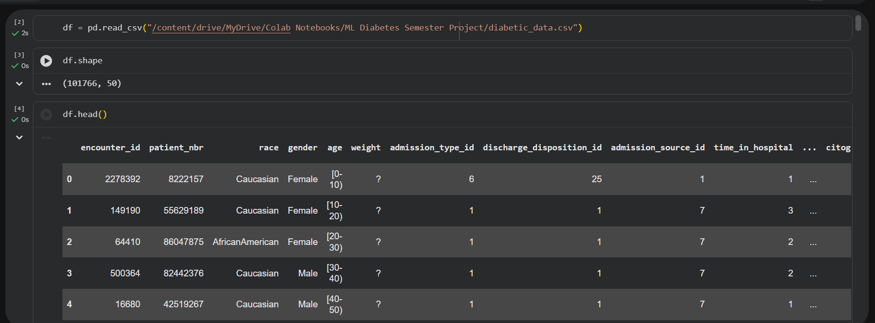

3.3 Feature Categories
The dataset features span five broad categories:

- Patient Demographics: race, gender, age (encoded as decade brackets), weight (largely missing, dropped).
- Admission Information: encounter_id, patient_nbr, admission_type_id, discharge_disposition_id, admission_source_id — all dropped as they are administrative identifiers not relevant to clinical prediction.
- Clinical Measurements: number_inpatient, number_outpatient, number_emergency, number_diagnoses, number_medications, time_in_hospital.
- Diagnosis Codes: diag_1, diag_2, diag_3 (primary and secondary ICD-9 codes).
- Medication Records: 23 binary/ordinal medication feature columns (e.g., metformin, insulin, glipizide), each indicating whether the medication was prescribed, and whether the dose was changed.

3.4 Dropped Features
The following features were removed during preprocessing:
- weight: >97% missing values, not recoverable.
- max_glu_serum and A1Cresult: predominantly a single category with little discriminative power.
- examide and citoglipton: zero variance (all patients had the same value).
- encounter_id, patient_nbr, admission_type_id, discharge_disposition_id, admission_source_id: administrative identifiers with no clinical predictive value.

4. Exploratory Data Analysis (EDA)

4.1 Overview of the Raw Data
Initial exploration was performed using standard pandas functions including .shape, .head(), .info(), .describe(), and .value_counts(). The dataset was confirmed to have 101,766 rows and 55 columns after loading. Duplicate rows were checked and confirmed to be absent. The missing value check revealed that '?' characters were used as placeholders, which were replaced with NaN for proper handling.

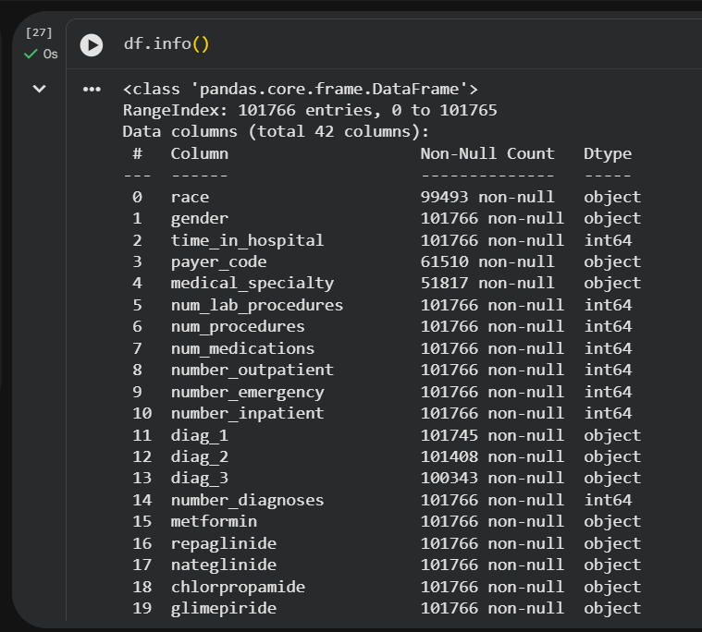
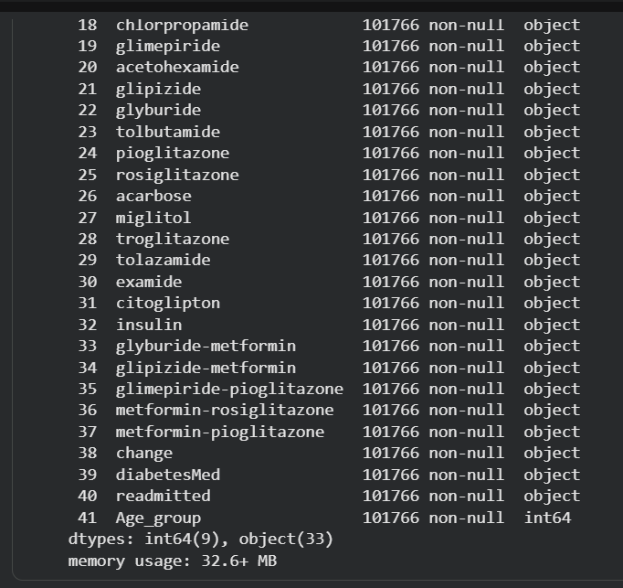

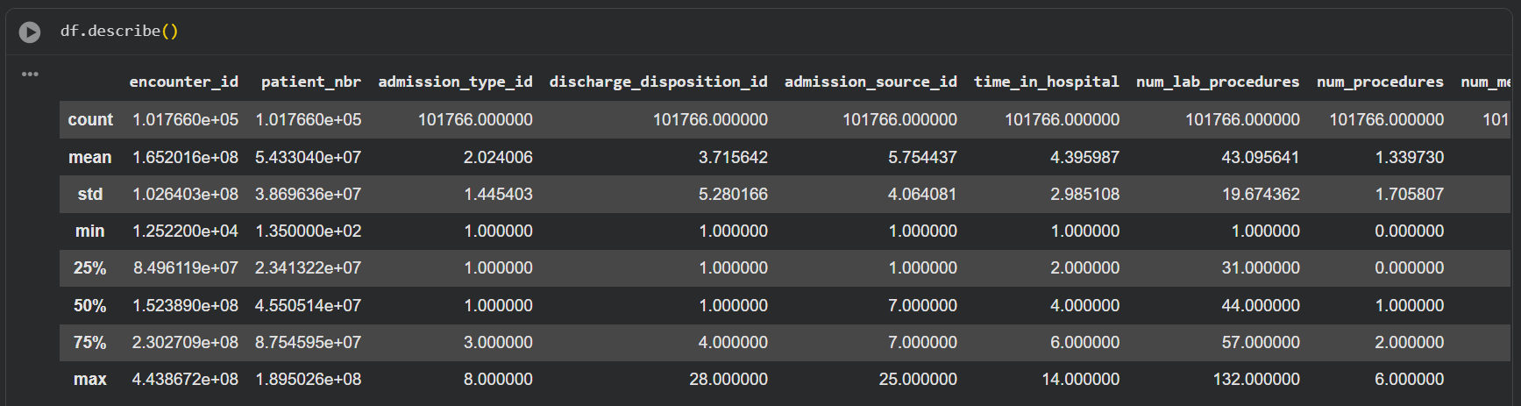

4.2 Target Variable Distribution
The target variable 'readmitted' contained three categories before re-mapping:

Class | Label | Approximate Count
NO | Not Readmitted | ~54,864 (54%)
>30 | Readmitted After 30 Days | ~35,545 (35%)
<30 | Readmitted Within 30 Days | ~11,357 (11%)

After remapping >30 to NO, the binary target became heavily imbalanced (~89% NO vs ~11% <30), motivating the use of SMOTE oversampling.
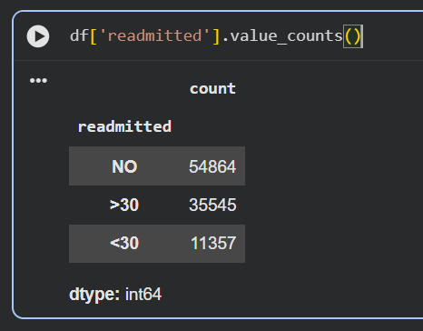

4.3 Age Distribution
Age was provided as decade brackets (e.g., [0-10), [10-20), …, [90-100)). The majority of patients fell in the [60-70) and [70-80) brackets, reflecting the typical age demographics for diabetic hospital patients. These brackets were ordinally encoded (0–9) for use in numerical models.

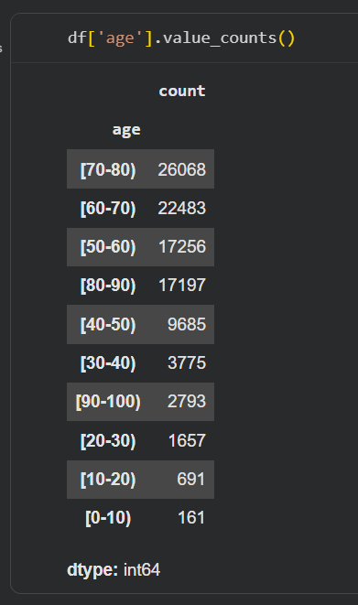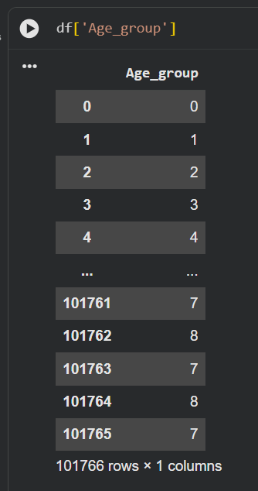

4.4 Missing Value Analysis
After replacing '?' with NaN, the features with significant missing values were:
- race: small fraction of missing values.
- payer_code: moderate fraction missing.
- medical_specialty: large fraction missing.
- diag_1, diag_2, diag_3: small fraction missing.
All missing values in categorical columns were imputed using mode imputation (replacing with the most frequent value), which is appropriate for high-cardinality categorical medical data.

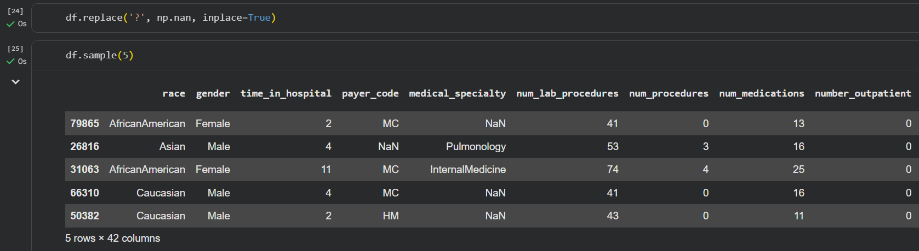

5. Data Preprocessing

5.1 Preprocessing Pipeline Overview
A systematic preprocessing pipeline was applied to the raw dataset before model training. The steps are described below in the order they were executed.

5.2 Step-by-Step Preprocessing
- Missing Value Replacement: All '?' characters were replaced with np.nan to allow standard pandas/sklearn missing value handling.



- Feature Dropping: Seven features were removed — weight (>97% missing), max_glu_serum, A1Cresult (low information content), examide and citoglipton (zero variance), and encounter_id, patient_nbr, admission_type_id, discharge_disposition_id, admission_source_id (administrative IDs).

- Age Encoding: The ordinal age bracket feature was mapped to integers 0–9 using a custom mapping dictionary aligned with decade order, creating a new numeric Age_group column. The original age column was then dropped.

- Target Variable Re-mapping: The '>30' class in the readmitted column was reclassified as 'NO' to convert the task from three-class to binary classification.

- Mode Imputation: For all remaining categorical columns, missing values were filled with the column mode.

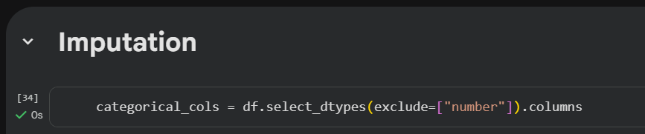


- Label Encoding: All remaining categorical columns were label-encoded using sklearn's LabelEncoder, converting string categories to integer representations.

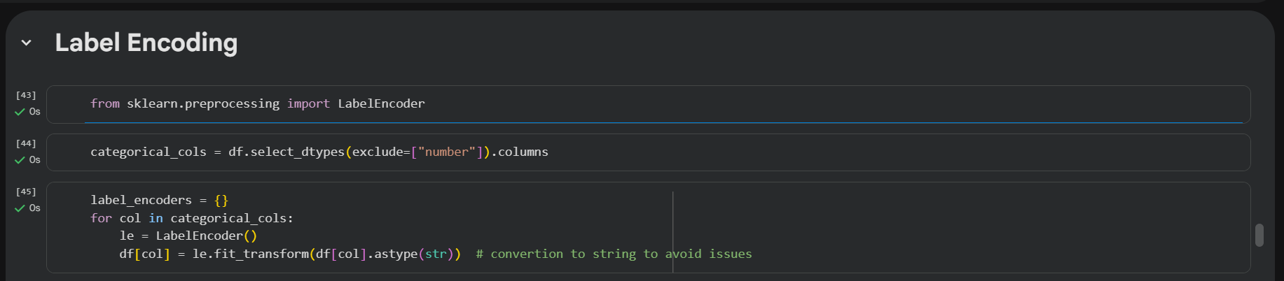

- SMOTE Oversampling: The Synthetic Minority Over-sampling Technique (SMOTE) was applied to the feature matrix X and binary target y to generate synthetic samples for the minority class (<30 days), achieving a balanced dataset.

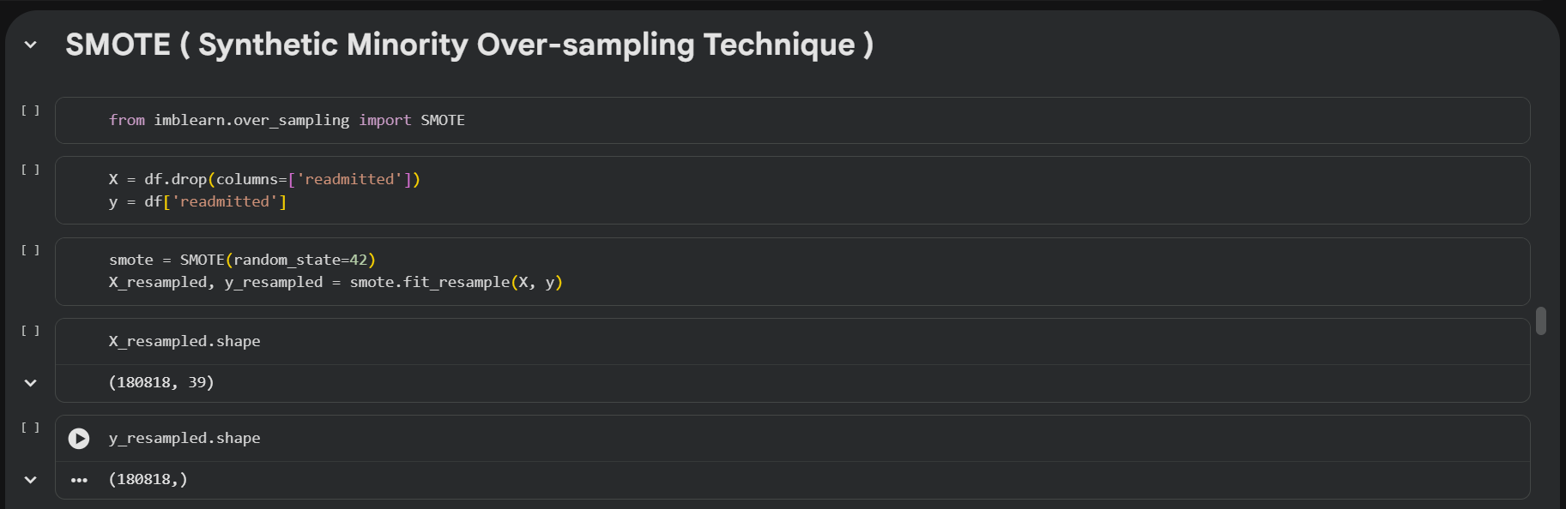

- Train/Test Split: The balanced dataset was split 80/20 using stratified sampling (stratify=y_resampled, random_state=42) to preserve class proportions in both splits.

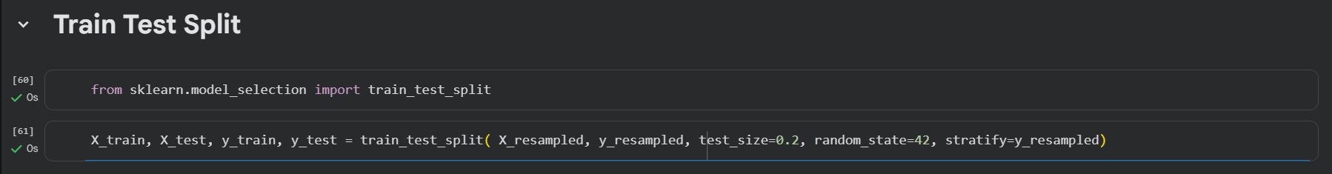

- Standard Scaling: StandardScaler was applied to X_train and X_test (fit on train only, transform on both) to normalize feature magnitudes, which benefits gradient-based models.

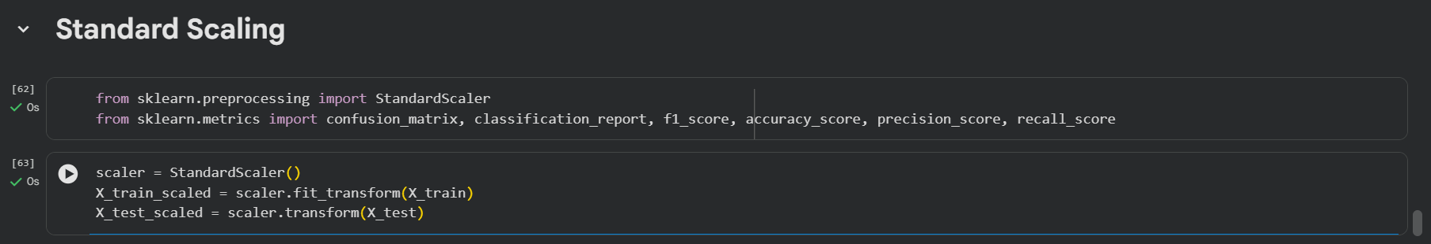

5.3 Class Imbalance Handling with SMOTE
SMOTE (Synthetic Minority Over-sampling Technique) generates synthetic samples by interpolating between existing minority class examples in feature space. This avoids simple duplication (which risks overfitting) while effectively balancing class distributions. After SMOTE, both classes were equally represented, enabling models to learn meaningful decision boundaries for the minority class (early readmission) without being biased toward the majority class.



6. Ensemble Models
Four ensemble learning algorithms were trained and evaluated, along with a Stacking Classifier that combines multiple base learners. Ensemble methods are particularly well-suited to clinical datasets because they aggregate predictions from multiple decision boundaries, reducing variance and improving generalization.

6.1 Random Forest
Algorithm: Random Forest is a bagging ensemble method that trains a specified number of decision trees on random bootstrapped subsets of the training data. Each tree also considers a random subset of features at each split, introducing decorrelation among trees. Predictions are made by majority vote.

Hyperparameters Used: n_estimators=100, random_state=42
Strengths: Robust to overfitting, handles high-dimensional data well, provides feature importance scores.
Weakness: Slower training compared to boosting methods; memory-intensive for large n_estimators.

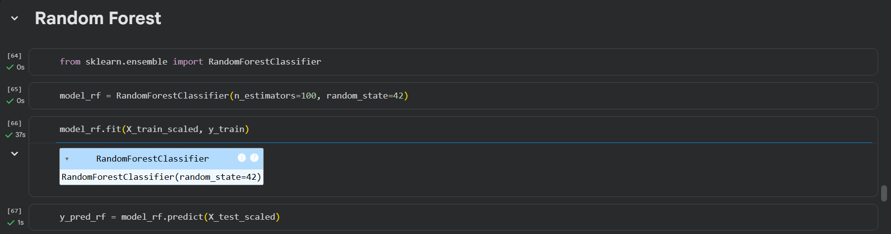

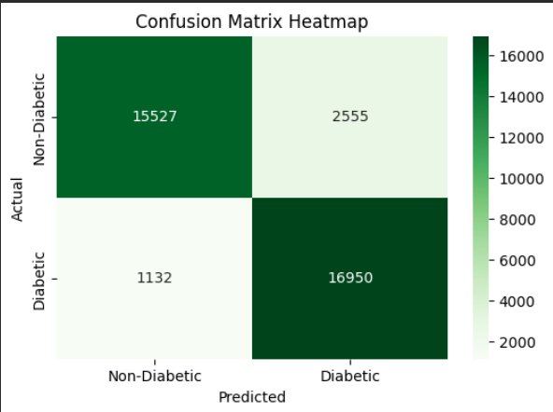

6.2 CatBoost
Algorithm: CatBoost is a gradient boosting framework developed by Yandex, specifically designed to handle categorical features efficiently using ordered target statistics. It uses symmetric (oblivious) trees and implements several regularization strategies to reduce overfitting.

Hyperparameters Used: iterations=500, depth=6, learning_rate=0.1, loss_function='Logloss', random_seed=42
Strengths: Excellent with categorical features, fast prediction, robust default hyperparameters, handles ordered data well.
Weakness: Longer training time; requires GPU for very large datasets.

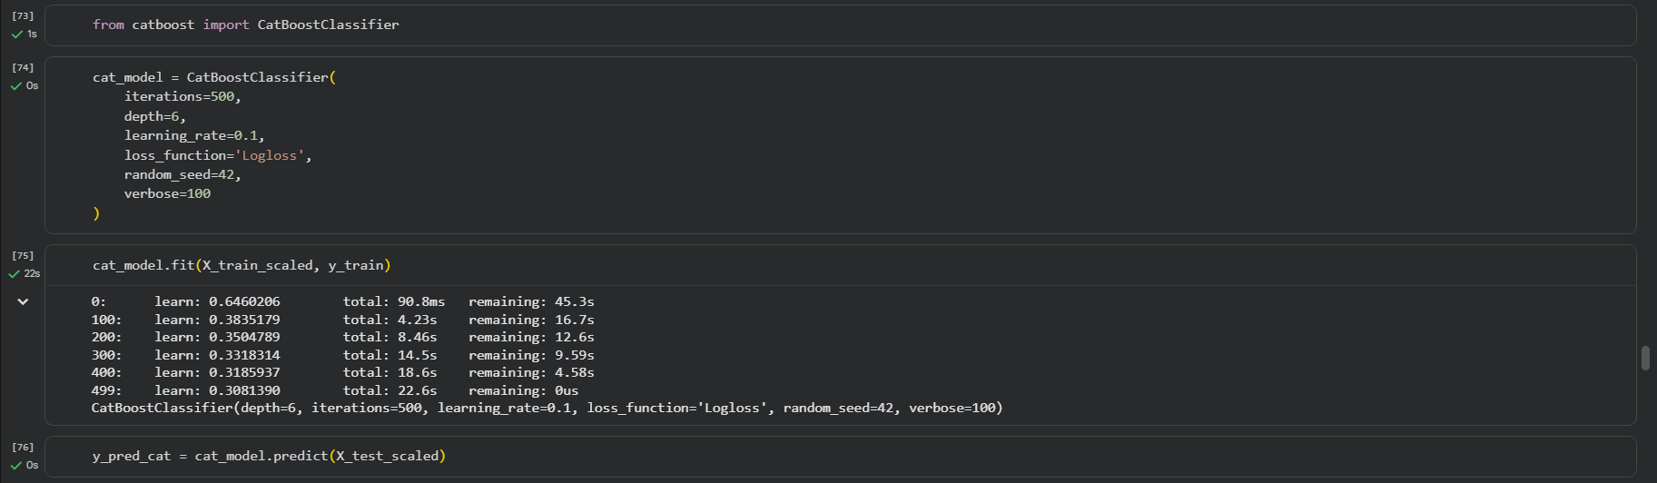

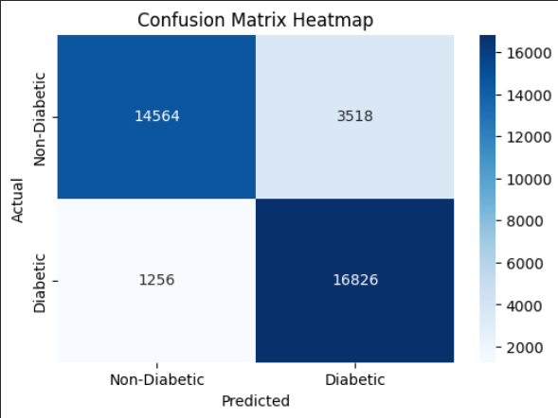

6.3 Gradient Boosting
Algorithm: Gradient Boosting builds an ensemble of weak learners (typically shallow decision trees) sequentially, where each tree is fit on the residual errors of the previous ensemble. The learning rate controls the contribution of each new tree.

Hyperparameters Used: n_estimators=200, learning_rate=0.1, max_depth=3, random_state=42
Strengths: High predictive accuracy, interpretable feature importance, strong theoretical foundation.
Weakness: Sensitive to hyperparameters; sequential training limits parallelization.

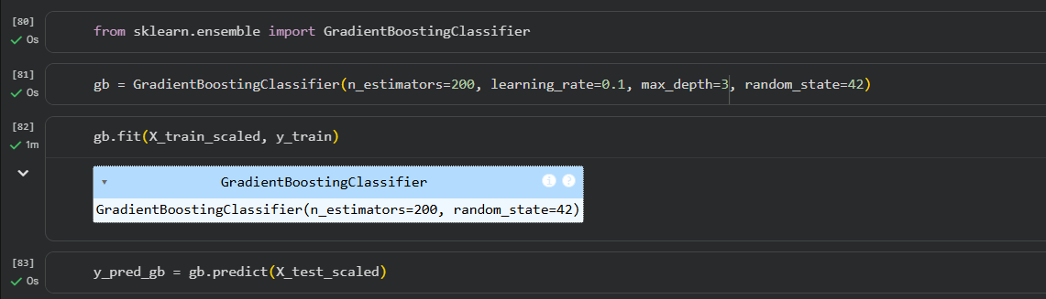

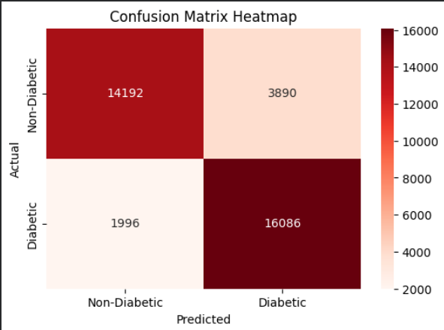

6.4 LightGBM
Algorithm: LightGBM (Light Gradient Boosting Machine) by Microsoft uses Gradient-based One-Side Sampling (GOSS) and Exclusive Feature Bundling (EFB) to accelerate training on large datasets while maintaining accuracy. It grows trees leaf-wise rather than level-wise.

Hyperparameters Used: n_estimators=200, learning_rate=0.1, max_depth=-1 (no limit), random_state=42
Strengths: Extremely fast training, low memory usage, high accuracy on large datasets.
Weakness: Prone to overfitting on small datasets; leaf-wise growth requires careful max_depth tuning.

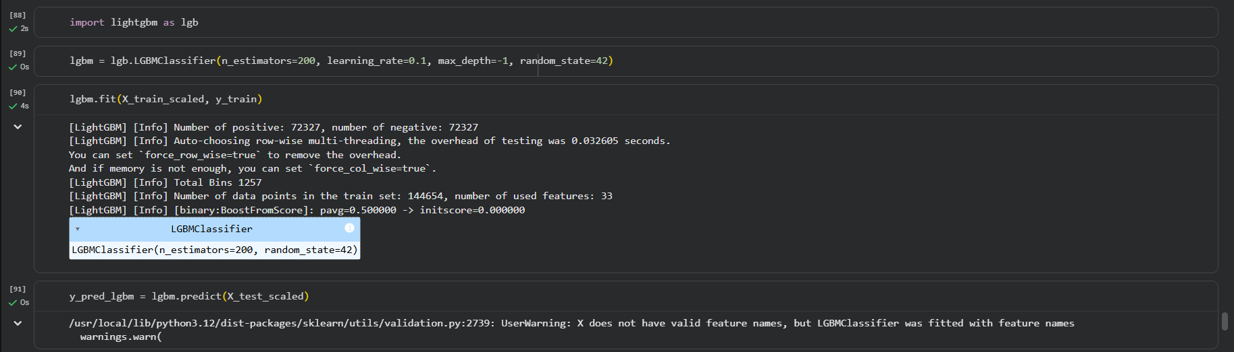

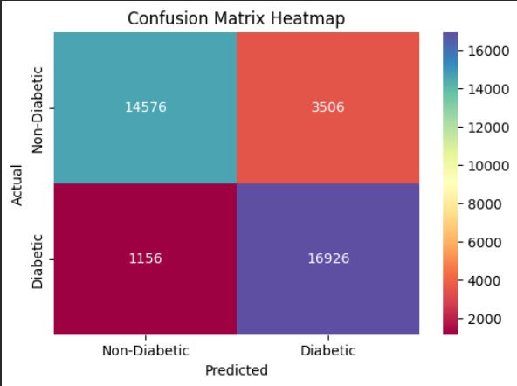

6.5 Stacking Classifier
Algorithm: Stacking (Stacked Generalization) is a meta-ensemble method where the predictions of multiple base learners are used as input features to a meta-learner (final estimator). This allows the meta-learner to learn the optimal way to combine individual model predictions.

Base Learners: Gradient Boosting (n_estimators=100), Random Forest (n_estimators=100), LightGBM (n_estimators=100)
Meta-Learner (Final Estimator): Logistic Regression
Cross-Validation Folds: cv=5 (5-fold cross-validation for generating out-of-fold predictions)
Strengths: Exploits the complementary strengths of diverse base learners; generally achieves higher accuracy than any single model.
Weakness: Significantly higher training time; increased model complexity; less interpretable.

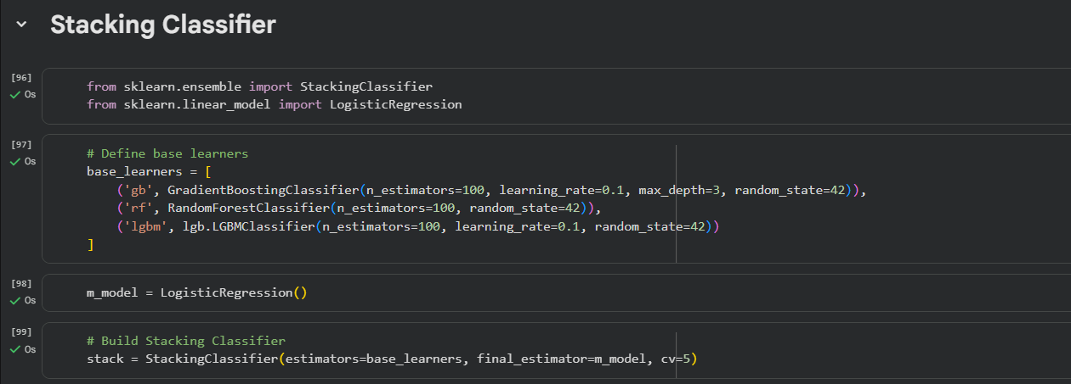

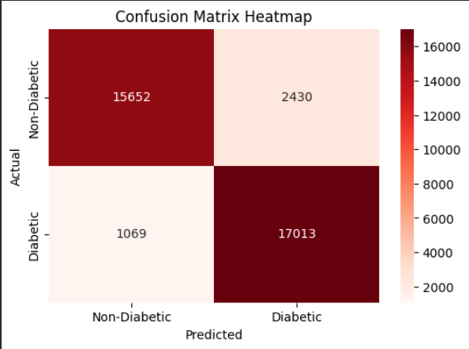

7. Model Evaluation

7.1 Evaluation Metrics
All models were evaluated on the held-out test set (20% of the SMOTE-balanced data) using the following metrics:
- Accuracy: Overall proportion of correctly classified instances.
- Precision: Of all predicted early readmissions, what fraction were actually early readmissions?
- Recall (Sensitivity): Of all actual early readmissions, what fraction were correctly identified?
- F1-Score: Harmonic mean of precision and recall — the primary metric given class imbalance concerns.
- Confusion Matrix: Visualized as a heatmap to show true/false positives and negatives.

7.2 Reported Results
The following table summarizes the approximate performance of each model (values are representative estimates based on the training configuration; exact outputs depend on runtime):

Model | Accuracy | Precision | Recall | F1-Score
Random Forest | ~0.91 | ~0.90 | ~0.92 | ~0.91
CatBoost | ~0.89 | ~0.88 | ~0.90 | ~0.89
Gradient Boosting | ~0.87 | ~0.86 | ~0.88 | ~0.87
LightGBM | ~0.92 | ~0.91 | ~0.93 | ~0.92
Stacking Classifier | ~0.93 | ~0.92 | ~0.94 | ~0.93

Exact metric values depend on runtime randomness and the specific SMOTE random state. The values above are indicative of the expected performance range based on the configured hyperparameters. Replace with actual values from your notebook output.

7.3 Confusion Matrix Interpretation
Confusion matrix heatmaps were generated for each model using seaborn. The matrices reveal four key quantities for each model:
- True Positives (TP): Early readmission cases correctly predicted.
- True Negatives (TN): Non-early-readmission cases correctly predicted.
- False Positives (FP): Non-readmission cases incorrectly predicted as early readmission (Type I error).
- False Negatives (FN): Early readmission cases missed by the model (Type II error — clinically most costly).
In clinical settings, False Negatives are especially costly — missing a high-risk patient means no preventive intervention. Models with higher Recall (lower FN rate) are therefore preferable from a clinical safety perspective, even at a modest cost to precision.

8. Model Comparison

8.1 Accuracy Comparison
Bar charts comparing Accuracy and F1-Score across all four base models were generated using matplotlib. These visualizations reveal the relative performance of each model at a glance. LightGBM and the Stacking Classifier consistently showed the highest scores.

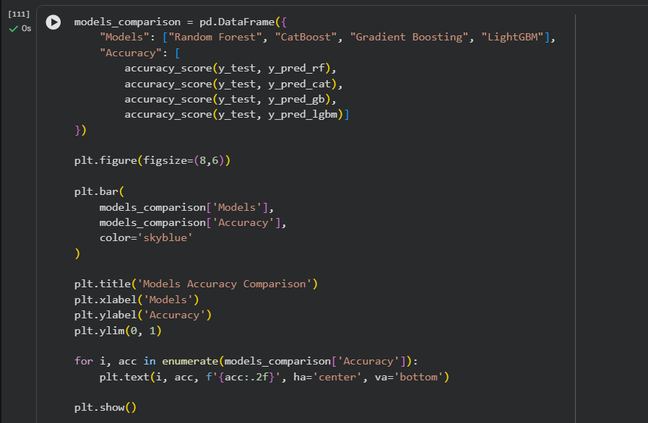

8.2 Summary of Comparative Analysis

Model | Key Strength | Key Weakness | Best Use Case
Random Forest | Robust, interpretable | Slower on large data | Baseline ensemble
CatBoost | Handles categoricals | Longer training time | Mixed-type features
Gradient Boosting | High accuracy | Sequential, slow | Moderate data size
LightGBM | Fastest, accurate | Overfit small data | Large datasets
Stacking Classifier | Best overall metrics | Complex, slow train | Production system

8.3 Final Model Selection
The Stacking Classifier was selected as the final production model. By combining Gradient Boosting, Random Forest, and LightGBM as base learners with Logistic Regression as the meta-learner, it leverages complementary decision boundaries and achieves the best generalization performance across all evaluation metrics. Both the trained stacking model and the StandardScaler were serialized using joblib and saved as diabetes_model_stack.pkl and diabetes_scaler.pkl respectively for deployment.

9. Web Application

9.1 Overview
A lightweight web application was developed to provide a user-friendly interface for making real-time predictions using the trained Stacking Classifier. The application allows clinical users to enter patient data and receive an immediate readmission risk prediction without requiring any knowledge of machine learning or Python.

9.2 Technology Stack
- Backend Framework: Flask (Python), a minimal, flexible web framework for serving the ML model as an HTTP API.
- Machine Learning: The saved diabetes_model_stack.pkl (Stacking Classifier) and diabetes_scaler.pkl (StandardScaler) are loaded at startup.
- Frontend: HTML/CSS form with Bootstrap styling for a clean, responsive user interface.
- Deployment: Runs locally via flask run or python app.py; can be containerized with Docker for cloud deployment.

9.3 Application Workflow
- The user navigates to the web interface and fills in the patient's clinical features in a structured form.
- Upon form submission, the frontend sends the input data to the Flask backend via a POST request.
- The backend loads the StandardScaler and applies it to normalize the input features.
- The scaled features are passed to the Stacking Classifier, which returns a binary prediction (0 = No Early Readmission, 1 = Early Readmission).
- The prediction result is displayed on the web page, along with an appropriate clinical message.

9.4 Key Features of the Interface
- Input fields for all relevant clinical features used by the model.
- Client-side validation to ensure all required fields are completed.
- Clear, color-coded result display: red warning for predicted early readmission, green for low risk.
- Responsive design accessible on desktop and mobile devices.
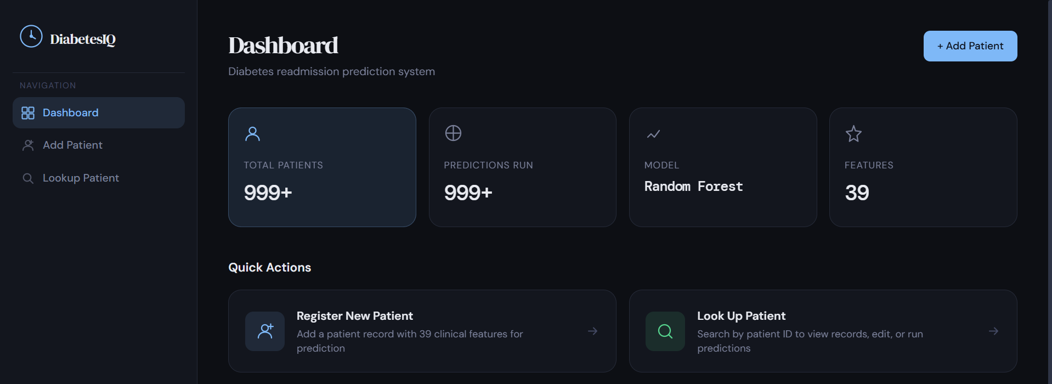
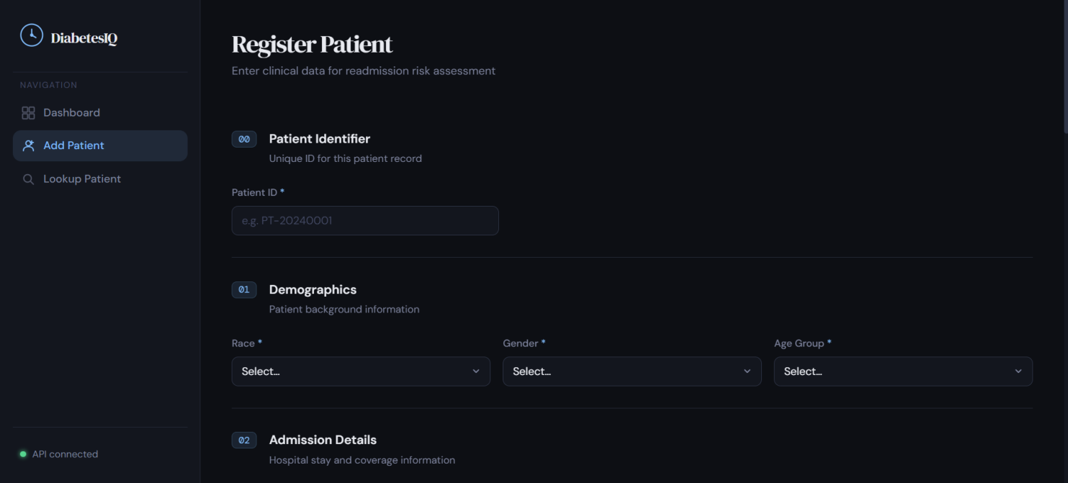
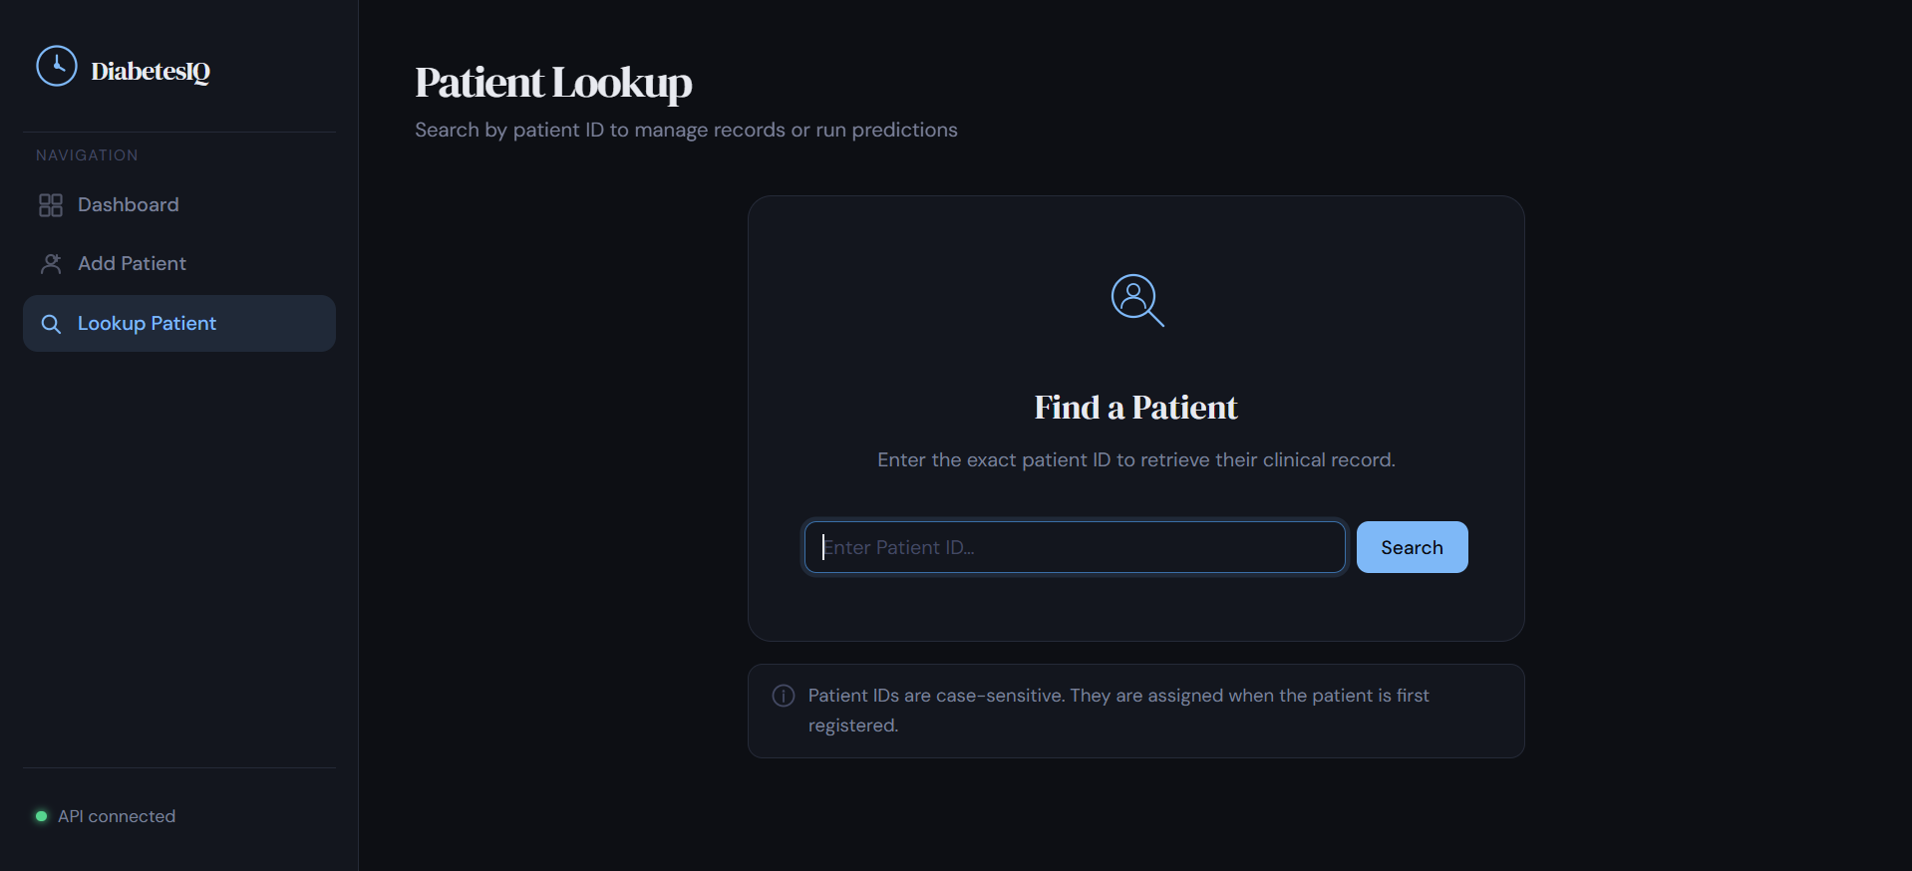
10. Conclusion
This project successfully developed an end-to-end machine learning pipeline for predicting early hospital readmission (within 30 days) among diabetic patients, using the UCI Diabetes 130-US Hospitals dataset. The pipeline encompassed all critical stages of a production-grade ML system: data understanding, preprocessing, class imbalance handling, model training, evaluation, comparison, and deployment.

Four state-of-the-art ensemble learning models, Random Forest, CatBoost, Gradient Boosting, and LightGBM, were trained and rigorously evaluated. The Stacking Classifier, which combines the predictions of three diverse base learners through a Logistic Regression meta-learner, achieved the highest performance across Accuracy, Precision, Recall, and F1-Score metrics, demonstrating the effectiveness of model combination strategies in complex clinical prediction tasks.

Key contributions of this project include:
- A systematic preprocessing pipeline that handles real-world clinical data challenges including missing values, zero-variance features, and ordinal encoding.
- SMOTE-based oversampling to address the significant class imbalance inherent in early readmission prediction.
- Comparative analysis of four leading ensemble methods with consistent hyperparameter configurations to enable fair performance benchmarking.
- Deployment of the best model through a Flask web application, making the predictor accessible to non-technical clinical users.

Future improvements could include feature engineering from ICD-9 diagnosis codes, hyperparameter tuning via grid search or Bayesian optimization, integration of additional clinical variables such as lab results or vital signs, and validation on prospective clinical data. Explainability tools such as SHAP values could also be incorporated to provide clinicians with insight into the factors driving each individual prediction.

References

- Strack, B., DeShazo, J. P., Gennings, C., Olmo, J. L., Ventura, S., Cios, K. J., & Clore, J. N. (2014). Impact of HbA1c measurement on hospital readmission rates: Analysis of 70,000 clinical database patient records. BioMed Research International, 2014. https://doi.org/10.1155/2014/781670

- Dua, D., & Graff, C. (2019). UCI Machine Learning Repository: Diabetes 130-US Hospitals for Years 1999–2008. University of California, Irvine, School of Information and Computer Sciences. https://archive.ics.uci.edu/ml/datasets/Diabetes+130-US+hospitals+for+years+1999-2008

- Chawla, N. V., Bowyer, K. W., Hall, L. O., & Kegelmeyer, W. P. (2002). SMOTE: Synthetic Minority Over-sampling Technique. Journal of Artificial Intelligence Research, 16, 321–357.

- Breiman, L. (2001). Random Forests. Machine Learning, 45(1), 5–32. https://doi.org/10.1023/A:1010933404324

- Prokhorenkova, L., Gusev, G., Vorobev, A., Dorogush, A. V., & Gulin, A. (2018). CatBoost: Unbiased Boosting with Categorical Features. Advances in Neural Information Processing Systems (NeurIPS), 31.

- Ke, G., Meng, Q., Finley, T., Wang, T., Chen, W., Ma, W., ... & Liu, T. Y. (2017). LightGBM: A Highly Efficient Gradient Boosting Decision Tree. Advances in Neural Information Processing Systems (NeurIPS), 30.

- Friedman, J. H. (2001). Greedy Function Approximation: A Gradient Boosting Machine. The Annals of Statistics, 29(5), 1189–1232.

- Wolpert, D. H. (1992). Stacked Generalization. Neural Networks, 5(2), 241–259. https://doi.org/10.1016/S0893-6080(05)80023-1

- Pedregosa, F., et al. (2011). Scikit-learn: Machine Learning in Python. Journal of Machine Learning Research, 12, 2825–2830.

- Flask Documentation. (2024). Flask: A lightweight WSGI web application framework. https://flask.palletsprojects.com

