IAC-26-A6.IP.6
Machine Learning-Based Simulation Approach for Assessing Space Debris Collision Risk in Low Earth Orbit
Mustafa İsa Oruçtutan*
Fırat University, Elazığ, Türkiye
mustafaisaoructutan@gmail.com
* Corresponding author
Abstract
This study presents an open-source framework for analysing conjunction events among catalogued objects in low Earth orbit using public Two-Line Element data and SGP4 propagation. Candidate encounters are identified through conservative screening followed by refined time-of-closest-approach estimation. A deterministic proxy label combines propagated minimum separation and relative velocity at closest approach. To prevent temporal leakage and catalogue-pair memorisation, Logistic Regression, Random Forest, Support Vector Machine and XGBoost models are evaluated using a chronological cutoff and held-out object pairs. The completed archive contained 97 verified snapshots, 19,018 candidate-pair observations and 1,469 proxy-positive observations. The held-out partition contained 2,795 observations and 223 positives. SVM achieved the highest learned-model PR-AUC of 0.418 and recall of 0.874, while LightGBM achieved the highest learned-model F1 score of 0.438. However, the propagated-distance ranking achieved a PR-AUC of 0.725, and its fixed 25 km operating point achieved an F1 score of 0.510. The exploratory results did not show a superior false-alarm trade-off. The pre-specified adaptability claim was not evaluated confirmatorily because the archive did not satisfy the pre-specified acquisition-cadence gates. Accordingly, these findings are reported as pilot evidence rather than as confirmatory or operational collision-risk performance. The principal contribution is a reproducible, leakage-resistant evaluation framework and a transparent negative result that identifies limitations of snapshot-only learning against a target-aligned distance comparator.
Keywords: space debris; conjunction analysis; SGP4; machine learning; temporal validation; false alarms
Acronyms/Abbreviations: FAR - false-alarm rate; LEO - low Earth orbit; PR-AUC - area under the precision-recall curve; SGP4 - Simplified General Perturbations 4; SVM - support vector machine; TCA - time of closest approach; TLE - Two-Line Element.

1. Introduction
The increasing number of active spacecraft and debris objects in LEO raises the volume of conjunctions that must be screened. Public TLE data make repeatable academic studies possible, but they do not provide the covariance, hard-body radius and validated outcome information needed for a reliable operational probability of collision. This work therefore studies a transparent simulation-derived proxy rather than physical collision probability. The distinction is essential: the reported labels describe propagated encounter geometry under stated assumptions, not confirmed hazardous events [9].
Machine-learning studies of repeated orbital observations are particularly vulnerable to optimistic validation. Random row splits can place the same catalogue pair, neighbouring snapshots, or information derived from the future closest approach in both training and test partitions. A model may then appear to generalise while memorising pair identity or exploiting target-defining variables. The present evaluation addresses both risks by separating time and catalogue pairs and by restricting learners to quantities available at the observation snapshot.
The accepted study hypothesis anticipated higher adaptability and fewer false alarms from machine-learning classifiers than from a classical fixed-distance method. The purpose of this paper is to test that expectation transparently, not to preserve it after observing the data. The contributions are: (i) an auditable TLE/SGP4 acquisition and propagation pipeline; (ii) conservative screening followed by refined TCA search; (iii) an explicit feature boundary that excludes future and target-defining information; (iv) a deterministic pair-held-out chronological evaluation; and (v) direct reporting of a negative exploratory result.

2. Data and methods

2.1 Observation archive and quality status
The frozen iac26-leo-mixed-75-v2 catalogue comprises 75 LEO objects identified by NORAD catalogue number, including selected Iridium 33 and Cosmos 2251 fragments and multiple inclination regimes. TLE snapshots were requested from CelesTrak [10], with an authenticated Space-Track fallback [11] when available, and stored as immutable schema-3 bundles. Each bundle binds the experiment identifier, embedded configuration, catalogue hash, source-data hash, runtime provenance and simulation parameters. The catalogue SHA-256 is 64c3d2329281da0e246226cb552aafe3b961c553c9487d7cfd9c96374aaa1f4c. All retained snapshots were re-simulated with the corrected global TCA search before the exploratory comparison.
The completed iac26-10d-v3 archive spans 26 July to 5 August 2026 and contains 97 verified snapshots from 120 planned two-hour slots. Coverage was 80.833%, below the pre-specified 90% minimum. The endpoint-inclusive maximum gap was 16.844 h rather than at most 6 h, and the longest identical-TLE-hash run was eight occupied bins rather than at most six. The canonical confirmatory outcome is therefore not_enough_data. Numerical model results below are explicitly exploratory and do not reopen the failed publication gate. The preceding v2 run was retained as a pilot and was not pooled after repeated identical TLE inputs made its corresponding gate irrecoverable; catalogue, thresholds, split seeds and model settings were unchanged in v3.

2.2 Propagation, screening and proxy target
State vectors are propagated with the modernised SGP4 implementation documented by Vallado et al. [1] over a 12 h horizon. A vectorised 30 s screen removes only pairs for which a 200 km encounter is impossible under the configured relative-speed bound and numerical guard. All remaining pairs are evaluated over every 5 min interval with a refined minimum search within each interval, consistent with established close-approach methods [2,13]. Invalid or unbounded screening assumptions fail open to exact refinement. The 200 km screen and 30 s step were frozen engineering choices balancing conservative retention and computational cost; they are not physical collision thresholds.
A row is proxy-positive when propagated minimum distance is at most 50 km and relative velocity at TCA is at least 10 km/s. The corrected history contains 19,018 candidate observations from 1,656 unique catalogue pairs; 1,469 rows (7.724%) satisfy this rule. The target is intentionally deterministic and auditable. It is not probability of collision, because public TLEs do not supply the covariance and hard-body information required for operational assessment [3].

2.3 Predictors and classifiers
The learned models receive six snapshot-state predictors: current pair distance, altitude difference, maximum TLE age, radial relative velocity, tangential relative velocity and approach angle. Minimum future distance, TCA, time to TCA, relative velocity at TCA, risk score and other target-defining or target-reconstructing quantities are excluded. Standardisation is fitted only on the training partition for Logistic Regression and the radial-basis-function SVM.
XGBoost [7] is the pre-specified primary learned model. Logistic Regression, Random Forest [5], SVM [6], Decision Tree and LightGBM [8] are secondary exploratory comparisons implemented with scikit-learn-compatible workflows [12]. Logistic Regression, Decision Tree, Random Forest, SVM and LightGBM use balanced class weights; XGBoost uses the training ratio of negative to positive rows as scale_pos_weight. Random Forest uses 100 trees. Fixed random seed 42 is used where the implementation exposes a random_state parameter. Binary metrics use each implementation's default decision rule (probability 0.5, or SVM decision score 0), not recall-matched thresholds. These choices are applied uniformly without test-set tuning.

2.4 Leakage-resistant split and metrics
Canonical catalogue pairs are assigned deterministically by a salted SHA-256 mapping. A cutoff is placed between complete snapshot blocks at 40% of the observed times, while 25% of catalogue pairs are reserved for testing. Only training-pair observations before the cutoff enter fitting; only held-out-pair observations after the cutoff enter evaluation. Cross-quadrant observations are excluded. The cutoff is 29 July 2026 at 15:13:52 UTC. This intersection design prevents both future-to-past leakage and direct catalogue-pair memorisation. It excludes 10,518 cross-quadrant rows, including 776 positives; they enter neither fitting nor held-out scoring.
Precision, recall, F1, accuracy and FAR are computed from each model's binary predictions. FAR is FP/(FP+TN). PR-AUC and ROC-AUC use continuous decision scores, which are more informative than accuracy under class imbalance [4]. For the distance comparator, binary confusion metrics use the fixed 25 km alarm, whereas PR-AUC and ROC-AUC use continuous negative propagated minimum distance. These are two views of the same distance comparator and are labelled separately in the interpretation to avoid treating a binary alarm as a full ranking.

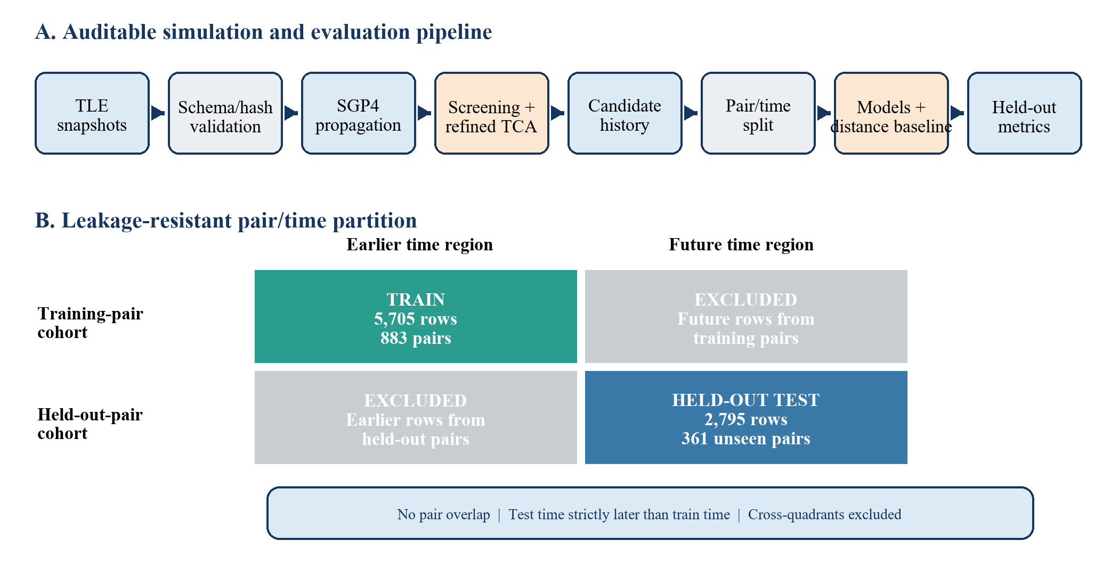
Fig. 1. Auditable TLE/SGP4 pipeline and leakage-resistant pair/time split. Only the future held-out-pair quadrant is used for testing; cross-quadrants are excluded.

3. Results

3.1 Dataset and split support
The training partition contains 5,705 rows from 883 catalogue pairs, including 470 positives. The held-out test partition contains 2,795 rows from 361 different pairs, including 223 positives across 43 positive pairs and 58 snapshots. No catalogue pair overlaps between train and test, and every test timestamp occurs after every training timestamp. Fig. 2 summarises why the evidence is exploratory, and Table 1 summarises the evaluated data.
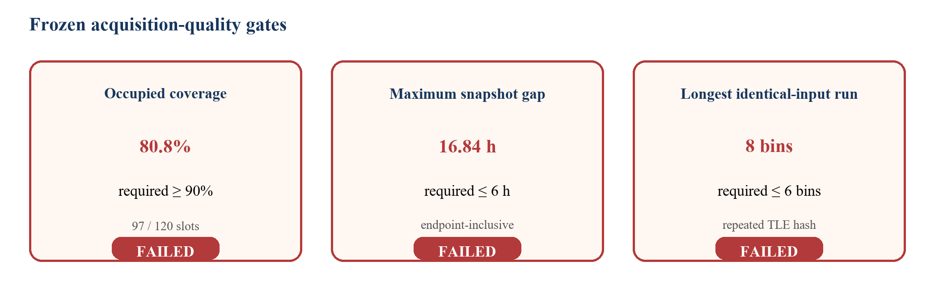
Fig. 2. Frozen acquisition-quality gates. All three shown gates failed; model results are therefore exploratory.
Table 1. Archive and leakage-resistant split summary
Partition | Rows | Positive rows | Catalogue pairs
Full corrected history | 19,018 | 1,469 | 1,656
Training | 5,705 | 470 | 883
Held-out test | 2,795 | 223 | 361

3.2 Held-out model comparison
Table 2 reports the pair-held-out future performance. The distance comparator achieved the strongest ranking performance (PR-AUC 0.725; ROC-AUC 0.975). At its 25 km operating point it also achieved the strongest F1 (0.510) and precision (0.754). Among learned models, SVM achieved the highest PR-AUC (0.418), ROC-AUC (0.904) and recall (0.874), while LightGBM achieved the highest learned-model F1 (0.438).
Table 2. Pair-held-out chronological test performance
Method | PR-AUC | ROC-AUC | Precision | Recall | F1 | FAR
Distance comparator | 0.725 | 0.975 | 0.754 | 0.386 | 0.510 | 0.011
Logistic regression | 0.385 | 0.826 | 0.170 | 0.839 | 0.283 | 0.355
Decision tree | 0.137 | 0.608 | 0.289 | 0.274 | 0.281 | 0.058
Random forest | 0.412 | 0.877 | 0.620 | 0.197 | 0.299 | 0.010
SVM | 0.418 | 0.904 | 0.265 | 0.874 | 0.406 | 0.211
XGBoost | 0.367 | 0.850 | 0.360 | 0.439 | 0.396 | 0.068
LightGBM | 0.408 | 0.876 | 0.338 | 0.623 | 0.438 | 0.106
Note: PR-AUC and ROC-AUC for the distance comparator use continuous -minimum-distance ranking; precision, recall, F1 and FAR use the fixed 25 km alarm.
The operating trade-offs are substantial. SVM recovered 195 of 223 positives but generated 542 false positives (FAR 0.211). Logistic Regression recovered 187 positives but generated 912 false positives (FAR 0.355). Random Forest approximately matched the fixed alarm's FAR (0.010 versus 0.011) but recovered only 44 positives, corresponding to recall 0.197. Its lower alarm burden therefore arose from missed positives rather than a superior precision-recall trade-off. The fixed alarm produced TP=86, FP=28, FN=137 and TN=2,544.
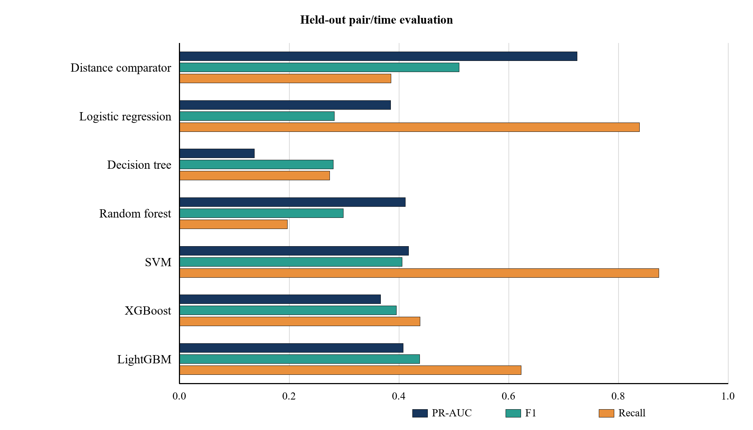
Fig. 3. Exploratory held-out comparison. The distance row uses continuous distance for PR-AUC and the fixed 25 km alarm for F1 and recall.

4. Discussion

4.1 What the negative result establishes
The exploratory results are inconsistent with the initially expected advantage of the learned models. They do not demonstrate reduced false alarms at non-inferior recall, and they do not establish higher adaptability. The pre-specified confirmatory adaptability analysis was not reached after the evidence gates failed. This wording is deliberately narrower than claiming that machine learning is universally inferior. The archive failed acquisition-quality gates, and the test covers one frozen 75-object cohort over approximately ten days. The defensible conclusion is that the hypothesis was not supported under this dataset, proxy target and evaluation protocol.
The result also reflects an important asymmetry in the task. The proxy label directly contains future propagated minimum distance. The distance comparator ranks rows using that same target component, whereas learned models are intentionally denied future TCA-derived information and must infer future severity from six snapshot-state variables. The comparator is consequently a stringent target-component control, not independent collision ground truth. Its advantage does not prove that a 25 km alarm is operationally optimal.
This asymmetry is scientifically useful because it exposes how target construction and feature availability shape apparent model performance. Adding future minimum distance or TCA-relative velocity to the learned features would make the classification easier but would reconstruct the deterministic label and create target leakage. A weaker random-row evaluation could similarly inflate results by repeating pairs and adjacent snapshots across partitions. The lower scores in this paper are therefore a consequence of a more realistic generalisation question.

4.2 Limitations and future work
First, 23 planned snapshot slots were missing, producing inadequate coverage and a 16.844 h maximum gap. Second, TLE/SGP4 uncertainty is not represented by covariance propagation. Third, the deterministic geometry/velocity target is not observed collision outcome or probability of collision. Fourth, observations sharing objects and neighbouring times remain correlated even after pair/time separation. Fifth, the exploratory comparison does not supply confirmatory bootstrap intervals or the pre-specified future-block adaptability test.
Future work should retain the frozen pair/time split logic while using longer, independently collected archives and targets closer to operational decision making. Validated conjunction data messages, covariance, hard-body radii, manoeuvre context and resolved outcomes would permit a more meaningful assessment [3]. Model calibration and threshold selection should remain confined to training/validation data, and any synthetic augmentation should be restricted to training data after the real test partition has been frozen.

5. Reproducibility and open-source artifacts
The implementation, frozen experiment configurations, acquisition manifests, corrected-TCA resimulation flow, split logic, model comparison and figure-generation code are published under the MIT License at https://github.com/Mustafaisa027/space-debris-ml-simulation. The exploratory manifest marks claim_eligible=false and binds outputs to the evaluated history and source revision. The repository includes automated tests covering propagation, target and feature boundaries, archive integrity, split leakage and evidence gates.

6. Conclusions
This work provides an auditable, leakage-resistant framework for comparing classifiers in public TLE/SGP4 conjunction screening. On later observations of unseen catalogue pairs, SVM maximised learned-model recall and PR-AUC, while LightGBM maximised learned-model F1. Neither surpassed the target-aligned distance comparator overall. The initially stated hypothesis of superior machine-learning false-alarm advantage was therefore not supported by the exploratory evidence. The principal result is a transparent negative finding and a reproducible evaluation design that clarifies the consequences of leakage control, target definition and comparator choice. The adaptability hypothesis remains unconfirmed rather than disproved.

Declaration on the use of generative AI and AI-assisted technologies
OpenAI Codex was used to assist with language editing, document organisation and formatting. The author is responsible for reviewing and verifying all scientific methods, numerical results, interpretations, references and final wording before submission.

References
[1] D.A. Vallado, P. Crawford, R. Hujsak, T.S. Kelso, Revisiting Spacetrack Report #3, AIAA/AAS Astrodynamics Specialist Conference, AIAA 2006-6753, 2006. https://doi.org/10.2514/6.2006-6753.
[2] S. Alfano, Determining satellite close approaches, Part II, Journal of the Astronautical Sciences 42(2) (1994) 143-152.
[3] 18th Space Control Squadron, Spaceflight Safety Handbook for Satellite Operators, Version 1.5, 2020.
[4] J. Davis, M. Goadrich, The relationship between Precision-Recall and ROC curves, Proceedings of the 23rd International Conference on Machine Learning (2006) 233-240. https://doi.org/10.1145/1143844.1143874.
[5] L. Breiman, Random forests, Machine Learning 45 (2001) 5-32. https://doi.org/10.1023/A:1010933404324.
[6] C. Cortes, V. Vapnik, Support-vector networks, Machine Learning 20 (1995) 273-297. https://doi.org/10.1007/BF00994018.
[7] T. Chen, C. Guestrin, XGBoost: A scalable tree boosting system, Proceedings of the 22nd ACM SIGKDD International Conference on Knowledge Discovery and Data Mining (2016) 785-794. https://doi.org/10.1145/2939672.2939785.
[8] G. Ke, Q. Meng, T. Finley, T. Wang, W. Chen, W. Ma, Q. Ye, T.-Y. Liu, LightGBM: A highly efficient gradient boosting decision tree, Advances in Neural Information Processing Systems 30 (2017) 3146-3154.
[9] European Space Agency, ESA Space Environment Report 2025, Issue 9, 2025. https://www.esa.int/Space_Safety/Space_Debris/ESA_Space_Environment_Report_2025.
[10] CelesTrak, Current GP Element Sets and GP Data Formats, accessed 28 August 2026. https://celestrak.org/NORAD/documentation/gp-data-formats.php.
[11] Space-Track.org, General Perturbations data service and documentation, accessed 28 August 2026. https://www.space-track.org.
[12] F. Pedregosa et al., Scikit-learn: Machine Learning in Python, Journal of Machine Learning Research 12 (2011) 2825-2830.
[13] F.R. Hoots, L.L. Crawford, R.L. Roehrich, An analytic method to determine future close approaches between satellites, Celestial Mechanics 33 (1984) 143-158. https://doi.org/10.1007/BF01234152.

