## 



## Cairo University Faculty of Computers and Information

## CS251

## Software Engineering 1

## Software Design Specifications

## Final phase 2

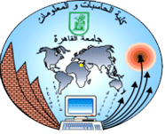

|  |  |
| --- | --- |
| **Name** | **ID** |
| **Islam Ibrahim Amin** | **20160320**  [**eslam98ebraheem@gmail.com**](mailto:eslam98ebraheem@gmail.com) |
| **Mostafa Mahmoud Abd El-aleem** | **20160322**  Mostafa**.ma7moud@hotmail.com** |

**Sequence Diagram :**

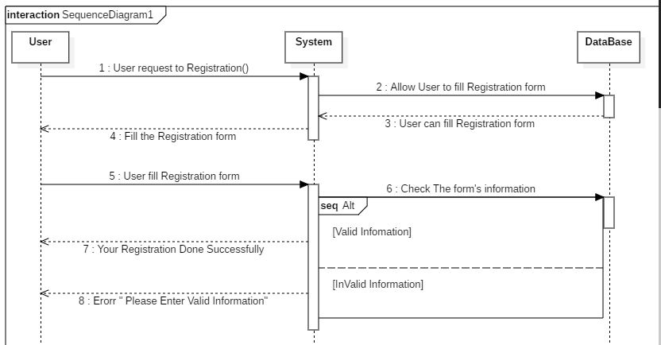

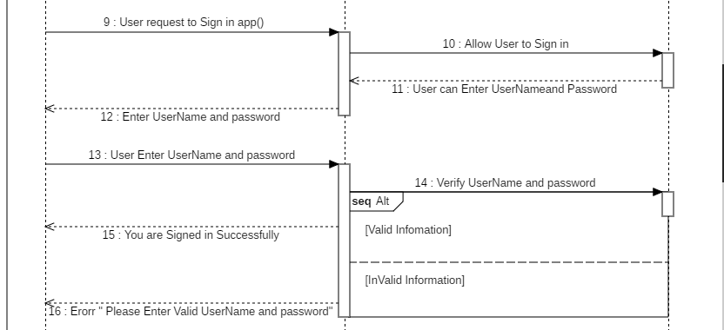

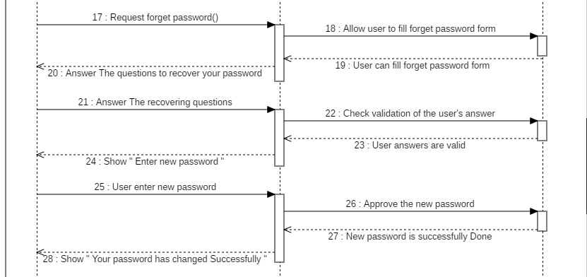

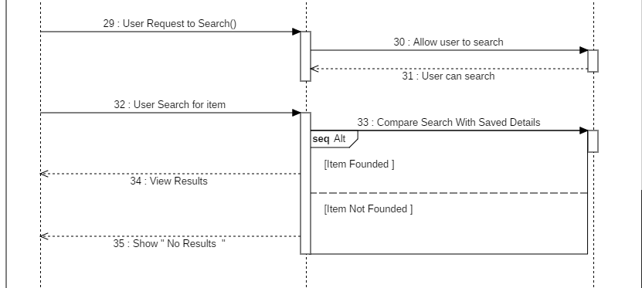

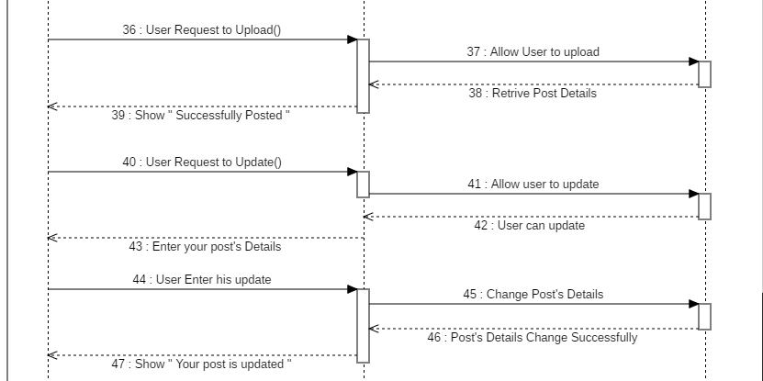

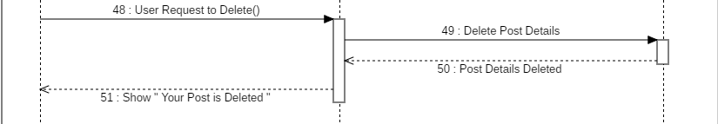

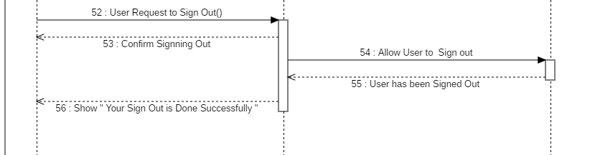

**Class Diagram :**

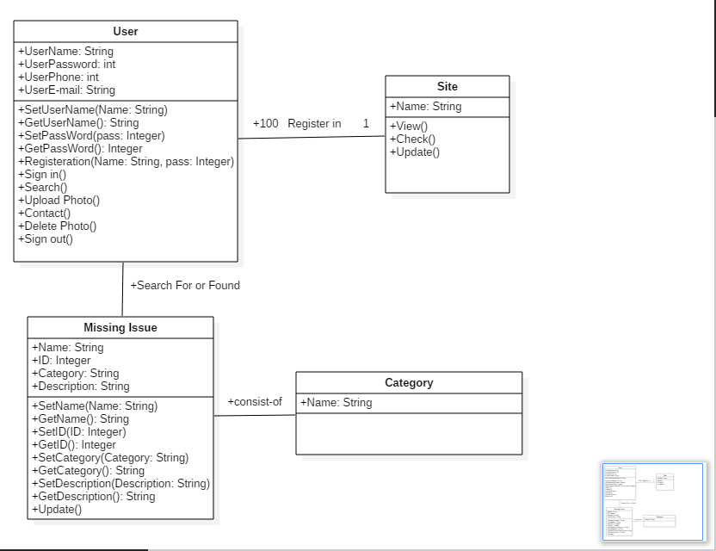

**Class- Sequence Table :**

|  |  |  |
| --- | --- | --- |
| **Class** | **Sequence Diagram** | **Overall used methods** |
| **User** | **1**  **9**  **17**  **29**  **36**  **44**  **48**  **52** | **Registration()**  **Sign in()**  **Forget password()**  **Search()**  **Update()**  **Upload()**  **Delete()**  **Sign Out()** |
| **Site** | **1**  **9**  **29**  **44** | **Registration()**  **Sign in()**  **Search()**  **Upload()** |
| **Missing Issue** | **29**  **36**  **44** | **Search()**  **Update()**  **Upload()** |
| **Category** | **44** | **Update()** |