**National University of Computer and Emerging Science**

**Assignment No: 3**

**Subject: Object Oriented Analysis and Design.**

**Submitted to: Asst. Prof. Engr Abdul Rahman Mahmood.**

**Name: Muhammad Mustafa Manga.**

**Roll no.: 17k-3795.**

**Date of Submission:17-Nov-2019**

**Section: E.**

**Department: Computer Science.**

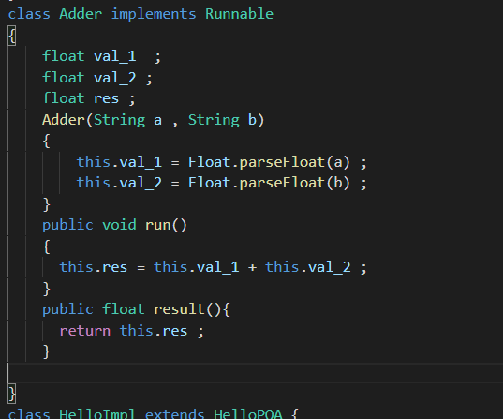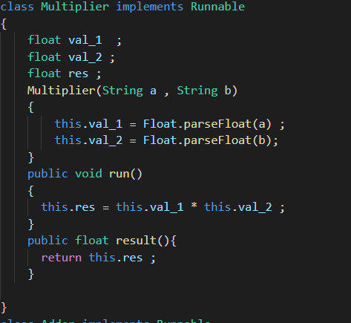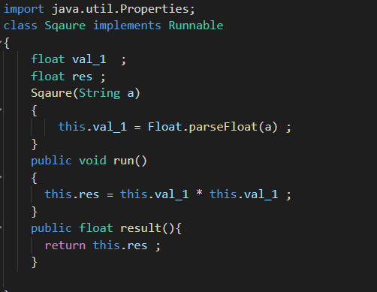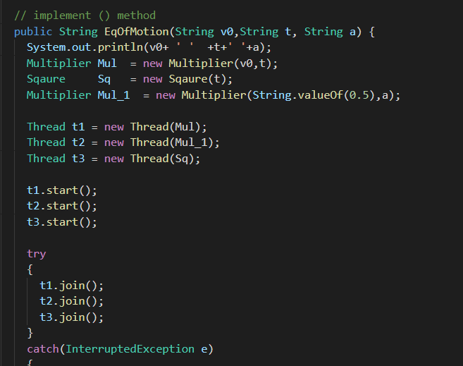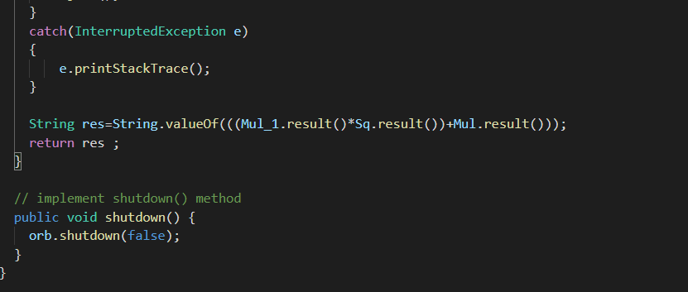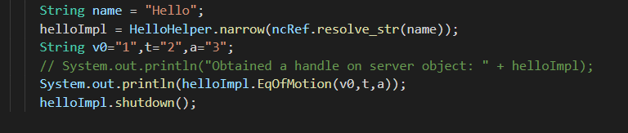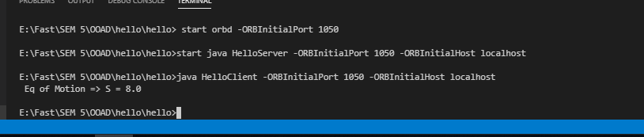

Adder thread takes two argument in string convert in float than add the two values and store it in result variable.

Multiplier thread takes two argument in string convert in float than Multiply the two values and store it in result variable.

Square thread takes one argument in string convert in float than square the value and store it in result variable.

Result function return the result.

Eq => S= v0t + ½ at^2

Break in Parallel thread

Thread One => v0t

Thread Two => ½ a

Thread Three => t^2

Start all three thread in parallel than join and get the result than multiply the result of thread two and thread three than add this result with thread one which is final answer.

Return the res to HelloI.idl file than print it in client file.