**HW 1,2 and 3**

**Question :**

**1. Write a C.F.G. for generating an alternating sequence of 0's and 1's.**

**2. Write a C.F.G. for generating equal number of 0's and 1's.**

**3. Write a C.F.G. for generating sequence of 0's and 1's such they are not equal in numbers.**

**Question :**

**1. Find FA1 ∩FA2, FA1FA2, FA1'**

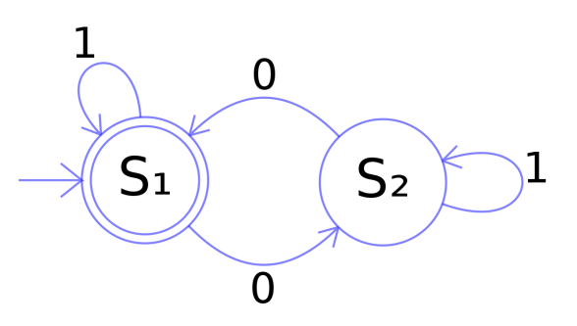

FA1

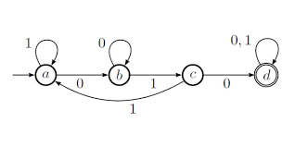

FA2

**Question :**

**1. Let language L = {$a^{n}b^{3n}|n,m≥1$}**

1. **Construct the PDA accepting L by final state.**
2. **Construct the PDA accepting L by empty store.**

**2. Construct an equivalent PDA for the following C.F.G.**

**S →Saa|aSa|aaS|aa**

**What language is accepted by it? Show simulation of any string of the accepting language.**