**Question 2:**

* **Naïve Bayes:**

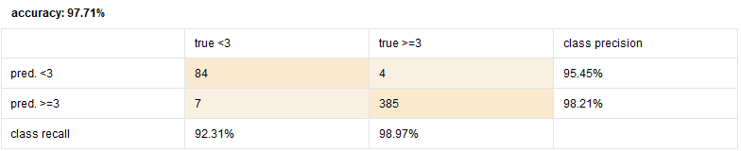

* **Naïve Bayes(kernel):**

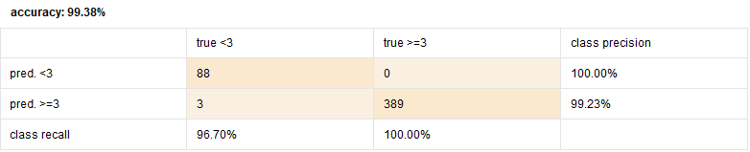

with replace missing value block.

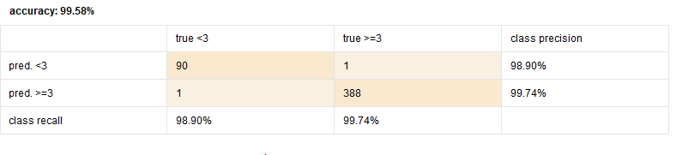

without replace missing value block

**Question 3:**

* **Naïve Bayes:**

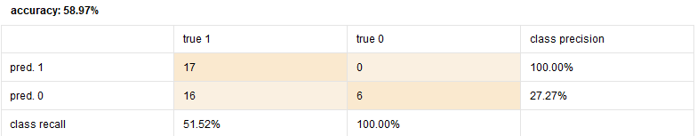

* **Naïve Bayes (kernel):**

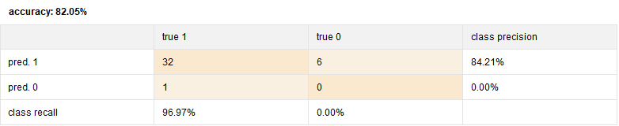

**Question 4:**

* **K-means Clustering:**