Capital University of Science and Technology



**Software Testing**

**Assignment:3**

**Section:2**

**Submitted to: Samir Obaid**

**Submitted By:**

* Mustafa Tahir (BSE173087)
* Awais Ahmed Khan (BSE173080)
* Faizan Ashraf(BSE173070)

**Date: 02/06/2020**

**Table of Contents**

CASE STUDY OF CurrencyConverter………………………………………….. 3

INTRODUCTION ……………………………………………………………………………………………………3

BRIEF DESCRIPTION…………………………………………………………………………………….3

Converter……………………………………………………………………………………………….3

Calculated_Currency:……………………………………………………………………………………..3

**BlackBox** Testing:………………………………\ ……………………… ………4

**Fucntions**:

Function 1CurrencyConverter…………………………. 5

Function 2 CurrencyConverted ( …………………………………….5

Function 3 TypeAmount………………………………. 5

Function 4:CalculatedAmount…………..………. 5

**Case-Study**

**Introduction:**

Currency converter or currency exchange is a mini project coded in Java programming language. This simple application provides a web-based interface for exchanging/converting money from one currency to another currency.

**Brief Description:**

Different countries use different currency, and there is daily variation in these currencies relative to one another. Those who transfer money from one country to another must be updated with the latest currency exchange rates in the market.

Currency converter mini project is built keeping this thing in mind. It is simply a calculator-like app developed using Java web features. In this application, there is regular update about currency of every country by which it displays present currency market value and conversion rate.

Such application can be used by any user, but it is mainly useful for business, shares, and finance related areas where money transfer and currency exchange takes place on a daily basis.

In this currency converter app, users are provided with an option to select the type of conversion for example from “this” currency to “that” currency. This simple feature allows users to enter amount to be display the converted amount

**Cause Effect Graph:**

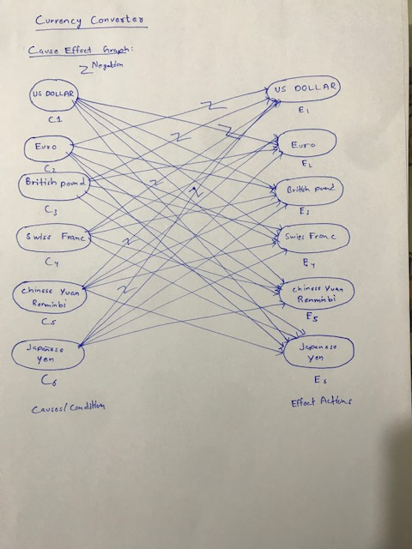

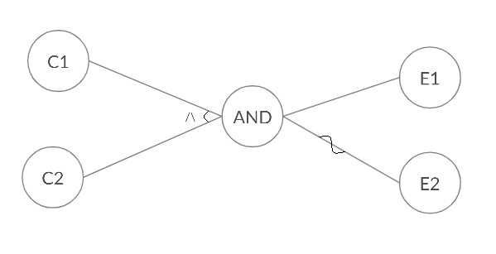

### Decision Table:

|  |  |  |  |  |  |  |
| --- | --- | --- | --- | --- | --- | --- |
| Action | US Dollar | Euro | Pounds | Swiss Franc | ChineseYuan | JapansesYen |
| C1 | 1 | 0 | 0 | 0 | 0 | 0 |
| C2 | 0 | 1 | 0 | 0 | 0 | 0 |
| C3 | 0 | 0 | 1 | 0 | 0 | 0 |
| C4 | 0 | 0 | 0 | 1 | 0 | 0 |
| C5 | 0 | 0 | 0 | 0 | 1 | 0 |
| C6 | 0 | 0 | 0 | 0 | 0 | 1 |
| E1 | 0 | 1 | 1 | 1 | 1 | 1 |
| E2 | 1 | 0 | 1 | 1 | 1 | 1 |
| E3 | 1 | 1 | 0 | 1 | 1 | 1 |
| E4 | 1 | 1 | 1 | 0 | 1 | 1 |
| E5 | 1 | 1 | 1 | 1 | 0 | 1 |
| E6 | 1 | 1 | 1 | 1 | 1 | 0 |

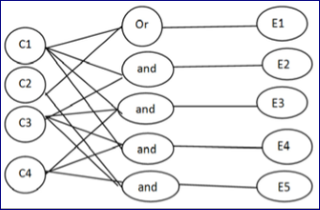

**Identified Causes & Effects:**

|  |  |
| --- | --- |
| **Causes** | **Effects** |
| Us Dollar to Euro |  |
| British Pound to Swiss Franc |  |
| ChineseYuan to Japanese Yen |  |
| Japansese Yen to US Dollar |  |

**Black Box Testing**

n black box testing, the structure of the program is not taken into consideration. It takes into account functionality of the application only. It is also called functional testing.

**Functions:**

**Function#1:**

**Currency Converter:**

A currency exchange is a business that has the legal right to exchange one currency for another to its customers.

**Function#2:**

**Converted Currency:**

Currency exchange businesses, both physical and online, allow you to exchange one country's currency for another by executing buy and sell transactions. For example, if you have U.S. Dollars and you want to exchange them for Euro.

**Function#3:**

**Calculated Amount:**

Suppose that the EUR/USD **exchange rate** is 1.20 and you'd like to convert $100 U.S. dollars into Euros.

**Function#4:**

**Calculated Result:**

3365.00 Japanese Yen = 26.92 Us Dollar