Docker DevOps Assignment
Docker_Mustafizur
Full-Stack Node.js/Express + Flask Application
Prepared by: Mustafizur Rahman

Ubuntu Server 24.04 | Docker | Docker Compose | GitHub | Docker Hub

1. Project Overview
This assignment demonstrates a containerized full-stack application consisting of a Node.js/Express frontend and a Flask backend. Docker Compose is used to run both services on a shared Docker network. The frontend is published on port 3000 and communicates with the Flask backend on port 5000.

2. Project Architecture
Browser
|
| HTTP :3000
v
Node.js + Express Frontend
|
| Docker Compose network
| HTTP :5000
v
Flask Backend

3. Project Structure
Docker_Mustafizur/
├── backend/
│ ├── .dockerignore
│ ├── app.py
│ ├── Dockerfile
│ └── requirements.txt
├── frontend/
│ ├── .dockerignore
│ ├── Dockerfile
│ ├── package.json
│ ├── public/
│ │ └── index.html
│ └── server.js
├── .gitignore
├── docker-compose.yml
└── README.md

4. Technologies Used
- Ubuntu Server 24.04
- Docker
- Docker Compose
- Node.js / Express.js
- Python / Flask / Flask-CORS
- Git / GitHub
- Docker Hub

5. Docker Compose Deployment
The application was built and started with:
docker compose build
docker compose up -d
docker compose ps
The final container status showed flask-backend running with port 5000 available internally and node-frontend running with port 3000 published to the Ubuntu server.

6. Application Verification
Frontend health check:
curl http://localhost:3000/health
The health endpoint returned a successful JSON response indicating that the Node.js frontend was running.
Full-stack API test:
curl -X POST http://localhost:3000/api/submit -H "Content-Type: application/json" -d '{"name":"Mustafizur","email":"mustafizur@example.com","message":"Final Docker test"}'
The API returned status=success and the submitted name, email, and message. This confirms frontend-to-backend communication through Docker Compose.

7. Docker Hub Images
mustak22/docker-mustafizur-backend:latest
mustak22/docker-mustafizur-frontend:latest
Both images were successfully pushed to Docker Hub. The Docker Hub account page also shows the two repositories as public images.

8. GitHub Repository
Repository: https://github.com/Mustak22/Docker_Mustafizur
The project source code, Dockerfiles, Docker Compose configuration, .gitignore and README.md were committed and pushed to the main branch.

9. Screenshots and Evidence
Screenshot 1 — Docker Hub repositories
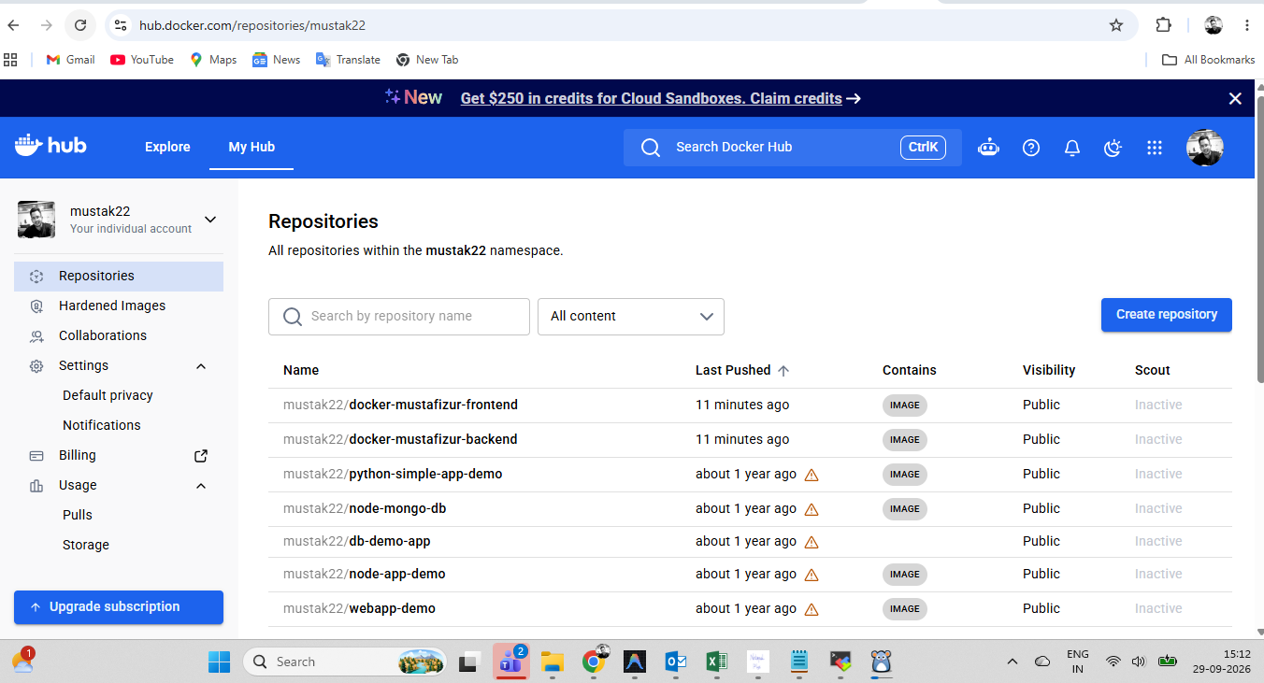
The Docker Hub repositories page shows the published frontend and backend repositories under the mustak22 namespace.
Screenshot 2 — Full-stack application and successful form submission
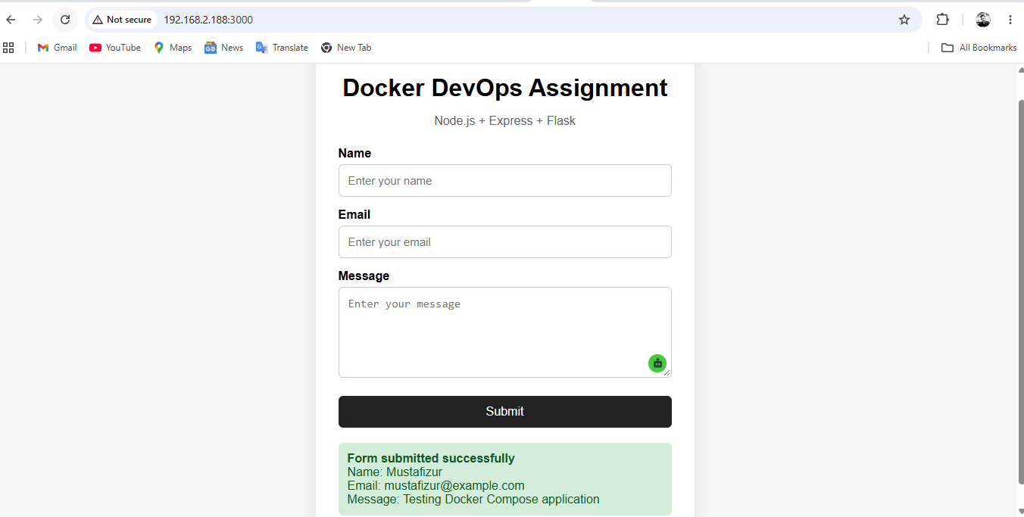
The browser shows the Docker DevOps Assignment form at 192.168.2.188:3000. The successful response confirms that the submitted data was processed by the application.
Screenshot 3 — GitHub repository
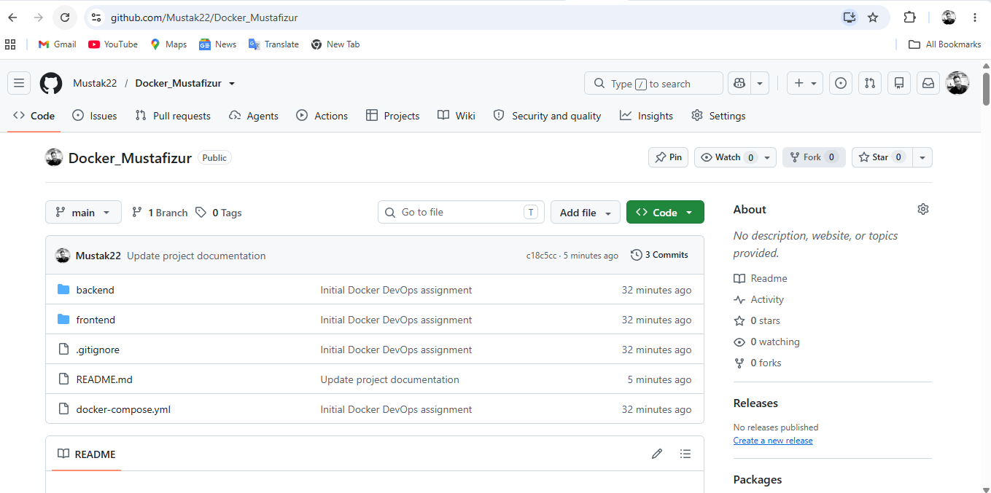
The GitHub repository shows the backend, frontend, .gitignore, README.md and docker-compose.yml files on the main branch.
Screenshot 4 — Full-stack application test
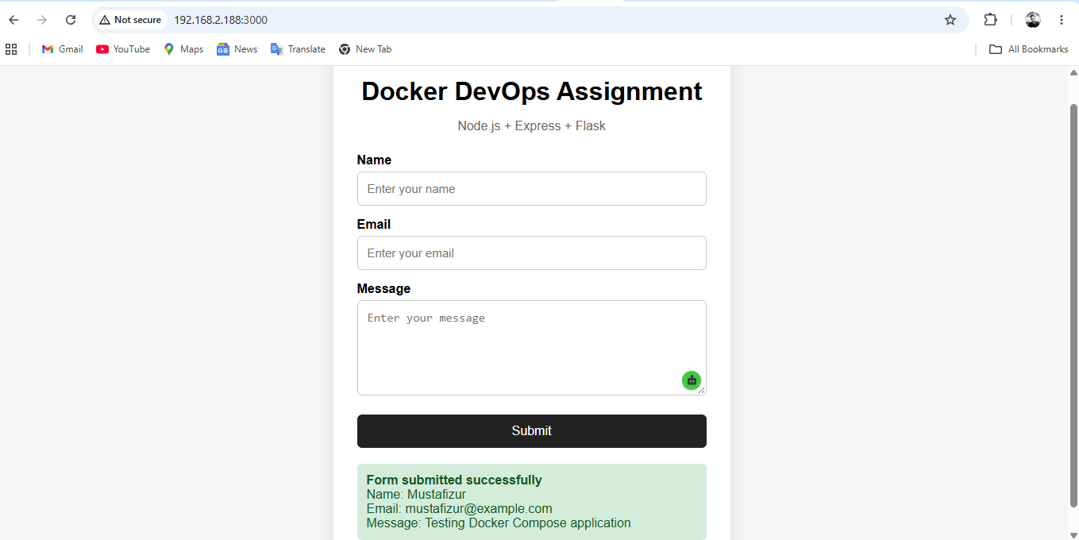
The browser test provides visual evidence that the application is accessible and the form submission returns a successful result.

10. Final Verification
✓ Docker images built successfully
✓ Docker Compose services running
✓ Node.js frontend reachable on port 3000
✓ Flask backend reachable through the Compose network
✓ Frontend-to-backend API request successful
✓ Browser form submission successful
✓ Docker Hub backend image pushed
✓ Docker Hub frontend image pushed
✓ GitHub repository updated
✓ Git working tree clean

11. Conclusion
The Docker_Mustafizur project demonstrates a complete containerized full-stack application. The frontend and backend are separated into independent services, connected using Docker Compose, tested locally through the browser and API, published to Docker Hub, and maintained in GitHub.

