

Software Requirements Specification
For
Sales Commission Automation 2026

History Card
Sl. | Date | Version | Description | Created/ Modified by | Reviewed by
01 | 19-June-2021 14-Jun-2026 | 1.0 | Initial draft | Sohel Rana

This version Updates:
- Initial Version.

Table of Contents
1. Introduction 3
1.1 Purpose 3
1.2 Project Scope 3
1.3 Definitions, Acronyms, and Abbreviations 3
2. Overall Description 3
2.1 Product Perspective 3
2.2 Product Functions 4
2.3 User Classes and Characteristics 5
2.4 Operating Environment 5
2.5 Design and Implementation Constraints 5
2.6 Assumptions and Dependencies 5
3. Business Rules 5
4. Specific Requirements 7
4.1 Functional Requirements 7
4.1.1 Data Source Setup 7
4.1.3 Report Setup 8
4.1.4 Report Final and Step Details Download 12
4.1.5 Approval (Maker and Checker) 12
4.1.6 Notification 13
4.1.7 Disbursement of Commission 13
4.2 Non-Functional Requirements 13
4.2.1 Security Requirements 13
4.2.2 Reliability Requirements 13
4.3 Interface Requirements 13
4.3.1 User Interfaces 13
4.3.2 Software Interfaces 13
5. Appendices 14
5.1 Glossary 14

1. Introduction

1.1 Purpose
The purpose of this document is to describe the software requirements for the Sales Commission Automation Platform. The platform replaces the existing manual SQL-based commission process with a self-service, configuration-driven system where Business Users set up Reports directly. This document provides a detailed overview of the functionality, performance, and constraints of the system.

1.2 Project Scope
This SRS covers the implementation of the end-to-end Sales Commission Automation Platform, including data source registration, KPI to data source mapping, report setup with achievement and incentive calculations, scheduled and on-demand runs, approval workflows, email notifications, and final disbursement of commissions.

1.3 Definitions, Acronyms, and Abbreviations
- CR: Change Request
- KPI: Key Performance Indicator
- SR: System Request
- SRF: Service Request Form (legacy process being replaced)
- UI: User Interface
- BRD: Business Requirement Document
- IR: Intermediate Representation (JSON form of a report definition)
- SMS: Short Message Service

2. Overall Description

2.1 Product Perspective
The Sales Commission Automation Platform is a new, self-contained web application that replaces the legacy SRF-driven manual SQL making process. It integrates with finished data source (GA data, EV Secondary, EV Tertiary and others) for KPI calculations, with EV & POS disbursement feature, and with central login with 2FA for user identity.

v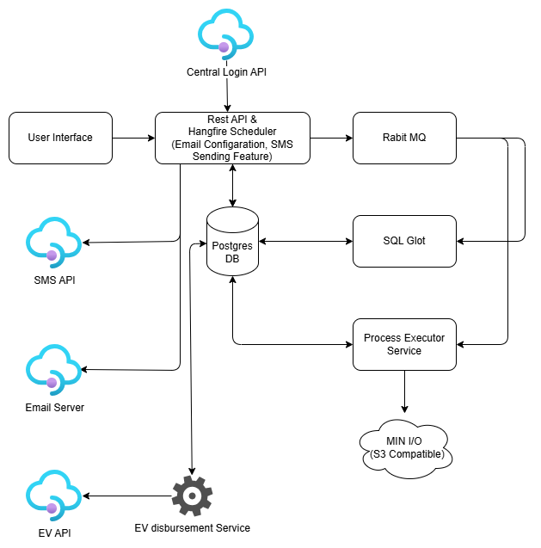
Figure 1: Proposed Sales Commission Automation System.

2.2 Product Functions
- Registering and managing data sources used by users.
- Setting up commission reports through a guided multi-step wizard.
- Computing achievement metrics from configurable UI.
- Computing incentive amounts from configurable UI.
- Executing reports on demand and on schedule.
- Showing current report run status.
- Configurable maker-and-checker approval workflow and make approval workflow for generated report.
- Notifying users via SMS after EV disbursement and Email at the approval workflow also send email or SMS alert for ETL.
- Disbursing approved commissions via POS and EV disbarment.

2.4 Operating Environment
- Web-based applications compatible with modern web browsers.
- Backend services hosted on Linux infrastructure with PostgreSQL as the primary database.

2.5 Design and Implementation Constraints
- Compliance with organizational security standards.

2.6 Assumptions and Dependencies
- Users must have valid and active AD account for login in this system and also assigned POS roles and the necessary permissions to access pages and pages actions.
- For Every report approver must need have approval level user in salescom portal.
- The system relies on accurate and up-to-date data inputs for commission calculations.

2.7 Role-Based Access Control (RBAC)
The SalesCom platform enforces Role-Based Access Control (RBAC) across every page and action. Authentication is handled through the central identity provider with a two-factor (password and OTP) flow, after which the user’s assigned role determines which pages are visible and which actions are permitted. Every user must hold exactly one role: Business User (Maker), Approver (Checker), or Administrator. This section consolidates the role definitions, the page-and-action permission matrix, and the access-governance rules that apply system-wide.
User Roles
- Business User (Maker): creates and clones Reports, configures Report setups, and submits report runs for approval. May view data sources but cannot configure them.
- Approver (Checker): reviews and approves or rejects commission report runs at one or more assigned approval levels. A written comment is required for any Reject action.
- Administrator: configures data sources, KPI mappings, and approval levels (including approval-level user assignment), and manages system-wide setup.
Permission Matrix
Page / Action | Business User (Maker) | Approver (Checker) | Administrator
Login, OTP and Dashboard | Yes | Yes | Yes
Data Source Setup (create, edit, deactivate) | View only | View only | Full access
Report Create, Edit and Clone | Yes | No | Yes
Report List view and Detail View | Yes | Yes | Yes
Approve or Reject Report | Yes (assigned levels) | Yes (assigned levels) | Yes (assigned levels)
Approval Level and User configuration | No | No | Yes
Access Governance
- Access to all pages and actions is governed strictly by the user’s assigned role; the system uses page-based access control to manage permissions (NFR-3).
- Only users with valid central credentials and an assigned role may access the system (BR1).
- User role rights are synchronized hourly. A change to a user’s rights takes effect in the system within one hour.
- Maker-Checker segregation is enforced: the same user cannot act as both the Maker and a Checker on the same report run (BR5).

4. Specific Requirements

4.1 Functional Requirements

4.1.0 Authentication and Session
The system will protect access to the Commission Platform through a two-factor login flow. The user signs in with username and password, then completes an OTP challenge before reaching the application.

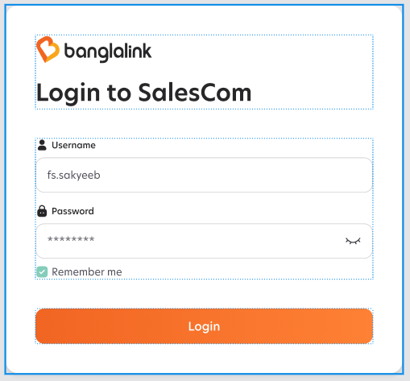
4.1.0.1 Login

- The system will provide a login screen with Username, Password and a Remember-me checkbox.
- The system will mask the password input by default and offer a show/hide toggle.
- The system will validate the credentials against the central identity provider and reject invalid attempts with a generic error.
- The system will record the last successful login timestamp and the last declined login timestamp per user and show both on the dashboard.
- The system will lock the account after 3 consecutive failed attempts.
- Then User role right will be sync in every hour. New right of a user will affect after one hour in system.


4.1.0.2 OTP Verification

- The system will present an OTP screen after a successful password step that displays the application name (SalesCom) and the logged-in username for context.
- The system will require the user to enter the OTP and submit before any application route is accessible.
- The system will provide a Resend action that re-issues a fresh OTP after a configurable cool-down.
- The system will provide a Back-to-Login link that discards the partial authentication and returns to the Login screen.
- The system will expire an OTP 2 minutes.
- A countdown timer will be displayed, showing the remaining time for the OTP's validity.

4.1.1 Data Source Setup
The system will provide an Administrator-only Data Source area where the admin registers and maintains the data sources business users may pick from when building Reports. This data source configuration menu will be available to admin user not the business user.

4.1.1.1 Data Source Listing

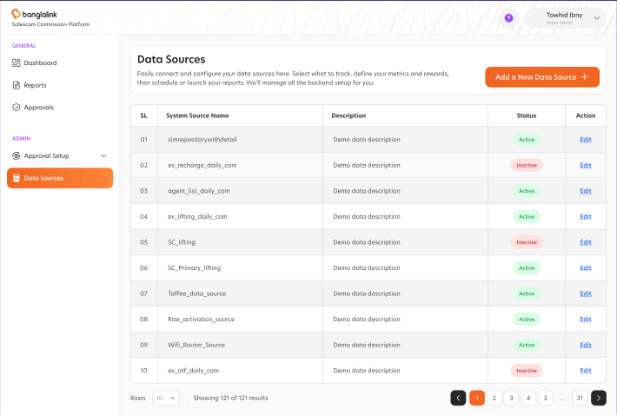
- The system will display the full list of registered data sources in a paginated table with columns: SL, Table Name, Description, Status and Action.
- The system will support row-action Edit for every row.
- The system will provide an Add a New Data Source action at the top-right of the listing.
- The system will support page-size selection (default 10 rows) and a Showing N of M results indicator.
- The system will support filtering and searching by Name.

4.1.1.2 Add and Edit Data Source
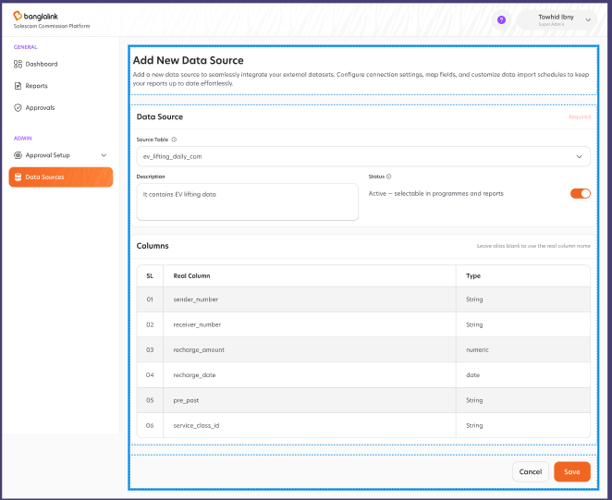
- The system will provide an Add New Data Source form with the fields: Source Table, Description, Status (Active / Inactive).
- Here user will select a Source table and all its columns list will be shown. In source table selection only not registered data sources will be available. Then user will input Description and give active status by default status will be Deactivate.
- The system will allow deactivating a data source without deleting historical references in saved Reports.
- The system will not allow deactivating used data source in any report.
- Business user can only use the active data sources admin will be configure here.

4.1.2 Report

4.1.2.1 Report Listing
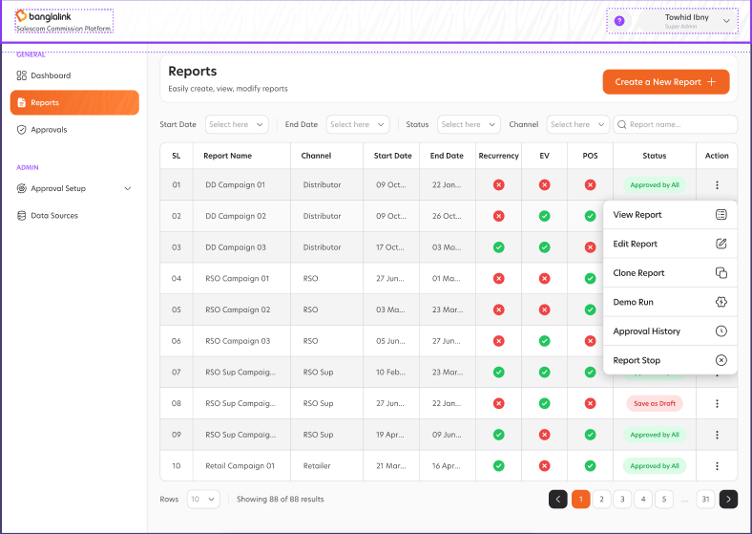
The system will provide a Report Listing page that is the primary entry point to every Report configured on the platform; the page surfaces status and row actions for each Report.
- The system will display Reports in a paginated table with columns: SL, Report Name, Channel, Start Date, End Date, Recurrency, EV, POS, Status and Action.
- The system will surface the Report status inline in the table (e.g. Save as Draft, Waiting for Running, Waiting for RA L1, Approved by All, Rejected by RA).
- The system will provide filters at the top of the page: Start Date, End Date, Status, Channel and report name. The search functionality for the Report Name field employs prefix-based filtering. As the user types, the system will dynamically return all report entries whose names begin with the provided input string.
- The system will paginate the table with page-size selection (default 10) and a Showing N of M results indicator.
- The system will provide a Create a New Report action at the top-right of the page.
- The system will provide an Action menu on every row with: View Report, Edit Report, Clone Report, Demo Run, Approval History, and Report Stop.
- The system will open a Clone Report modal from the Action menu that asks for a new Report Name and re-validates uniqueness before creating the draft.
- Here Edit Report will be hidden if report configuration is approved mean user cannot edit if report is approved by all.
- If a Report has approved and schedule for run on a certain date then only “Report Stop” button will be available otherwise not.
- There will be also a button for Run Now button available if report is approved by all. When click Run Now button then Report will be start running immediately if currently no other report is running. If a report is running then the report will be first queue by priority.

4.1.2.2 Report Setup
The system will provide a five-step Report Setup wizard that the Business User completes to configure a commission Report. Each step is described below.

4.1.2.2.1 Basic Input
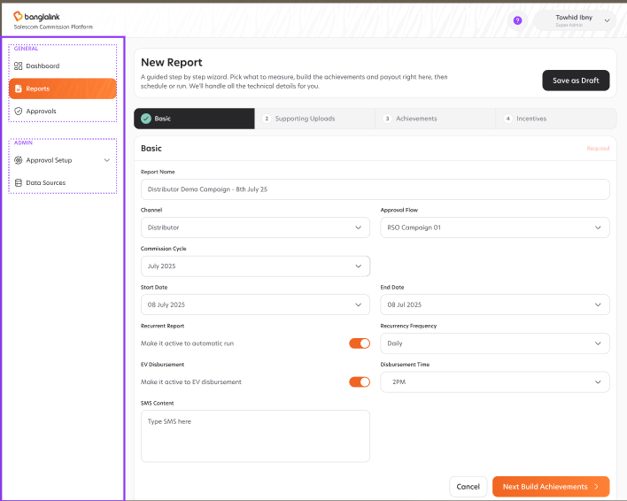
- The system will provide a Step 1 form to capture the Report Name (required). The system will validate that the Report Name is unique within the system.
- The system will provide a Commission Cycle picker (e.g. "July 2025") and a Channel picker (e.g. Distributor, Retailer, RSO).
- The system will provide Start Date and End Date pickers and validate that Start Date is on or before End Date.
- The system will provide a Recurrent Report toggle: when active the user must pick a Recurrency Frequency (Daily, Weekly, Monthly, etc.) and the system will schedule the report to run automatically per the chosen frequency.
- The system will provide an EV Disbursement toggle: when active the user must pick a Disbursement Time of day; the system will trigger EV disbursement at that time after the run is approved.
- The system will provide an optional Remarks free-text field for the user to record context or notes about the Report.
- The system will allow saving the basic input as a draft via Save as Draft so the user can return and edit before running.
- The system will provide a Cancel action that returns the user to the Report listing without persisting any unsaved input.
- The system will advance the wizard to Step 2 (Supporting Uploads) via Next: Build Achievements.

4.1.2.2.2 Supporting Upload
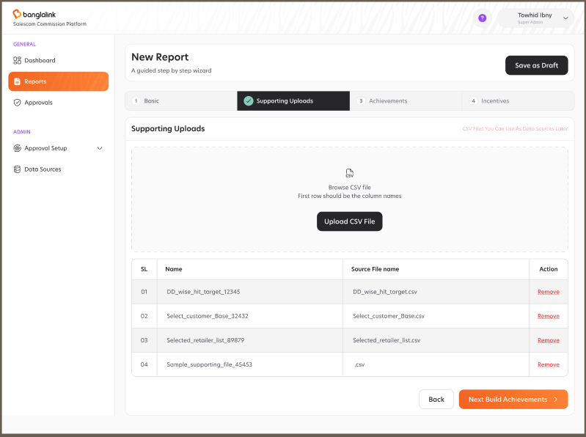
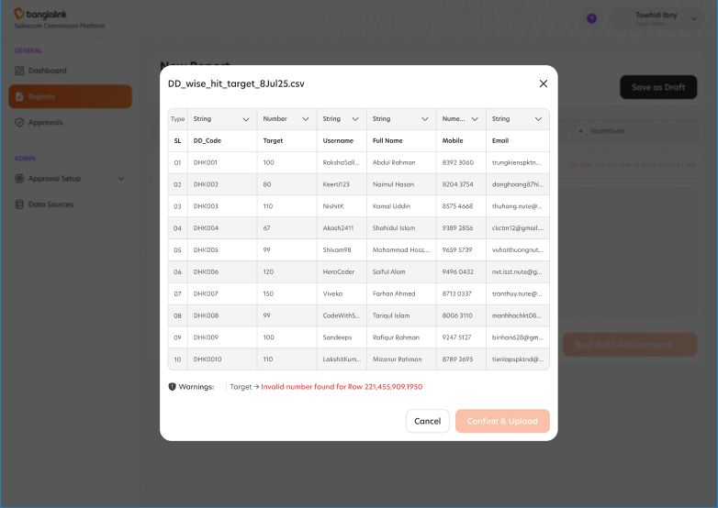
- The system will provide a Step 2 page with a drag-and-drop CSV upload area and a Browse CSV file action; the helper text will remind the user that the first row must contain column names.
- The system will support uploading multiple CSV files in a single Report Setup; each upload appears in a list with columns: SL, Original File Name, Source File Name, Action.
- The system will allow removing an uploaded file via the Remove row action before the Report is save.
- The system will preview the first rows of the uploaded file inline with auto-detected column data types (String, Number, date).
- The system will surface validation Warnings inline when values do not match the auto-detected column type (e.g. "Target: Invalid number found for First column value - DHK0040, DHK-900, DHK999").
- The system will store the raw uploaded file in object storage and create a database table with data from the parsed rows so the file can be referenced as a datasource in later pipeline steps.
- The system will record per-upload metadata: file name, byte size, file hash, uploaded-by user and uploaded-at timestamp.
- The system will allow downloading the original uploaded file from the Report Details view at any time.
- Here user can change column type (string/number/date) and upload.
- User can also remove Supporting upload if needed.
- User can upload with max column 30 and file size 500 megabyte.

4.1.2.2.3 Achievement Calculation
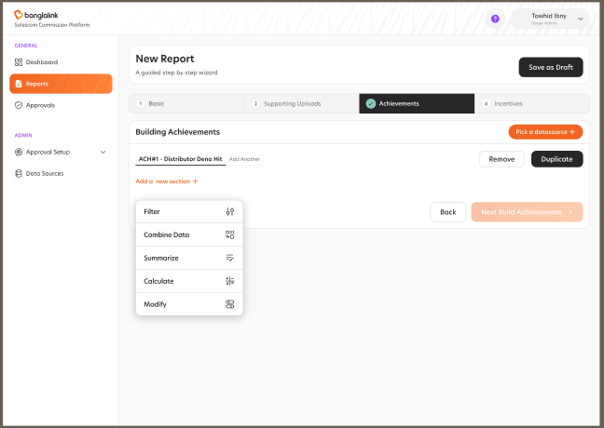
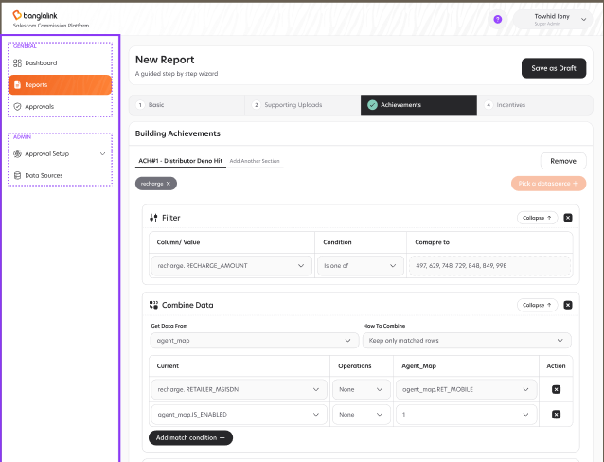
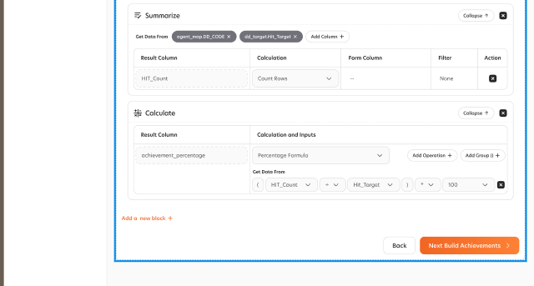
- The system will provide a Step 3 builder where the user composes one or more Achievement blocks (e.g. ACH#1 - Distributor Deno Hit). T
- The system will allow the user to pick a datasource for the Achievement block from the registered data sources and the supporting CSVs uploaded in Step 2.
- The system will support the following pipeline stages per block, each shown as a collapsible card the user can expand: Filter, Combine Data, Summarize, Calculate, Modify.
- The Filter stage will let the user pick Column / Value, Condition (Is one of, Equals, Greater than, etc.) and Compare-to values.
- The Combine Data stage will let the user pick Get-Data-From source, join keys (e.g. last9(recharge.RETAILER_MSISDN) = agent_map.ENABLED), Which-columns-to-bring (e.g. DD_CODE, RET_CODE, RSO_CODE), Operations (None, Aggregate) and How-to-combine (Keep only matched rows, Keep all rows).
- The Summarize stage will let the user pick Get-Data-From, set a Result Column (e.g. HIT), pick a Calculation (Count Rows, Sum, Avg, Min, Max), and optionally pick a Form Column and Filter.
- The Calculate stage will let the user enter a Result Column and a Calculation that may be a Math Formula (e.g. (Hit ÷ Hit_Target) ÷ 100), with Add-Operation and Add-Group controls.
- The Modify stage will let the user cast/modify columns value before passing the dataframe to the next block.
- The system will provide actions on every block: Add a new section, Add another Block, Remove. User can remove block from last not from middle.
- The system will provide an Outputs panel beside the builder that shows the projected output columns of the active Achievement block with Column Name, Type and Source so the user sees what will be produced before saving.
- User can use existing Achievement as input data source in new achievement calculation.
- The system will pre-validate every pipeline by checking that referenced columns and calc fields exist before allowing Next: Build Incentives.

4.1.2.2.4 Incentive Calculation
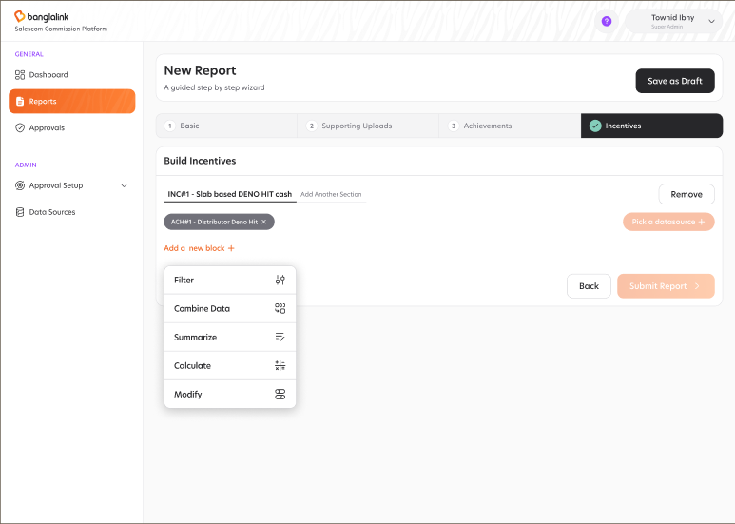
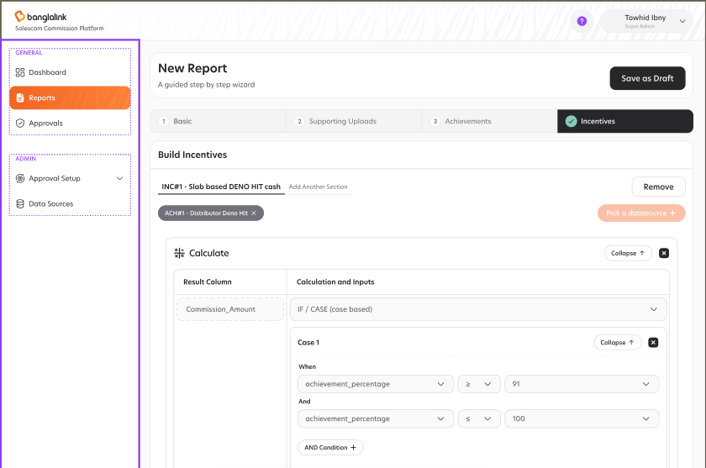
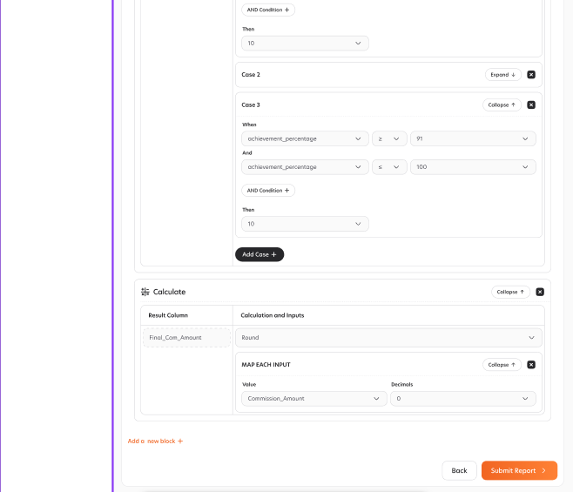

- The system will provide a Step 4 builder where the user composes one or more Incentive blocks (e.g. INC#1 - Slab based DENO HIT cash).
- The system will support the same pipeline stages as Step 3 per Incentive block: Filter, Combine Data, Summarize, Calculate, Modify.
- The Calculate stage for Incentive will support an IF / CASE (case based) calculation where the user adds one or more Cases; each Case consists of: When <column> <comparator> <value> And <column> <comparator> <value> Then <value>.
- The system will let the user Add Case to grow a slab table and Expand / Collapse individual cases for readability.
- The system will allow Incentive blocks to read one or more Achievement blocks or system data source as input.
- The system will allow user to use existing incentive as data source in new incentive calculation.
- The system will provide actions on every block: Add a new section, Add Another block, Remove. User can remove block from last not from middle.
- The system will provide an Outputs panel that lists every output column with Source Name and Column Name (e.g. distributor_code from Recharge, ach.Cluster from Agent_Map, slab.rate_per_hit from Recharge, raw_payout from Agent_Map).
- The system will pre-validate every Incentive pipeline before allowing Submit Report.

4.1.2.2.5 Run Now and Schedule Run
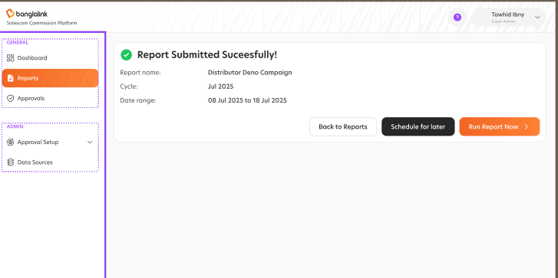
- The system will show a "Report Submitted Successfully!" confirmation that displays Report Name, Commission Cycle and Date Range after Submit Report.
- The system will provide three actions on the success screen: Back to Reports, Schedule for Later, Run Report Now.
- The system will open a Schedule Report modal when Schedule for Later is chosen; the modal will show the Report Name as its title and a Schedule Time picker (date + time, e.g. 08 Jul 2025, 2:00 AM).
- The system will provide Cancel and Schedule Report actions in the Schedule modal; on confirmation the system will register the run on the platform scheduler.
- The system will support pausing, editing and cancelling scheduled runs from the Report Details view.
- The system will record who triggered each run (manual or scheduled) and the run timestamp.
- Report Run Now will only available after report is approved.

4.1.2.5 Report Detail View
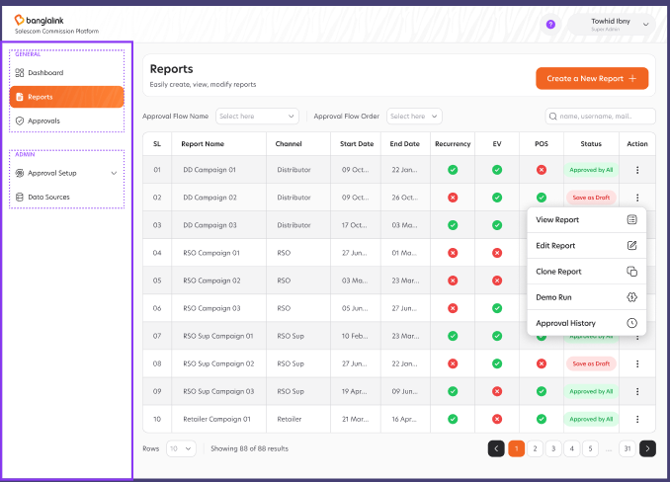
The system will provide a Report Detail View that opens when the Business User chooses View Report from the Report Listing. The page header shows the Report Name, Commission Cycle and Date Range, and a global Export action sits at the top-right. The body is organised into five tabs (Basic, Supporting Uploads, Achievements, Incentives, Run Log) that surface the saved configuration in read-only form together with every artefact produced by past runs.

4.1.2.5.1 Basic Tab
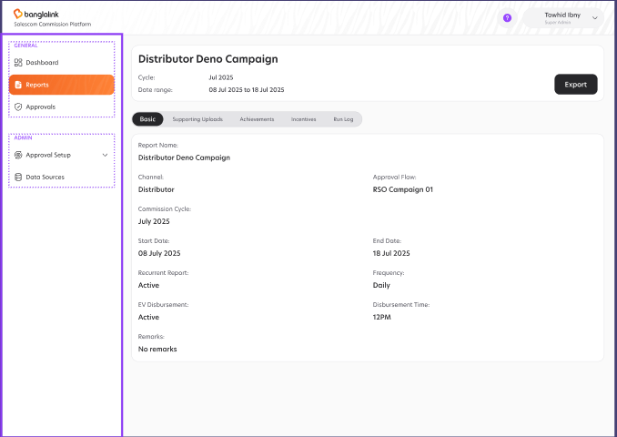
- The system will display the Report Name as a section header.
- The system will display the Channel, Approval Flow, Commission Cycle, Start Date, End Date, Recurrent Report (Active / Inactive), Frequency, EV Disbursement (Active / Inactive), Disbursement Time and Remarks as read-only fields.
- The system will display "No remarks" when the Remarks field was left blank in setup.

4.1.2.5.2 Supporting Uploads Tab
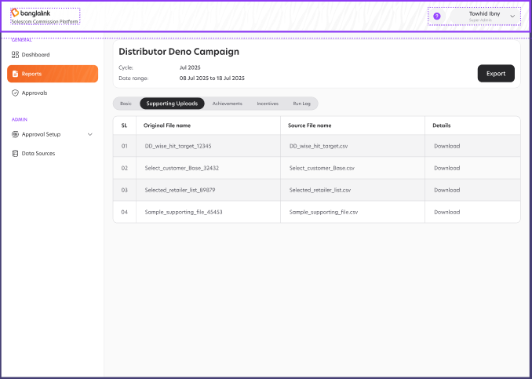
- The system will list every supporting CSV uploaded for the Report in a table with columns: SL, Original File Name, Source File Name and Details.
- The system will provide a per-row Download action that streams the original uploaded CSV from object storage.
- The system will not allow uploading new files from the Detail View.

4.1.2.5.3 Achievements Tab
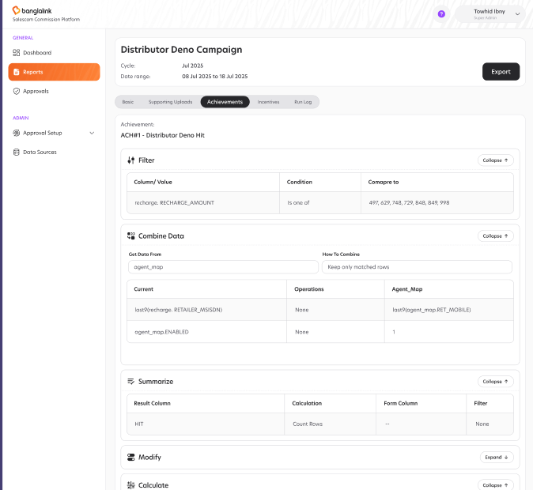
- The system will list every Achievement block configured for the Report (ACH#1, ACH#2, ...) with the block name as the section header.
- The system will render every pipeline stage as a collapsible card: Filter, Combine Data, Summarize, Modify, Calculate.
- The Filter card will display Column / Value, Condition and Compare-to values as read-only fields.
- The Combine Data card will display Get-Data-From, How-to-Combine, the Current vs Joined match keys, Operations and Which-columns-to-bring.
- The Summarize card will display Result Column, Calculation, Form Column and Filter.
- The Calculate card will display Result Column and the Math Formula or expression as a read-only token chip.
- The system will allow expanding and collapsing each card individually for readability and will remember the user’s expand state across tab switches.

4.1.2.5.4 Incentives Tab
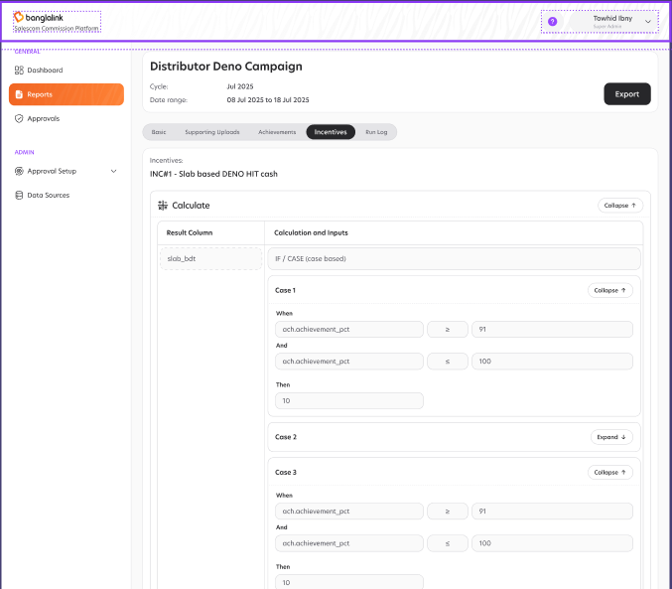
- The system will list every Incentive block configured for the Report (INC#1, INC#2, ...) with the block name as the section header.
- The system will render every Calculate card with its Result Column and the IF / CASE definition.
- The system will display every Case row with its When / And / Then expression and allow expand and collapse per Case.
- The system will render a MAP EACH INPUT card with the Value and Decimals fields it was saved with.
- The system will render all other pipeline stages (Filter, Combine Data, Summarize, Modify) as collapsible read-only cards just like the Achievements tab.

4.1.2.5.5 Run Log Tab
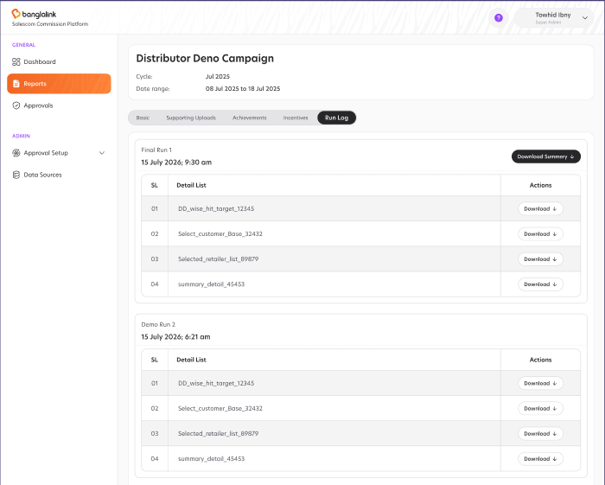
- The system will list every execution of the Report in descending order; each entry is titled with the run kind and ordinal (e.g. "Final Run 1", "Demo Run 2") and shows the run timestamp ("15 July 2026, 9:30 am").
- The system will provide a Download All action per run that packages every details produced by that run.
- The system will list each details of the run in a table with columns: SL, Detail List (details file name) and Actions.
- The system will provide a per-detail Download action that streams the file from object storage.
- The system will paginate the run list when more than ten runs exist.

4.1.2.5.6 Disbursement Tab
The system will show a Disbursement tab in the Report Detail View only when the Report Setup enables one of the two disbursement modes. At most one tab is shown: "EV Disbursement" when the Report has EV Disbursement = Active, or "POS Disbursement" when the Report has POS Disbursement = Active. The tab is hidden entirely when neither is enabled.
- The system will show an "EV Disbursement" tab when the Report's EV Disbursement toggle is Active in the Basic setup.
- The system will show a "POS Disbursement" tab when the Report's POS Disbursement toggle is Active in the Basic setup.
- The system will hide the Disbursement tab entirely when neither EV nor POS disbursement is enabled.
- The system will list every disbursement instance for the Report in descending order; each entry is one disbursement batch produced by a Report Run.
- The system will display the per-batch summary with columns: SL, Disbursement Time, Record Count (how many rows of report data were disbursed in that batch) and Action.
- The system will provide a Download CSV action per batch that streams a CSV file containing exactly the rows of report data disbursed in that batch.
- For EV Disbursement batches, the CSV will include: Channel Type, Channel Code, Amount, Disbursement Time, Status and Message (one row per disbursed record).
- For POS Disbursement batches, the CSV will include: Channel Code and Amount as written to the POS dump file.

4.1.2.2 Report Approval
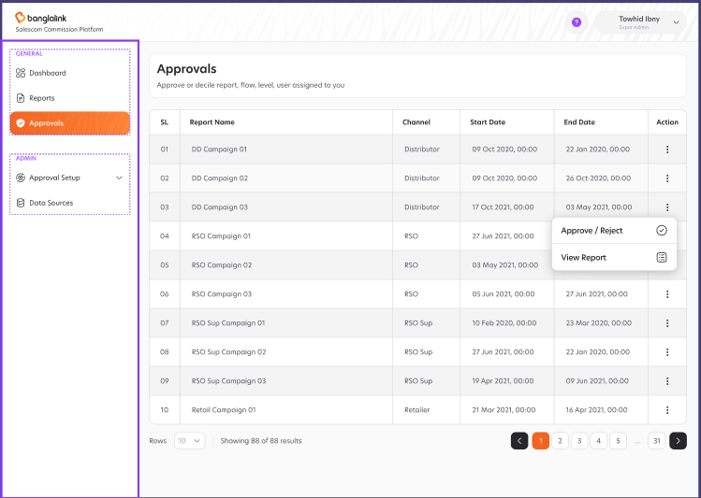
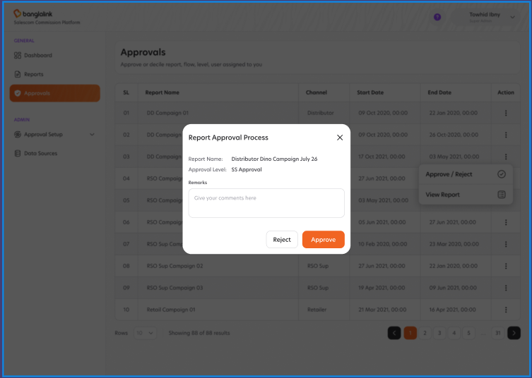
- The system will provide a Report Approval list view to the approver.
- Only this assign user can see report approval pending and can approve/reject.
- The system will provide the approver with Approve, Reject actions.
- The system will require the approver to enter a comment before Reject.
- The system will route the run to the next approval level on Approve and back to the previous level on Reject.

4.1.2.4 Report Setup Cloning
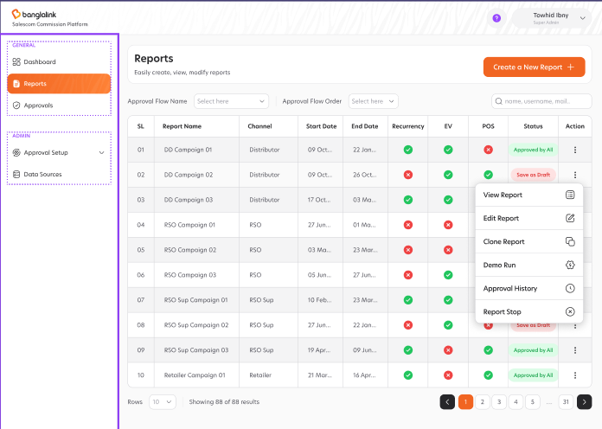
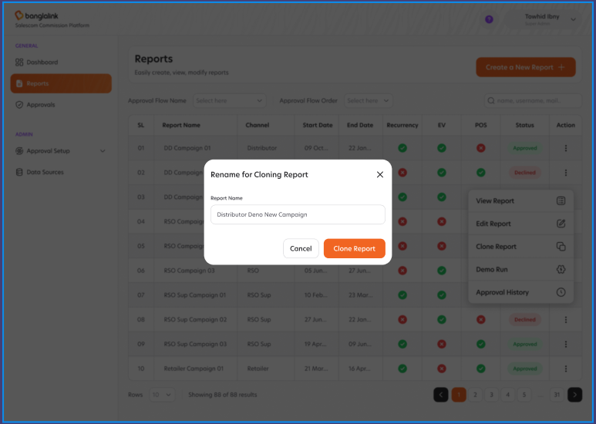
The system will let a Business User create a new Report Setup by cloning an existing one. The clone carries over the full configuration (achievement and incentive blocks, calc field and datasource references, approval levels) and starts as a fresh draft.
- The system will provide a 'Clone' action on the Report Setup listing page and on the Report Details View page of any saved Report.
- The system will require the user to enter a new unique Report Name.
- The system will validate that the new Report Name is unique within the system; duplicate names are rejected with an error message.
- The system will copy the source Report's configuration into the clone, including achievement and incentive blocks, calc field references, datasource references and assigned approval levels.
- The system will not copy supporting Excel uploads, historical runs, approval decisions or disbursement records from the source Report; the cloned Report starts as a fresh draft.
- The system will redirect the user to the Basic Input step of the new clone after creation so the user can adjust fields before running.

4.1.3 Approval (Maker and Checker)
The system will let the administrator configure the approval workflow using a three-page maker-checker model: Approval Flow (the named workflow), Approval Level (the ordered steps inside a flow) and Approval Level User (the people who may act at a step). Flows are reusable across Reports and types.

4.1.3.1 Approval Flow
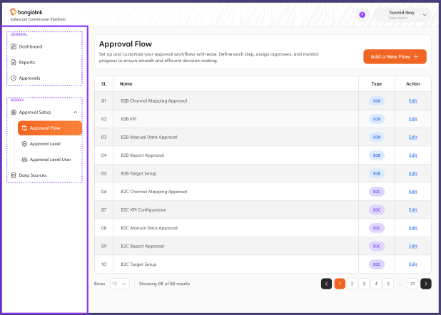
- The system will provide an Approval Flow listing page with columns: SL, Name, Type and Action.
- The system will support filtering by Type and searching by Name.
- The system will provide an Add a New Flow action that opens a modal with: Flow Name (required) and Flow Type (selector).
- The system will validate that Flow Name is unique within the system.
- The system will provide an Edit action on every row to rename the flow and change its type.
- The system will record every change to an Approval Flow in the audit log with actor and timestamp.

4.1.3.2 Approval Level
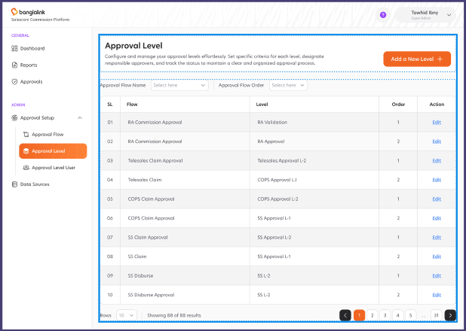
- The system will provide an Approval Level listing page with columns: SL, Flow, Level, Order and Action.
- The system will support filtering by Approval Flow Name and Approval Flow Order.
- The system will provide an Add a New Level action that opens a modal with: Flow Name, Level Name and Order.
- The system will validate Order as a positive integer that is unique within the chosen Flow.
- The system will allow editing every level field except Flow Name after the first save.
- The system will route an Approval Request through levels in ascending Order

4.1.3.3 Approval Level User
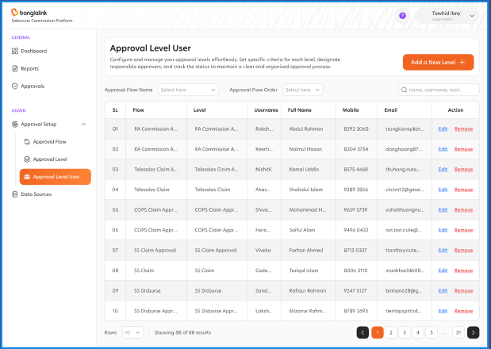
- The system will provide an Approval Level User listing page with columns: SL, Flow, Level, User identity (Name, Username, Mail) and Action.
- The system will support filtering by Approval Flow Name and Approval Flow Order.
- The system will provide an Add a New User action that opens a modal with: Flow Name, Login Name, Mobile and Email.
- The system will resolve Login Name against the central identity directory so the assigned user is always a real, current employee.
- The system will allow the same user to be assigned to multiple levels and multiple flows.
- The system will provide row-action Edit (update Mobile and Email) and Remove (revoke assignment) per row.
- The system will record every assignment change in the audit log with actor and timestamp.

4.1.4 Dashboard
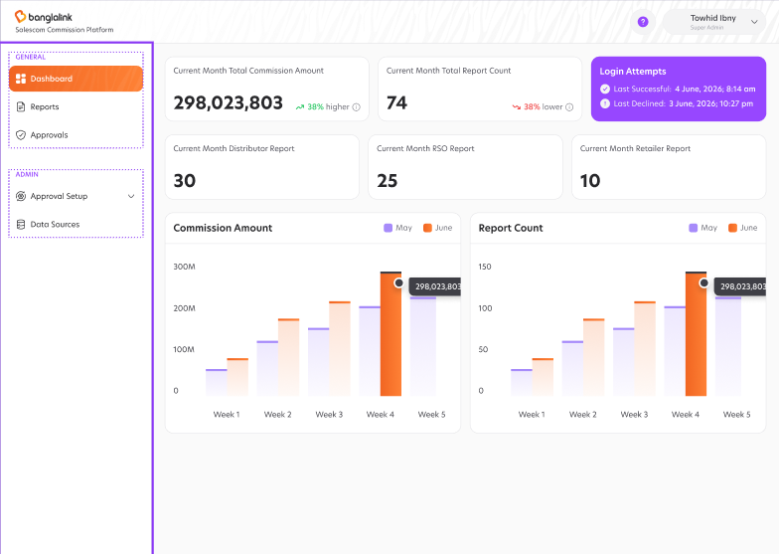
The system will provide a Dashboard that is the default landing page after authentication; the Dashboard surfaces commission KPIs for the current month, login-attempt audit and time-series trends across the recent weeks.
- The system will display a Current Month Total Commission Amount KPI card with a delta versus previous month (e.g. "38% higher").
- The system will display a Current Month Total Report Count KPI card with a delta versus previous month.
- The system will display a Login Attempts card showing Last Successful and Last Declined timestamps for the signed-in user.
- The system will render a weekly Commission Amount trend chart for the current and previous month.
- The system will render a monthly Report Count trend chart for the current and previous month.
- The system will scope every menu, page, and chart with user claim authorization.

4.1.5 Notification

4.1.5.1 SMS
- The system will send SMS notifications after completing every EV disbursement.

4.1.5.2 Email
- The system will send Email notifications for all workflow events: approval request, approval rejected, disbursement complete, run failed.
- The system will support multiple recipients per event (To, CC).
- The system will record delivery and read status for audit.

4.1.6 Disbursement of Commission
- The system will trigger commission disbursement only after the final approval level approves the run.
- The system will generate disbursement as required.
- The system will notify the commission candidate on successful disbursement (SMS).

4.2 Non-Functional Requirements

4.2.1 Security Requirements
- NFR-3: The system will use page-based access control to manage permissions.
- NFR-4: Data transmission will be secured using HTTPS.

4.2.2 Reliability Requirements
- NFR-7: The system will have an uptime of 99.9%.
- NFR-8: The system will log all user login information.

4.3 Interface Requirements

4.3.1 User Interfaces
- IR-1: The system will provide web-based interfaces for users.
- IR-2: The UI will support all major browsers.

4.3.2 Software Interfaces
- IR-3: The system will integrate with existing ETL system and third-party APIs

5. Appendices

5.1 Glossary
- API: Application Programming Interface
- HTTPS: Hypertext Transfer Protocol Secure

