August 18, 2017

Brian D. Fath

Editor-In-Chief

Ecological Modelling

I am pleased to resubmit our manuscript, “Parameter sensitivity and identifiability for a biogeochemical model of hypoxia in the northern Gulf of Mexico,” to be considered as an original research article for publication in Ecological Modelling.

This manuscript is a major revision to address constructive comments from the associate editor and reviewer. Detailed responses to individual comments are included in the resubmission. Most importantly, our analysis to calibrate the zero-dimensional model uses a completely different dataset that satisfies assumptions for the approach. We also included additional and improved content describing the model as requested by the editor.

Please feel free to contact me with any questions or concerns about our resubmission. The source files are included with the submission as a zipped folder. We appreciate the opportunity to publish our work with Ecological Modelling

Sincerely,

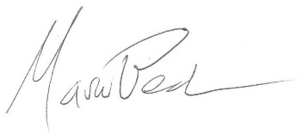

Marcus W. Beck, PhD

Post-Doctoral Research Fellow

U.S. Environmental Protection Agency

1 Sabine Island Drive

Gulf Breeze, FL 32561