April 9, 2017

Brian D. Fath

Editor-In-Chief

Ecological Modelling

I am pleased to submit our manuscript, “Parameter sensitivity and identifiability for a biogeochemical model of hypoxia in the northern Gulf of Mexico,” to be considered for publication as an original research article in Ecological Modelling.

This paper describes a simple but under-represented approach to evaluate parameter sensitivity and identifiability for large biogeochemical models. The Coastal General Ecosystem Model was developed to describe and predict the spatial extent of bottom-water hypoxia in the Louisiana Continental Shelf of the northern Gulf of Mexico. This area experiences seasonal hypoxia in late summer to early Fall and is one of the largest marine hypoxic zones in the world. The model includes over 100 biogeochemical and 251 associated parameter values that describe biogeochemical processes relevant for hypoxia. Parameter sensitivity has never been evaluated for this model, and more importantly, we demonstrate that significant redundancies in the effects of parameter subsets on state variables lead to challenges in parameter identifiability. As such, we propose explicit parameter selection heuristics that balance the tradeoff between parameter sensitivity and ecological certainty for model calibration. These parameter subsets are calibrated to demonstrate the potential for improved model precision. Both the questions that we address and our methods should be of broad interest in ecological modelling and to those interested in managing coastal ecosystems.

Please feel free to contact me with any questions or concerns about our submission. I can be reached at (850) 934-2480 and [beck.marcus@epa.gov](mailto:beck.marcus@epa.gov). We appreciate the opportunity to publish our work with Ecological Modelling

Sincerely,

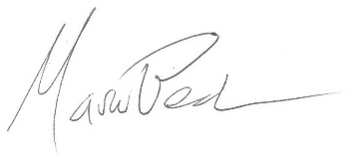

Marcus W. Beck, PhD

Post-Doctoral Research Fellow

U.S. Environmental Protection Agency

1 Sabine Island Drive

Gulf Breeze, FL 32561