Download and install Node.js

1. In a browser enter https://nodejs.org
2. In middle of page select v6.9.1 LTS to download node-v6.9.1-x64.msi.

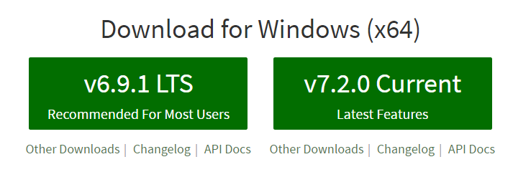

1. Click on node-v6.9.1-x64.msi to start installation
2. Accept all defaults

Download and install Visual Studio Code (note you do not need Visual Studio Code because you can use any other IDE or notepad to code in Node, buts it’s free and makes it easier)

1. In a browser enter to [https://**code**.**visualstudio**.com](https://code.visualstudio.com)
2. On left-hand-side click ‘Download for Windows’

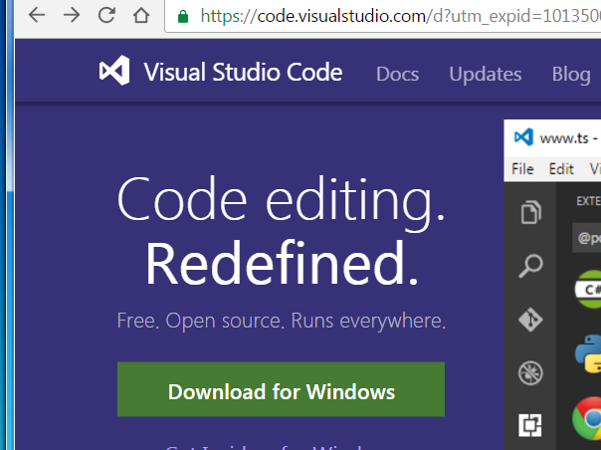

1. Click VSCodeSetup-1.7.2.exe
2. Accept all defaults.

Get helloWorld.js from my git hub account

1. In a browser enter <https://github.com/MustaqHussain>
2. Select repository Node-Introduction

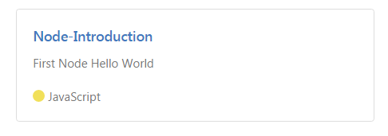

1. Select helloWorld.js
2. Select ‘Raw’ (code above on left hand side)
3. Keep open for copying code in next section

Create file helloWord.js on laptop.

1. Create directory D:\Projects\Node
2. Open Visual Studio Code
3. File->Open Folder..-> D:\Projects\Node
4. File->New File (or New File Icon)

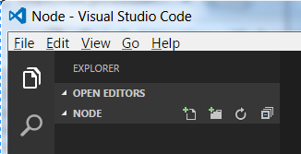

1. Paste code from GitHub browser
2. Display Explorer side-bar by View->Explorer (or clicking on File icon)
3. Save file as helloWorld.js

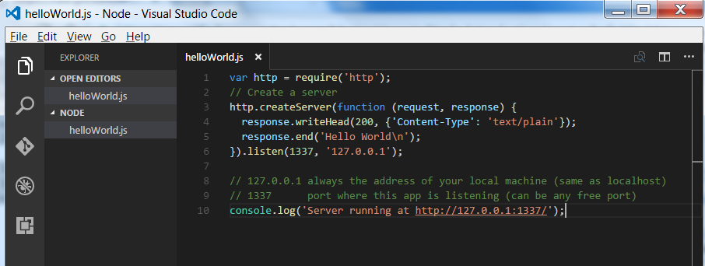

Run node app

1. Either open Dos/Command window or

in Visual Studio Code select View->Integrated Terminal

1. Type following command to create and run a Node server of your app:

**node helloWorld**

1. You should see message in console

**Server running at http://127.0.0.1:1337**

1. Open browser and enter url

**http://127.0.0.1:1337**

1. In browser you should see message

**Hello World**

**Congratulations you have created and deployed your first Node app (possibly)**