Express: Get all books Routing

Setup express

1. Create directory D:\Projects\VS\angular1-library
2. Open Visual Studio Code
3. Open

File->Open Folder..-> D:\Projects\angular1-library Select Folder

1. In Visual Studio Code open Integrated Terminal
2. Run following to create a new package (project folder)

npm init

Accept all defaults. This creates a package.json file.

1. Next install external express & mongo modules:

npm install express --save

npm install mongodb –save

This creates folder node_module in EXPLORER

1. Back in Visual Studio Code, at root of project ANGULAR1-LIBRARY create a file called app.js
2. Paste and save the following into it.

var http = require('http');

var express = require('express');

var app = express();

var mongodb = require('mongodb').MongoClient;

var url = 'mongodb://localhost:27017/libraryApp';

// Where to find images and web pages

app.use(express.static('app'));

app.set('views', __dirname + '/app/views');

app.get('/', (req, res) => {

res.sendFile(__dirname + '/app/views/index.html');

});

app.get('/allBooks', (req,res) => {

mongodb.connect(url, (err, db) => {

if ( err ) {

console.log('Error connecting to mongoDB', err);

return;

}

// Connected to DB

var collection = db.collection('books');

collection.find()

.toArray((err, docs) => {

//console.log(docs);

db.close();

res.json(docs);

});

});

});

app.listen(3000, () => {

console.log('listening on 3000');

});

(NOTE: after finding all books returns documents as a JSON object res.json(docs))

1. Start mongodb server: mongod.exe
2. In the Integrated Terminal start the node application app.js:

node app

1. Opens a browser navigate to localhost:3000/allBooks
2. Confirm you get all the books in JSON format.

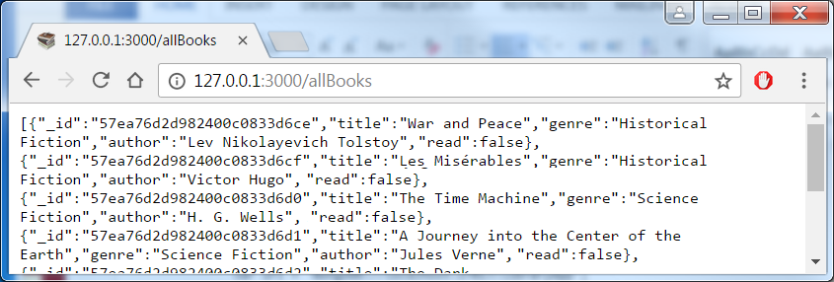

(Note if you enter localhost:3000, you will get an error message as index.html has not be defined )

MongoDB: Re-Import Books with Goodreads Ids

Re-import books with Goodreads’ bookId.

1. Create or overwrite file in C:\Program Files\MongoDB\Server\3.4\bin\books.json and paste in following – which has the Goodreads book ID:

{"_id":{"$oid":"57ea76d2d982400c0833d6ce"},"title":"War and Peace","genre":"Historical Fiction","author":"Lev Nikolayevich Tolstoy","bookId":656,"read":false}

{"_id":{"$oid":"57ea76d2d982400c0833d6cf"},"title":"Les Misérables","genre":"Historical Fiction","author":"Victor Hugo","bookId":24280,"read":false}

{"_id":{"$oid":"57ea76d2d982400c0833d6d0"},"title":"The Time Machine","genre":"Science Fiction","author":"H. G. Wells","bookId":2493,"read":false}

{"_id":{"$oid":"57ea76d2d982400c0833d6d1"},"title":"A Journey into the Center of the Earth","genre":"Science Fiction","author":"Jules Verne","bookId":827174,"read":false}

{"_id":{"$oid":"57ea76d2d982400c0833d6d2"},"title":"The Dark World","genre":"Fantasy","author":"Henry Kuttner","bookId":1881716,"read":false}

{"_id":{"$oid":"57ea76d2d982400c0833d6d3"},"title":"The Wind in the Willows","genre":"Fantasy","author":"Kenneth Grahame","bookId":5659,"read":false}

{"_id":{"$oid":"57ea76d2d982400c0833d6d4"},"title":"Life On The Mississippi","genre":"History","author":"Mark Twain","bookId":99152,"read":false}

{"_id":{"$oid":"57ea76d2d982400c0833d6d5"},"title":"Childhood","genre":"Biography","author":"Lev Nikolayevich Tolstoy","bookId":33515440,"read":false}

1. Open a command prompt and cd to C:\Program Files\MongoDB\Server\3.4\bin
2. Type

mongo

this is the shell where you type in your mongoDB commands

1. In the mongo shell drop the books collection by entering:

show dbs

show collections

use libraryApp -- switch to libraryApp DB

show collections

db.books.find().pretty() -- shows books collection

db.books.drop()

db.books.find() -- nothing shown

1. Open another command prompt and cd to C:\Program Files\MongoDB\Server\3.4\bin
2. Type following to import db with books with bookId added:

mongoimport --db libraryApp --collection books --file books.json

1. In the mongo shell verify new field added

db.books.find().pretty() -- new field shown

1. Verify in browser, navigate to localhost:3000/allBooks
2. Confirm you can see new field bookId

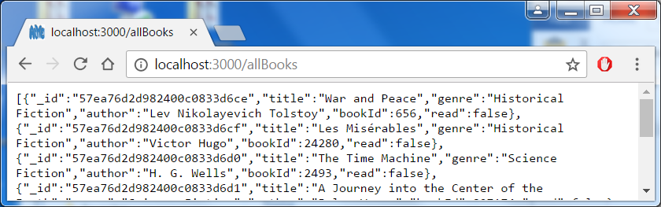

Express: Get book details via Goodreads Id

Add express route app.get('/book/:id'…) to get book details from LibraryApp DB & Goodreads

1. Stop the application and Install the xml2js module (convert xml data into to JSON):

npm install xml2js --save

1. In the app.js file, add following at top of file

var xml2js = require('xml2js');

var parser = xml2js.Parser({explicitArray: false});

1. Then add and save the express route app.get('/book/:id'…)

path: '/book/show/'+id+'?format=xml&key=mN1DyVoFS4cfbCMh5HmnpA'

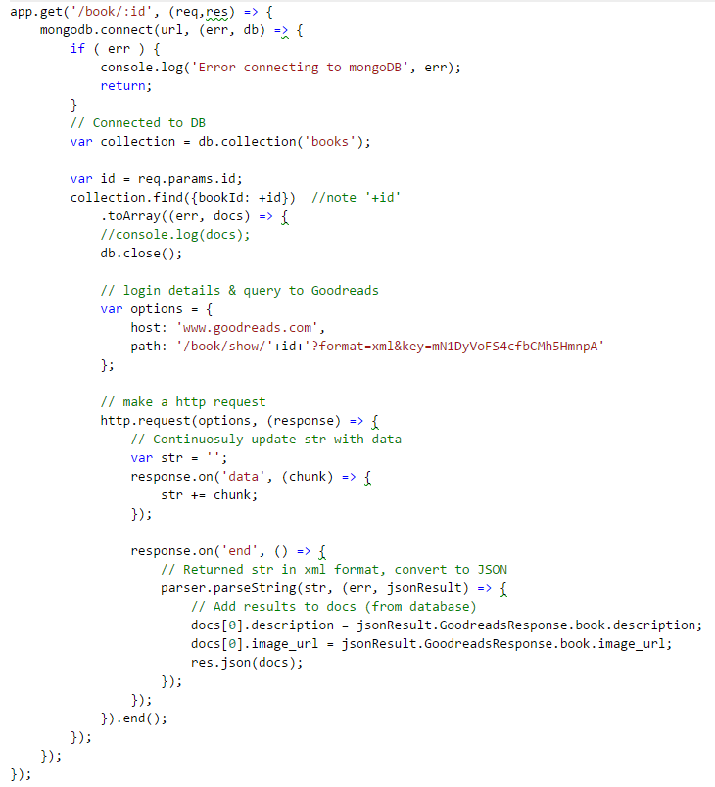

1. Restart the application.
2. Verify newly added route in browser with bookId 656 and contains Goodreads’ image_url & description:

localhost:3000/book/656

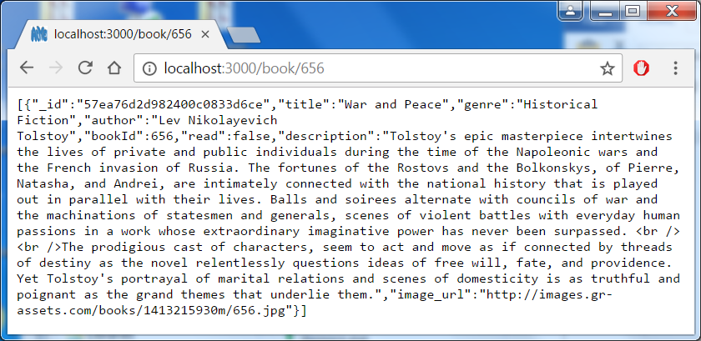

Download static files from Bootswatch & Github

Download a Bootstrap theme from Bootswatch (if not already done)

1. Go to this site <https://bootswatch.com/>
2. Scroll down and pick a theme (use the Preview button to help you choose):

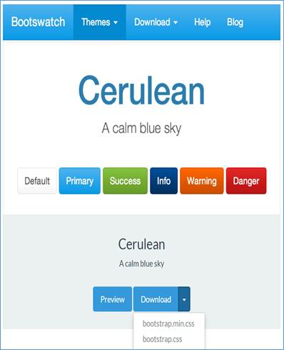

1. Select Download arrow.
2. Select bootstrap.css.
3. Download (instructions may be slightly different depending on your browse) and rename file as bootstrap-<theme>.css in project e.g. D:\Projects\VS\angula1-library\bootstrap-cerulean.css

(I used Superhero theme i.e. renamed as bootstrap-superhero.css)

1. Back in Visual Studio Code in route of EXPLORER create folder ‘app’,
2. Under folder ‘app’ create folders images, scripts, views

Download images/scripts from GitHub:

1. Go to GitHub <https://github.com/MustaqHussain/Node-Introduction>
2. Inside folder S06, select favicon.ico, then ‘Download’ and save into folder ‘app’
3. Inside folder S06/images, select old-books.jpg, then ‘Download’ and save into folder ‘app/images’
4. Inside folder S06/scripts, select bootstrap.7z, then ‘Download’ and save into folder ‘app/scripts’
5. Unzip bootstrap.7z by using option ‘Extract here’. Check bootstrap folder created, and delete bootstrap.7z.
6. Move your bootstrap-<theme>.css file (created above) (or get SO6/bootstrap-superhero.css) into ‘app\scripts\bootstrap\dist\css’

Your EXPLORER view should look similar to this: 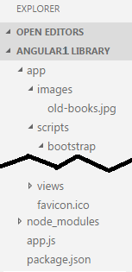

Angular: Add index.html, header.html & home.html

1. Inside ‘app’ folder add file index.html
2. Enter and save following code in index.html (replace bootstarp-superhero.css with your theme):

<script src="https://ajax.googleapis.com/ajax/libs/jquery/3.1.1/jquery.min.js"></script>

<script src="scripts/bootstrap/dist/js/bootstrap.min.js"></script>

<script src="https://ajax.googleapis.com/ajax/libs/angularjs/1.6.1/angular.min.js"></script>

<script src="https://cdnjs.cloudflare.com/ajax/libs/angular.js/1.6.1/angular-route.js"></script>

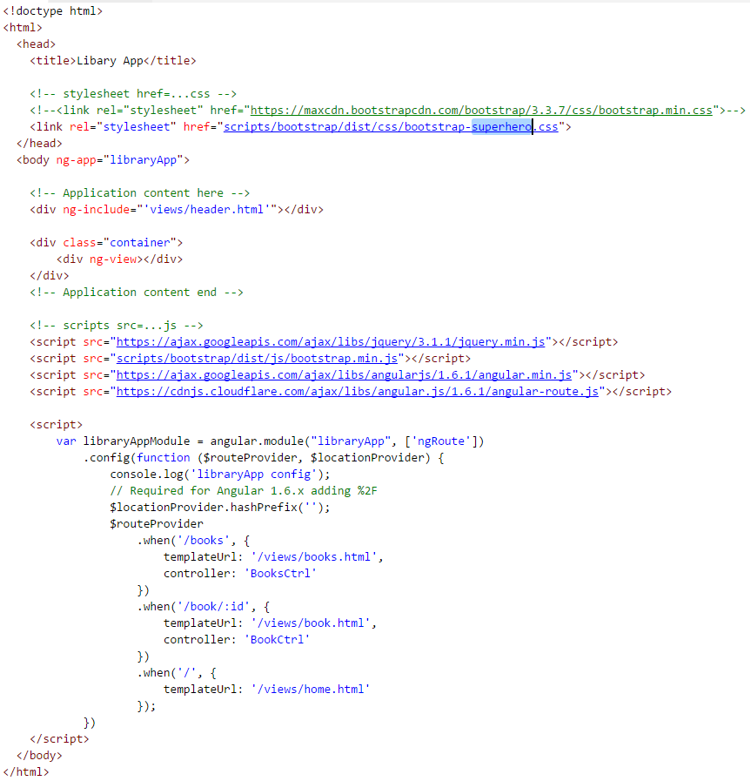

1. Inside ‘views’ folder add file header.html
2. Enter and save following code in header.html:

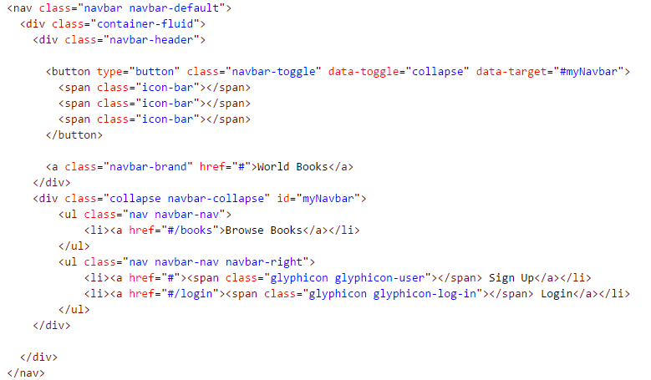

Test you are getting favicon in browser tab and navbar.

1. Re-start you app, then open you app in browser.
2. Ensure you are getting favicon in tab and navbar and your bootstrap theme (Superhero in this example)

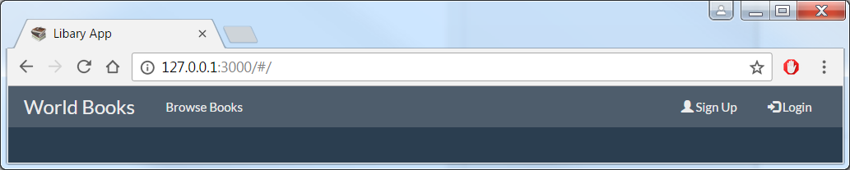

1. Confirm this behaves as a responsive page by making page smaller and ‘hamburger’ icon appears, and menu appears when clicked:

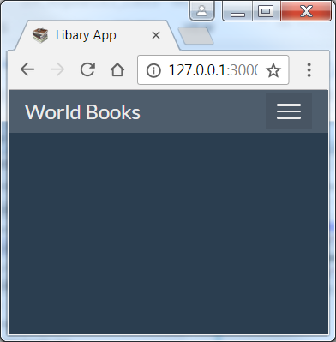 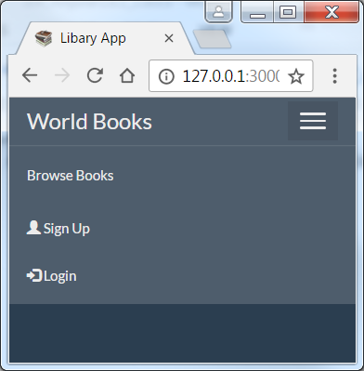

1. Open browser’s Developer tools (F12) and you should see 2 errors – related to missing home.html:

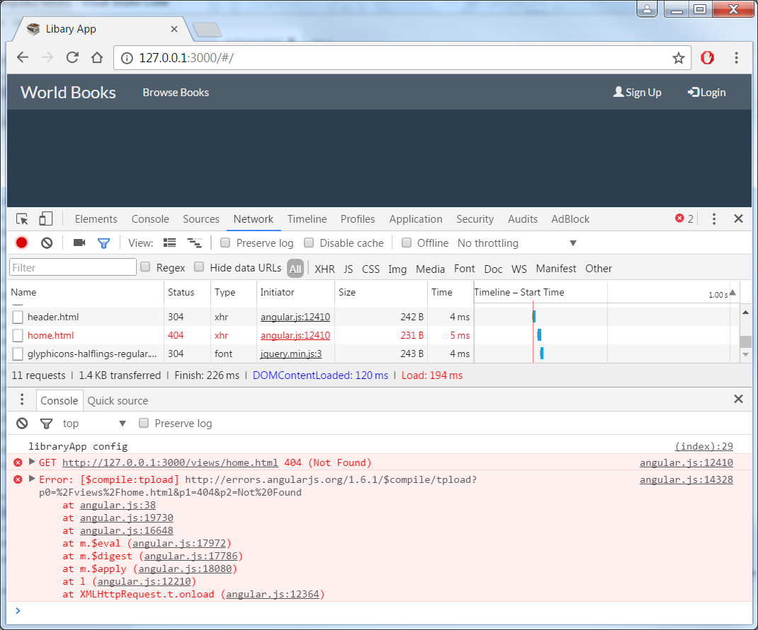

1. Inside ‘views’ folder add file home.html
2. Enter and save following code in home.html:

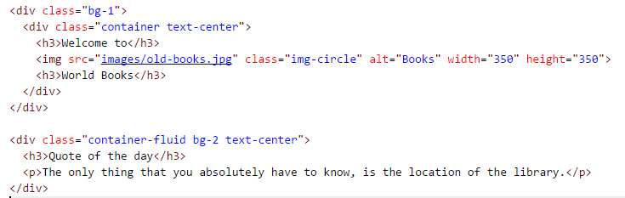

1. Re-open app in browser and ensure you are getting home page with old-books image:

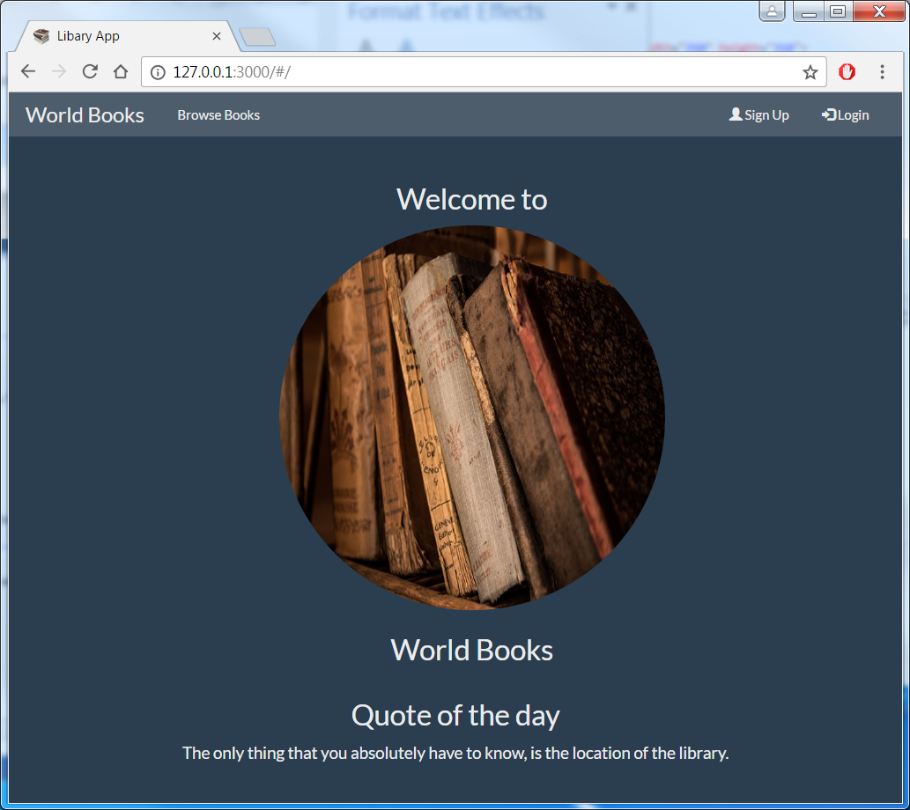

1. Open Developer Tools (F12) on browser and ensure there are no error.

