Download & Install quickstart Project

This section describes how to install the barebones project LibraryApp2 from quickstart from angular.io (from <https://angular.io/docs/ts/latest/quickstart.html>)

1. In a command window cd to d:\projects\vs
2. Now clone Angular 2 startup project into LibraryApp2 using git:

git clone https://github.com/angular/quickstart.git LibraryApp2

or download from <https://github.com/angular/quickstart>

1. Navigate to LibraryApp2 directory

cd LibraryApp2

1. Remove unnecessary files (these are for test/git…) using following commands:

for /f %i in (non-essential-files.txt) do del %i /F /S /Q

rd .git /s /q

rd e2e /s /q

1. Install all required modules (note npm inspects package.json to find out what to install):

npm install

1. Launch the sample application (again npm inspects package.json for the ‘start’ script which uses Angular’s dev lite-server):

npm start

You should see Hello Angular open in browser automatically

1. Stop application (Ctrl-C Y)

Create Home Page

This section will describe how to configure TypeScript’s JavaScript files

1. **Copy** from your previous LibraryApp the folder ‘scripts’ into .LibraryApp2/src/app (so you can reuse the bootstrap theme from LibraryApp)
2. **Copy** from your previous Librar App the folder ‘images’ into .LibraryApp2/src/app
3. **Copy** from your previous Librar App favicon.ico into .LibraryApp2/src/app
4. Open Visual Studio Code in folder LibraryApp2.
5. Open an integrated Terminal and start the Angular server in watch mode:

npm start

The Hello Angular message should appear in your default browser. Keep browser open as updates will automatically refresh the browser.

(Note: If you prefer you can turn on auto save File->Auto Save)

1. Update index.html
   1. Title

<title>Library App 2</title>

* 1. Reference default bootstrap or your own version (middle 3 lines below):

  <link rel="stylesheet" href="styles.css">

  <!-- Global User imported CSSs -->

  <link rel="stylesheet" href="https://maxcdn.bootstrapcdn.com/bootstrap/3.3.7/css/bootstrap.min.css">

  <!--<link rel="stylesheet" href="app/scripts/bootstrap/dist/css/bootstrap-superhero.css">-->

  <!-- Polyfill(s) for older browsers -->

* 1. Loading message

<my-app>Loading Library App 2's AppComponent content here ...</my-app>

(Note: Browser should be refreshing as you type/save as well as the output window in Integrated Terminal)

1. Add header to app.component.ts where <my-app> tag is defined (note use of back-ticks):

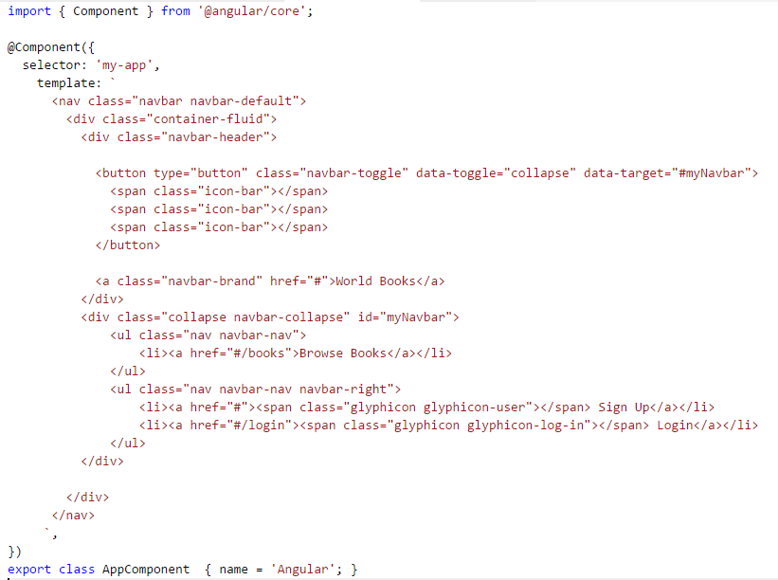

Should see the following familiar home page (without the old-books pic)

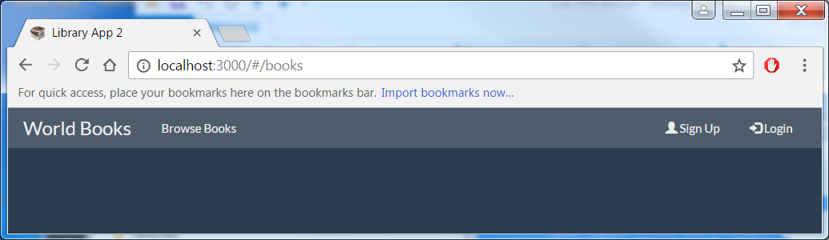

Clicking on the links – nothing such appear to happen

(Tip : Use the header.html file from LibraryApp to save on typing!)

Add Routing

In this section you will create the home, book-list& book pages that you will be able to navigate to

1. Under app directory create a home directory
2. Create file [home.component.ts](http://home.component.ts) and paste following code into it:

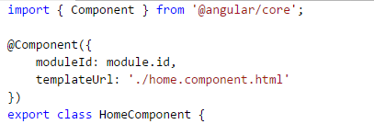

    quoteOfTheDay = 'The only thing that you absolutely have to know, is the location of the library.';

}

1. Create home.component.html and paste following code into it:

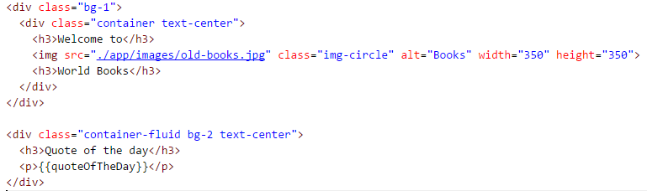

1. Modify app.component.ts’s template to include the [routeLink]s and <route-outlet> tag

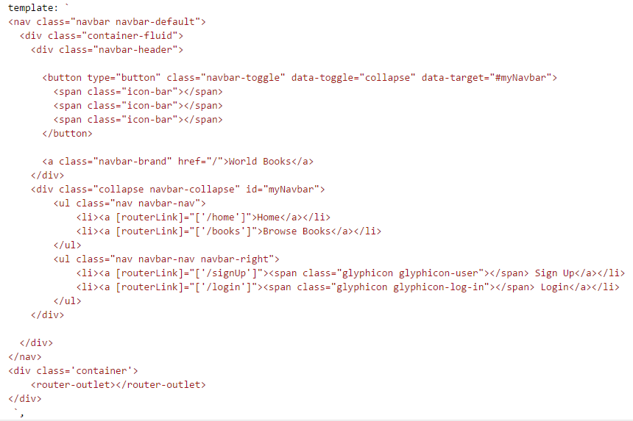

1. Back in app.module.ts add RouteModule to navigate to the home page:

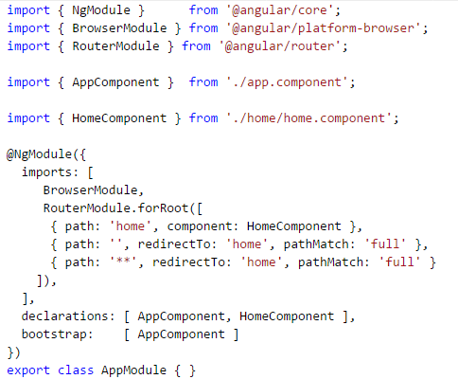

1. You should now see the home page with the library picture:

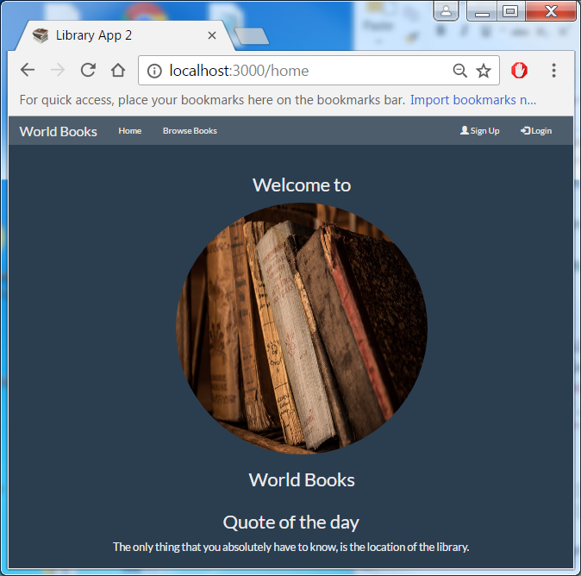

Now add in the books and book-list

1. Under app create folder books.
2. Create file book-list.component.ts in the books directory and paste following into it (note hardcoded set of books for now – not via DB yet).

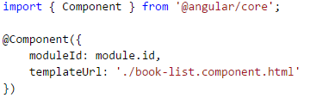

export class BookListComponent {

     books: any[] = [

        {'title': 'War and Peace', 'genre': 'Historical Fiction', 'author': 'Lev Nikolayevich Tolstoy', 'bookId': 656, 'read': false},

        {'title': 'Les Misérables', 'genre': 'Historical Fiction', 'author': 'Victor Hugo', 'bookId': 24280, 'read': false},

        {'title': 'The Time Machine', 'genre': 'Science Fiction', 'author': 'H. G. Wells', 'bookId': 2493, 'read': false},

        {'title': 'A Journey into the Center of the Earth', 'genre': 'Science Fiction', 'author': 'Jules Verne', 'bookId': 827174, 'read': false},

        {'title': 'The Dark World', 'genre': 'Fantasy', 'author': 'Henry Kuttner', 'bookId': 1881716, 'read': false},

        {'title': 'The Wind in the Willows', 'genre': 'Fantasy', 'author': 'Kenneth Grahame', 'bookId': 5659, 'read': false},

        {'title': 'Life On The Mississippi', 'genre': 'History', 'author': 'Mark Twain', 'bookId': 99152, 'read': false},

        {'title': 'Childhood', 'genre': 'Biography', 'author': 'Lev Nikolayevich Tolstoy', 'bookId': 33515440, 'read': false}

    ];

}

1. Create corresponding book-list.component.html and paste:

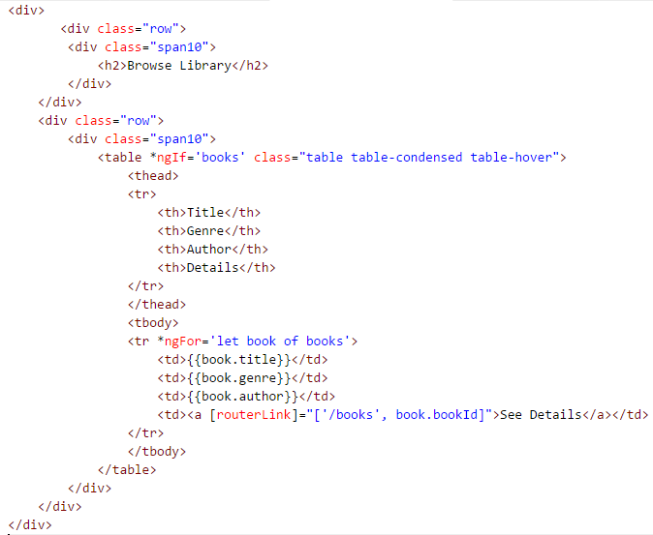

1. Add book.component.ts (in books folder)

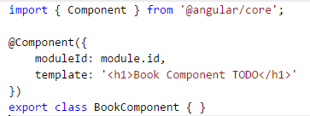

1. Now modify RouteModule to navigate to these pages

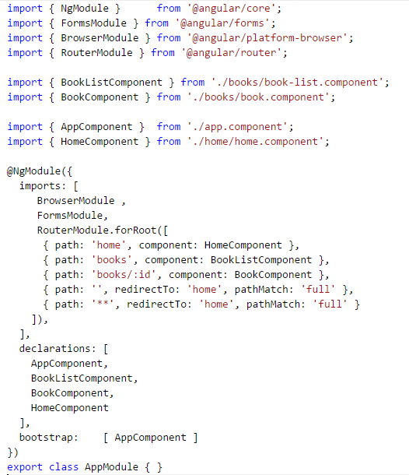

You should now be able to navigate to book-list and books

