Total time 10-15minutes:

# Download UCB Files

1. Download these files and unzip.

<https://fts.capgemini.com/private/24617392072182/UCB_DotNetFiles.zip> link valid until 2017-04-13 11:00 UTC (SSO protected)

<https://fts.capgemini.com/private/23096335397518/Ucb_Angular_TODO_11April.zip> link valid until 2017-04-21 15:00 UTC (SSO protected)

This is the old link – please ignor~~e~~[~~https://NOTTHISONEfts.capgemini.com/private/24617392072182/Ucb_2015.zip~~](https://NOTTHISONEfts.capgemini.com/private/24617392072182/Ucb_2015.zip) ~~link valid until 2017-04-13 11:00 UTC (SSO protected)~~

# Install MVC 4.00 DLLs

Your version of Visual Studio 2015 will have installed different versions of the DLLS from Visual Studio 2010. The Zip file contains Visual Studio 2010 files (this demo version of UCB has not been fully upgraded to 2015 .Net 4.5.1).

1. Open ‘UCB_DotNetFiles.zip’ – and double click folder ‘UCB_DotNetFiles’. You should see three folders.

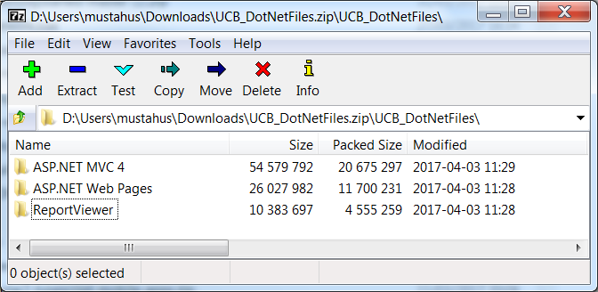

Keep this zip windows open for later use.

1. In Windows Explorer navigate to C:\Program Files (x86)\Microsoft ASP.NET
2. Rename the following two folders (append 2015_ to their name):

‘ASP.NET MVC 4’ to ‘2015_ ASP.NET MVC 4’

‘ASP.NET Web Pages’ to ‘2015_ASP.NET Web Pages’

1. From the opened zip file copy:

‘ASP.NET MVC 4’ to folder ‘C:\Program Files (x86)\Microsoft ASP.NET ‘

1. From the opened zip file copy:

‘ASP.NET Web Pages’’ to folder ‘C:\Program Files (x86)\Microsoft ASP.NET ‘

1. If folder ‘C:\Program Files (x86)\Microsoft Visual Studio 10.0’ does not exist create it.
2. From the opened zip file copy:

‘ReportViewer’ to folder ‘C:\Program Files (x86)\Microsoft Visual Studio 10.0’

1. Close the zip window.

# Restore UCB Application

1. Open ‘UCB_Angular_TODO_11April.zip’ – you should see one folder Ucb.
2. In Windows Explorer navigate to D:\Projects and create a folder DotNet
3. From the opened zip file copy:

‘Ucb to folder ‘D:\Projects\DotNet’

1. Close the zip window.
2. In folder Ucb, select Ucb.sln->RHC->Select Open with ‘Microsoft Visual Studio 2015’
3. If there there are any warnings simply accept them **EXCEPT this one**

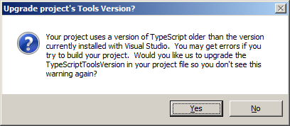**Select No**

1. In VS2015, in the Solution Explorer pane select UcbWeb->Reference

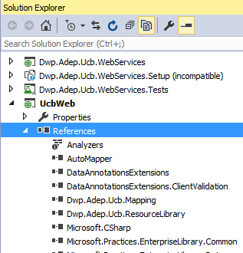

1. Select and Delete following References (if they exist):

Microsoft.ReportViwer.Common

Microsoft.ReportViwer.WebForms

System.Web.Helpers

System.Web.Mvc

System.Web.WebPages

System.Web.WebPages.Razor

1. Select UcbWeb->Reference->RHC->Add reference

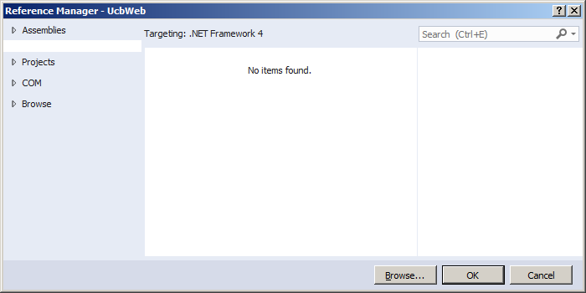

1. Select Browse and Add following 6 files (one at a time):

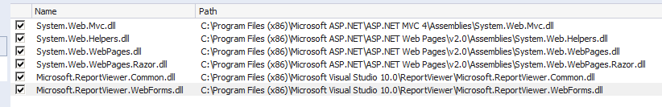

This is so that they reference the version just installed from the zip files.

1. Select project UcbWeb.Tests and repeat delete and add process but only for System.Web.Mvc

# Start SQL Server Services

1. Turn on SQL Server services from Windows Start -> SQL Server Configuration Manager
2. SQL Server Network Configuration -> Protocols for MSSQLSERVER -> TCP/IP-> (RHC) Enabled

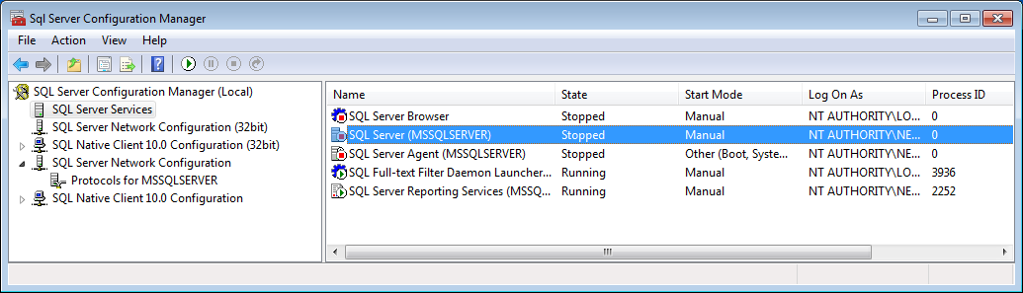

1. SQL Server Services -> SQL Server (MSSQLSERVER) -> (RHC) Start
2. SQL Server Services -> SQL Server Browser -> (RHC) Start

# Launch UCB

1. Press F5 to launch app.

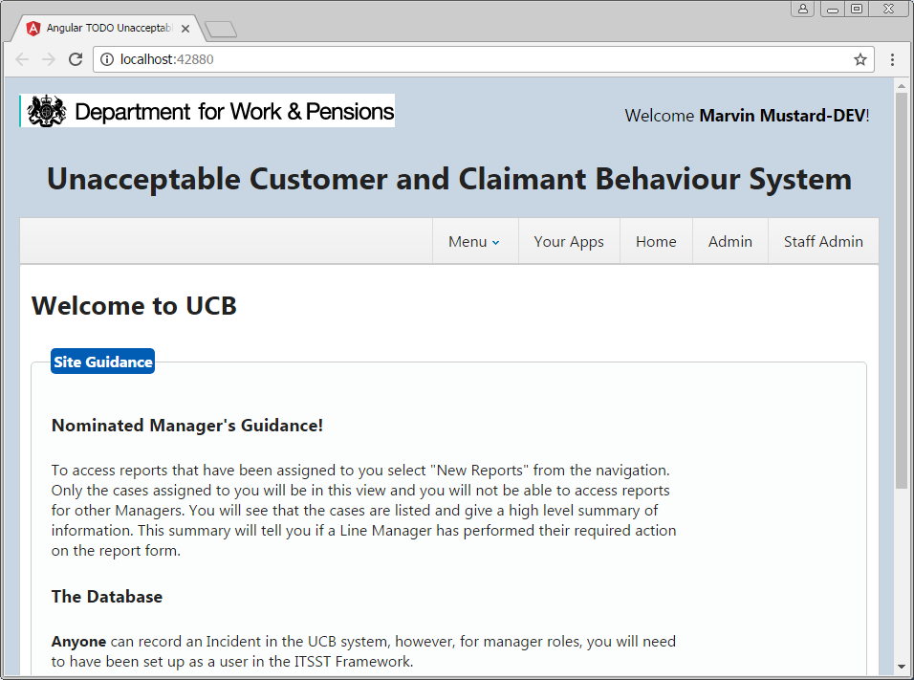

Congratulations you have successfully installed Dot Net version of UCB

1. Paste on to address bar following to see an existing Incident

http://localhost:42880/Incident/FindIncident?Code=E2E94A90-AEF1-4D7A-96AD-8CB7EDFEF2A3