# Installation of Visual Studio 2015 With Update 3

**Time ~1.5 hours**

<https://my.visualstudio.com/>

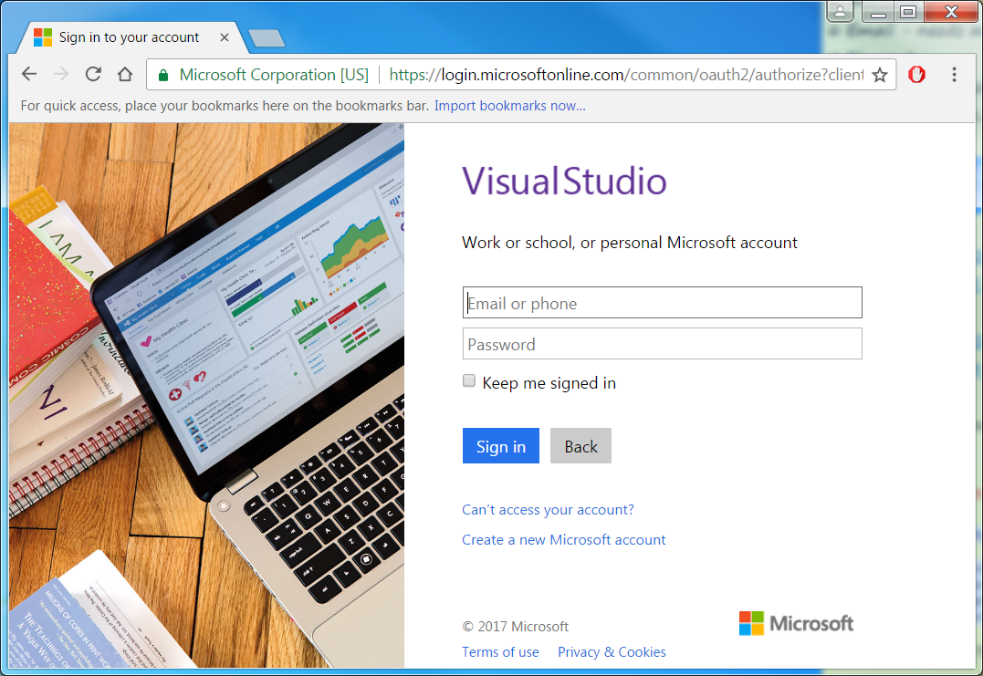

Enter your work email

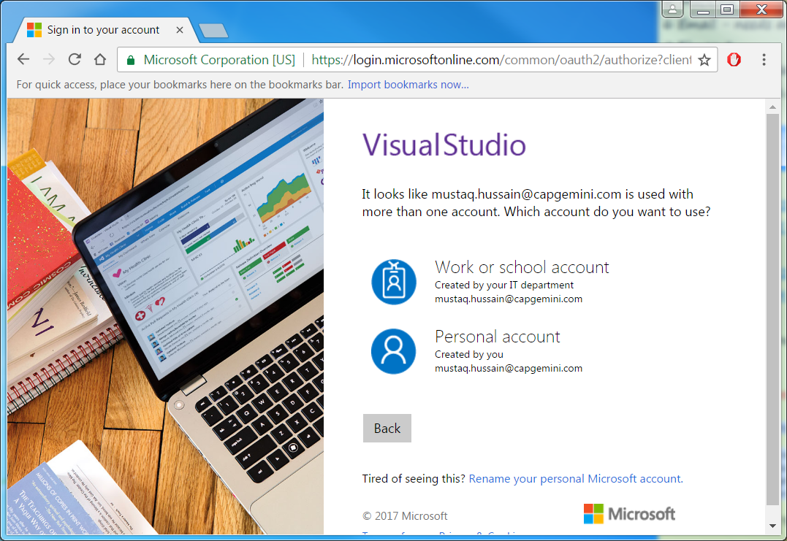

Select -> Personal account -> your password->Visual Studio->Download

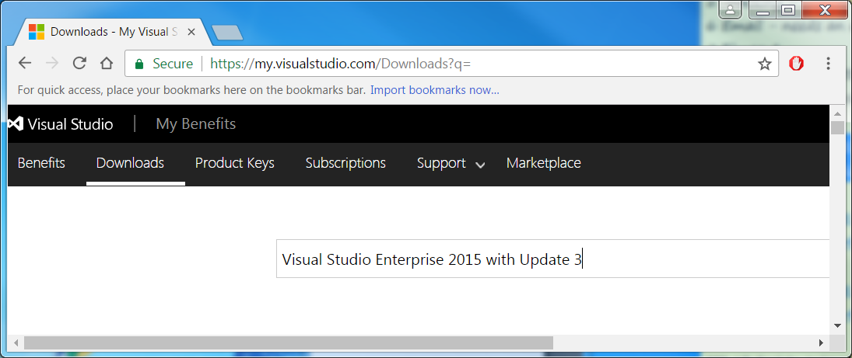

Enter-> Visual Studio Enterprise 2015 with Update 3

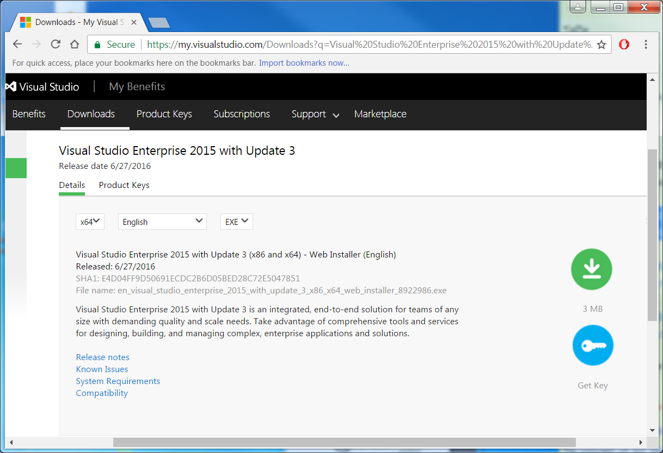

Select -> Get Key -> NOTE key

Select -> Details -> Download Icon -> Run download file (en_visual_studio_enterprise_2015_with_update_3_x86_x64_web_installer_8922986.exe)

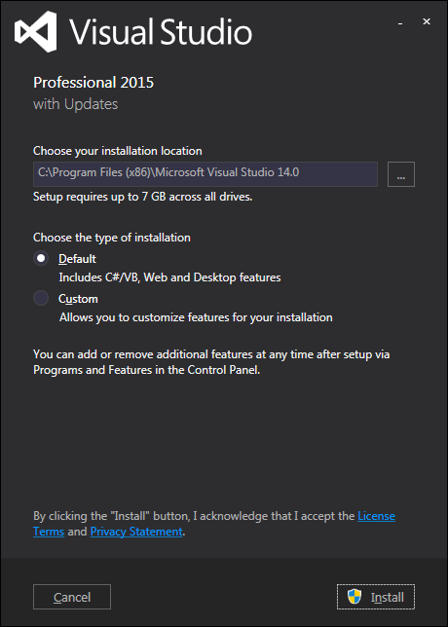

Select -> Install

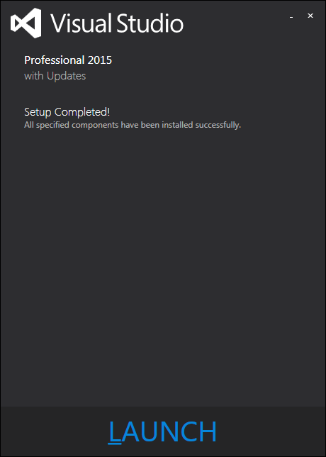

(~1:15 minutes later!)

Select -> Launch

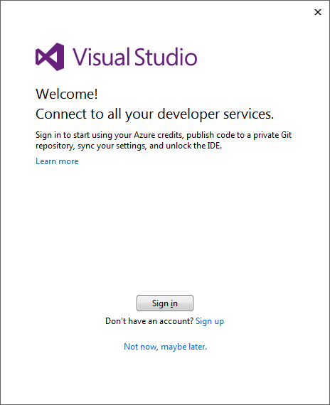

Select -> Not now, maybe layer

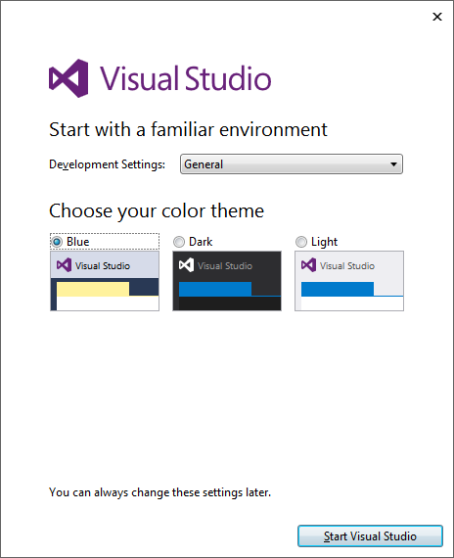

Select -> Start Visual Studio

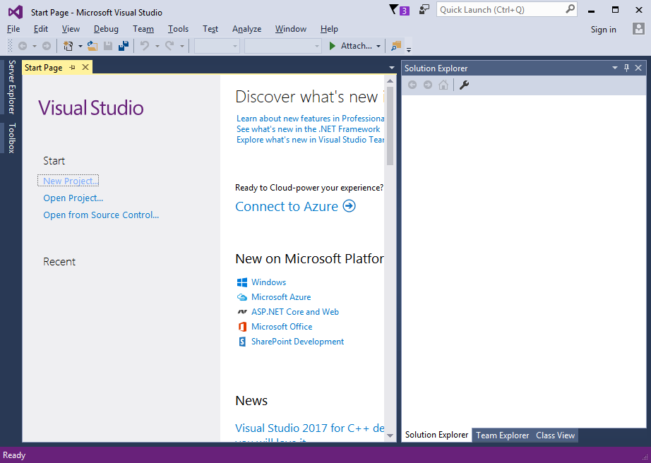

Select -> Help -> Register Product

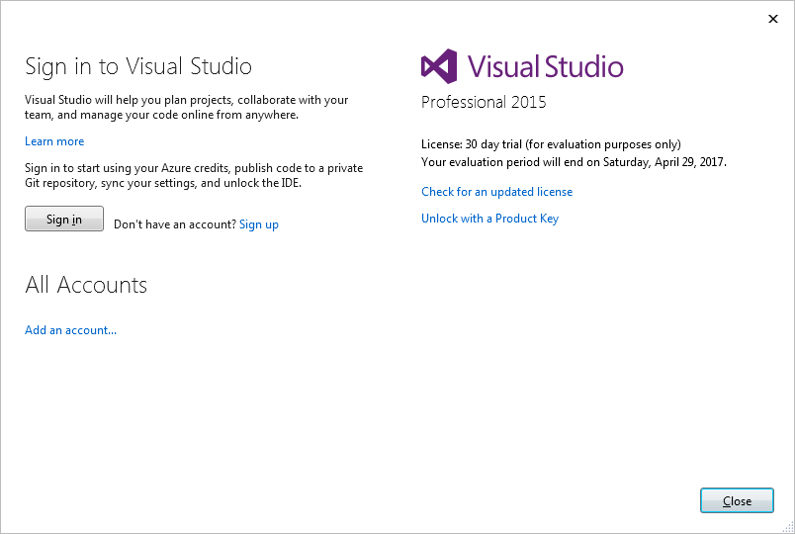

Select -> Unlock with a Product Key

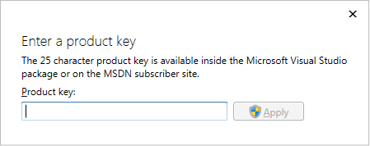

Enter product Key -> Apply

Close

Close Visual Studio