# Session 20

# 

Outline

1. Create one Windows and one Linux VM
2. Both in the same resource group
3. Install Node.js in both VMs
4. Update Windows Firewall rules
5. How to transfer files to/from laptop/VM

# Create Windows Node.js VM

1. Login to portal using

https://portal.azure.com

1. Create a Windows 2016 Datacentre VM:

In a resource group 'session20RG'

In a subnet 'webTier-sn'

With a Network Security Group ‘webTier-nsg’ (Firewall) with rules

: RDP (port 3389) priority 1000 -- For Windows

: SSH (port 22) priority 2000 -- For Linux in later section

: port 3000 open (for your Node server) priority 100

# Update Windows Firewall

You should have just created an Azure Network Security Group ‘webTier-nsg’ to allow connection via port 3000, but Windows too has its own Firewall and which has to be configured to allow connection via port 3000 (other ports are open by default such as 3389 for rdp, or port 80 if you install IIS).

1. Select Windows Icon-> Windows Administrative Tools->Windows Firewall with Advanced Security

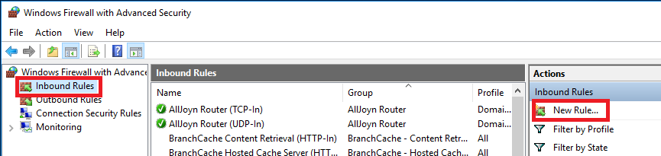

1. Select ‘Inbound Rules’->’New Rule…’

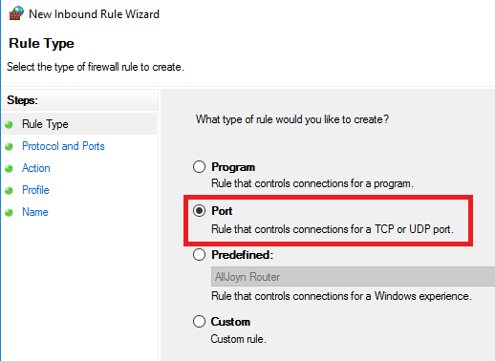

1. Select Port->Next

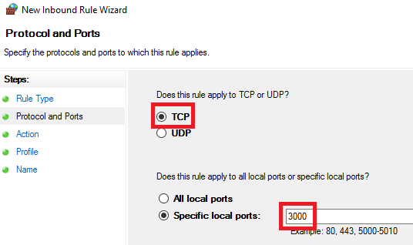

1. Select TCP->Specified local ports: 3000->Next->Next->Next

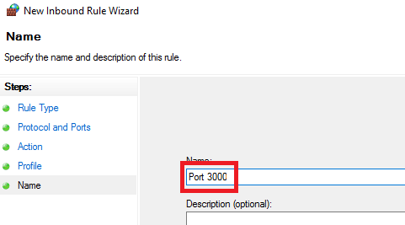

1. Name->Port 3000->Finish-> Close Windows firewall with Advanced security

# Install Node.js

1. Open browser in your Windows VM and save and install Node.js & NPM via

<https://nodejs.org/en/download/> (select Windows installer .msi 64-bit)

1. Open a command prompt and type 'node -v', 'npm -v' to confirm you have installed node & npm
2. Create a directory ‘hello’ for the node application
3. From this directory create a default project (accept all defaults)

npm init

1. Install Express

npm install express --save

1. Create file hello.js (make sure file is not saved as ‘hello.js.txt’) and paste in:

var express = require('express');

var app = express();

app.get('/', function(req,res) {

res.send('Windows say: Hello World!');

});

app.listen(3000, function() {

console.log('Example app listening on port 3000');

});

1. Start the Node.js server

node hello.js

1. From your Laptop browser, browser to node app

http://<Public IP>:3000

# Transfer Files From/To Laptop/Windows VM

If you want to transfer files from/to laptop/Windows VM you can configure RDP to do this. You will be able to transfer your existing Node.js application into the Cloud.

Note don’t transfer the ‘node_modules’ folder – use ‘npm install’ to regenerate

1. In your Downloads location locate the rdp file of your VM

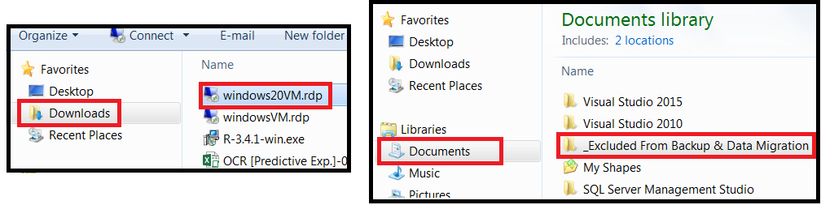

1. Select RDPFile->Right Mouse Click->Edit

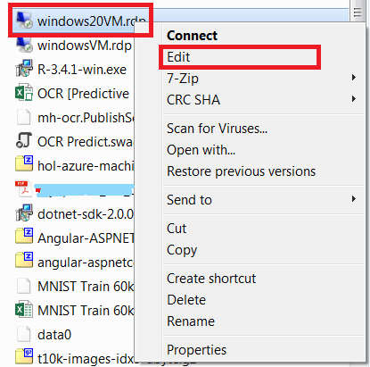

1. Select Local Resources->More

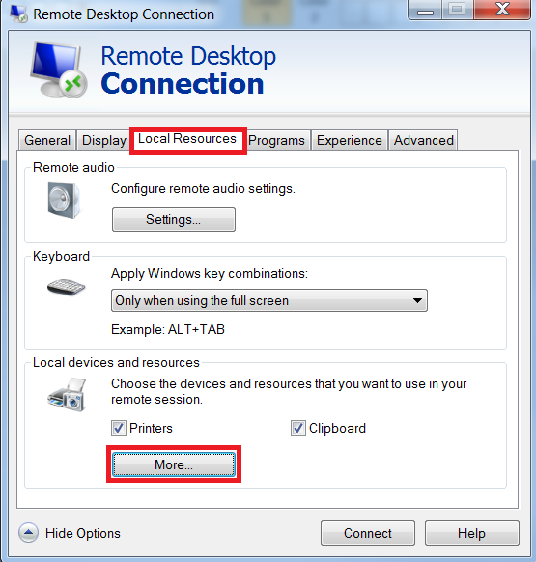

1. Expand Drives->Data (D:)->OK->Connect

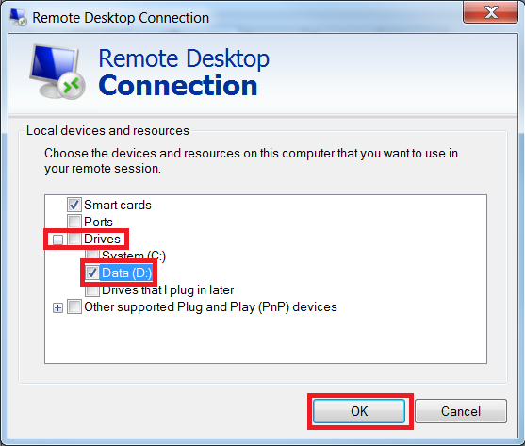

1. Connect and login as usual to your VM
2. In Windows VM open Windows File Explore->This PC

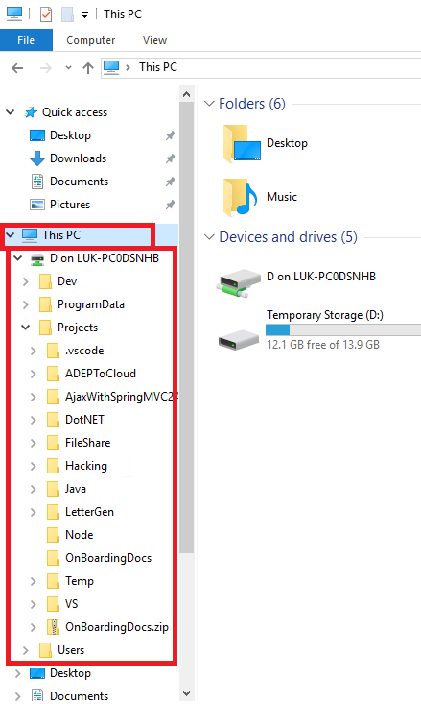

1. You can drag to/from your laptop/VM

# Ubuntu Node.js Virtual Machine

Create a Ubuntu server in the same resource group as the Windows server in the previous section.

1. From your Azure portal create a Ubuntu Server 16.04 LTS VM:

In the resource group 'session20RG'

In in the subnet 'webTier-sn'

With the Network Security Group ‘webTier-nsg’

1. SSH onto your Ubuntu server (using Putty)
2. Update new VM

sudo apt-get update –y

1. Install Node & NPM

curl -sL https://deb.nodesource.com/setup_6.x | sudo bash -

sudo apt-get install nodejs

sudo apt-get install build-essential -y

1. Open a command prompt and type 'node -v', 'npm -v' to confirm you have installed node & npm
2. Create a directory ‘hello’ for the node application
3. From this directory create a default project (accept all defaults)

npm init

1. Install Express

npm install express --save

1. Create a file ‘hello.js’ using ‘nano’ and paste in:

var express = require('express');

var app = express();

app.get('/', function(req,res) {

res.send('Ubuntu says: Hello World!');

});

app.listen(3000, function() {

console.log('Example app listening on port 3000');

});

1. Start the Node.js server

node hello.js

1. From your Laptop browser, browser to node app

http://<Public IP>:3000

# Transfer Files From/To Laptop/Linux VM

Use Putty Secure Copy (pscp) to copy files from/to Laptop/Linux VM

1. To copy recursively all your files from library app

pscp -l dwpadmin -pw Pass@word011 -r D:\Projects\VS\library <Public IP>:/home/dwpadmin/

# Remove Resource Group or Stop VM

1. Delete resource group if you have no need for it to stop incurring any charges at all or
2. Stop your VMs to stop incurring Instance charges – but you will still incur a storage charge for keeping image of your disk