# NOTE : Difference between V1 & V2 of this document is point 15 where you need to add which Cosmos DB DB to use made explicit

# Outline

From previous session, deployed Library App is trying to connect to MongoDB on localhost – which in Azure does not exist:

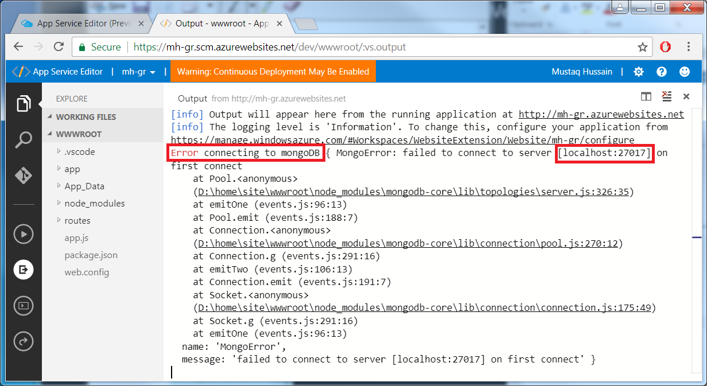

So need to change the connection string to point to MongoDB or equivalent.

Outline of session

* Create a Cosmos DB in Azure
* Import data from local mongoDB library app DB into Cosmos DB
* Change connection string to point to CosmoDB

Cosmos DB is:

* PaaS DB
* NoSQL DB
* Azure’s implementation of Mongo DB

Reference

<https://docs.microsoft.com/en-us/azure/app-service/app-service-web-tutorial-nodejs-mongodb-app>

<https://docs.microsoft.com/en-us/azure/cosmos-db/mongodb-migrate>

<https://docs.microsoft.com/en-us/azure/cosmos-db/connect-mongodb-account#connection-string-requirements>

# Create Azure Cosmos DB

In this section you will:

* Create a Cosmos DB account
* Create database ‘libraryAppDB’
* Create the collection (table in SQL) ‘books’
* Pick pricing tier (through-put capacity)

1. Select Azure Cosmos DB->Add and fill in ‘New account’ details followed by Create (this may take around 5minutes)

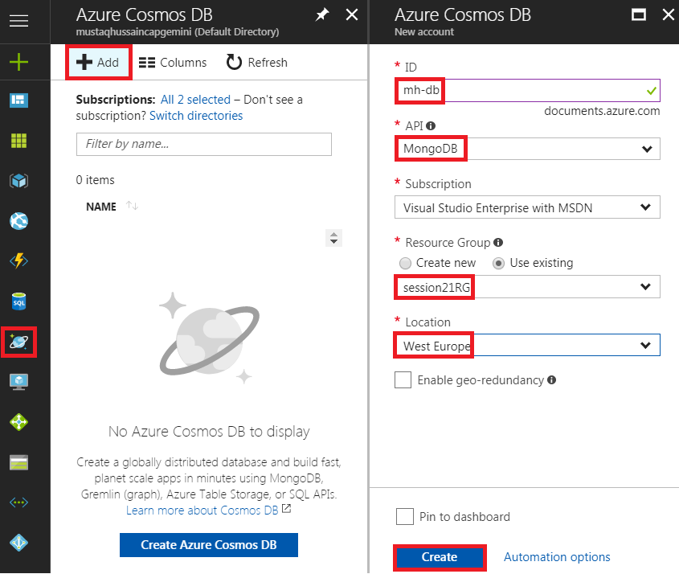

Note: ID must be unique across Azure Cosmos (try ‘YourInitials-db’)

1. Select Azure Cosmos DB->mh-db->Add Collection and fill as below

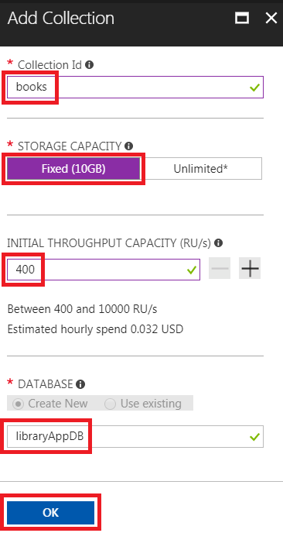

1. On Overview blade select ‘books’ collection

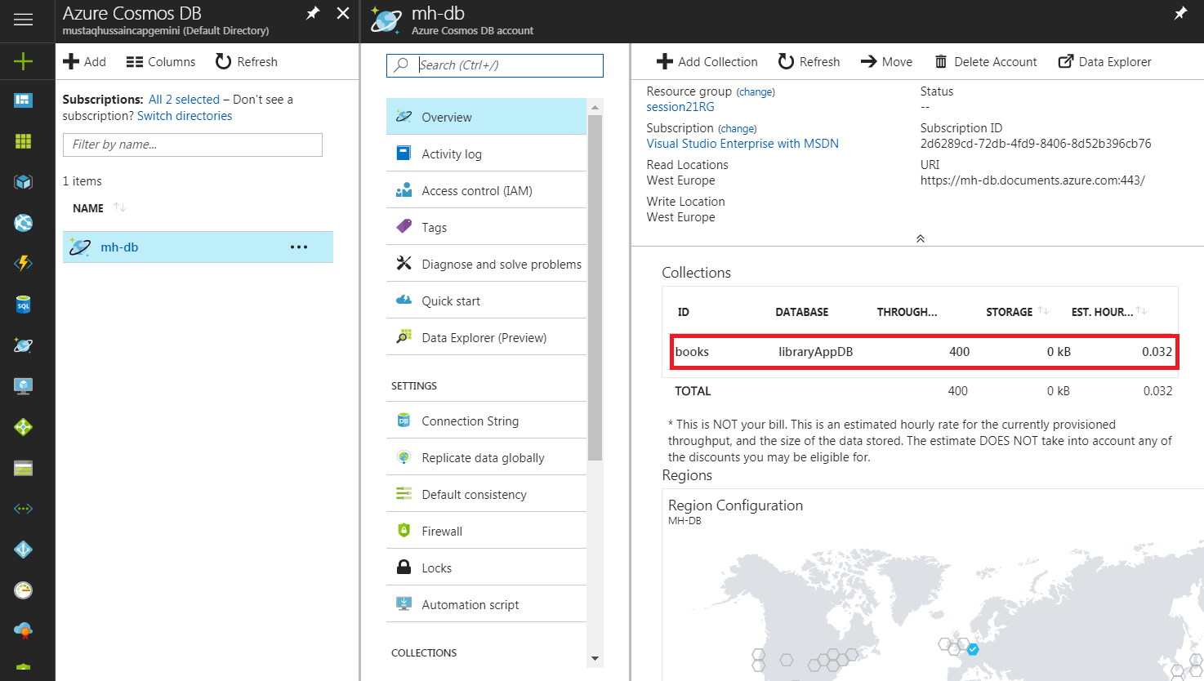

1. This opens the ‘Data Explorer’ blade, showing ‘books’ collection with no Documents (_id empty)

Note option ‘New Mongo Shell’ where you can enter mongo db commands to interrogate DB

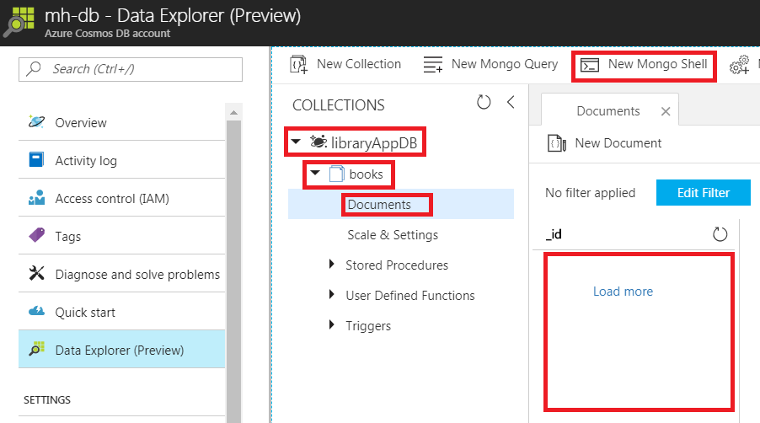

# Get Azure Cosmos DB Keys

1. Select Connection String and note keys (CONNECTION STRING) needed to communicate with your Cosmos DB for later use

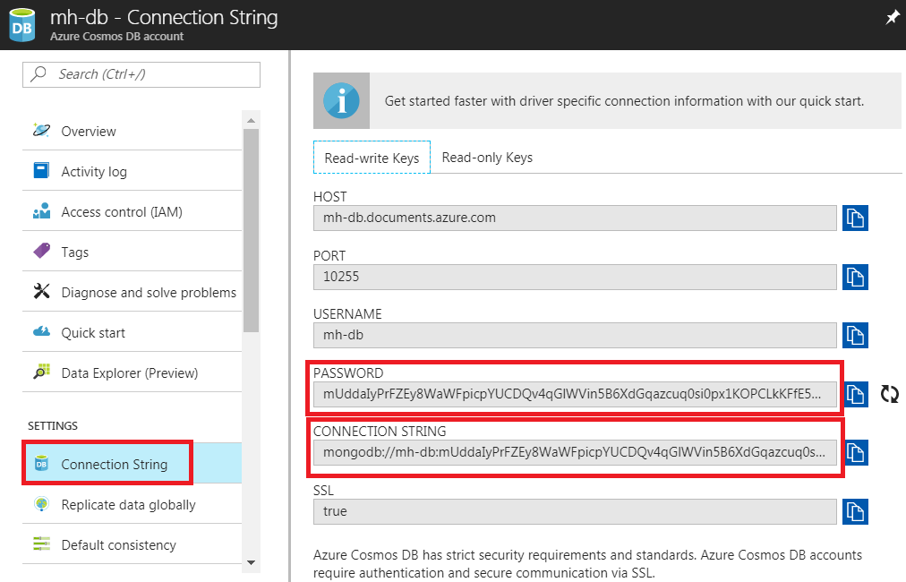

# Import Data into Azure Cosmos DB

Outline:

* Export the existing libraryApp data from your laptop instance of MongoDB
* Import data into your Azure Cosmos DB

1. Open a command prompt window in MongoDB bin location

(eg C:\Program Files\MongoDB\Server\3.4\bin)

1. Start MongoDB server:



1. Open another command prompt window in the same location
2. Enter following to extract from the ‘libraryApp’ DB the ‘books’ collection into a books.bson file (…/bin/dump/libraryApp/books.bson will be created)



1. Restore into Cosmos DB ‘libraryAppDB’ from ‘./dump/libraryApp/books.bson’ file, using your Cosmos DB HOST, PORT and PASSWORD from previous section

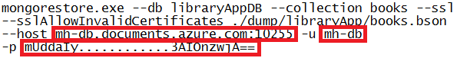

1. Switch back to Cosmos DB Data Employer blade to see restored data. Try pressing _id’s refresh icon, or delete (x icon) Document tab then select Documents under books (to refresh Documents tab). You should see restored data

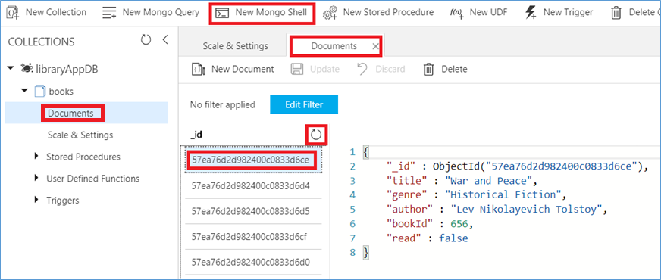

1. Press ‘New Mongo Shell’ and enter mongodb commands, such as db.books.find()

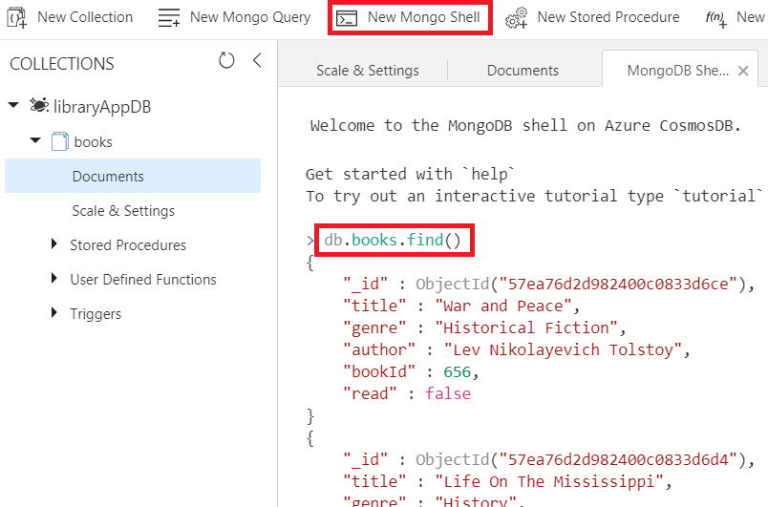

NOTE: For Step 9. If you have lost your copy of ‘libraryApp’ DB in MongoDB use this zip file. Unzip in MongoDB bin directory. Should have file …/bin/dump/libraryApp/books.bson



# Update App to Reference Azure Cosmos DB

1. Open a command prompt where your library app is (should be in directory session21-library (tip use SHIFT key to see ‘Open command window here’))
2. In command window start Visual Code (code followed by full-stop)

code .

1. Update app.js with your Cosmos DB CONNECTION STRING (note var url should be on one line) and inserting which db to use (libraryApp)



1. Open an Integrated terminal within Visual Studio Code (View->Integrated terminal)
2. In the terminal window commit change to your local Git and push up to Azure



1. Open up your deployed Library App and select ‘Browse Books’ to see books in collection in Cosmos DB

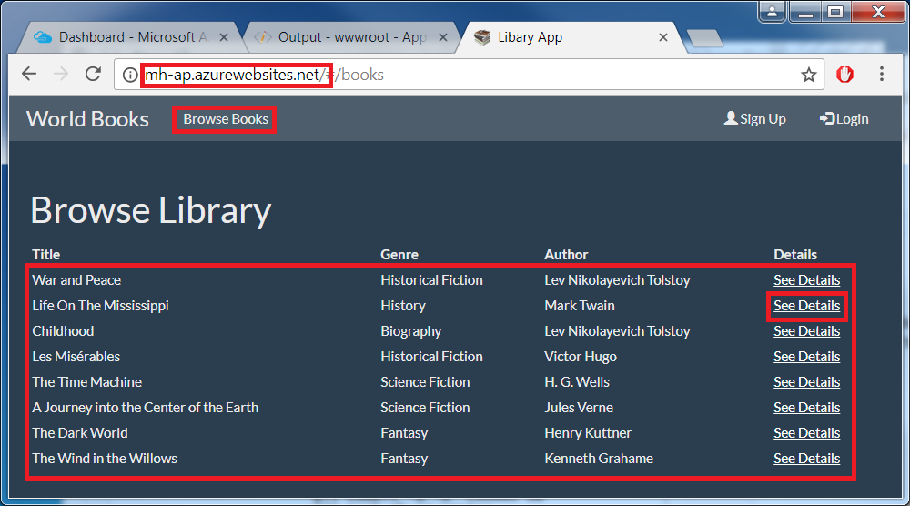

1. Click ‘See Details’ but this time it is empty

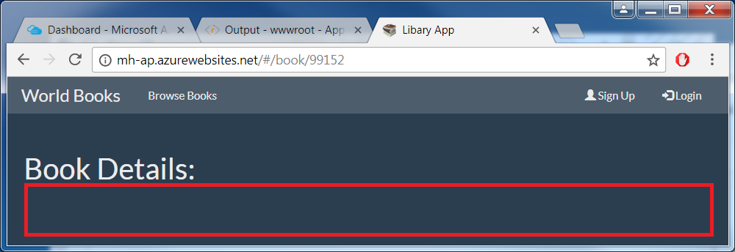

1. Back in App Server Overview blade select App Service editor (Preview)->Go

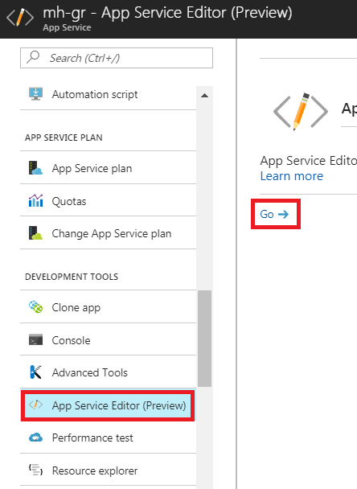

1. Select ‘Show Output’ to see exception thrown

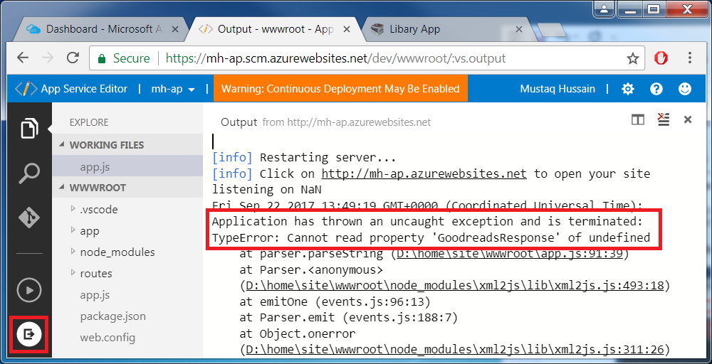

Exception is due to GoodReads API key no longer being valid in app.js

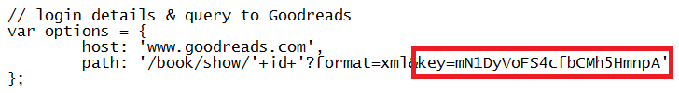

If you wish, register at GoodReads (<https://www.goodreads.com/api>) for your own API key.

Why not register and share key with rest of team?