# Comparison of Linear Regression and Random Forest Regression

This document visually compares the performance metrics of Linear Regression and Random Forest Regression models. A logarithmic scale is used to highlight differences in error magnitudes and accuracy metrics.

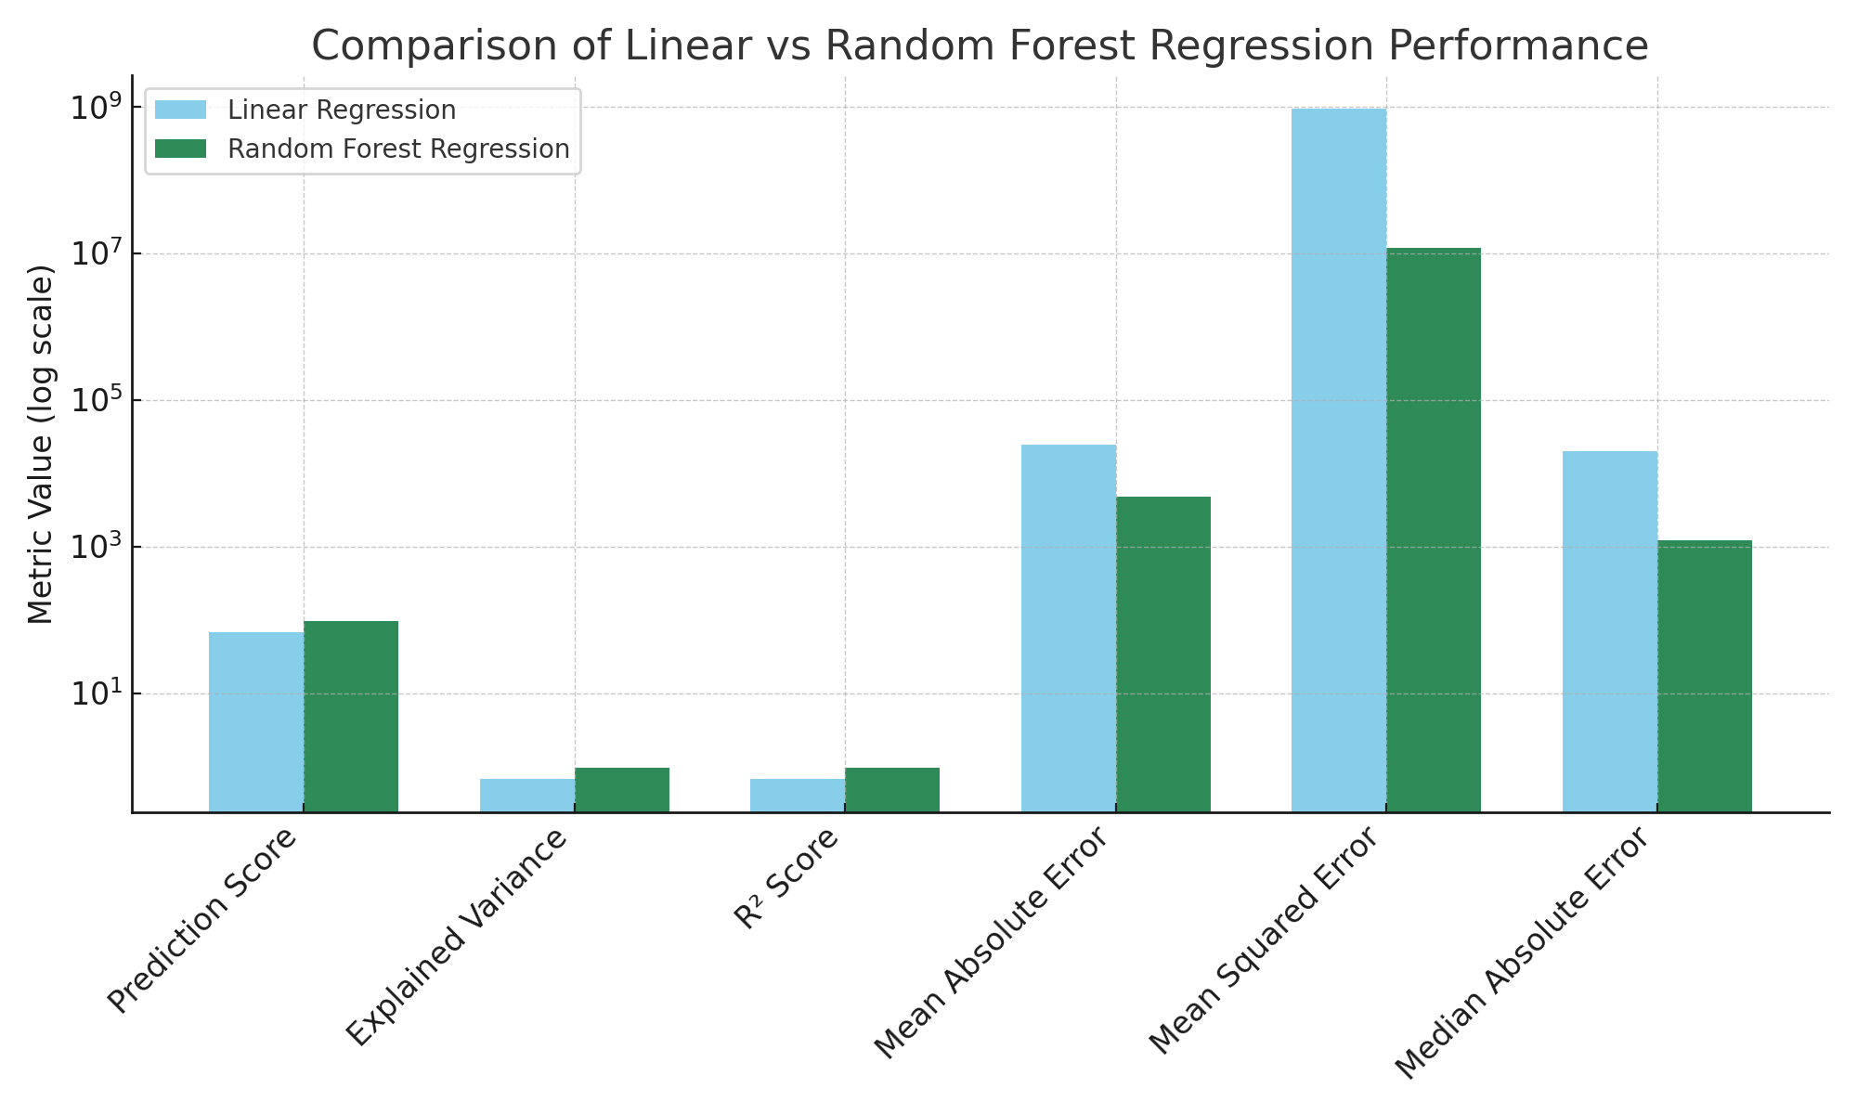

Key Insights:

- Random Forest Regression outperforms Linear Regression in prediction accuracy (higher Prediction Score, R², and Explained Variance).  
- Error metrics (MAE, MSE, and Median AE) are significantly lower for Random Forest, indicating better model reliability.  
- This justifies the transition from a Linear Regression algorithm to a Random Forest Regression algorithm.