Baarsma NA, Niels

[Email address]

Abstract

[Draw your reader in with an engaging abstract. It is typically a short summary of the document.   
When you’re ready to add your content, just click here and start typing.]

[Document title]

[Document subtitle]

Table of Contents

1. Network 2

1.1 IP Management 2

1.2 Security 2

# Network

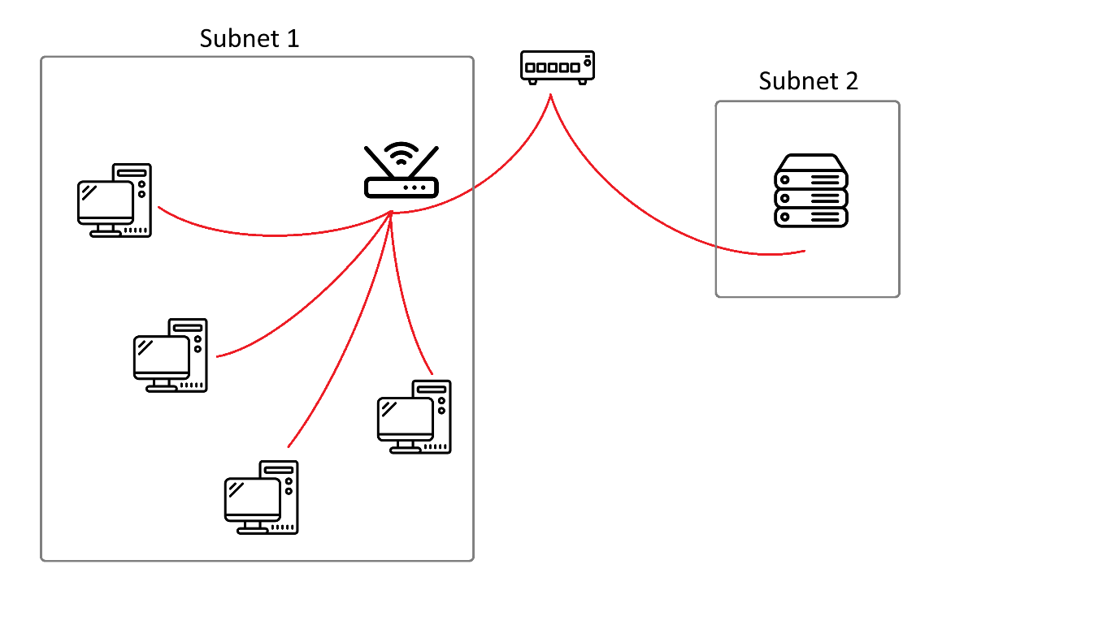

## IP Management

The network’s IP addresses will be assigned by the DHCP server. The DHCP should be hosted on the main network provided by the switch.

Both the router in subnet 1 and the server in subnet 2 must have a static IP address.  
The hosts connected to the router in subnet 1 can be assigned a dynamic IP address.  
This can be configured by assigning an IP address to the server and the router through the interface of the DHCP server. This way it is ensured that these devices will always be reached on the same address.

## Security

To improve network security a firewall will be deployed on both subnets. The router comes with an integrated firewall and allows for NAT. The server will only allow certain traffic bound to the following ports:

* Port 80/TCP (apache2 / http)
* Port 53/TCP&UDP (DNS)
* Port 443/TCP (apache2 / https)
* Port 5000/UDP (VoIP-service)