## Introduction

The Adaptive Case for PS4 Controller is an inexpensive and non-destructive controller modification designed to make the stock PS4 controller more accessible. This device aims to assist those with limited hand dexterity by enlarging and spreading out the buttons on the PS4 controller. This device can be mounted to a surface so that both hands can freely operate the controls.

## Features

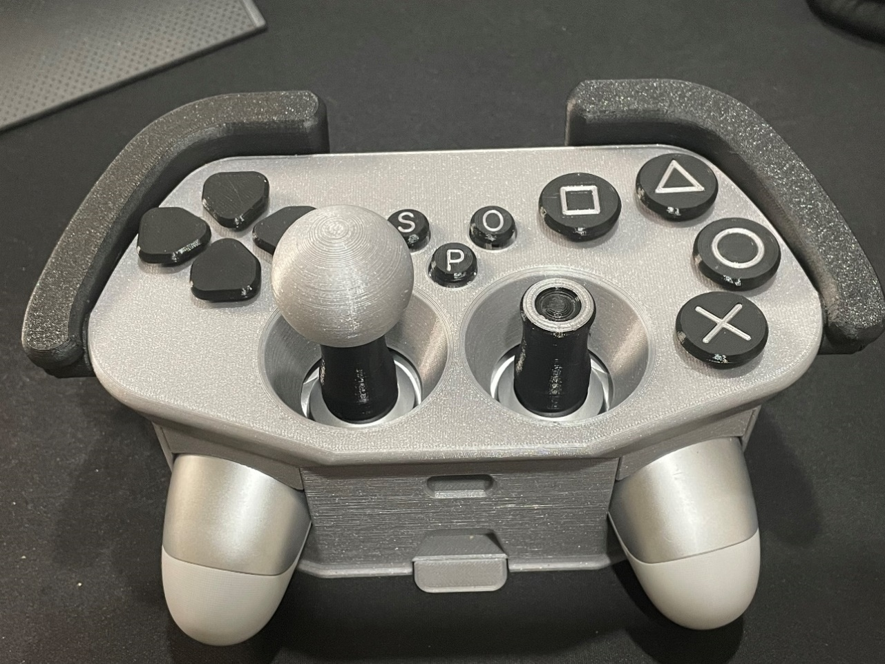

## Compatibility

Note that the PS4 controller can be used for PC based gaming.

**Platforms:** PlayStation 4, PC

**Controllers:** DualShock 4 Controller

## Specifications

|  |  |  |  |
| --- | --- | --- | --- |
| **Weight (Case only)** | **Length** | **Width** | **Height** |
| ~200g | ~22 cm | ~12 cm | ~8 cm |

## Usage

To use this device, the DualShock 4 controller must be mounted into the case and the preferred joysticks installed onto the remote.

### Installing the Controller

To install the PS4 controller into the adaptive case, lift the top of the case and swivel it behind as shown below. Place the controller into the case and resecure the top by aligning the lip of the case with the slots in the top face. Press firmly to snap these two halves together.

**Note:** Joysticks can only be installed once the controller has been mounted.

|  |
| --- |
| A grey and black 3D printed adaptive case with the top removed and swiveled behind. The inside of a half opened adaptive case showing a PS4 controller inside.  A PS4 controller inside a grey and black 3D printed adaptive case |

To remove the controller from the case, follow the installation instructions in reverse order, starting by removing the large joysticks as they will not fit through the top face.

### Installing the Joysticks

There are a few different adaptive joystick options that are shown in the next section. Place each half of the 3D-printed screws around the joysticks on the controller. Press the halves together to form a solid screw and thread on your preferred joystick topper.

|  |
| --- |
| A close up of a grey and black ball shaped joystick and a black cylindrical joystick. A close up a 3D printed joystick being screwed onto a PS4 controller that's mounted inside an adaptive case. A grey and black 3D printed adaptive case with a helper joystick attached. |

### Joystick Topper Options

|  |  |
| --- | --- |
| **Topper Design** | **Usage** |
| Extended Joystick  A black 3D printed joystick topper with a concave top. | A standard extended joystick topper with a concave top face for grip. To allow room for both joysticks to move, it is recommended to use this topper along side one of the others. |
| Ball Joystick | The ball joystick topper gives lots of room to grip the controller’s joystick. Its length allows the joystick to be operated with very little force. |
| Ring Joystick | The Ring Joystick allows you to insert a thumb finger into the topper to aid in controlling the joystick. |
| Helper Joystick | The helper Joystick adds a second Joystick topper that can be operated by another user. This allows secondary users to help wait with the controllers. |

### Mounting the Device

This device comes with an optional dock that allows you to secure the adaptive case to a table or surface. This may benefit users who find it challenging to hold onto the device. The low profile “Dock” can be screwed to a surface before sliding in the case to click-lock it in place. The front tab can be pushed down to unlock and remove the case from the dock.

|  |
| --- |
| A grey low profile 3D printed dock with four holes to allow it to be screwed to a surface.A close up of an adaptive case being slid into a dock. A close up of an adaptive case being secured into a dock with a front tab. |

## Cleaning

The device can be cleaned by disassembling and removing the controller before wiping down the pieces with a damp cloth or plastic safe cleaning wipes.