**Decomposing to Subtract**

Hi Student.

Happy to work with you today.

For today, we are going to work on the topic “Decomposing to Subtract.”

As a reminder, you can use a microphone to speak directly instead of typing in the chat window.

Would you like to communicate through a microphone or through the chat window?

CFU question:-

What is called difference?

Decompose means to break down into smaller pieces.

An equation is a number sentence where both sides are equal to each other.

Addend is a number added to another number.

The sum is the total of the numbers added together.

The difference is the answer when subtracting one number from another.

Subtrahend is the number taken away from the minuend to get the difference.

The minuend is the first number in a subtraction problem.

I DO: -

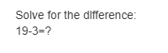

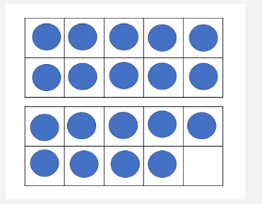

Start with the minuend or whole and fill in the frame with 19.

The equation says subtract or take away 3.

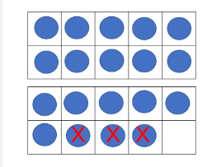

After take away 3.

There are 16 left.

So, the answer will be 16.

_____________________________________________________________

WE DO QUESTION:-

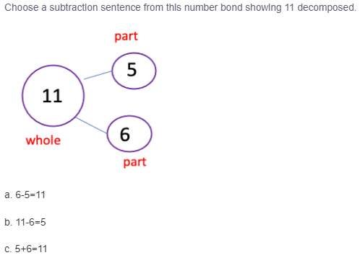

In this question, we need to choose to subtract sentences from numbers.

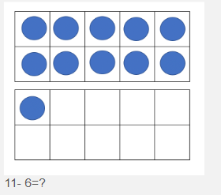

We start with the number 11.

To find the difference, decompose the subtrahend or smaller number, so you make a friendly ten first.

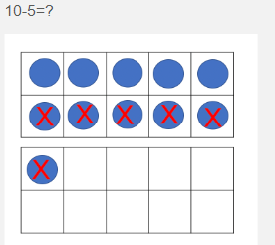

The correct answer is Option A.

______________________________________________________________

Would you like to start this problem?

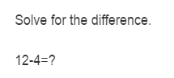

In this question, we need to find the difference between 12 and 4.

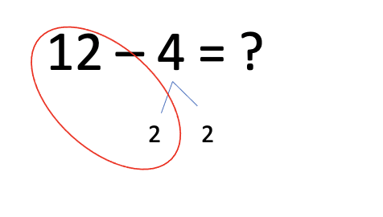

Start with the minuend and think how to decompose the subtrahend to make a friendly 10.

When there is a friendly ten, you can mentally subtract.

Two more because we decomposed four into 2 and 2.

The difference between 12 and 4 is 8.

The answer will be 8.

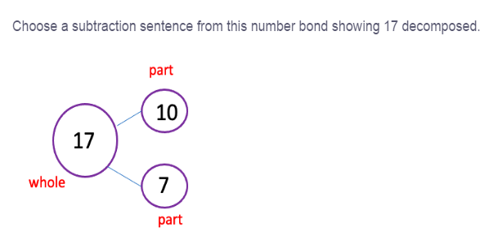

In this question, we must subtract the sentence from the number bond showing 17 decomposed.

When you have an equation with equal numbers in the one's column, you can remove seven from 17 because it decomposes into 10 and 7.

______________________________________________________________

YOU DO QUESTION:-

In this first section, I will model how to solve problems related to the lesson. Please ask questions about any of the steps along the way.

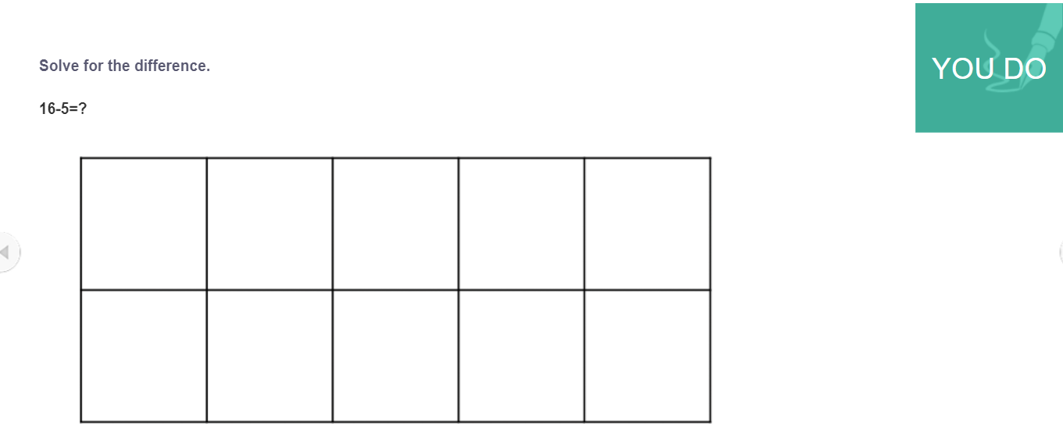

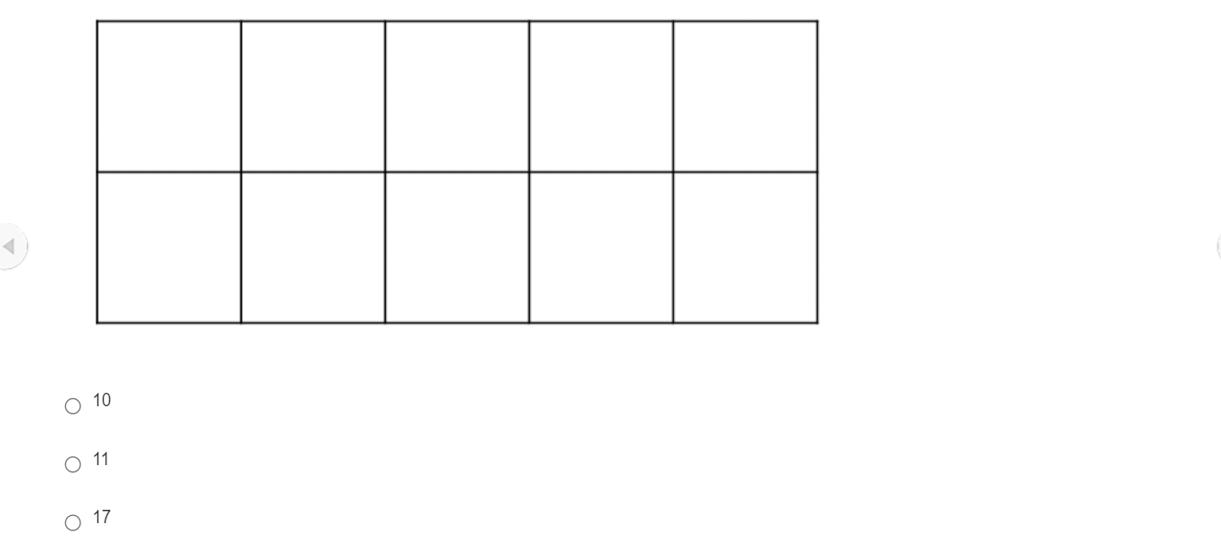

We are asked to find the difference between 16 - 5 = 11

Option C

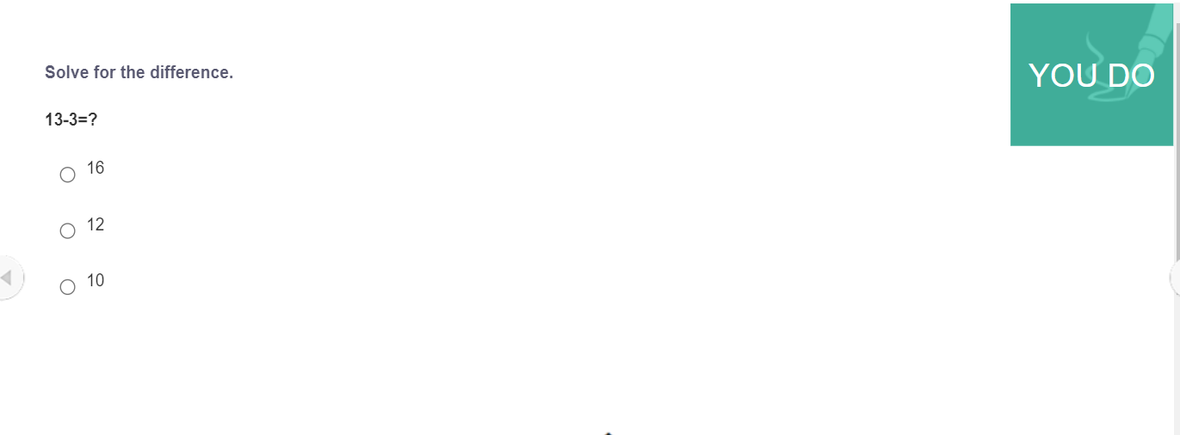We need to find the difference between the numbers 13 and 3.

13 - 3 = 10.

Option C.

_______________________________________________________________

EXIT TICKET QUESTION:-

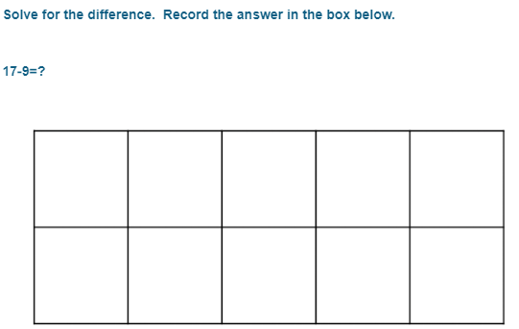

In this question, we need to find the difference between 17 - 9.

We need to use the frame to find the difference.

17 - 9 = 8.

Therefore, the final answer will be 8.

________________________________________________________

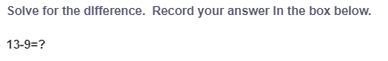

In this question, we are asked to find the difference between 13 - 9.

The answer will be 13 - 9 = 4.

Therefore, the answer will be 4.

_________________________________________________________