2.OA.1.3.Counting On

Hi Student.

Happy to work with you today!

Would you like to communicate through a microphone or through the chat window?

Today we will work on the topic “Counting On.”

What do you know about Addition?

The addition is a way of combining things and counting them together as one large group.

Addition in math is a process of combining two or more numbers.

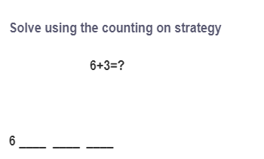

This is your first I-Do question.

Start with the largest number of addends.

Count on the number of the smaller addend.

Start at six, the largest number, and count on three more.

Write or type 7, 8, and 9 on lines after the number six.

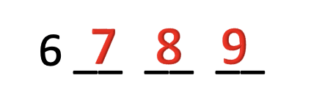

Check your work by making sure the number of spaces to count on matches the smallest added.

The sum of 6 and 3 is 9.

Let’s move on to the next question.



In this question, we need to solve using counting with a number line strategy.

And find the sum of 5 and 7.

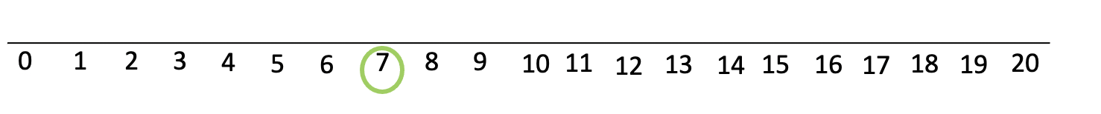

Circle number 7 on the number line.

Another strategy for counting is using the number line.

Start with the largest addend and mark that number on the number line.

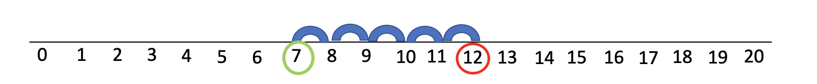

Starting on number seven, we take five hops.

Circle the number you land on.

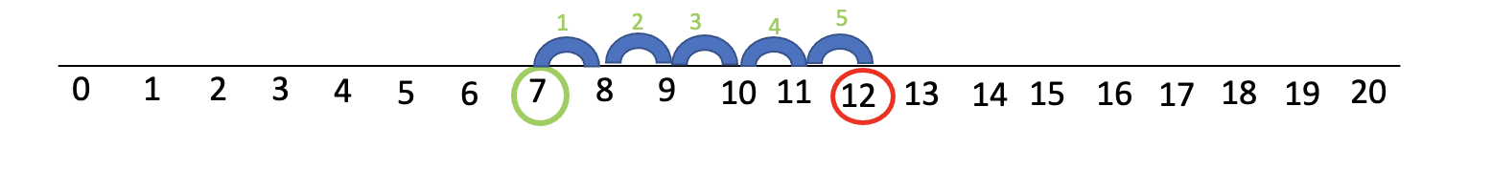

When we add 5 to 7, it equals 12.

To check your work, be sure you started at the largest addend.

Then number the hops to see if they equal the smaller addend.

Therefore, the answer is 12.

_____________________________________________________________________.

Here is a similar example.

Would you like to start this problem?

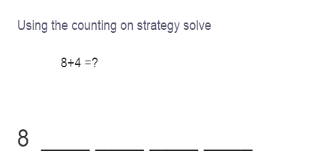

Point to the 8 with four lines after it.

Start with the largest number or add.

Count on the number of the smaller addend.

Fill in the lines after the eight by counting on them.

8 9 10 11 12

The smallest addend is 4, with four spaces to count on.

Therefore, the answer is 12.

Let's look at another example.

Would you like to help me start this one?

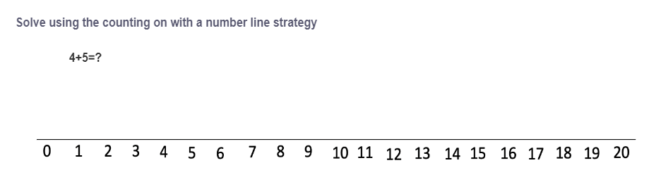

Start with the largest addend and mark that number on the number line.

Circle the number 5.

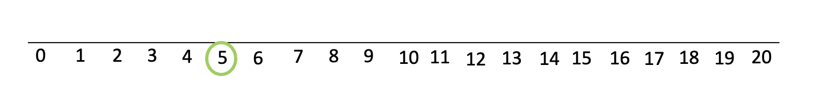

Starting on number five, we take four hops.

Circle the number you land on.

Circle number 9.

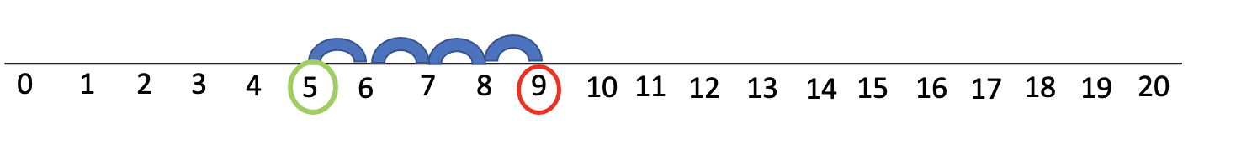

When we add 4 to 5, it equals 9.

To check your work, be sure you started at the largest addend.

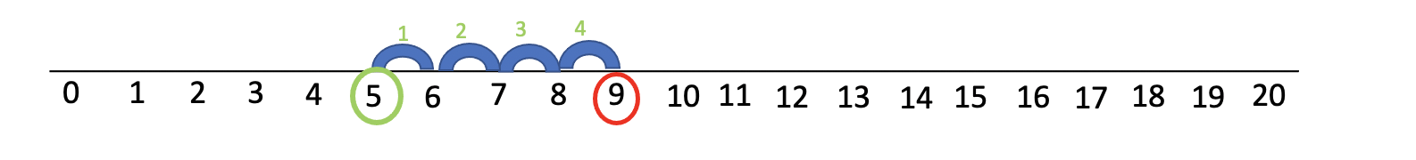

Then number the hops to see if they equal the smaller addend.

Therefore, 9 is the answer.

Time for independent work!

 Use what you've practiced completing the next few problems on your own.

Please do all of your work in the space provided so that I may help you if you get stuck.

You may use your notes too.



In this question, we need to add 5 and 6.

Point to the 6 with five lines after it.

Start with the number or add.

Count on the number of the smaller addend.

Fill in the lines after the six by counting on them.

6 7 8 9 10 11

The smallest addend is 5, and there are five spaces to count on.

Therefore, the answer is 11.

Let us now be directed to the next question.



In this question, we need to find the sum of 14 and 5.

Point to the 14 with 5 lines after it.

Start with the largest number or added.

Count on the number of the smaller addend.

Fill in the lines after the five by counting on them.

14 15 16 17 18 19

The smallest addend is 5 and there are five spaces to count on.

Therefore, the answer is 19.

Here comes our next question.



In this question, we need to add 4 and 9.

Point to the 9 with 4 lines after it.

Start with the largest number or added.

Count on the number of the smaller addend.

Fill in the lines after the four by counting on them.

9 10 11 12 13

The smallest addend is 4 and there are four spaces to count on.

Therefore, the answer is 13.

Now it is time for you to show what you have learned by completing the Exit Ticket.

Work hard on all 3 questions to earn 100%.

You will have a chance to earn 3 points for every question.

This is our first exit-ticket question.

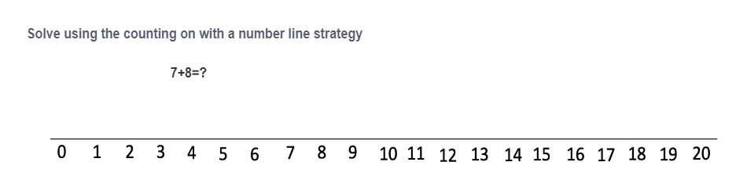

In this question, we need to find the sum of 7 and 8.

The sum of 7 and 8 is 15.

Therefore, Option C is the correct answer.

This is your next exit-ticket question.



In this question, we need to find the sum of 6 and 7.

Start with the largest number or added.

Count on the number of the smaller addend.

Fill in the lines after the four by counting on them.

The sum of 6 and 7 is 13.

Therefore, option A is the correct answer.

Now you'll see the next question on board.



In this question, we need to find the sum of 11 and 5.

Start with the largest number or added.

Count on the number of the smaller addend.

Fill in the lines after the four by counting on them.

The sum of 11 and 5 is 16.

Therefore, Option C is the answer.

You worked really hard in today's lesson.

I would like to hear some of your feedback.

Please complete the survey before you leave.

Thanks, and enjoy the rest of your day!