Software Requirements Specification
for
Generational Run
Version 1.0 approved
Prepared by:
Fatima Imran 21L-5166
Hadi Ali Bhatti 21L-5426
Mustaqim Afzal 21L-7605
Rafay Junaid 21L-7607
Software Engineering Section 6F
31st March 2024
Table of Contents
Table of Contents ii
Revision History ii
1. Introduction 1
1.1 Purpose 1
1.2 Document Conventions 1
1.3 Intended Audience and Reading Suggestions 1
1.4 Product Scope 1
2. Overall Description 1
2.1 Product Perspective 1
2.2 Product Functions 1
2.3 User Classes and Characteristics 2
2.4 Operating Environment 2
2.5 Design and Implementation Constraints 2
2.6 User Documentation 2
2.7 Assumptions and Dependencies 3
3. External Interface Requirements 3
3.1 User Interfaces 3
3.2 Hardware Interfaces 3
3.3 Software Interfaces 3
3.4 Communications Interfaces 3
4. System Features 3
4.1 Endless Side-scrolling Gameplay 3
4.2 Multi-Generational Tools and Obstacles 4
4.3 Scoring and Leaderboard 5
4.4 Audio and Visual Effects 5
4.5 Character Controller 6
4.6 Save and Load Progress 6
4.7 Game Menu 7
5. Other Nonfunctional Requirements 7
5.1 Performance Requirements 7
5.2 Safety Requirements 7
5.3 Security Requirements 7
5.4 Software Quality Attributes 7
5.5 Business Rules 8
6. Other Requirements 8
Appendix A: Glossary 8
Appendix B: Analysis Models 9
Appendix C: To Be Determined List 22

Revision History
Name | Date | Reason For Changes | Version

Introduction

Purpose
This Software Requirements Specification (SRS) document describes the requirements for "Generational Run", a 2D side-scrolling platformer game for Windows. The game is an endless side-scroller that merges different eras seamlessly, requiring the player to utilize multi-generational tools to overcome obstacles.

Document Conventions
- Requirements are given a unique identifier "REQ-X" for traceability.
- TBD (To Be Determined) is used as a placeholder for requirements that are not yet finalized.

Intended Audience and Reading Suggestions
This document is intended for the development team, course instructor and teaching assistant involved in the development of Generational Run. It is recommended to read the Overall Description (Section 2) first to understand the game's concept, followed by the External Interface Requirements (Section 3) and System Features (Section 4) for detailed requirements.

Product Scope
Generational Run is a single-player 2D side-scrolling platformer game for the Windows platform. The game is an endless runner where the player must navigate through obstacles and utilize multi-generational tools to progress as the fabric of reality crumbles behind them.

Overall Description

Product Perspective
Generational Run is a standalone game product for Windows. It does not involve any external systems or components.

Product Functions
- Endless side-scrolling gameplay
- Seamless merging of different eras and environments
- Utilization of multi-generational tools to overcome obstacles
- Collection of power-ups and aids for progress
- High score tracking and leaderboard functionality

Use Case Diagram:
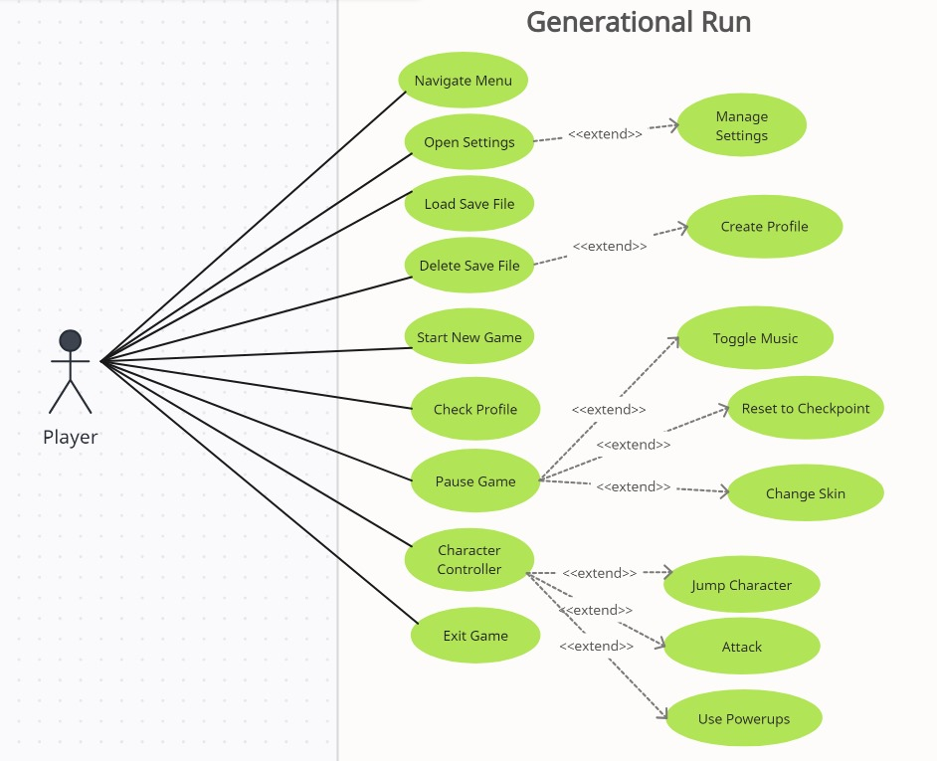

User Classes and Characteristics
- Single player: The game is designed for a single user to play.

Operating Environment
- Windows operating system (specific version TBD)

Design and Implementation Constraints
- The game will be developed using the Unity game engine and may utilize existing libraries and assets that are freely available for use within Unity.
- The game should follow pixel art style and blend 8-bit and modern sound effects.
- The game should maintain a fast-paced gameplay experience.

User Documentation
- In-game tutorial or instructions
- Game manual (optional)

Assumptions and Dependencies
- The game will be developed using the Unity game engine and programming languages supported by Unity (e.g., C#).

External Interface Requirements

User Interfaces
- Main menu: Options to start the game, view leaderboard, and access settings.
- In-game UI: Display of score, power-ups, and other relevant information.
- Pause menu: Options to resume, restart, or quit the game.
- Game over screen: Display of final score and option to restart or return to the main menu.

Hardware Interfaces
- Keyboard input for player controls (e.g., jump, crouch, interact with tools).
- Mouse input for interface navigation.

Software Interfaces
- TBD (if any external software components are required)

Communications Interfaces
- TBD (if online functionality like leaderboards is required)

System Features

Endless Side-scrolling Gameplay
4.1.1 Description and Priority
The core gameplay feature of Generational Run is an endless side-scrolling experience where the player must navigate through obstacles and utilize multi-generational tools to progress as the fabric of reality crumbles behind them. This is a high-priority feature.
4.1.2 Stimulus/Response Sequences
- Player starts the game
- Game world continuously scrolls from left to right
- Player navigates through obstacles and collects power-ups
- Player utilizes multi-generational tools to overcome obstacles
- Game ends when the player falls into the void or collides with an obstacle or gets hit by an enemy attack.
4.1.3 Functional Requirements
REQ-1: The game world should continuously scroll from left to right, simulating an endless runner experience.
REQ-2: The player should be able to control the vertical movement of the character (jump and crouch) using keyboard inputs.
REQ-3: The game should introduce obstacles that the player must overcome by utilizing multi-generational tools.
REQ-4: Power-ups and collectibles should be present in the game world to aid the player's progress.
REQ-5: The game should track the player's score or distance traveled and display it on the in-game UI.
REQ-6: When the player collides with an obstacle or falls into the void, the game should end and display the game over screen.

Multi-generational Tools and Obstacles
4.2.1 Description and Priority
The player will have access to various tools and abilities that are inspired by different eras or time periods. These tools will be essential for overcoming obstacles and progressing through the game. Similarly, the obstacles and enemies will also represent a mix of different eras or themes.
4.2.2 Stimulus/Response Sequences
- The game introduces a new tool or ability to the player (e.g., sword, grappling hook, gravity switch, time manipulation).
- The player uses the provided controls to activate and utilize the tool or ability.
- The game presents obstacles or enemies that can be overcome or defeated by using the appropriate tool or ability.
- If the player successfully uses the tool or ability, they can progress further in the level.
- If the player fails to use the tool or ability correctly, they may take damage or encounter a game over scenario.
4.2.3 Functional Requirements
REQ-7: The player should have a sword that can be used to deflect enemy bullets or projectiles.
REQ-8: The player should have a grappling hook that allows them to swing from platforms and traverse gaps or obstacles.
REQ-9: The player should have a gravity switch tool that enables them to walk on the ceiling or walls, defying gravity.
REQ-10: The player should have a watch or time-manipulation tool that allows them to slow down time, providing an advantage in challenging situations.
REQ-11: The game should introduce a variety of obstacles and enemies that the player must overcome using the multi-generational tools.
REQ-12: Obstacles should include spikes, bullets or projectiles, boulders or falling debris, and other hazards that can harm the player's character.
REQ-13: Enemies should have different behaviors and attack patterns, requiring the player to utilize the appropriate tools and strategies to defeat them.

Scoring and Leaderboard
4.3.1 Description and Priority
The game will keep track of the player's score based on various factors, such as distance traveled, obstacles overcome, and items collected. The score will be displayed on the in-game UI, and the player's high scores will be recorded in a leaderboard.
4.3.2 Stimulus/Response Sequences
- The game starts, and the player's score is initialized to zero.
- As the player progresses through the level, their score increases based on predetermined scoring rules (e.g., distance traveled, items collected, etc.).
- The current score is displayed on the in-game UI.
- If the player achieves a high score, it is recorded in the game's leaderboard.
- The player can access the leaderboard through the game menu to view their high scores and those of other players.
4.3.3 Functional Requirements
REQ-14: The game should have a scoring system based on the distance traveled and items collected by the player.
REQ-15: The game should display the player's current score on the in-game UI.
REQ-16: The game should maintain a leaderboard to display the highest scores achieved by players.

Audio and Visual Effects
4.4.1 Description and Priority
The game will feature various audio and visual effects to enhance the overall gameplay experience and immersion. This includes background music, sound effects, particle effects, and visual cues or indicators.
4.4.2 Stimulus/Response Sequences
- The game starts, and the background music begins playing.
- As the player progresses through the level, different sound effects are played based on the actions performed (e.g., jumping, using a tool, collecting an item, etc.).
- Particle effects and visual cues are displayed to indicate specific events or actions (e.g., using a tool, taking damage, etc.).
- The audio and visual effects can be adjusted or toggled through the game's settings menu.
4.4.3 Functional Requirements
REQ-17: The game should have a variety of sound effects that are appropriate for the different tools, obstacles, and environments encountered throughout the game.
REQ-18: The game should utilize a pixel art style for its visual assets, such as character sprites, backgrounds, and user interface elements.
REQ-19: The game should incorporate visual effects and particle systems to enhance the overall aesthetic and provide visual feedback for certain actions or events (e.g., using a tool, taking damage, collecting a power-up, etc.).

Character Controller
4.5.1 Description and Priority
The player will have control over the character's movements and actions using keyboard inputs or other input devices. The character controller should allow for smooth and responsive control, enabling the player to navigate through obstacles and utilize the provided tools effectively.
4.5.2 Stimulus/Response Sequences
- The game starts, and the player's character begins moving automatically.
- The player presses the designated keys or buttons to control the character's movements (e.g., move left, move right, jump, duck, etc.).
- The character responds accordingly based on the player's inputs, allowing for omni-directional movement.
- The player can perform additional actions or utilize tools by pressing specific keys or buttons (e.g., activate grappling hook, use sword, etc.).
- The character's movements and actions are displayed on the game screen in real-time.
4.5.3 Functional Requirements
REQ-20: The game should provide a character controller that allows the player to control the movement of the character using keyboard inputs.
REQ-21: The character controller should support omni-directional movement, allowing the player to move the character in various directions (e.g., left, right, up, down).

Save and Load Progress
4.6.1 Description and Priority
The game will allow the player to save their progress at any point during gameplay. The player can then load their saved progress and continue from where they left off, enabling them to pause and resume the game as needed.
4.6.2 Stimulus/Response Sequences
- During gameplay, the player accesses the game menu or pause screen.
- The player selects the option to save their current progress.
- The game saves the current game state, including the player's position, score, and any other relevant data.
- When the player wants to resume their saved game, they access the game menu or main screen.
- The player selects the option to load a saved game.
- The game loads the previously saved game state, and the player continues from where they left off.
4.6.3 Functional Requirements
REQ-22: The game should allow the player to save their progress at any point during gameplay.
REQ-23: The game should allow the player to load their previously saved progress and continue from where they left off..

Game Menu
4.7.1 Description and Priority
The core gameplay feature of Generational Run is an endless side-scrolling experience where the player must navigate through obstacles and utilize multi-generational tools to progress as the fabric of reality crumbles behind them. This is a high-priority feature.
4.7.2 Stimulus/Response Sequences
- Player starts the game
- Game world continuously scrolls from left to right
- Player navigates through obstacles and collects power-ups
- Player utilizes multi-generational tools to overcome obstacles
- Game ends when the player falls into the void or collides with an obstacle or gets hit by an enemy attack.
4.7.3 Functional Requirements
REQ-24: The game should have a menu system that allows the player to access various settings and options.
REQ-25: The menu should provide options to start a new game, load a saved game, access settings, view the leaderboard, and quit the game.

Other Nonfunctional Requirements

Performance Requirements
REQ-26: The game should maintain a consistent frame rate of at least 60 frames per second (FPS) on most modern systems to provide a smooth gameplay experience.

Safety Requirements
- Not applicable (the game does not involve any safety-critical features).

Security Requirements
- TBD (if online functionality or user accounts are required)

Software Quality Attributes
REQ-27: The game should be easy to learn and provide an intuitive control scheme.
REQ-28: The game should be responsive and provide immediate feedback to player actions.
REQ-29: The game should be visually appealing and consistent with the pixel art style.
REQ-30: The game should provide options to customize various settings, such as audio, graphics, and controls.
REQ-31: The game should support multiple save files, allowing players to have multiple game progress saves.

Business Rules
- TBD (if any business rules apply)

Other Requirements
REQ-32: The game should provide an option to select different playable characters with varying appearances.
Appendix A: Glossary
- Endless Runner: A game genre where the player navigates through an endless level that continuously scrolls.
- Side-scroller: A game where the gameplay view is from a side-on perspective, and the player character typically moves from left to right.
- Power-up: An in-game collectible that provides temporary benefits or abilities to the player.
Appendix B: Analysis Models
Design Class Diagram:
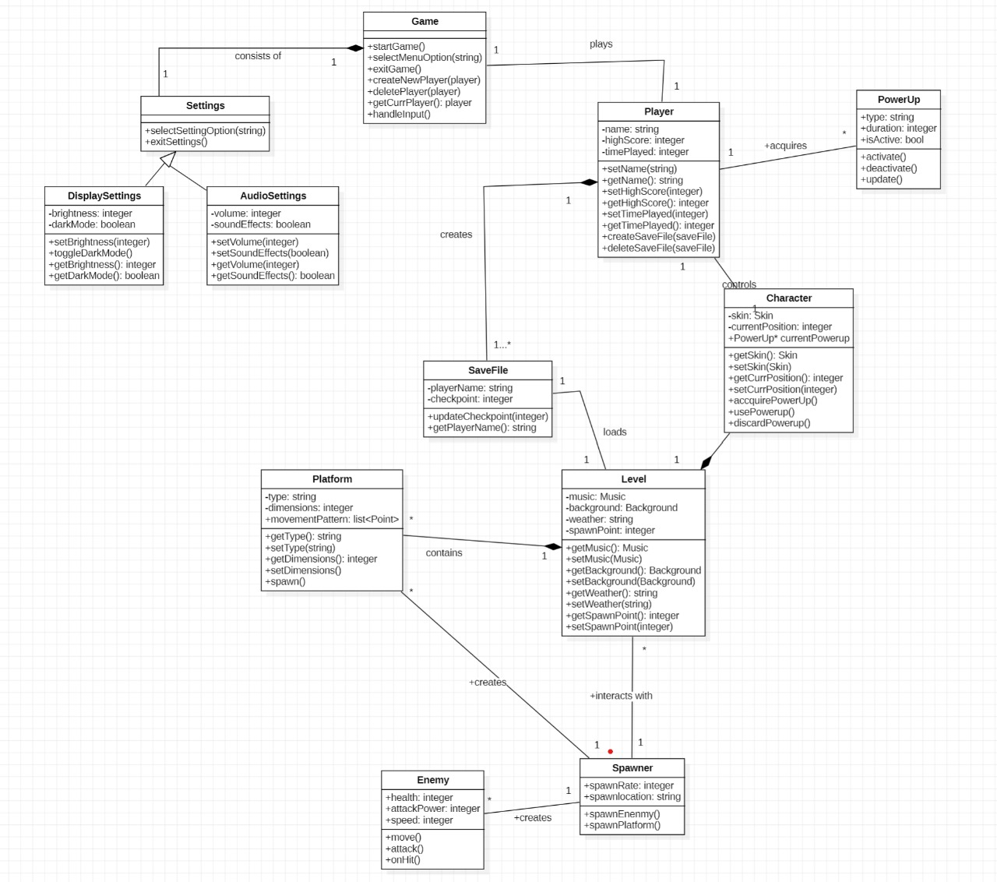

Data Flow Diagram:
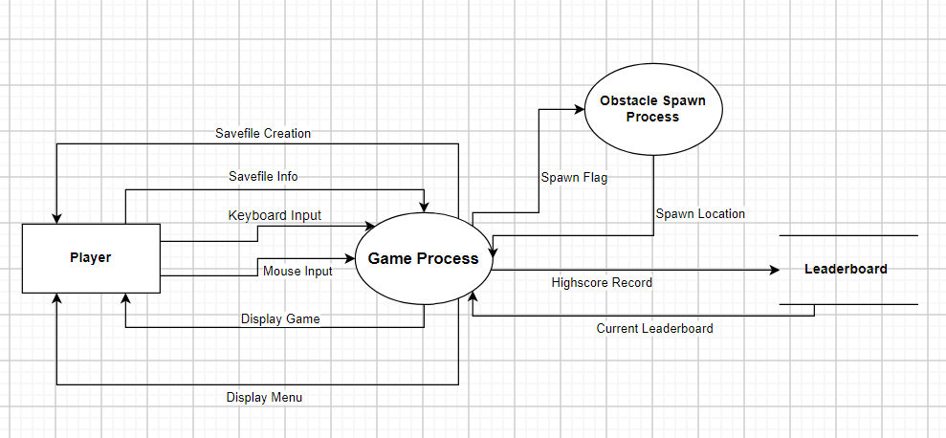

Use Case Descriptions:
Identifier | UC-01
Name | Navigate Menu
Purpose
Priority | High
Actors | Player
Pre-conditions | Game on
Post-conditions | Load Saved game, Open Settings, start new game, exit game
Dependencies
Typical Course of Action (Primary Flow)
S# | Actor Action | S# | System Response
1 | Opens the game | 1 | Loads the menu
2 | Exit to menu | 2 | Loads the menu
Alternative Course of Action
S# | Actor Action | S# | System Response
Exceptions: No saved files

Identifier | UC-02
Name | Load Save File
Purpose | Load up any previous saved game progress
Priority | Medium
Actors | User
Pre-conditions | Saved Game, Navigate Menu
Post-conditions | Start Game
Dependencies
Typical Course of Action (Primary Flow)
S# | Actor Action | S# | System Response
1 | Navigate Menu | 1 | Opens the menu
2 | Clicks Load Saved Game | 2 | Opens a pop-out which lists all previous saved games
Alternative Course of Action
S# | Actor Action | S# | System Response
Exceptions: No saved game, corrupt file

Identifier | UC-03
Name | Delete Save File
Purpose | Remove any previous saved game from memory
Priority | Medium
Actors | User
Pre-conditions | Saved Game, Navigate Menu
Post-conditions | Open Navigate Menu
Dependencies
Typical Course of Action (Primary Flow)
S# | Actor Action | S# | System Response
1 | Navigate Menu | 1 | Opens the menu
2 | Clicks Delete saved game | 2 | Opens a pop-out which lists all previous saved games
Alternative Course of Action
S# | Actor Action | S# | System Response
Exceptions: No saved game

Identifier | UC-04
Name | Start New Game
Purpose | This use case creates a fresh save with no progress.
Priority | High
Actors | Player
Pre-conditions | Player must be on the menu screen.
Post-conditions | The game will move the player to the profile creator.
Dependencies | UC-01
Typical Course of Action (Primary Flow)
S# | Actor Action | S# | System Response
1 | Click the start new game button. | 1.1 | New profile screen is displayed.
Alternative Course of Action
S# | Actor Action | S# | System Response
- | - | - | -

Identifier | UC-05
Name | Create Profile
Purpose | This use case allows the player to create a new profile.
Priority | High
Actors | Player
Pre-conditions | Player must have started a new game.
Post-conditions | The game will start from the first level.
Dependencies
Typical Course of Action (Primary Flow)
S# | Actor Action | S# | System Response
1 | Enter the player’s name. | 1.1 | Display a confirmation prompt.
2 | Click confirmation button. | 1.1 | Game starts from first level.
Alternative Course of Action
S# | Actor Action | S# | System Response
- | - | - | -
Exceptions: Player enters a name that already exists. Error message is displayed.

Identifier | UC-06
Name | Open Settings
Purpose | This use case takes the player to the settings menu.
Priority | Medium
Actors | Player
Pre-conditions | Player must be on main menu screen.
Post-conditions | The game settings may change based on player’s changes.
Dependencies
Typical Course of Action (Primary Flow)
S# | Actor Action | S# | System Response
1 | Click the settings button. | 1.1 | Display settings menu screen.
Alternative Course of Action
S# | Actor Action | S# | System Response
- | - | - | -
Exceptions:

Identifier | UC-07
Name | Manage Settings
Purpose | This use case allows the player to manage various game settings.
Priority | Medium
Actors | Player
Pre-conditions
Post-conditions | The game’s settings may change based on player’s changes.
Dependencies | UC-06
Typical Course of Action (Primary Flow)
S# | Actor Action | S# | System Response
1 | Select “Display Settings” option. | 1.1 | Taken to Display Settings menu.
2 | Modify game brightness or toggle dark mode. | 1.1 | The brightness of the game is changed, or the theme is toggled from dark to light or vice versa.
Alternative Course of Action
S# | Actor Action | S# | System Response
1 | Select “Audio Settings” option. | 1.1 | Taken to Audio Settings menu.
2 | Modify game volume or toggle sound effects | 1.1 | The volume of the game is changed, or the sound effects are toggled on/off.
Exceptions:

Identifier | UC-08
Name | Check Profile
Purpose | This use case allows the player to view their profile and statistics.
Priority | Medium
Actors | Player
Pre-conditions | Player must be on main menu screen.
Post-conditions
Dependencies
Typical Course of Action (Primary Flow)
S# | Actor Action | S# | System Response
1 | Click “Check Profile” button. | 1.1 | Taken to profile screen.
Alternative Course of Action
S# | Actor Action | S# | System Response
- | - | - | -
Exceptions:

Identifier | UC-09
Name | Exit Game
Purpose | This use case allows the player to exit the game.
Priority | High
Actors | Player
Pre-conditions | Player must be on main menu or pause screen.
Post-conditions | Game is terminated.
Dependencies
Typical Course of Action (Primary Flow)
S# | Actor Action | S# | System Response
1 | Click “Exit Game” button. | 1.1 | Display confirmation prompt.
2 | Click confirmation | 2.1 | Game is closed.
Alternative Course of Action
S# | Actor Action | S# | System Response
1 | Click “Exit Game” button. | 1.1 | Display confirmation prompt.
2 | Click back button. | 2.1 | Taken back to previous screen.
Exceptions:

Identifier | UC-10
Name | Character Controller
Purpose | Allows the player to the move the character.
Priority | High
Actors | Player
Pre-conditions | Must be in game, game must not be paused
Post-conditions | Character will change position
Dependencies | UC-12
Typical Course of Action (Primary Flow)
S# | Actor Action | S# | System Response
1 | Player presses A | 1 | Character moves left
2 | Player presses D | 2 | Character moves right
3 | Player presses W | 3 | Character jumps
4 | Player presses S | 4 | Character moves down
Alternative Course of Action
S# | Actor Action | S# | System Response
1 | Player presses left arrow key | 1 | Character moves left
2 | Player presses right arrow key | 2 | Character moves right
3 | Player presses up arrow key | 3 | Character jumps
4 | Player presses down arrow key | 4 | Character moves down
Exceptions:

Identifier | UC-11
Name | Jump Character
Purpose | Allows the player to the move the character up
Priority | High
Actors | Player
Pre-conditions | Must be in game, game must not be paused
Post-conditions | -
Dependencies | UC-12
Typical Course of Action (Primary Flow)
S# | Actor Action | S# | System Response
1 | Player presses ‘W’ button | 1 | Character is moved up.
Alternative Course of Action
S# | Actor Action | S# | System Response
 | Player presses up arrow key | 1 | Character moves up
Exceptions:

Identifier | UC-12
Name | Pause Game
Purpose | Allows the player to stop all functionalities of the game
Priority | High
Actors | Player
Pre-conditions | Must be in game
Post-conditions | The play will be halted
Dependencies | -
Typical Course of Action (Primary Flow)
S# | Actor Action | S# | System Response
1 | Player presses pause button | 1 | System stops everything and displays pause menu
Alternative Course of Action
S# | Actor Action | S# | System Response
1 | Player presses escape | 1 | System stops everything and displays pause menu
Exceptions:

Identifier | UC-13
Name | Toggle Music
Purpose | This use case involves toggling the music within the current level.
Priority | Low
Actors | Player
Pre-conditions | The game must currently be paused.
Post-conditions | The music will start playing if it is currently off. The music will stop playing if it is currently on.
Dependencies | UC-12
Typical Course of Action (Primary Flow)
S# | Actor Action | S# | System Response
1 | Click the toggle button. | 1.1 | Music will be muted/unmuted.
Alternative Course of Action
S# | Actor Action | S# | System Response
- | - | - | -
Exceptions: User leaves the pause game menu before clicking the button.

Identifier | UC-14
Name | Change skin
Purpose | This use case allows the user to change the skin of the character they are playing.
Priority | Low
Actors | Player
Pre-conditions | The game must currently be paused.
Post-conditions | The character’s current skin will be changed.
Dependencies | UC-12
Typical Course of Action (Primary Flow)
S# | Actor Action | S# | System Response
1 | Click the change skin button. | 1.1 | Display a list of all skins.
2 | Select one of the skins shown. | 2.1 | Display selected skin and confirmation button.
3 | Click confirmation. | 3.1 | Current skin is changed to selected skin.
Alternative Course of Action
S# | Actor Action | S# | System Response
1 | Click the change skin button. | 1.1 | Display a list of all skins.
2 | Select one of the skins shown. | 2.1 | Display selected skin and confirmation button.
3 | Click back button. | 3.1 | Display back to pause screen.
Exceptions: Player has not unlocked the selected skin. Error message displayed.

Identifier | UC-15
Name | Reset to checkpoint
Purpose | This use case resets the position of the character to the last checkpoint.
Priority | Medium
Actors | Player
Pre-conditions | The game must currently be paused.
Post-conditions | The character will be transported to the checkpoint location.
Dependencies | UC-12
Typical Course of Action (Primary Flow)
S# | Actor Action | S# | System Response
1 | Click the reset to checkpoint button. | 1.1 | Display a confirmation prompt.
2 | Click confirm button. | 2.1 | Move player character to previous checkpoint.
Alternative Course of Action
S# | Actor Action | S# | System Response
1 | Click the reset to checkpoint button. | 1.1 | Display a confirmation prompt.
2 | Click back button. | 2.1 | Display back to pause screen.
Exceptions:

Identifier | UC-16
Name | Attack
Purpose | Kill enemies or reflect enemy bullets
Priority | High
Actors | Player
Pre-conditions | The game must be running.
Post-conditions
Dependencies | UC-12
Typical Course of Action (Primary Flow)
S# | Actor Action | S# | System Response
1 | Player presses ‘P’ button | 1.1 | Reflect bullets or kills enemies on contact
Alternative Course of Action
S# | Actor Action | S# | System Response
Exceptions:

Identifier | UC-17
Name | Powerups
Purpose | Gives player an additional functionality of grapple, gravity switch and pause timer
Priority | High
Actors | Player
Pre-conditions | Player collects the powerups by colliding with it
Post-conditions | Powerup activated for a specific duration of time
Dependencies | UC-12
Typical Course of Action (Primary Flow)
S# | Actor Action | S# | System Response
1 | Player collides with the powerups | 1.1 | Powerup activates
Alternative Course of Action
S# | Actor Action | S# | System Response
Exceptions:

Sequence Diagrams:
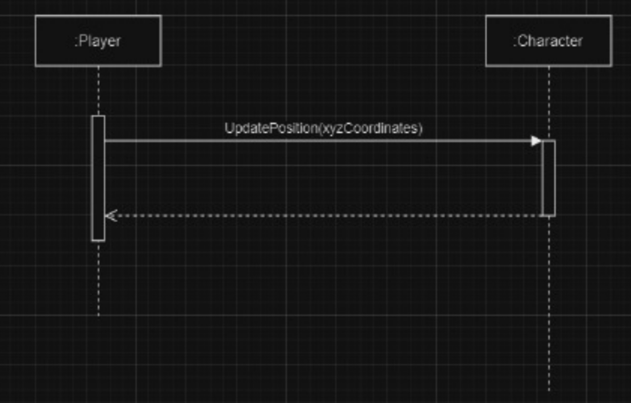
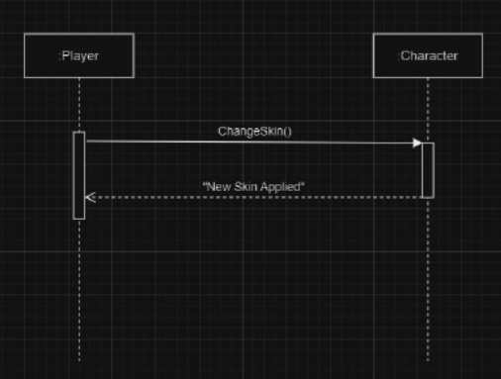
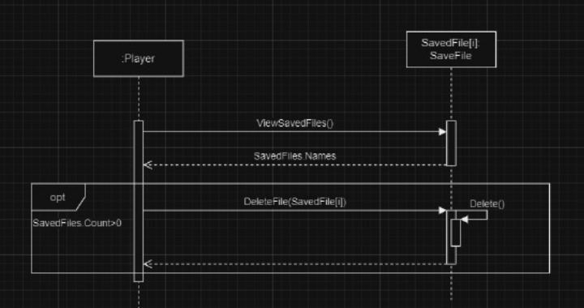
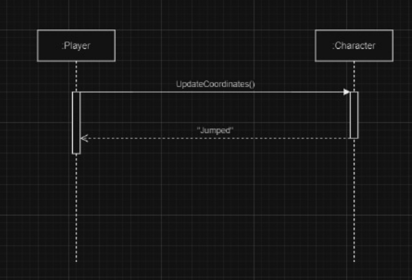
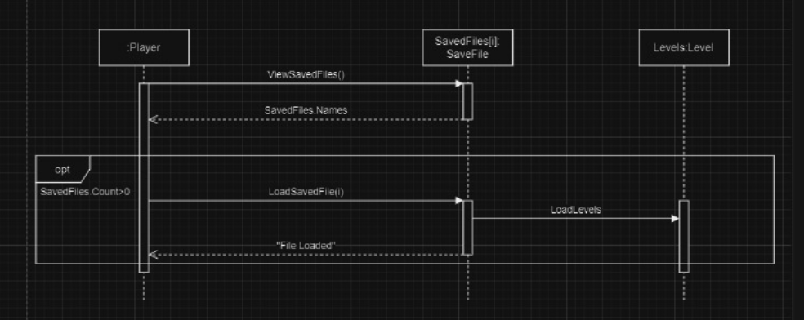
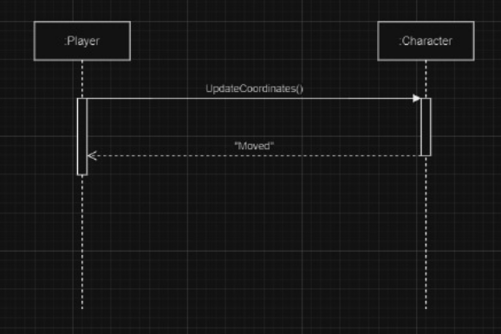
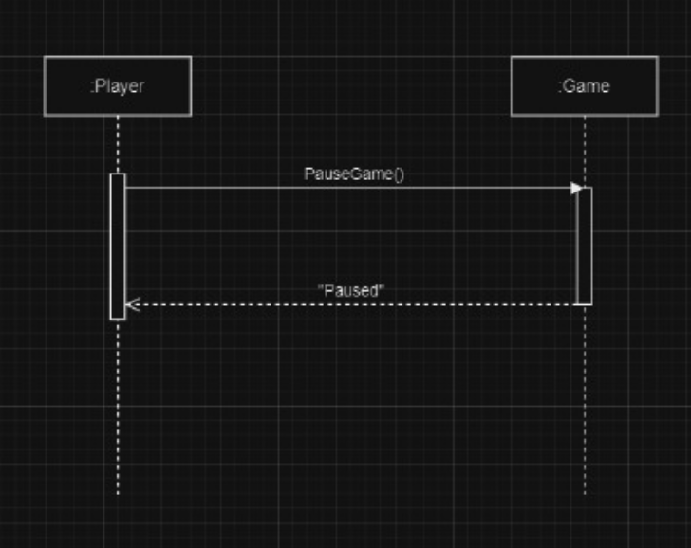
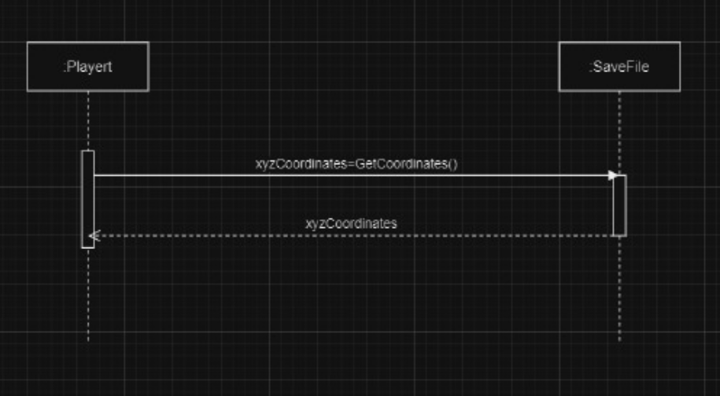
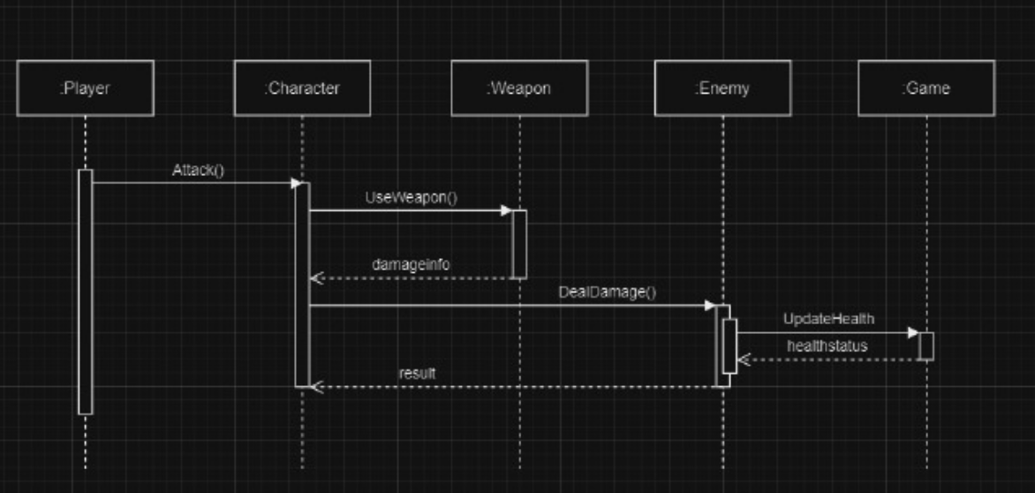
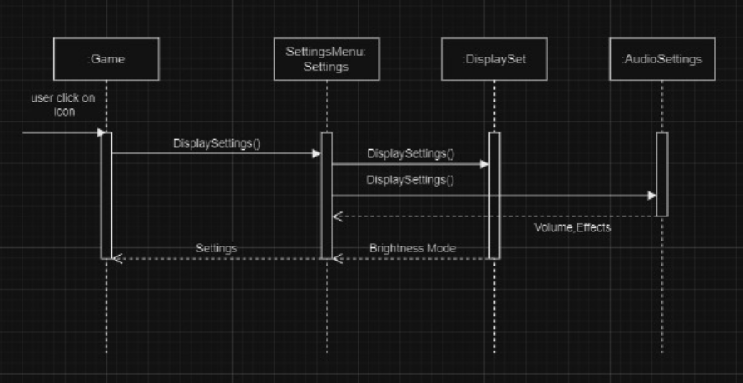
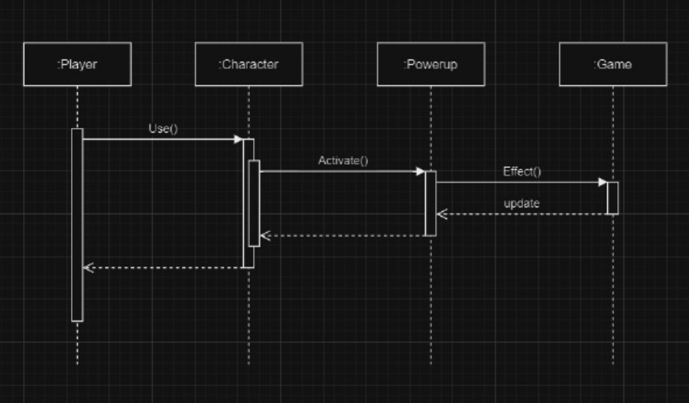
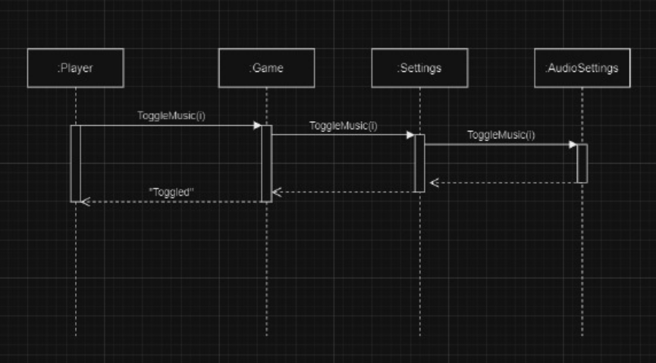

Appendix C: To Be Determined List
1. Specific version of the Windows operating system that the game will target (Section 2.4).
2. Any external software components or interfaces required (Section 3.3).
3. Requirements for online functionality or user accounts, if applicable (Section 5.3).
4. Any business rules that may apply to the game (Section 5.5).
5. Additional requirements or features that may be identified during the development process (Section 6).

