Submitted By: Mustufain Rizvi
Student# : 426044
Submitted to : Jaakko Peltonen

Problem Pre1: Properties of High-dimensional Spaces

#Quesion 1 of exercise dimensionality reduction
import numpy as np
#mean+- SD is the range
def GenerateDataPoint(dim):
points = 10000000
data = np.empty(shape=(dim,points))
for i in range(dim):
data[i] = np.random.uniform(1,-1,points)
pointOutsideHypershpere=0
pointInsideHypersphere=0
pointsInsideHyperSphericalShell=0
for i in range(points):
distance = np.linalg.norm(data[:,i]) #Euclidean Distance
if distance <= 1 :
pointInsideHypersphere += 1
if 0.95<distance and distance<1:
pointsInsideHyperSphericalShell+=1
else:
pointOutsideHypershpere+=1
print ("Dimension: " + str(dim),str(float(pointInsideHypersphere)/float(points) * 100)+"%","inside hemisphere")
print ("Dimension: " + str(dim), str(float(pointsInsideHyperSphericalShell) / float(unemployed job seekers (purple curve) and
amount of open jobs (yellow curve)) * 100) + "%", "inside HyperShpericalShell")
for i in range(3,15,3):
GenerateDataPoint(i) #Dimension 3,6,9,12
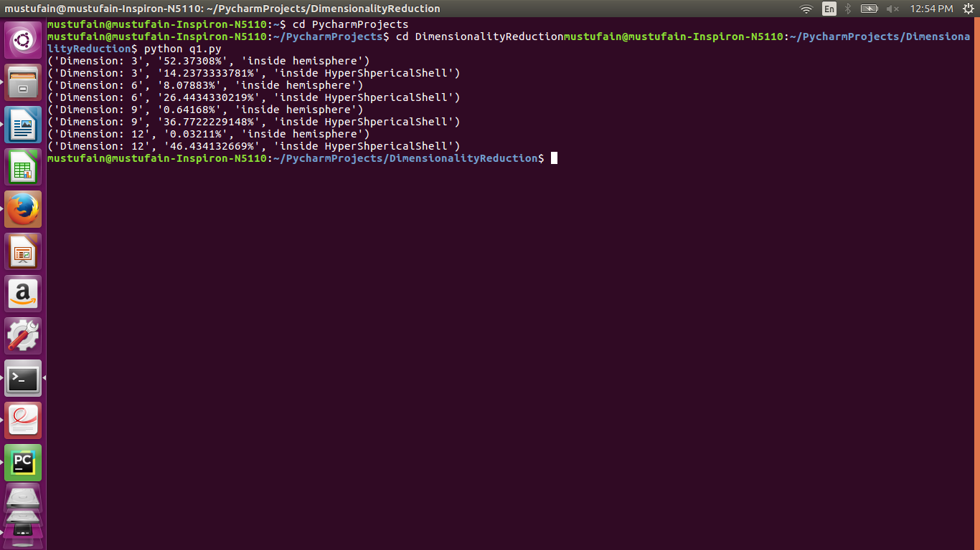
Problem Pre2: Curse of Dimensionality

def GenerateDataPoints(dim):
points=2000
dataset=[]
data = np.empty(shape=(dim,points))
for i in range(dim):
data[i] = np.random.normal(0,1,points)
for i in data[0]: #Taking coordinates of each data point of first dimension
target = np.sin(i)
t = (i,target)
dataset.append(t)
#Split dataset 1000 Training and 1000 testing
train_data = data[:,:points/2] #First 1000 columns
test_data = data[:,points/2:points] #Last 1000 columns
return train_data,test_data,points,dataset
def getNeighbors(train_data,test_data,k,points):
k=5
Euclidean = []
Neighbors=[]
Neighbors_x_test=[]
for x in range(0,points/2):
dist=(train_data[0][x],np.linalg.norm(train_data[:,x]-test_data))
Euclidean.append(dist)
Euclidean.sort(key=operator.itemgetter(1))
for i in range(k):
Neighbors.append(Euclidean[i][0])
return test_data[0],Neighbors
def Predict(Neighbors,x_test,dataset):
sum=0
x_test = x_test
for i in Neighbors:
for j in dataset:
if i == j[0]:
result = sum + j[1]
sum = result
break
predicted = float(result)/float(len(Neighbors))
for i in dataset:
if x_test == i[0]:
target_actual = i[1]
break
return predicted,target_actual
def Visualization(pred_actual):
plt.xlabel("Data cordinate x1 in test_set")
plt.ylabel("Target variable")
plt.plot(list(zip(*pred_actual)[2]),'ro',label="Actual Data Point") #Actual
plt.plot(list(zip(*pred_actual)[1]),'bo',label="Predicted Data Point") #Predicted
plt.legend(loc='best',ncol=1,fontsize=10)
plt.show()
def Error(pred_actual,points):
SSE=0
actual = list(zip(*pred_actual)[2])
pred = list(zip(*pred_actual))[1]
for x in range(len(pred_actual)):
SSE += (actual[x] - pred[x])**2
return float(float(SSE)/1000)
def Main():
pred_actual=[]
train_data,test_data,points,dataset = GenerateDataPoints(1) #Change Dimension here
for x in range(0,points/2):
x_test,Neighbors = getNeighbors(train_data,test_data[:,x],5,points)
Predicted,Actual=Predict(Neighbors,x_test, dataset)
result = (x_test,Predicted,Actual)
pred_actual.append(result)
Visualization(pred_actual)
print "SSE",Error(pred_actual,points)
Main()

Dimension : 1

SSE = 0.00184439662118

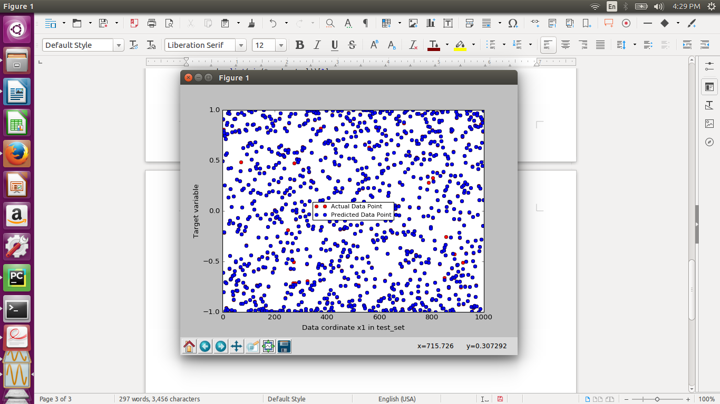

Dimension 2 :

SSE= 0.00145016958409

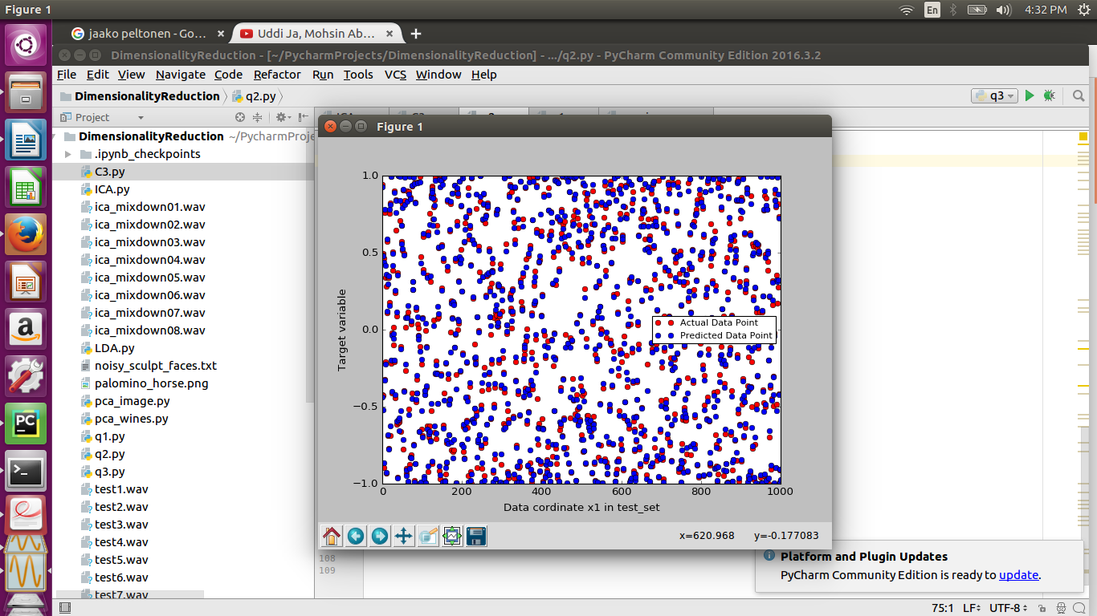

Dimension : 4

SSE : 0.0173472295474

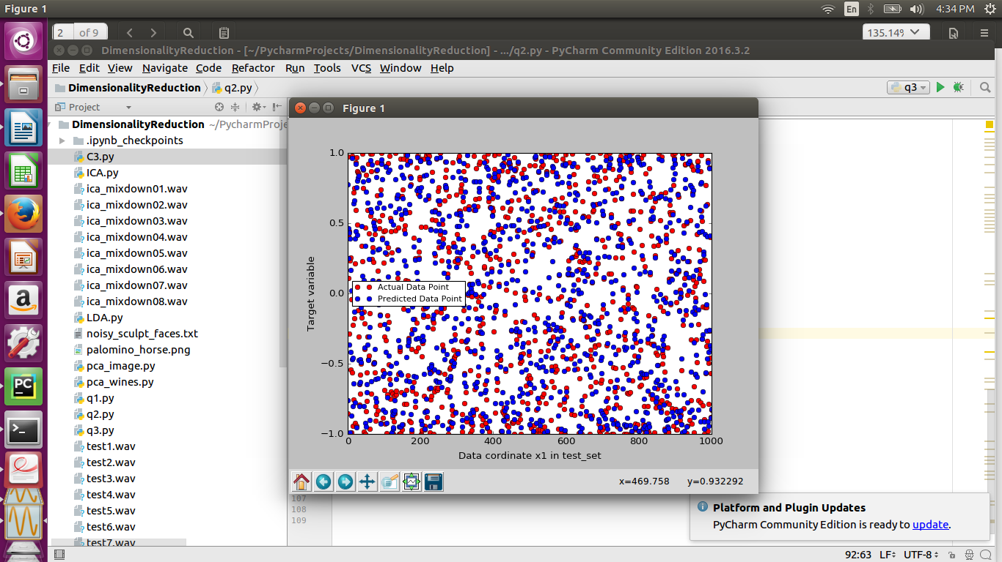

Dimensionality 8

SSE: 0.0715201955861

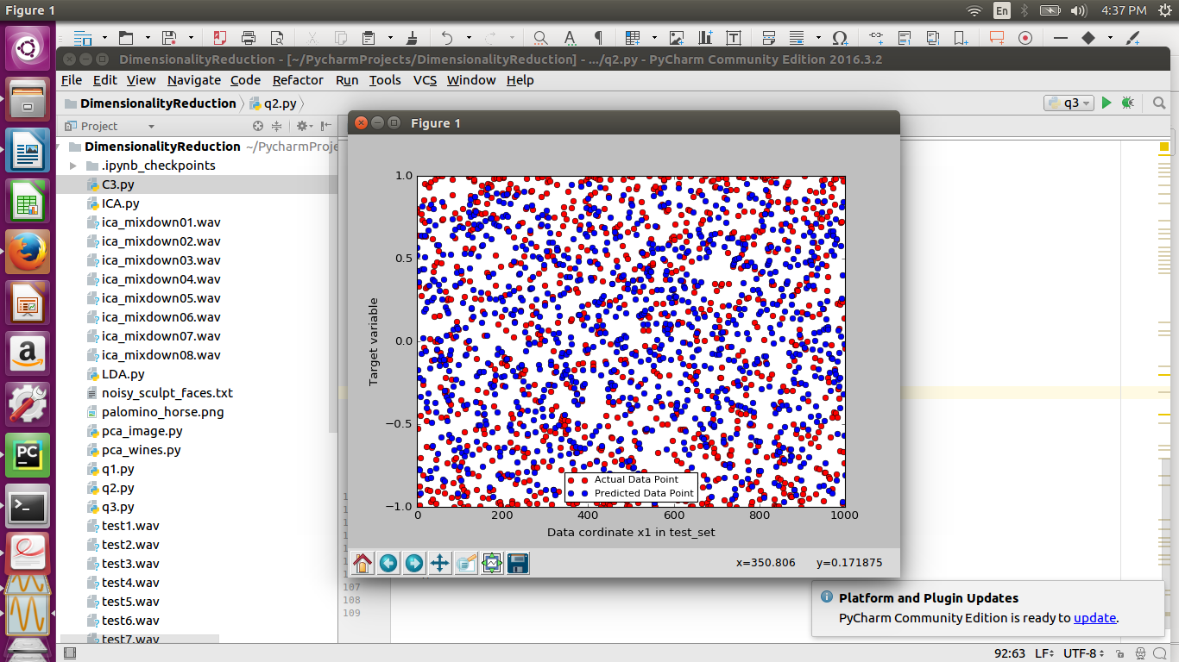

Dimensionality 12

SSE : 0.113823667182
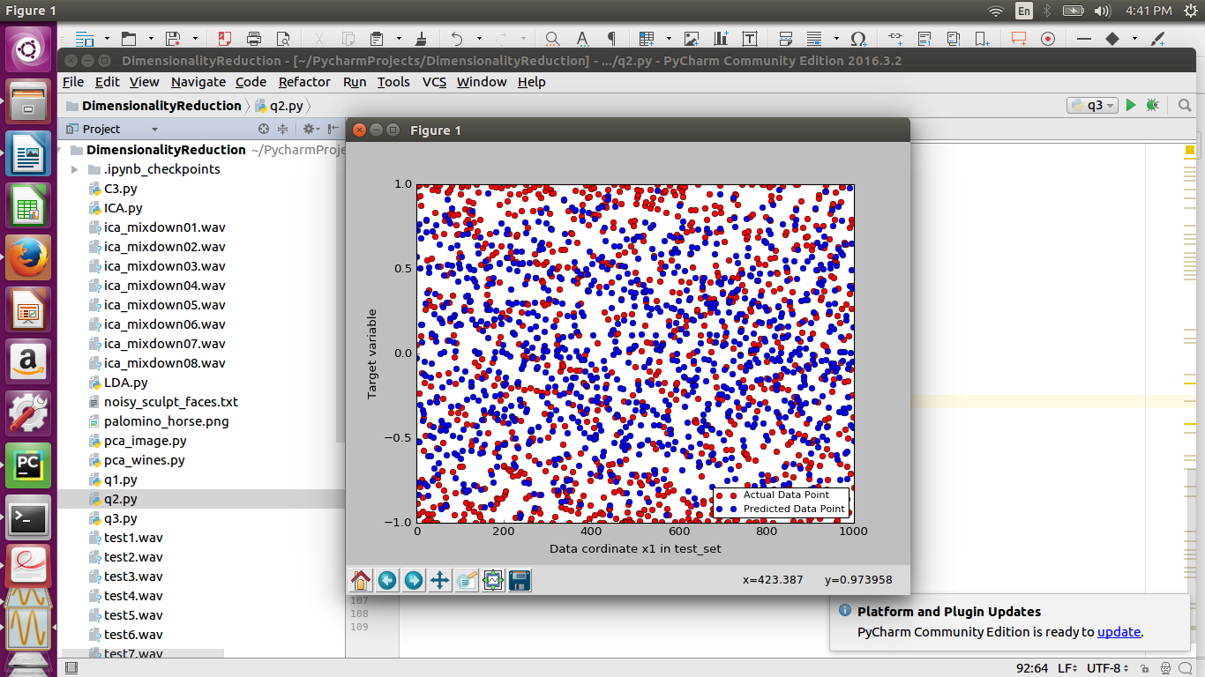

Dimensionality 16

SSE: 0.143308780951

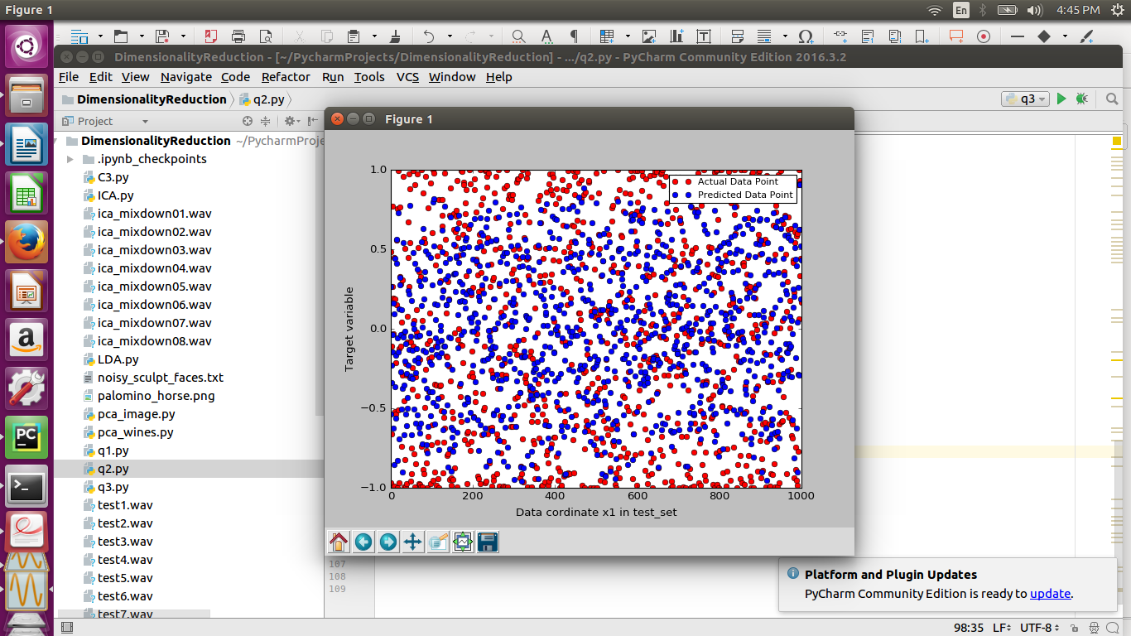

Note : As Dimension Increases SSE increases as you can show in graphs that as we are increasing the dimensions then points are deviating from each other.

Problem A1: Forward Selection

a)

data = np.loadtxt('noisy_sculpt_faces.txt')
def NearestNeighbor(face_i,data,index,n_features):
row = face_i
SSE=[]
index=index
for i in range(len(data)):
if index!=i: #Exclude the ith face as it is leave one out
sse=(i,np.sum((row[n_features]-data[i][n_features])**2))
#sse=(i,np.sum((row[n_features]-data[i][n_features])**2))
SSE.append(sse)
SSD = min(SSE, key = lambda error : error[1])
return SSD
def Predict(SSD,data,index):
predict_label=[]
for i in range(len(data)):
if i == SSD[0]:
target_predict=(index,data[i][256:])
predict_label.append(target_predict)
return predict_label
def Sum_Of_Squared_Differences(predict_label):
result =0
for i in predict_label:
index=i[0]
predict_value = i[1]
actual_value = data[index][256:]
for i in range(3):
e = (actual_value[i]-predict_value[i])**2 + result
result = e
return (index,e)
def Main():
index=0
total=0
for face_i in data:
SSD = NearestNeighbor(face_i,data,index,[x for x in range(0,256)])
target_pred=Predict(SSD,data,index)
error = Sum_Of_Squared_Differences(target_pred)
total = total + error[1]
index += 1

print (total/100)
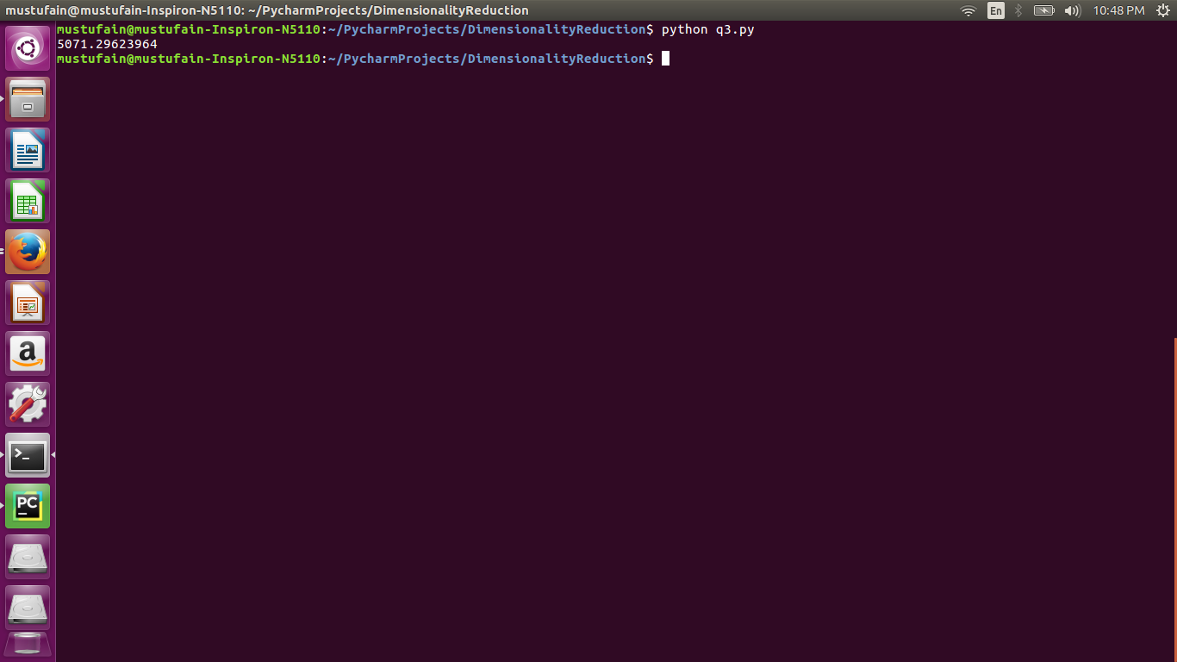

Note: This is sum of squared error overall faces which is the baseline which we tend to improve using Forward selection and variable ranking techniques.

b)

def ForwardSelection(Features,data):
#Find variance of each column
#Increase features uptil there is no change in SSE
#Features 256
temp_chosen_feature=[]
error_list=[]
chosen_feature=[]
Feature_count=[]
tempset=[]
count=0
for i in range(Features):
Feature_count.append(i)
for i in range(Features): #it would run 256 times
for k in Feature_count:
tempset.extend(chosen_feature)
tempset.append(k)
index=0
total=0
for face_i in data:
SSD=NearestNeighbor(face_i,data,index,tempset)
target_pred=Predict(SSD,data,index)
error=Sum_Of_Squared_Differences(target_pred)
total = total + error[1]
index+=1
total=total/100
e=(k,total)
error_list.append(e)
tempset=[]
count+=1
min_sse = min(error_list, key=lambda error: error[1]) #we get a tuple (feature,sse)
chosen_feature.append(min_sse[0])
m=(chosen_feature,min_sse[1])
temp_chosen_feature.append(m)
Feature_count.remove(min_sse[0])
error_list=[]
best_feature = min(temp_chosen_feature, key=lambda sse: sse[1]) # Feature set with min SSE
print best_feature
Feature_set = list(zip(*temp_chosen_feature)[0])
F = [i for i in range(0,256) ]
SSE = list(zip(*temp_chosen_feature))[1]
plt.xlabel("Features")
plt.ylabel("SSE")
plt.plot(F,SSE)
plt.show()
return error_list

SSE : 391.60974821559643

Features = 50

Note: We see that by running forward selection we were able to get these features so you can see the set of these columns gives a very minimum SSE compared to our previous SSE which was 5071

c)

In this order features have been added

([189, 53, 137, 224, 32, 24, 147, 102, 13, 192, 229, 138, 84, 207, 206, 107, 200, 180, 26, 167, 116, 245, 8, 132, 205, 105, 80, 54, 135, 125, 120, 250, 174, 12, 218, 46, 153, 113, 56, 9, 124, 208, 194, 59, 228, 104, 98, 89, 165, 17, 166, 73, 96, 18, 246, 253, 142, 114, 146, 81, 190, 197, 214, 122, 112, 71, 182, 222, 101, 62, 99, 184, 170, 219, 179, 128, 37, 57, 226, 162, 87, 171, 70, 188, 244, 198, 49, 215, 35, 15, 0, 52, 151, 2, 6, 100, 201, 199, 181, 115, 133, 33, 220, 251, 159, 238, 230, 187, 126, 106, 169, 148, 68, 240, 67, 58, 79, 51, 93, 38, 212, 97, 185, 39, 186, 252, 48, 191, 110, 41, 195, 1, 140, 233, 78, 210, 241, 172, 145, 163, 111, 27, 16, 134, 20, 247, 254, 40, 85, 176, 143, 150, 45, 164, 5, 22, 64, 248, 60, 213, 3, 211, 202, 155, 141, 177, 42, 152, 118, 77, 91, 204, 76, 94, 50, 61, 158, 23, 29, 144, 175, 65, 221, 129, 117, 83, 234, 131, 249, 136, 44, 154, 255, 69, 31, 236, 47, 149, 92, 217, 157, 63, 75, 7, 86, 237, 103, 95, 235, 183, 232, 34, 231, 4, 74, 139, 11, 127, 223, 242, 21, 225, 55, 36, 178, 108, 19, 90, 227, 119, 243, 28, 82, 160, 30, 121, 72, 66, 43, 14, 203, 130, 239, 123, 193, 173, 25, 196, 10, 168, 156, 109, 216, 88, 161, 209]

d)

didn't found any better solution

Note: Following is the graph showing all the Features added one by one and not stopping on min SSE when SSE becomes stale

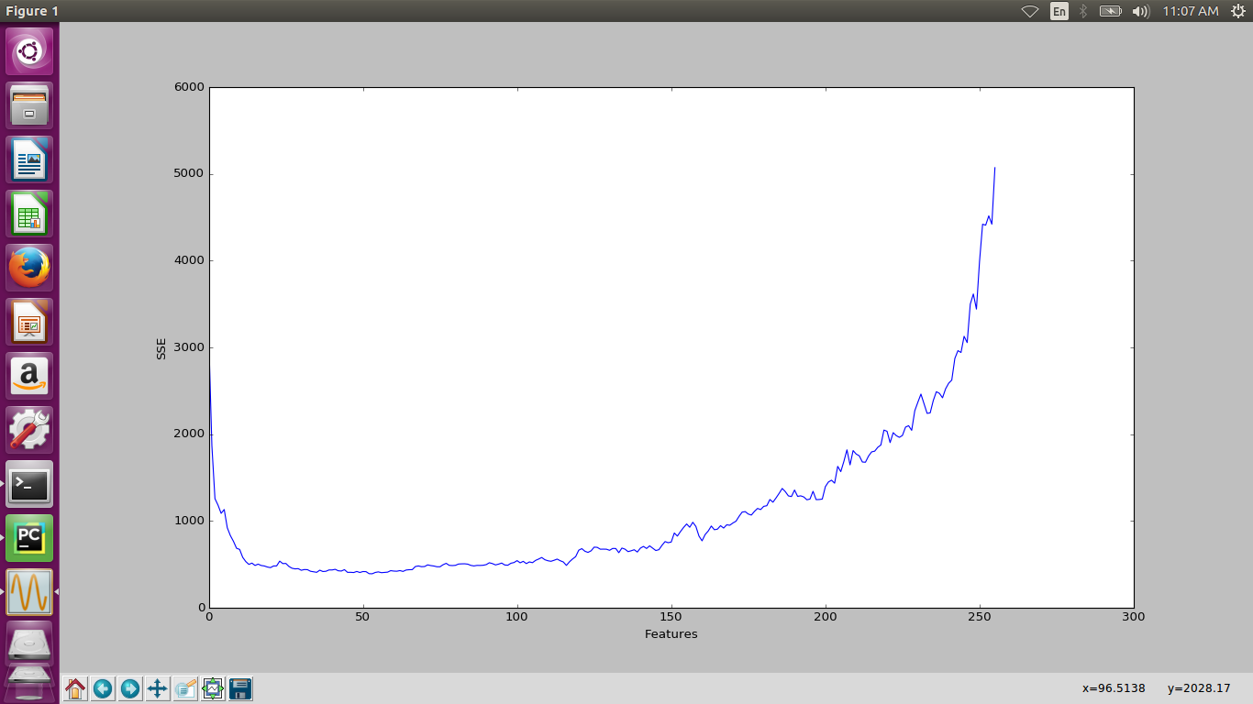

Note: this Graph shows SSE when Features are added one by one so you can see adding more features after a point which we have achieved in the above question does not really help rather it makes the SSE even worse.

Problem A2: Variable Ranking

We want to rank variables 1-256 by how good they can predict the last three variables 257-259
We can choose of the last variables for example 259 and then rank pixels by taking correlation coefficient. With every other pixel i.e cor(pixel1,position 259),cor(pixel2,position 259),... and then we can rank variables by absolute value of coorelation. Higher the correlation the better the results will be.

2)

In this you have to add each features once and then calculate the SSE and rank the features bases on SSE calculated. You can do use the previous function but not appending features to a set rather adding it one by one at a time and then giving it to the nearest neighbor predictor function.
It does change significantly when we do the ranking the graph looks almost the same. There can be slight variation in the 2nd best index as first best index was 189 which would be same in both the bases. Second best was 53 as stated above and here it is 6th.

Problem B1: Mathematics of Principal Component Analysis
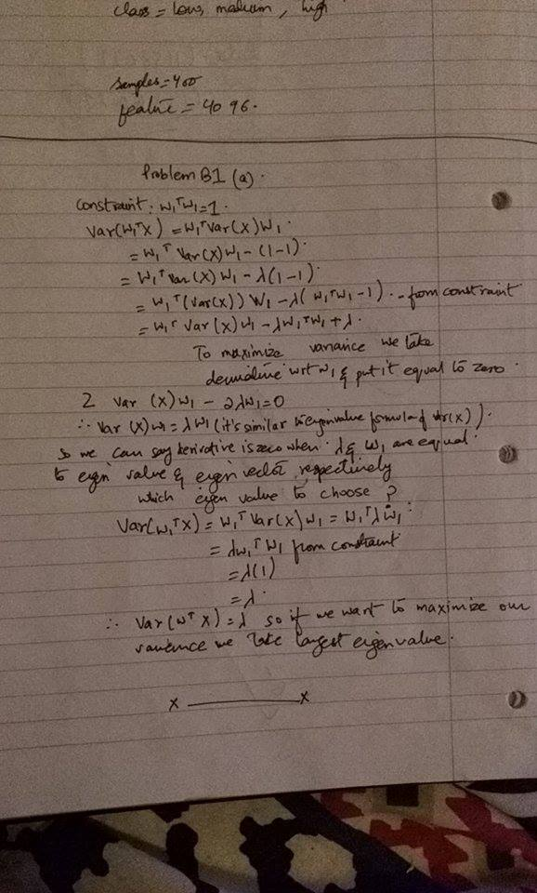

Problem B2: Principal Component Analysis of Wines

def PCA(data,n_components): #Compute Eigen values and Eigen vectors
data_file = np.loadtxt(data)
D, V = eig(cov(data_file, rowvar=False))
V = V[:, np.argsort(D)] #Eigen vector with maximum variance is at lastt
#eigen values are not very similar there is variation so the dataset is not in a good subspace
X = data_file - np.tile(data_file.mean(axis=0), [data_file.shape[0], 1])
D = sorted(D ,reverse=True)
var=[]
for k in range(n_components):
var.append(D[k])
#Find info given by first component
print "Variance",str(var/sum(D)*100)+'%'
print "Component 1",V[:,-1]
print "Component 2",V[:,-2]
# Map X through the PCA (rotate axes):
X_rot = np.matmul(X, V)
transformed = X_rot[:,:n_components] #2 pca
#project the data onto these transformation #check value of quality column in origional file
low=[]
medium=[]
high=[]
labels=["Low quality","Medium quality","High quality"]
for i in range(data_file.shape[0]):
if data_file[i][11]<=5:
#plt.scatter(transformed[i][0],transformed[i][1],color='red')
low.append(i)
elif data_file[i][11]==6:
#plt.scatter(transformed[i][0], transformed[i][1], color='blue')
medium.append(i)
elif data_file[i][11] >=7:
#plt.scatter(transformed[i][0], transformed[i][1], color='green')
high.append(i)
plt.scatter(transformed[low,0],transformed[low,1],label=labels[0],color='red')
plt.scatter(transformed[medium,0], transformed[medium,1], label=labels[1], color='blue')
plt.scatter(transformed[high][0], transformed[high][0], label=labels[2], color='green')
plt.legend(loc='lower left',
ncol=3,
fontsize=10)
plt.title(data)
plt.show()

def VariableRanking(data):
#one variable per projection
var=[]
low = []
medium = []
high = []
data_file=np.loadtxt(data)
for i in range(data_file.shape[1]):
a=(i,np.var(data_file[:,i]))
var.append(a)
var = sorted(var ,key=lambda variance:variance[1],reverse=True) #Descending order
for i in range(2):
print var[i]
labels = ["Low quality", "Medium quality", "High quality"]
for i in range(data_file.shape[0]):
if data_file[i][11]<=5:
#plt.scatter(transformed[i][0],transformed[i][1],color='red')
low.append(i)
elif data_file[i][11]==6:
#plt.scatter(transformed[i][0], transformed[i][1], color='blue')
medium.append(i)
elif data_file[i][11] >=7:
#plt.scatter(transformed[i][0], transformed[i][1], color='green')
high.append(i)
plt.scatter(data_file[low, 6], data_file[low, 5], label=labels[0], color='red')
plt.scatter(data_file[medium, 6], data_file[medium, 5], label=labels[1], color='blue')
plt.scatter(data_file[high][6], data_file[high][5], label=labels[2], color='green')
plt.legend(loc='lower left',
ncol=3,
fontsize=10)
plt.title("Variable Ranking")
plt.show()

def Main():
file1="winequality-red.txt"
file2="winequality-white.txt"
n_components=2
PCA(file1,n_components)
VariableRanking(file2)

Main()

Red Wine :

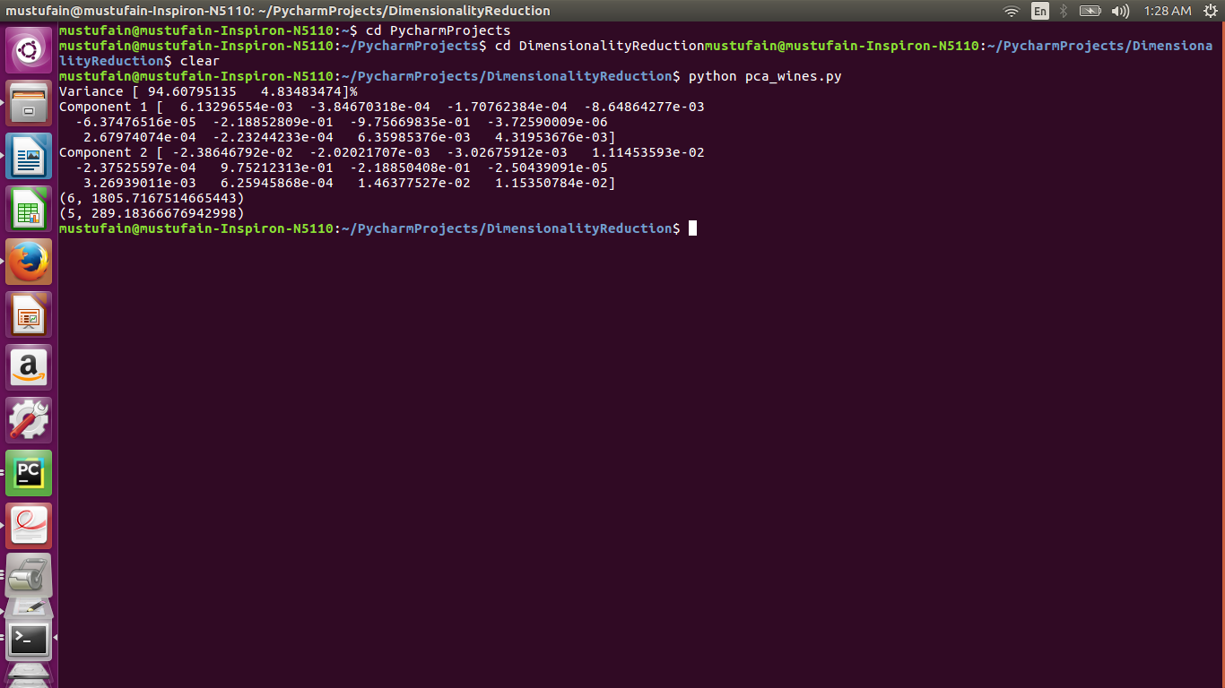
Variance shows variance explained by first two components
You can also see first 2 components

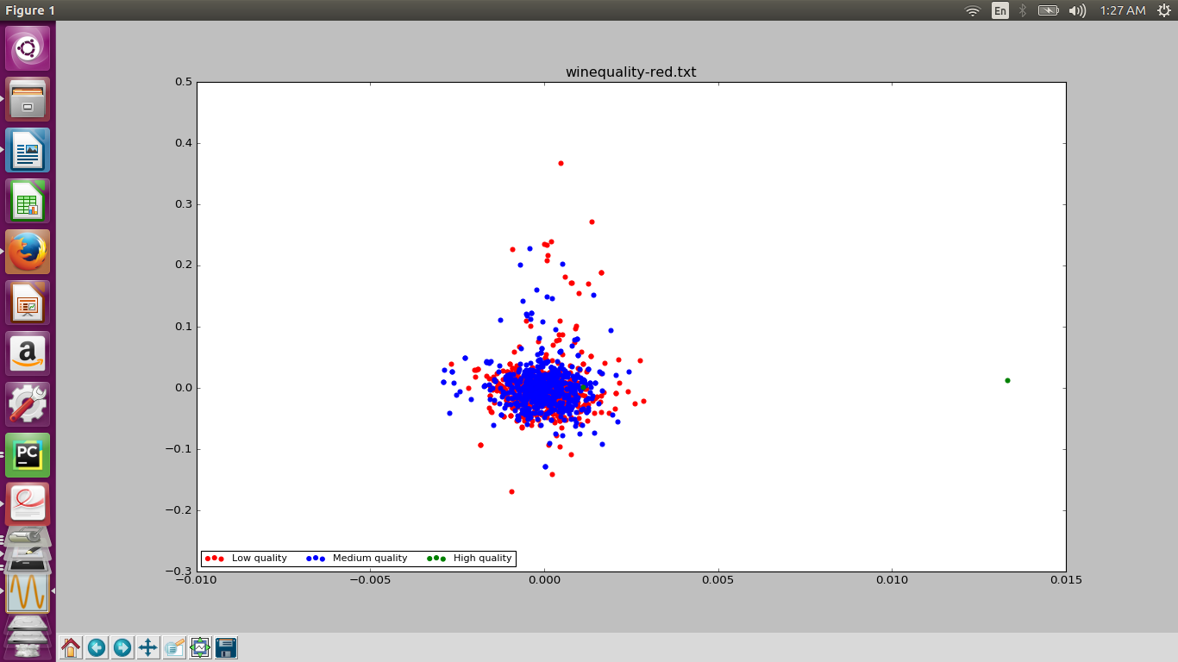

White wines:

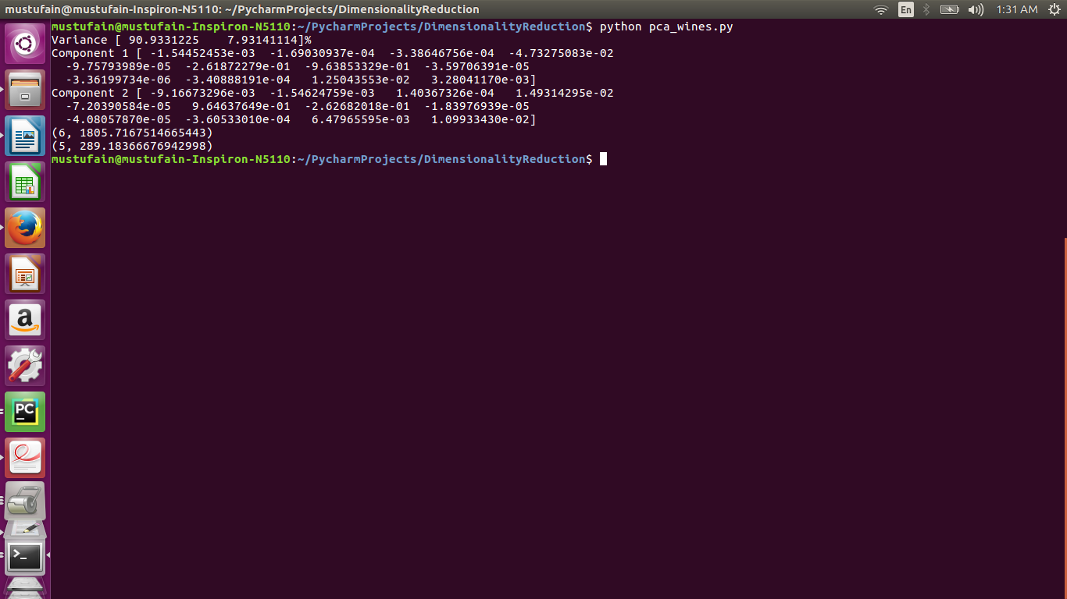

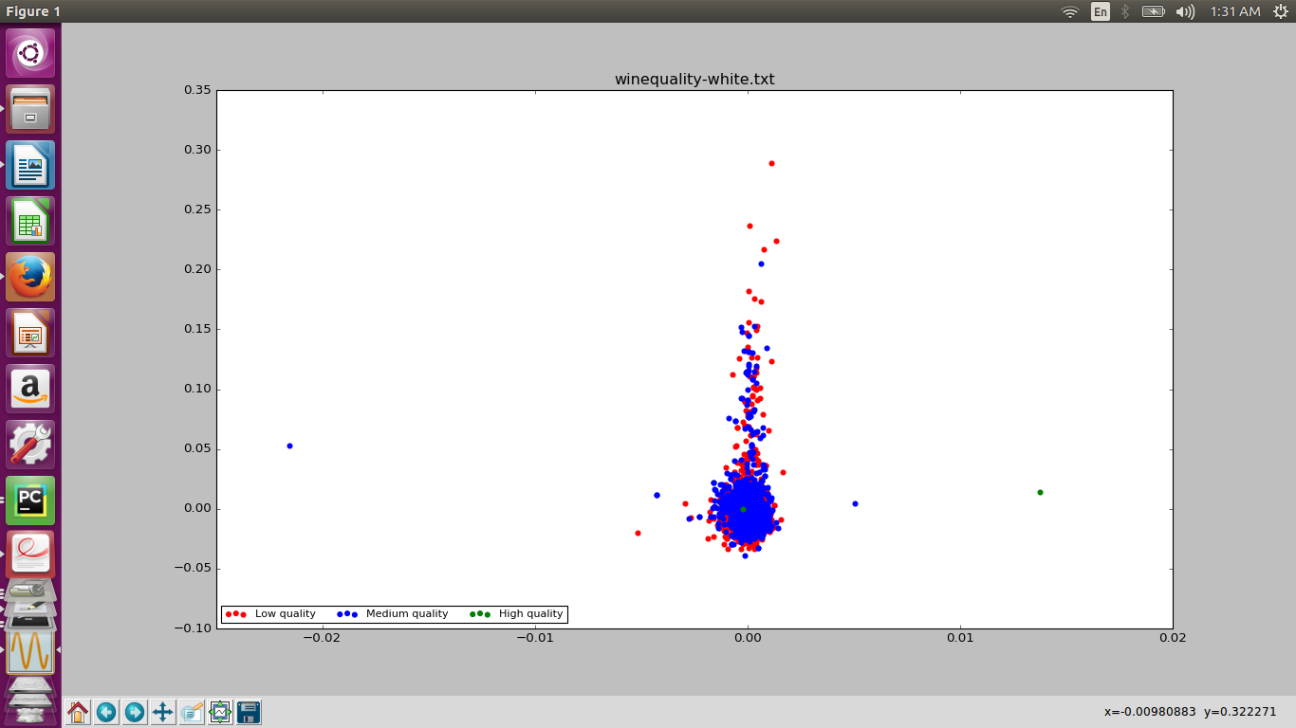
Variable Ranking:

(6, 1805.7167514665443) - Most variance in free sulphur dioxide
(5, 289.18366676942998) - 2nd most variance in chlorides

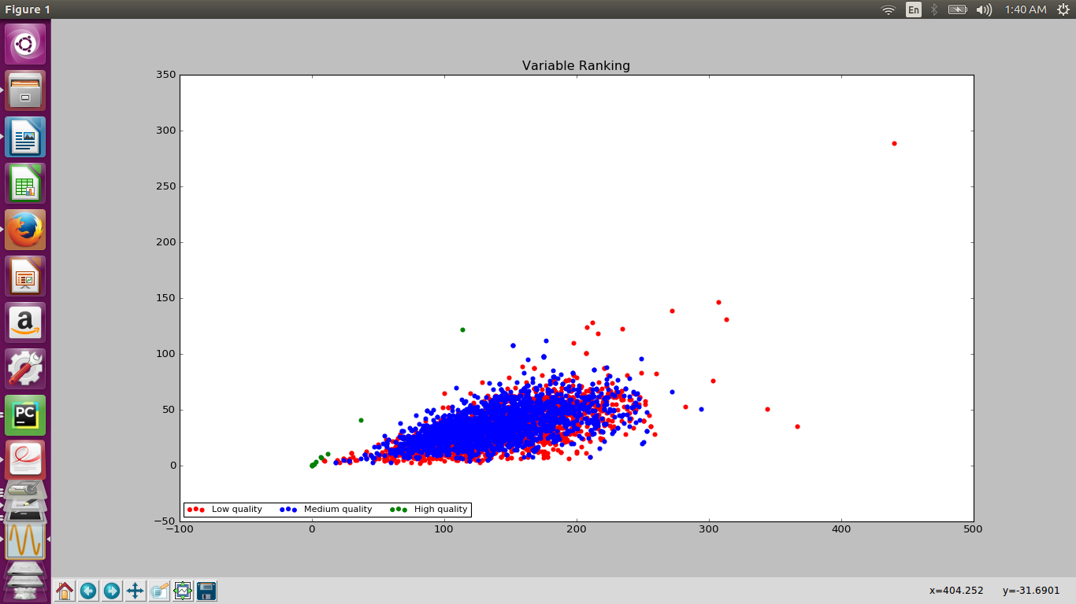

Problem B3: Principal Component Analysis of an Image

def LoadImage():
image = Image.open("palomino_horse.png")
img = np.array(image)
img = img[:,:,0]
#Generate 400 block of 10 x 10 pixels
#print (img[:, :, 0]) #R
#print "-"
#print img[:,:,1] #G
#print "-"
#print img[:,:,2] #B
#All channels have same values just pick one
im_width,im_height =image.size
pixel_block = 10
Features=[]
for i in range(0,im_height,pixel_block): #row
for j in range(0,im_width,pixel_block): #coliumn
end_row = i+pixel_block
end_column = j+pixel_block
Features.append(img[end_row-pixel_block:end_row,end_column-pixel_block:end_column]) #100 dimensional vector 10 x 10
Features=np.array(Features)
Features=Features.reshape(Features.shape[0],Features.shape[1]*Features.shape[2])
return Features,img
def PCA(Features,image,n_components):
D, V = eig(cov(Features, rowvar=False))
V = V[:, np.argsort(D)] # Eigen vector with maximum variance is at last
# eigen values are not very similar there is variation so the dataset is not in a good subspace
X = Features - np.tile(Features.mean(axis=0), [Features.shape[0], 1]) #Centre data
D = sorted(D, reverse=True)
var = []
for k in range(3):
var.append(D[k])
# Find info given by first component
print np.sum(var)/np.sum(D)*100

# Map X through the PCA (rotate axes):
Z= np.matmul(X, V) #score
num=1
for component in n_components:
T = Z[:,V.shape[0]-component:V.shape[0]] # n pca
E = V[:, V.shape[0]-component:V.shape[0]] # n pca components(most variance)
R = np.dot(T,np.transpose(E)) + np.mean(Features,axis=0)
print R
#Now reconstruct the whole image
pixel_block = 10
im_height= 200
im_width=200
Reconstructed_image = np.zeros(shape=(200,200))
x=0
for i in range(0, im_height, pixel_block): # row (200) #run 20 times
for j in range(0, im_width, pixel_block): #column (200) #run 20 times
end_row = i + pixel_block
end_column = j + pixel_block
Reconstructed_image[end_row-pixel_block:end_row,end_column-pixel_block:end_column]=np.reshape(R[x],(10,10))
x+=1
ax = subplot(2, 3, num, frame_on=False)
ax.xaxis.set_major_locator(NullLocator()) # remove ticks
ax.yaxis.set_major_locator(NullLocator())
num += 1
plt.imshow(np.flipud(Reconstructed_image),cmap='gray',origin='lower')
plt.title('PCs # ' + str(component))
plt.show()

def Main():
n_components=[5,10,20,30]
Features,image = LoadImage()
PCA(Features,image,n_components)
Main()

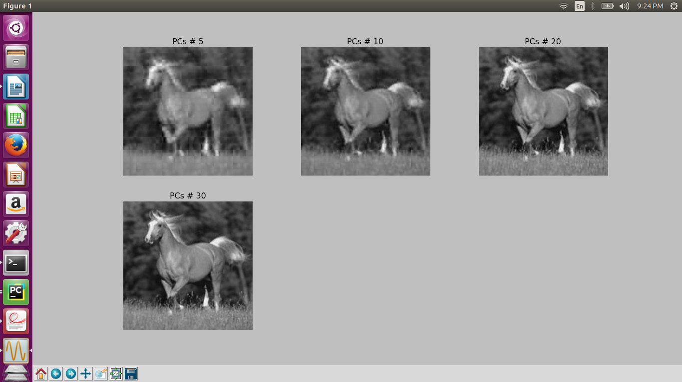

Note: As we can see we can get fair good image with 30 principal components so PCA has reduced the dimension and size of the image with minimal loss of information.

Problem B4: Independent Component Analysis

This part of the code changes the data into Timeseries Data

def ReadAudioFile():
sample_freq, data=wavfile.read("ica_mixdown01.wav")
sample_freq1, data1 = wavfile.read("ica_mixdown02.wav")
sample_freq2, data2 = wavfile.read("ica_mixdown03.wav")
sample_freq3, data3 = wavfile.read("ica_mixdown04.wav")
time = np.linspace(0, data.shape[0] / sample_freq, num=data.shape[0])
timeseries = np.zeros(shape=(data.shape[0],4))
for i in range(data.shape[0]):
timeseries[i][0] = (data[i]) * (time[i])
timeseries[i][1] = (data1[i]) * (time[i])
timeseries[i][2] = (data2[i]) * (time[i])
timeseries[i][3] = (data3[i]) * (time[i])
return timeseries,sample_freq,time
def Main():
timeseries,freq,time = ReadAudioFile()
Independent_Component_Analysis(timeseries,freq,time)
SeperateComponents() #part c

Main()

b)

def Independent_Component_Analysis(timeseries,freq,time):
ica = FastICA(n_components=4)
S_=ica.fit_transform(timeseries)
wavfile.write("test1.wav",freq,S_[:,0]*4)
wavfile.write("test2.wav", freq, S_[:, 1] * 4)
wavfile.write("test3.wav", freq, S_[:, 2] * 4)
wavfile.write("test4.wav", freq, S_[:, 3] * 4)
plt.figure(1)
plt.subplot(211)
plt.plot(time,timeseries)
plt.subplot(212)
plt.plot(time,S_[:,[0,2,3]] )
plt.show()
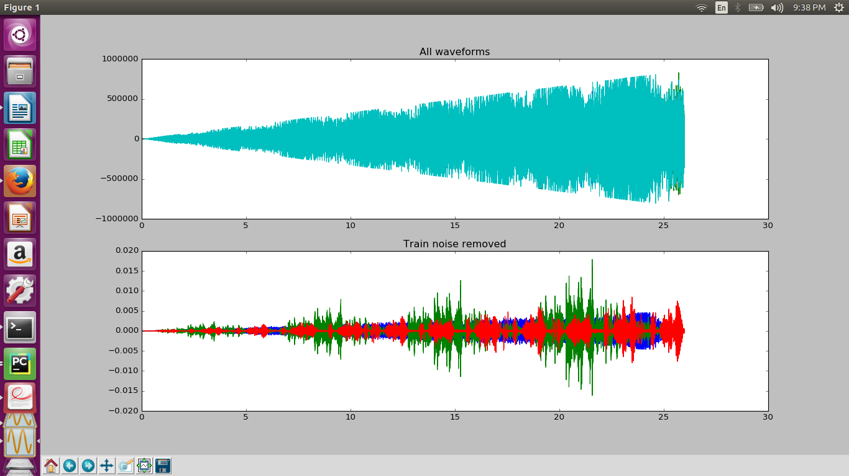

c)

def SeperateComponents(): #This is the c part
sample_freq, data = wavfile.read("ica_mixdown05.wav")
sample_freq1, data1 = wavfile.read("ica_mixdown06.wav")
sample_freq2, data2 = wavfile.read("ica_mixdown07.wav")
sample_freq3, data3 = wavfile.read("ica_mixdown08.wav")
time = np.linspace(0, data.shape[0] / sample_freq, num=data.shape[0])
timeseries = np.zeros(shape=(data.shape[0], 4))
for i in range(data.shape[0]):
timeseries[i][0] = (data[i]) * (time[i])
timeseries[i][1] = (data1[i]) * (time[i])
timeseries[i][2] = (data2[i]) * (time[i])
timeseries[i][3] = (data3[i]) * (time[i])
#print timeseries.shape
ica = FastICA(n_components=4)
S_ = ica.fit_transform(timeseries)
wavfile.write("test5.wav", sample_freq, S_[:, 0] * 50)
wavfile.write("test6.wav", sample_freq, S_[:, 1] * 50)
wavfile.write("test7.wav", sample_freq, S_[:, 2] * 50)
wavfile.write("test8.wav", sample_freq, S_[:, 3] * 50)

Note: If you would run the script then each of these wavfiles would be generated and you can hear the individual sources.

Problem B5: Linear Discriminant Analysis
#Applying Linear Discriminant Analysis for Dimensionality Reduction
import numpy as np
from sklearn.datasets import fetch_olivetti_faces
from numpy.linalg import eig
from numpy import cov
import matplotlib.pyplot as plt
import matplotlib.cm as cm
#4096 features
class_label=0

def LoadData():
dataset = fetch_olivetti_faces()
faces = dataset.data
labels = dataset.target
n_samples, n_features = faces.shape
label_set=list(set(labels))
classes_list=[]
faces = faces - np.tile(faces.mean(axis=0), [faces.shape[0], 1])
for i in range(len(label_set)):
indices=[]
for j in range(len(labels)):
if labels[j] == label_set[i]:
indices.append(j)
classes_list.append(faces[indices,:])
return classes_list,faces,labels

def LinearDiscriminantAnalysis(classes_list,faces,n_components):
Sb=0
Sw = 0
Mean = 0
#Each class has 10 samples and 4096 features
c=0
classMean=[]
for i in classes_list:
classMean.append(np.mean(i,axis=0))
Mean += np.mean(i, axis=0)
for i in classes_list: # First i is np array of 0 class
Sb+=np.multiply((len(i)),np.outer((classMean[c]-Mean),(classMean[c]-Mean)))
c+=1
#The within-class scatter matrix
Sw = np.zeros(Sb.shape)
sw=0
c=0
column=0
for i in classes_list: #i is np array of zero class
Sw+=np.cov(i.T)
#S_{w}^{-1}S_{b}w = \lambda w
EigenMatrix = np.dot(np.linalg.inv(Sw), Sb)
D, V = np.linalg.eigh(EigenMatrix)
V = V[:, np.argsort(D)] # Eigen vector with maximum variance is at last
D = sorted(D, reverse=True)
W=np.column_stack((V[:,-1],V[:,-2])) #(4096,2) Combine 2 highest eigen vectors
X = faces - np.tile(faces.mean(axis=0), [faces.shape[0], 1])
Transformed = np.matmul(X,W) #(400,4096)(4096,2) #Project the data onto 2 highest eigenvectors
# Analyze Projection matrix
# Ranking of eigen values gives importance of each feature
return Transformed #(400,2)

def Visualization(transformed):
labels=[]
for i in range(transformed.shape[0]/10):
labels.append(str(i)) #40 colors
colors = cm.rainbow(np.linspace(0, 1, len(labels)))
labelcount=-1
for k in range(0,transformed.shape[0],10):
labelcount+=1
plt.scatter(transformed[k:k+10,0],transformed[k:k+10,1],label=labels[labelcount],color=colors[labelcount])
plt.legend(loc='lower left',
ncol=3,
fontsize=7)
plt.show()
#Analyze Projection matrix
#Ranking of eigen values gives importance of each feature
def Main():
n_components=2
classes_list,faces,labels=LoadData()
transformed=LinearDiscriminantAnalysis(classes_list,faces,n_components)
Visualization(transformed)
Main()

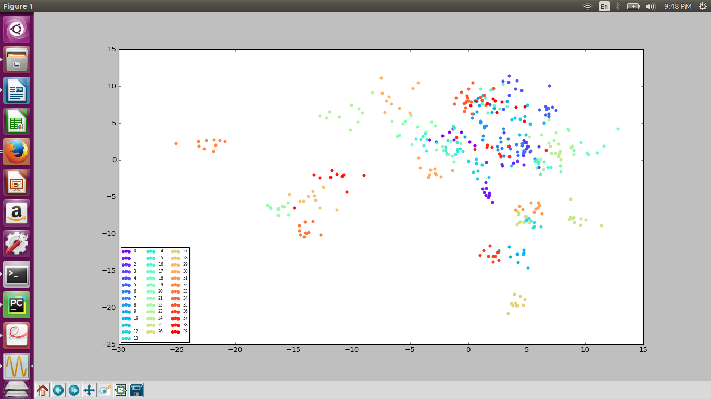
As we can see that some classes are well seperated (atleast some of them).

When PCA applied to the same problem following result was achieved,
You can see that the classes have not been fairly seperated.

LDA Performs well against PCA incase of multi class(in this case)

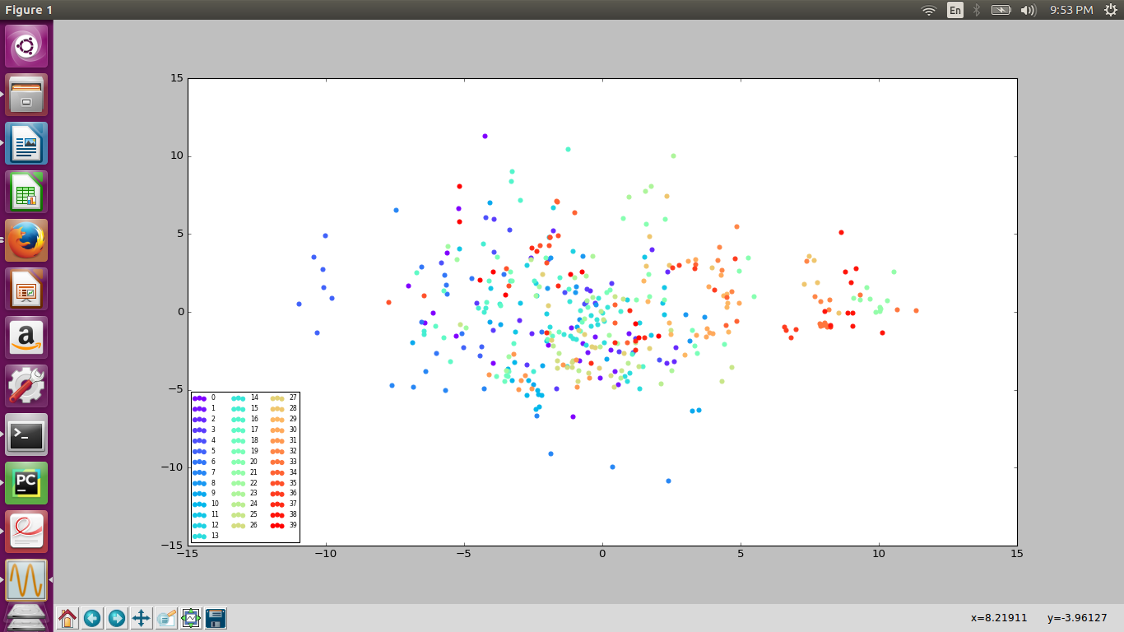
Part C: Graphical Excellence

https://stackoverflow.com/insights/survey/2017#technology-programming-languages

Recently I came across a survey on stack overflow which Showed the popularity of languages among the developers. The graph is really easy to interpret and shows comparison between different programming languages and ranks them in the order of their popularity. The colors used are very soothing visually. Moreover ranking them with the progress bar showing immediately gives you an idea that it is in a decreasing order.

LieFactor = Size of effect shown in graphics / size of effect in data

To calculate that we first find out the volume increase of the cylinder data

('The lie factor is: ', 9.171296296296301)

def LieFactor():
size_ratio = 2.6 / 1.2
area_increase = size_ratio ** 2
volume_increase = size_ratio ** 3
volume_increase = (volume_increase * 100) - 100
# Now we find the increase in data
data_ratio = float(30 / 14)
data_increase = (data_ratio * 100) - 100
# Lie-factor
lie_factor = volume_increase / data_increase
print ("The lie factor is: ", lie_factor)

Problem C3: Chartjunk and Data-Ink Ratio

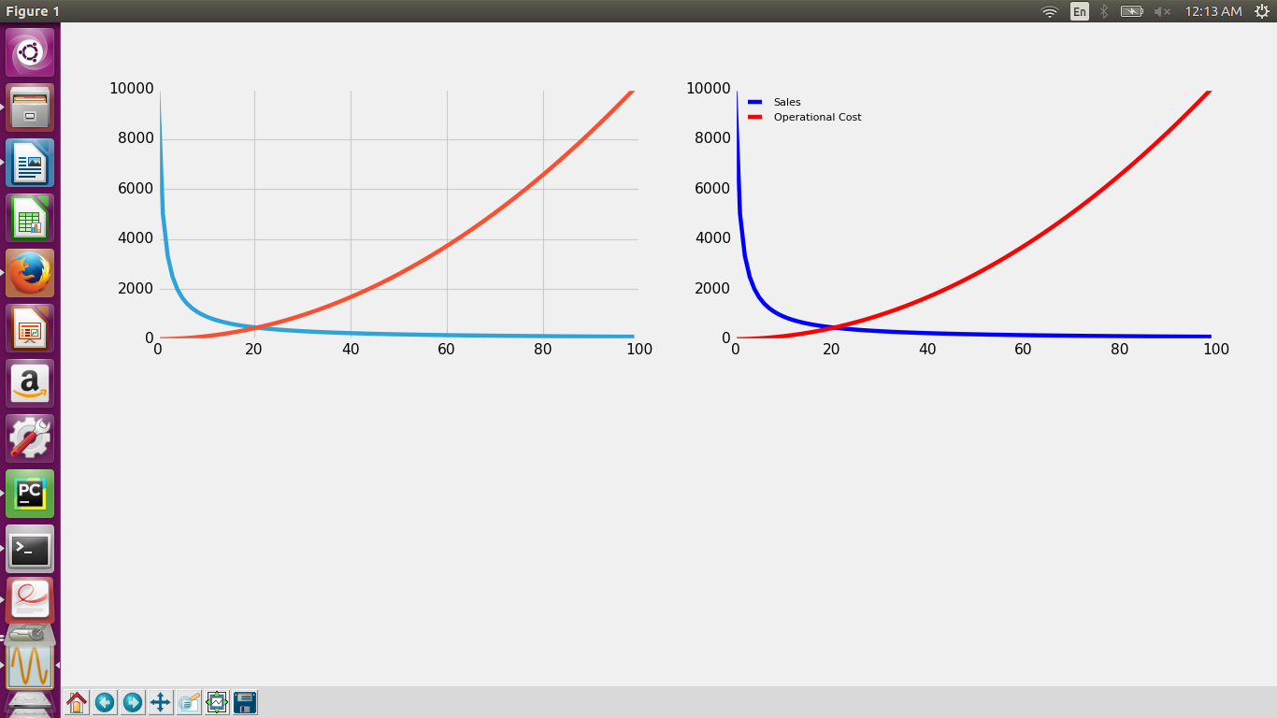

These are the two graphs showing the trend in decreasing sales and increasing Operational costs over time. Difference can be seen clearly in the two graphs. In the second graph which is the improved version I have removed the grid, Added labels along with the colors which makes it self- explanatory.

Part of the code used to create dataset is as follows:

def CreateDataSet():
#Sales and operating costs are inversely related
Data = np.zeros(shape=(100,2)) #First column Sales #Second column Operating costs
x=[]
y=[]
#y=1/x
for i in range(100):
Sales = i+1
Data[i][0]=float(10000/float(Sales)) #Sales decreasing as time passes by
Data[i][1] = float(Sales**2) #operational costs increases as time passes by
time= [i for i in range(100)]
fig= plt.figure()
ax1=fig.add_subplot(221)
ax2=fig.add_subplot(222)
ax1.plot(time,Data[:,0]) #Junk
ax1.plot(time,Data[:,1])
ax2.plot(time,Data[:,0],'b',label='Sales') #Improved
ax2.plot(time,Data[:,1],'r',label='Operational Cost')
ax2.legend(loc='best',ncol=1,fontsize=10)
ax2.grid()
plt.show()

Problem C4: Improving Real-world Visualizations

Chartjunk refers to all visual elements in charts and graphs that are not necessary to comprehend the information represented on the graph, or that distract the viewer from this information.

a)

In this figure there is quite a lot of unnecessary information. There is a lot of text other than visual representation. The text should be minimal and visual representations should be self-explanatory. Viewer should get an overall idea by seeing the visuals while keeping the text at minimum level.

b)

We can improve the visualization by minimizing the text. May be using some bright colors so as to get the attention of the viewer.

c)

unemployed job seekers (purple curve) VS amount of open jobs (yellow curve)

In this graph it can be seen that there are two y label values on both side of the graph. It can be such that since both values are same so just keep one y-label value for both the plots. We can also remove the grid as it is kind of distracting at least for me.

<-----------------------------------------------END-------------------------------------------------------------------->

