 **ST. CECELIA’S COLLEGE – CEBU INC.** LASSO SUPERVISED SCHOOL

Ward II, Poblacion Highway, Minglanilla, Cebu

**“ E S P R E S S O ”** Title

**Name of student: Delicano Kim**

**Section: BSIT 1-B**

**INTRODUCTION**

This research presents the development of "Espresso" – a coffee-themed website designed to showcase a warm, rich coffee shop experience online. The team aimed to build a responsive and stylish multi-page website consisting of Home, About, Products, Reviews, Contact, and Call-to-Action sections. The inspiration came from the need to create a compelling online presence for modern cafés, highlighting aesthetic branding and accessibility.

**PROBLEM**

Coffee shops today require more than a physical location to attract customers – they need an effective digital presence. Most small cafés lack appealing websites, and customers often rely on third-party platforms that don't represent the brand well. This project solves that problem by building a visually appealing, mobile-responsive, user-friendly website that presents all aspects of a café business in one place.

**TARGET USER**

The target audience includes:

* Coffee lovers looking for new places to try
* Students and remote workers who enjoy studying in cozy cafés
* Small café owners who want a sample design for their own web presence

**SOLUTION**

Espresso provides a modern, responsive, and user-friendly website that captures the ambiance of a cozy, upscale coffee shop. The site includes sections such as Home, About, Menu, Reviews, Contact, and a Call to Action. Each page is designed with attention to detail—rich visuals, warm colors, and elegant fonts—to evoke the feeling of being in a café while providing all the essential information a visitor might need.

**PERSONA**

**Name:** Delicano kim  
**Age:** 19

**TASKS  
Browse the Menu** – View coffee and food items with names, prices, and categories.

**Read Reviews** – Check customer testimonials and ratings to gauge service and quality.

**Learn About the Café** – Explore the story, values, and uniqueness of Espresso.

**Contact the Café** – Send messages via a contact form or find contact details and location.

**Use Call to Action** – Quickly place orders, book a table, or join a newsletter.

**Mobile-Friendly Navigation** – Easily access all features across devices.

**DESIGN**

The design of the **Espresso** website blends elegance with warmth, reflecting the cozy yet modern atmosphere of a real-world coffee shop. The overall layout is clean and intuitive, allowing users to focus on content without distraction.

**LOW FIDELITY / STORY BOARD**

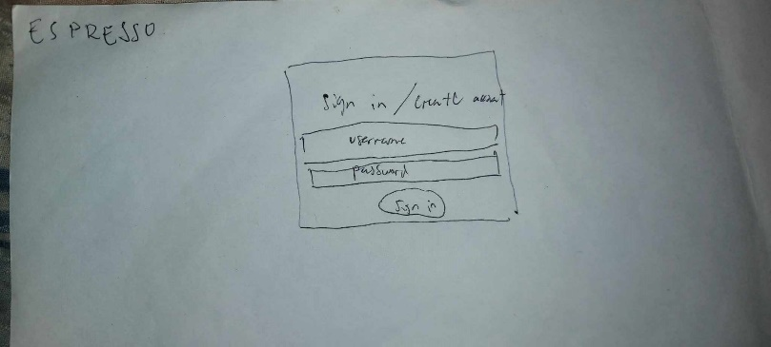

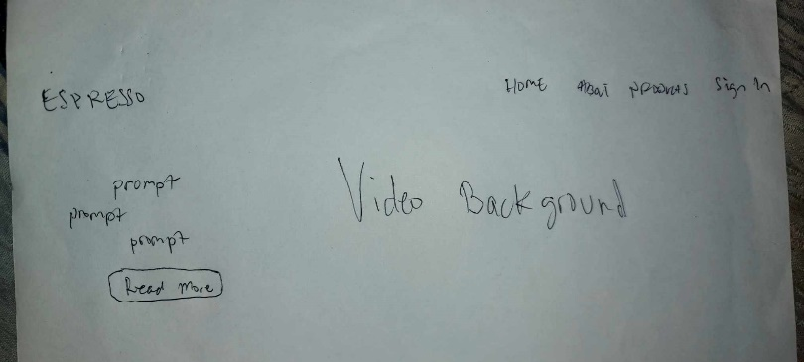

**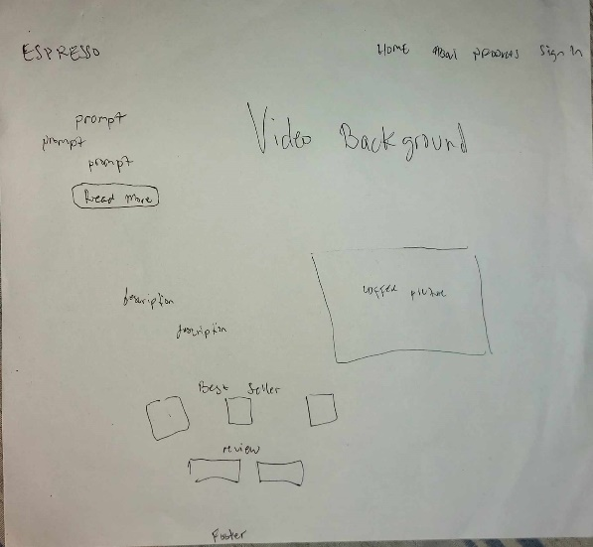  
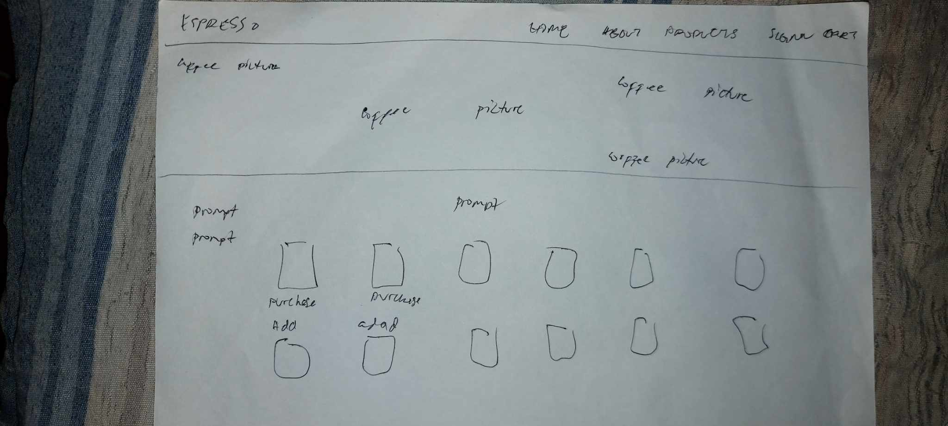**

**WEBSITE**

The design of the **Espresso** website blends elegance with warmth, reflecting the cozy yet modern atmosphere of a real-world coffee shop. The overall layout is clean and intuitive, allowing users to focus on content without distraction.

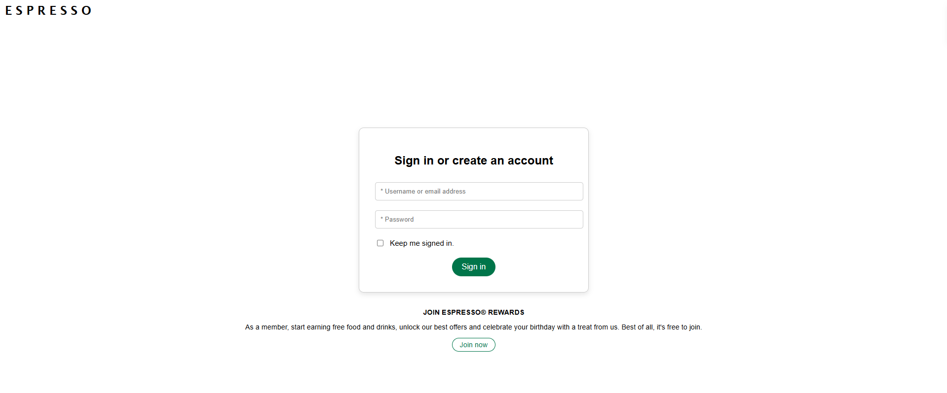

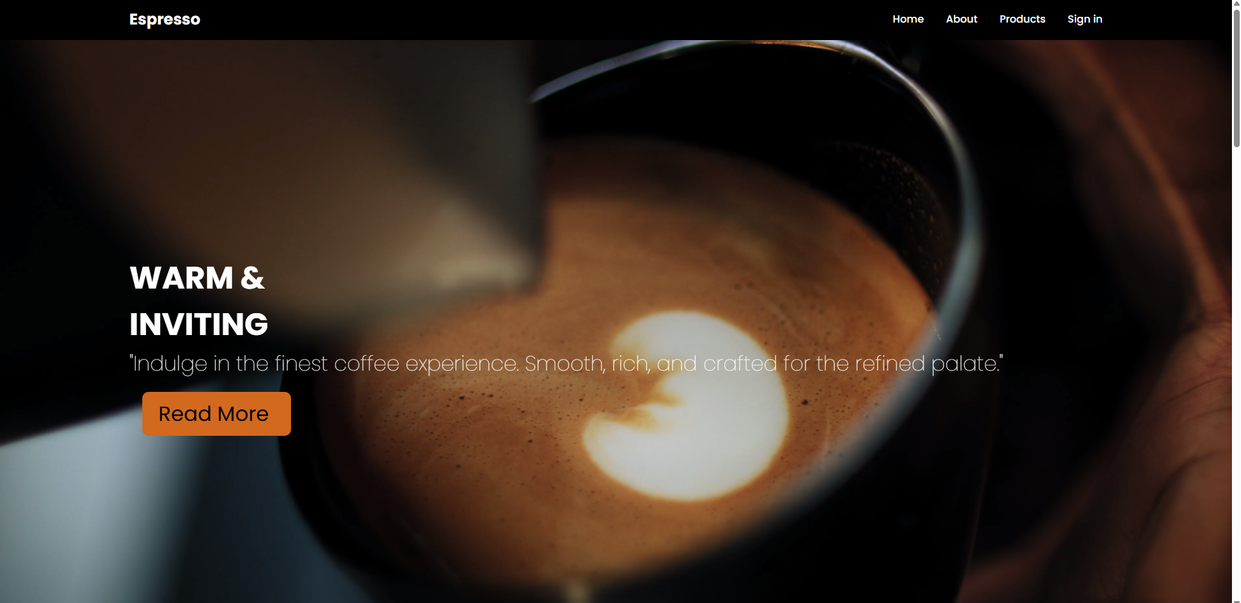

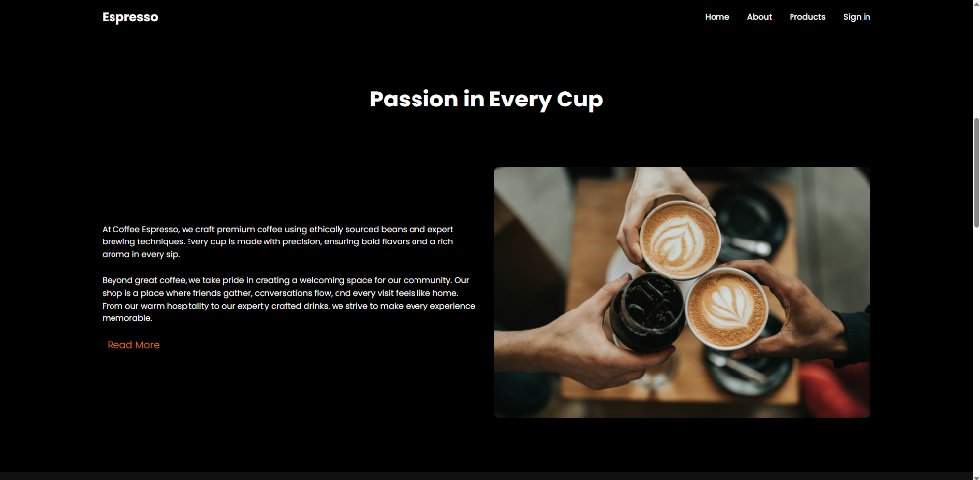

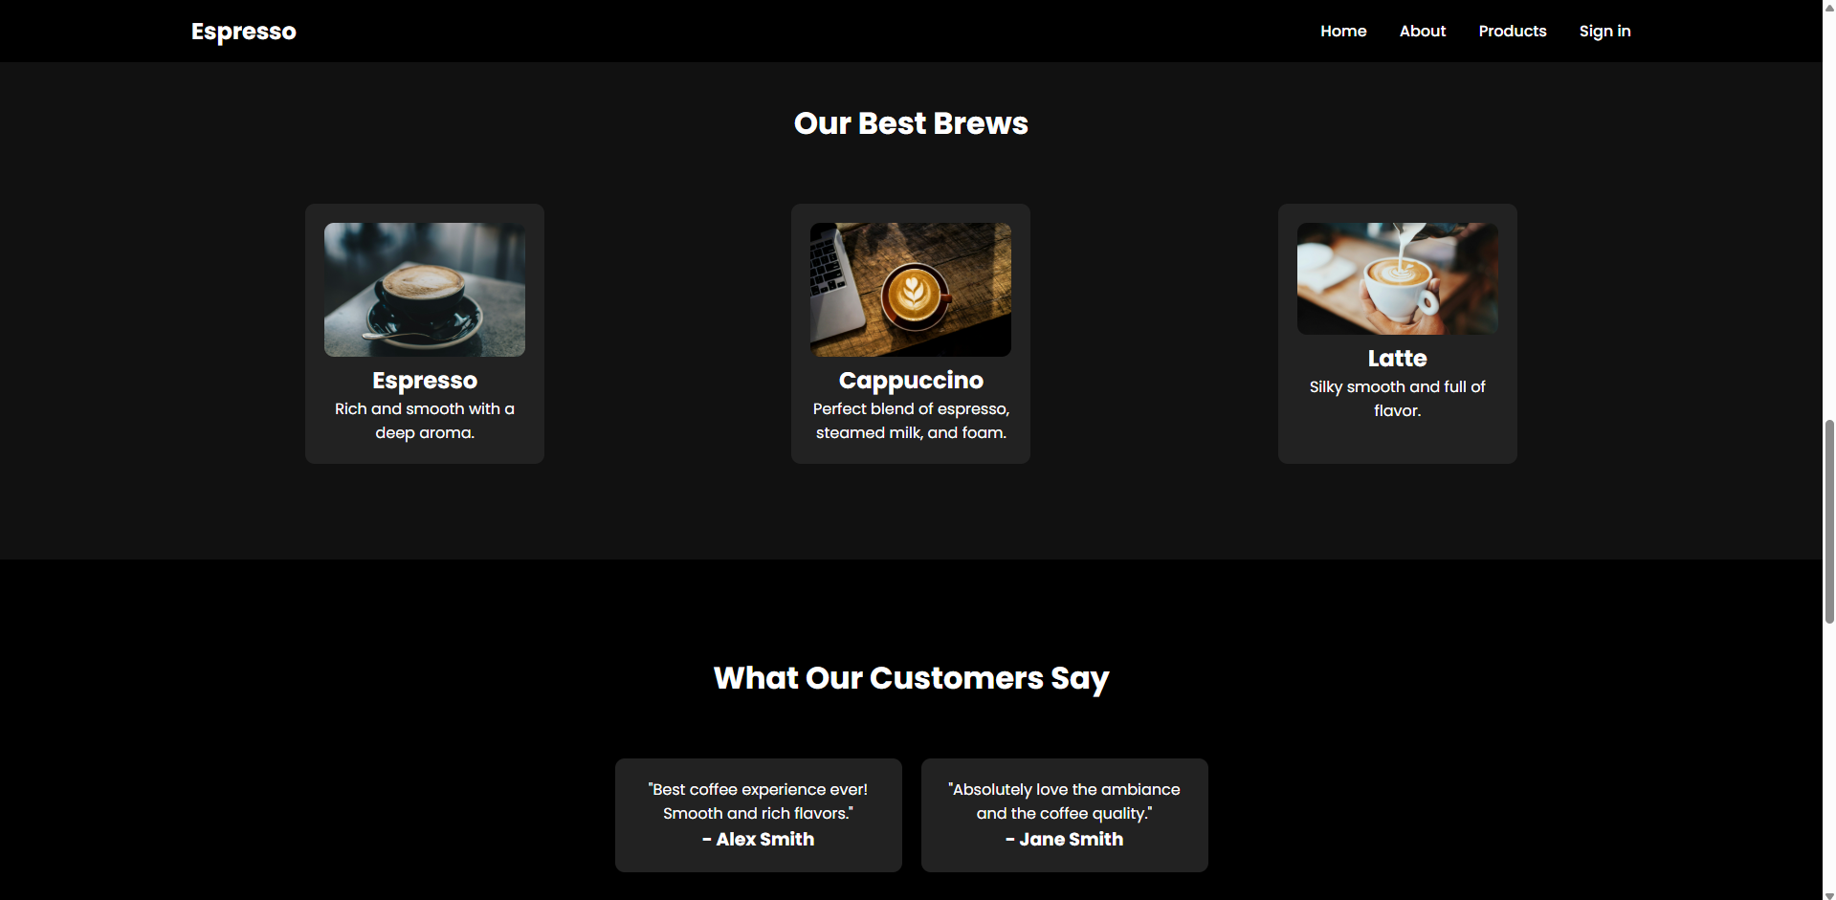

**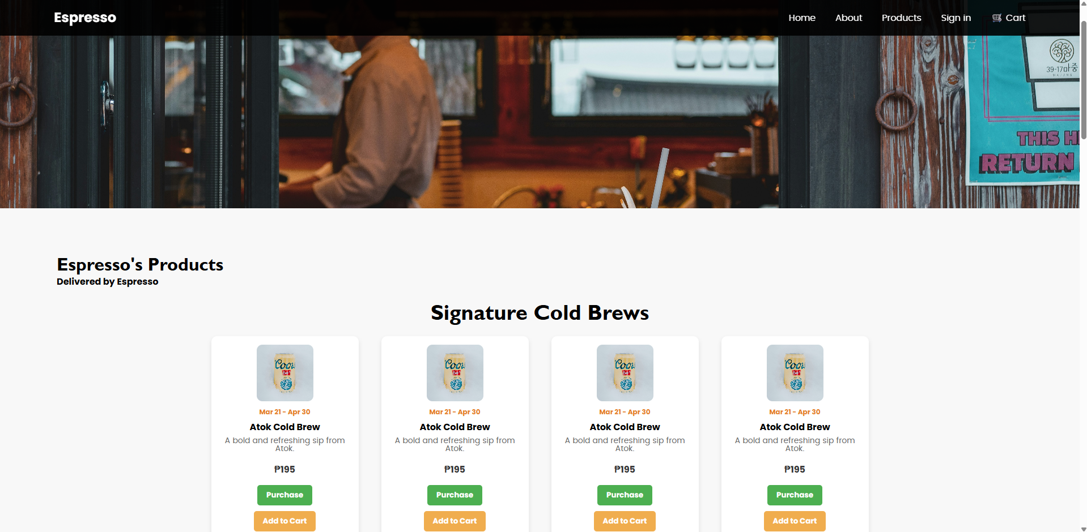  
  
  
  
  
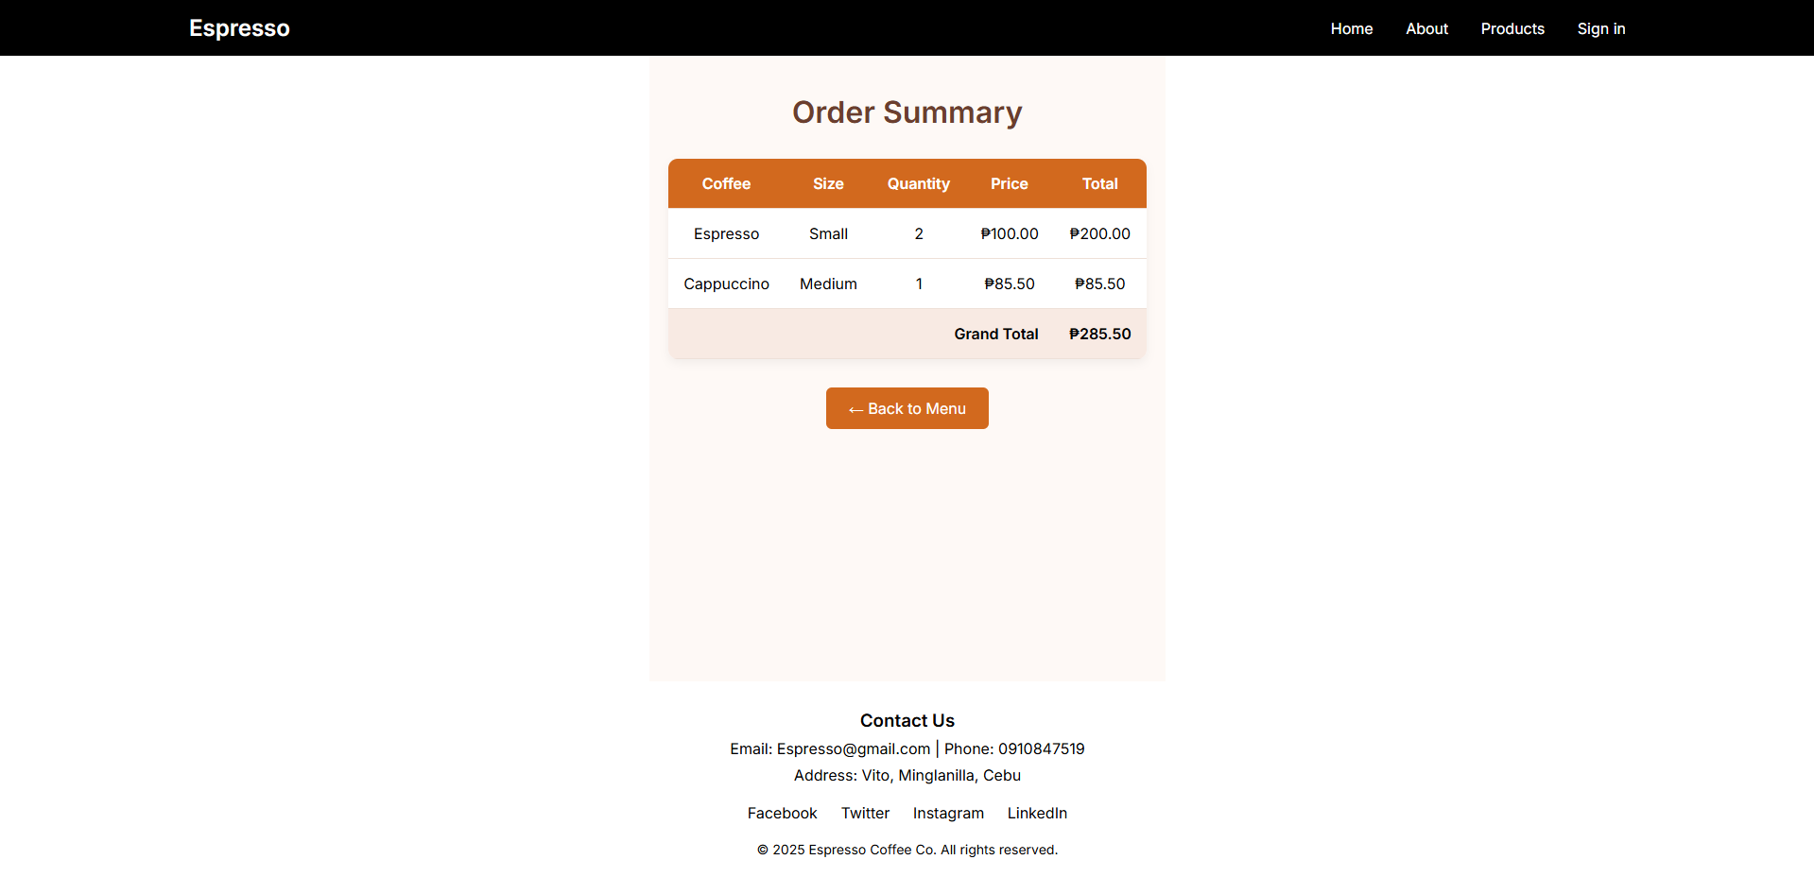**

**EVALUATION**

The Espresso website was evaluated based on:

* **Usability Testing:** Friends and target users were asked to navigate the site and complete tasks (e.g., finding the menu or submitting a contact form).
* **Mobile Responsiveness:** The site adapts smoothly across desktop, tablet, and mobile views.
* **Aesthetic Design:** Feedback praised the color scheme, typography, and cozy café vibe.
* **Performance:** Load times were optimized, and navigation was intuitive and quick.

**REFLECTION**

Creating the Espresso website allowed a deeper understanding of how thoughtful design enhances user experience. The challenge was balancing visual appeal with functionality, especially for mobile users. User feedback highlighted the strengths of the site—especially its design and layout—while also suggesting future features like a blog or coffee subscription service. Overall, Espresso serves as both a portfolio piece and a functional model for digital café branding.