

THE COPPERBELT UNIVERSITY
SCHOOL OF INFORMATION AND COMMUNICATION TECHNOLOGY
COMPUTER SCIENCE DEPARTMENT

CS 400: PROJECT SEMINARS
An Algorithmic Framework for Building Energy Management: Integrating IQR-Based Anomaly Detection and Grid-
Search Optimized SARIMA
(Project System Design)

Submitted by:
Luckson Musyani (22998143)

Supervised by:
Dr. George Mufungulwa

22nd May 2026
Contents Page
CHAPTER 4: SYSTEM DESIGN 3
4.1 Introduction 3
4.2 Analysis of the System 3
4.3 Context Model of the System 4
4.4 Design Methods 5
4.4.1 Architectural Design 5
4.4.1.1 Forecast Processing and Task Management 8
4.4.2 Detailed Design 8
4.4.3 Physical Design 18
4.4.3.1 Database Design 18
4.4.3.2 Data Validation and Physical Constraints 21
4.4.3.3 Implementation-Level Forecasting Logic (Pseudocode Update) 22
4.4.3.4 Design Rationale 23
4.4.3.5 User Interface 23
4.5 Conclusion 27

CHAPTER 4: SYSTEM DESIGN

4.1 Introduction
Building energy demand forecasting and decision-support system in most facilities remains reactive: anomalies are investigated after consumption spikes have already occurred and planning relies on historical averages rather than forward-looking projections. The system designed in this study addresses this gap by automating the full cycle from raw data cleaning to 30-day demand forecasting within a single integrated application. This chapter documents the design decisions made in constructing that system, the alternatives that were evaluated and rejected, and the rationale that governed each choice.
The design adopts the Object-Oriented Analysis and Design (OOAD) approach and is organised around a five-module pipeline architecture. The context model establishes the system boundary and its interactions with external actors. The architectural, detailed, and physical designs then specify, in increasing levels of detail, how the system fulfils the eleven functional and six non-functional requirements established in Chapter 3.

4.2 Analysis of the System
Prior to designing the system, an analysis of the problem domain was conducted to establish what the system must do before any decisions about how it would do it were made. This analysis identified three root causes that the system must resolve.
The first cause is data quality degradation. Electricity consumption records sourced from building meters contain gaps caused by sensor dropouts, duplicate timestamps from logging errors, and outlier readings caused by instrumentation faults. These issues corrupt the statistical properties of the time series and make it unsuitable for direct modelling without a preprocessing stage.
The second cause is the absence of automated demand forecasting. No existing tool in the target building environment generates forward projections of electricity consumption. The absence of such projections means that procurement decisions, load-balancing actions, and maintenance scheduling are made without quantitative demand evidence.
The third cause is the lack of structured forecast communication. Even where informal predictions exist, they are not accompanied by uncertainty estimates, confidence intervals, or accuracy metrics that would allow a facility manager to assess reliability or communicate findings to stakeholders.
These three causes established the minimum functional scope of the system: a preprocessing engine, a forecasting engine, and a communication layer. Every module in the design and every requirement in Chapter 3 maps directly to one of these three causes. The decision-support component of the system is operationalized through the dashboard’s peak demand indicators and forecast visualizations. These outputs enable Facility Managers to identify periods of expected high electricity consumption and make proactive operational decisions such as load balancing, maintenance scheduling, and energy procurement planning before peak demand occurs.

4.3 Context Model of the System
The context model places the Building energy demand forecasting and decision-support system at the centre and identifies the external entities that exchange data with it. Four external entities were identified during the requirements elicitation phase.
The Facility Manager is the primary human actor. This actor uploads historical consumption data, triggers the forecasting pipeline, views the dashboard output, and exports reports. All user-initiated interactions flow through this actor.
The System Administrator is responsible for managing system-level operations. This includes user account management, access control, and configuration of system parameters. The administrator ensures the system operates within defined policies and maintains its integrity and security.
The data source is the source of raw data. This encompasses smart meters, building management system logs, and historical utility billing records. Data from this entity enters the system as CSV or Excel files provided by the Facility Manager; the metering infrastructure does not connect to the system directly. The system follows an offline-first operational model rather than a live-stream IoT architecture. Although the data originates from smart meters and building management logs, the current implementation requires datasets to be manually uploaded by the Facility Manager in CSV or Excel format. Real-time sensor integration was intentionally excluded from the present scope to reduce infrastructure complexity and focus on preprocessing and forecasting reliability.
Report Storage represents the external entity responsible for receiving and storing exported forecast reports generated by the system. It acts as the downstream repository for outputs produced by the reporting module, including formats such as PDF and CSV files. These reports are archived for future reference, analysis, and decision-making by authorized users within the system.
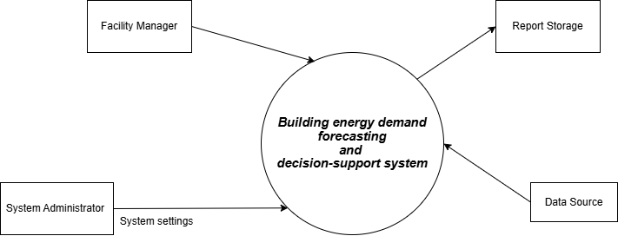
Figure 4.1: Context Model — Building energy demand forecasting and decision-support system

As illustrated in Figure 4.1, data enters the system through the Facility Manager in the form of uploaded historical consumption files. In response, the system processes this input and provides forecast visualisations and accuracy metrics back to the Facility Manager during the active session.

4.4 Design Methods

4.4.1 Architectural Design
Two principal architectural approaches were evaluated before the final system architecture was selected: monolithic architecture and client-server architecture with a layered pipeline design.
A monolithic architecture, in which all system functionalities are integrated into a single tightly coupled application, was considered but not adopted. Although this approach simplifies initial development, it presents significant limitations in terms of maintainability and extensibility. In such a design, components such as data upload, preprocessing, forecasting, visualisation, and reporting would all reside within a single codebase and execution unit. As a result, future modifications, such as replacing the SARIMA forecasting model with an alternative algorithm, would require extensive changes and retesting across the entire system. This would violate the maintainability requirement (NFR4) and reduce the system’s ability to scale in future phases.
The selected architecture is therefore a client-server architecture with an internal five-layer processing pipeline.
At the deployment level, the system adopts a client-server architecture. The client layer consists of a browser-based web dashboard through which the facility manager and the system administrator interacts with the system. This interface supports data upload, visualisation of forecast trends, display of evaluation metrics, and export of generated reports.
The system adopts a three-tier client-server architecture comprising a presentation layer, application layer, and database layer. The presentation layer is implemented using React.js to provide an interactive dashboard for data visualisation, forecast display, and report export. The application layer is implemented using Python Django, which manages request routing, preprocessing workflows, forecasting API endpoints, and report generation services. The data layer is implemented using MySQL for persistent storage of user accounts, uploaded datasets, cleaned data, forecast outputs, and evaluation metrics. This architecture was selected for three main reasons.
First, it enables modular development by allowing the presentation layer, application layer, and database layer to be developed, tested, and maintained independently, which aligns with the Agile sprint-based methodology adopted in this study.
Second, it provides clear separation of concerns between presentation logic, processing logic, and data persistence, thereby improving maintainability and future scalability in line with Non-Functional requirements 4 and 5.
Third, the server-side application logic naturally follows a layered pipeline structure, reflecting the sequential workflow of the forecasting problem.
The internal architecture therefore consists of five processing layers, as illustrated in Figure 4.2.
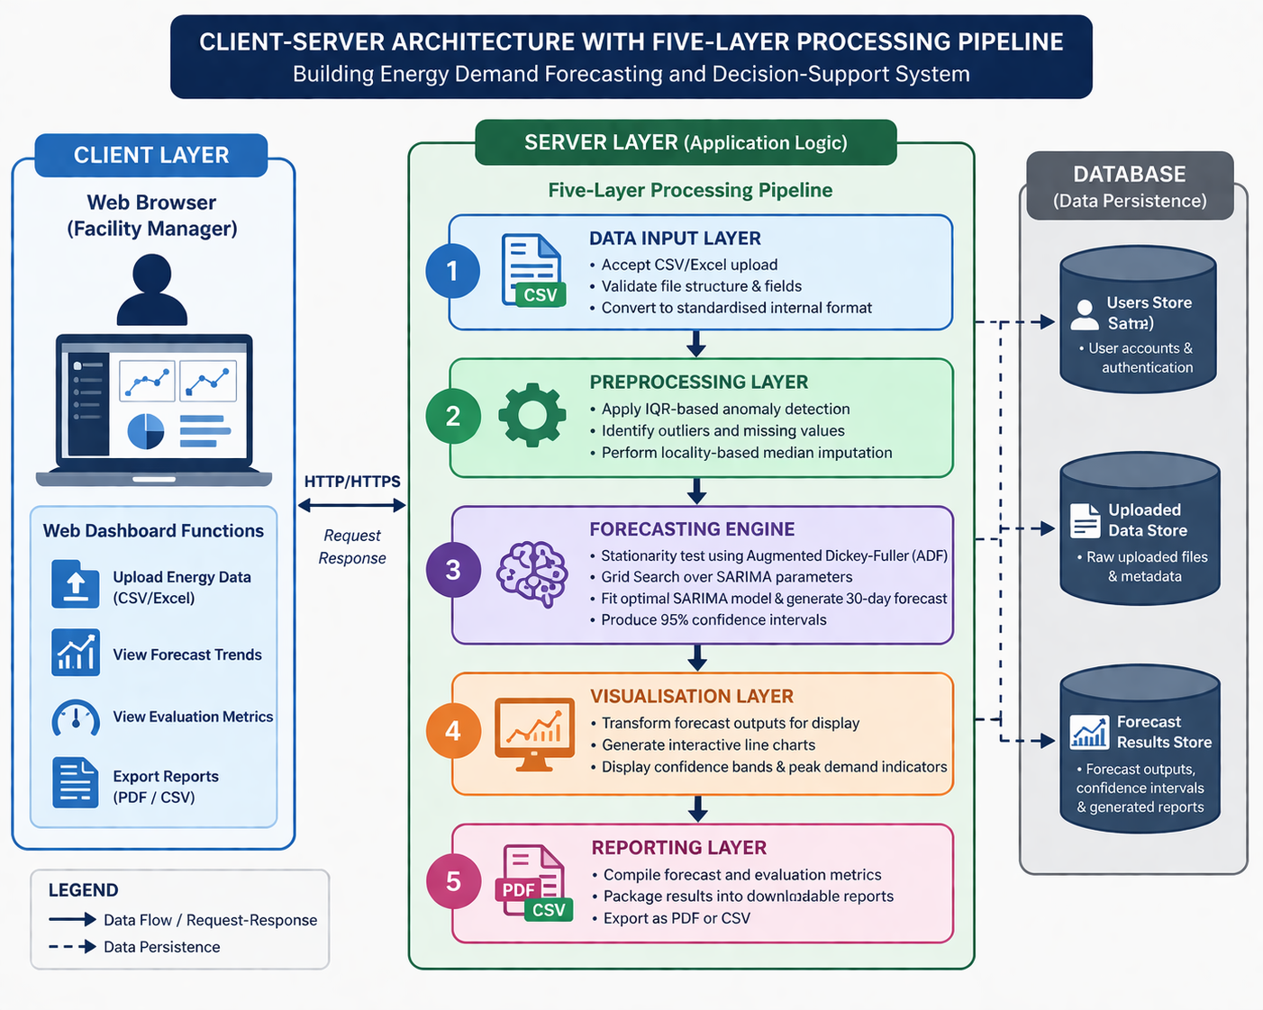
Figure 4.2: System Architecture — Client-server Architecture
Layer 1: Data Input Layer
This layer accepts uploaded CSV or Excel files from the web dashboard, validates file structure and field integrity, and converts raw records into a standardised internal format.
Layer 2: Preprocessing Layer
This layer applies IQR-based anomaly detection to identify outliers and missing values, followed by locality-based median imputation to preserve temporal consistency.
Layer 3: Forecasting Engine
This layer performs stationarity testing using the Augmented Dickey-Fuller (ADF) test, executes Grid Search over SARIMA parameter combinations, fits the optimal model, and generates the 30-day electricity demand forecast together with 95% confidence intervals.
Layer 4: Visualisation Layer
This layer transforms forecast outputs into interactive dashboard components, including line charts, confidence bands, and peak demand indicators.
Layer 5: Reporting Layer
This layer packages forecast outputs and evaluation metrics into downloadable PDF and CSV reports.

4.4.1.1 Forecast Processing and Task Management
Forecast generation is computationally intensive because the Grid Search optimisation process evaluates multiple SARIMA parameter combinations sequentially. To prevent browser freezing and HTTP timeout failures during long-running execution, the system adopts asynchronous task handling within the application layer.
When a forecast request is submitted, the server places the forecasting task into a background processing queue while the client dashboard enters a loading state. The dashboard displays preprocessing and forecasting progress indicators until execution completes. This prevents interruption of the user session and improves responsiveness during high-computation workloads.
For scalability, the architecture is compatible with task queue frameworks such as Celery integrated with Redis message brokering. Under this approach, forecasting tasks execute independently from the main web request lifecycle, enabling reliable handling of Grid Search operations that may require several minutes to complete.

4.4.2 Detailed Design
The detailed design specifies the internal structure of each module using OOAD tools. Six UML models were produced. Use Case Diagram, a Class Diagram, a Sequence Diagram, an Activity Diagram, and a two-level Data Flow Diagram. Pseudocode is provided for the two core algorithms.

Use Case Diagram
The Facility Manager is the single external actor in the system. Eleven use cases were derived from the functional requirements and are shown in Figure 4.3. Upload Energy Data, which corresponds to FR1, is the entry point for all subsequent interactions. Data Validation (FR2), Anomaly Detection (FR3), and Missing Value Imputation (FR4) are triggered automatically as internal extensions of the upload interaction, requiring no separate action from the actor. Stationarity Testing (FR5) and Parameter Optimisation (FR6) are likewise triggered automatically as part of the forecasting pipeline. Generate Forecast (FR7) produces the ForecastResult object that enables the remaining use cases: View Confidence Intervals (FR8), View Dashboard (FR9), Evaluate Accuracy (FR10), and Export Report (FR11), all of which are available to the actor after a successful forecast run.

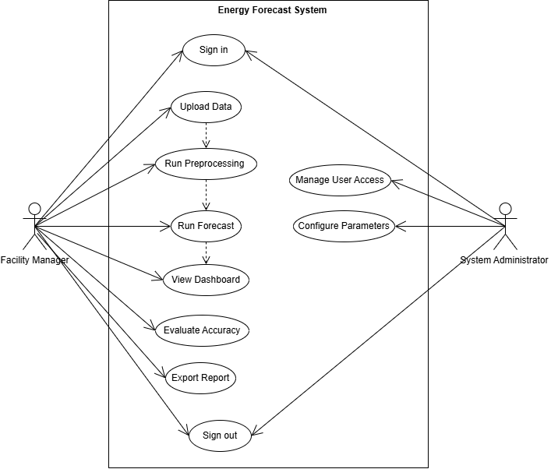
Figure 4.3: Use Case Diagram — Building energy demand forecasting and decision-support system

Class Diagram
Eight classes were identified and specified during the detailed design phase. Table 4.1 summarises each class along with its key attributes and methods. Figure 4.4 shows the full class diagram with associations.
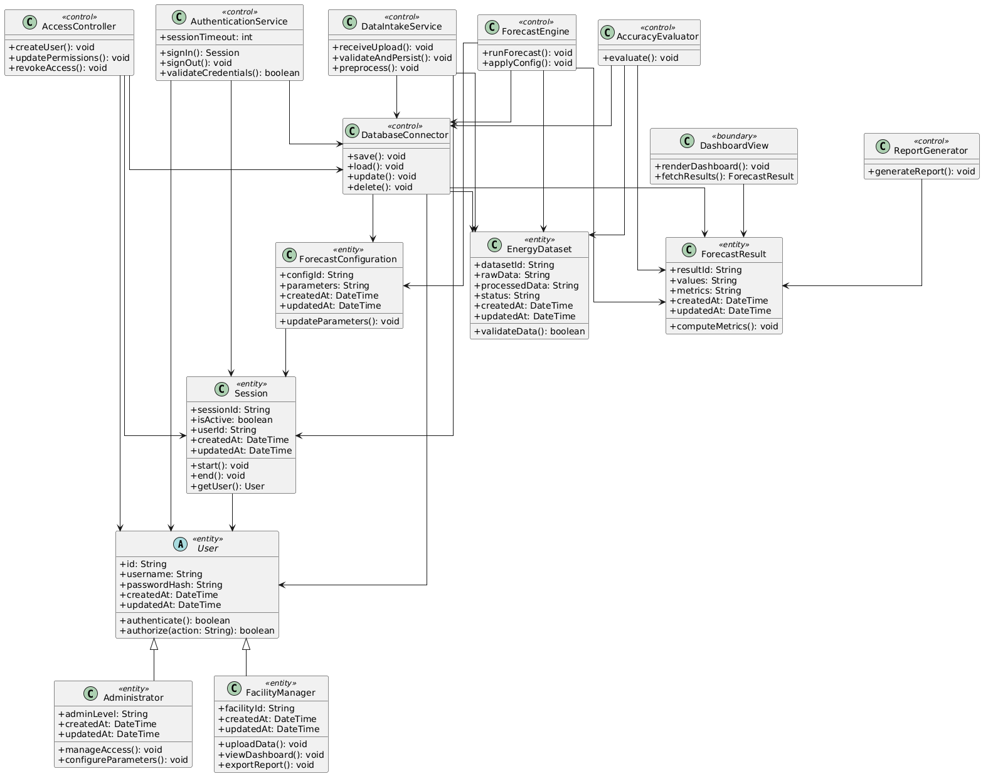
Figure 4.4: Class Diagram — Building energy demand forecasting and decision-support system

The system follows a coordinated processing pipeline managed by the EnergyForecastSystem. When a FacilityManager initiates a forecast, energy consumption data is retrieved as Dataset objects via the DatabaseConnector. This data is then processed by the ForecastEngine, which performs ADF-based stationarity testing, applies necessary transformations, and uses Grid Search to determine optimal SARIMA parameters before generating forecast outputs.
The results are encapsulated in a ForecastResults object and persisted through the DatabaseConnector. These results are subsequently used by the EvaluationService to compute accuracy metrics and by the ReportService to generate exportable reports. Both services operate without modifying the underlying data, ensuring a clear separation between computation and presentation. Administrative configurations are handled independently by the SystemAdministrator through the ConfigService.

Sequence Diagram
Figure 4.5 shows the sequence of method calls exchanged between the Facility Manager, the system modules, and the data objects during a complete forecast generation cycle.
The Facility Manager calls upload() on the DataUploader. DataUploader calls validateFormat() then parseToRecords(), returning a List<EnergyRecord>. This list is passed to IQRPreprocessor, which calls computeIQR(), detectAnomalies(), and imputeMedian() in sequence, returning a cleaned list. The cleaned list is passed to ADFTester, which calls runTest(). Where the series is found to be non-stationary (p-value > 0.05), ADFTester calls applyDifferencing() before returning. The processed series is passed to GridSearchOptimiser, which calls search() and evaluateAIC() and returns the optimal parameter tuple. The tuple is passed to SARIMAForecaster, which calls fit() followed by forecast(horizon=30), returning a ForecastResult. The Visualisation Dashboard reads this object and renders the chart. If the Facility Manager then requests an export, ReportExporter calls exportPDF() or exportCSV() against the same ForecastResult.

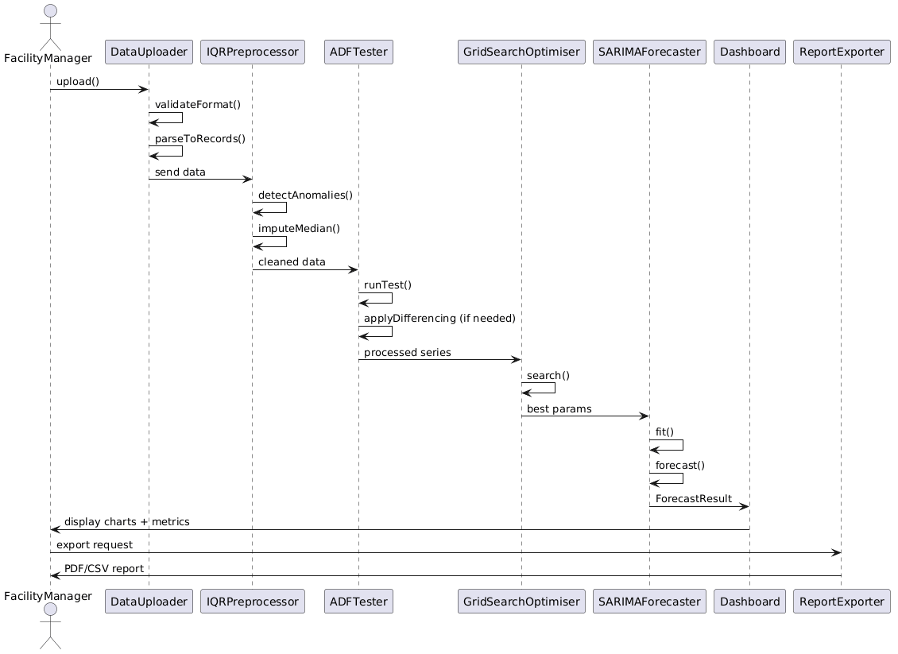
Figure 4.5: Sequence Diagram — Forecast Generation Workflow

Activity Diagram
The activity diagram in Figure 4.6 models the control flow of the system including decision points and exception paths.
The workflow begins when the Facility Manager uploads a file. If the file format is invalid, the system raises a validation error and halts, returning the actor to the upload screen. If the format is valid, the file is parsed and the IQR bounds are computed. If anomalies are detected, imputation is applied; if none are found, the series proceeds unchanged. The ADF test is applied to the cleaned series. If the series is non-stationary, differencing is applied and the test is re-run; this loop continues until stationarity is achieved or a maximum differencing order (d ≤ 2) is reached, after which the process proceeds to model selection to prevent infinite iteration. Grid Search then iterates over the parameter space and selects the lowest-AIC configuration. The model is fitted and the 30-day forecast is generated. RMSE and MAE are computed against a held-out validation window. The dashboard is rendered with the forecast, confidence bands, and accuracy metrics. The Facility Manager may then export the report or end the session.

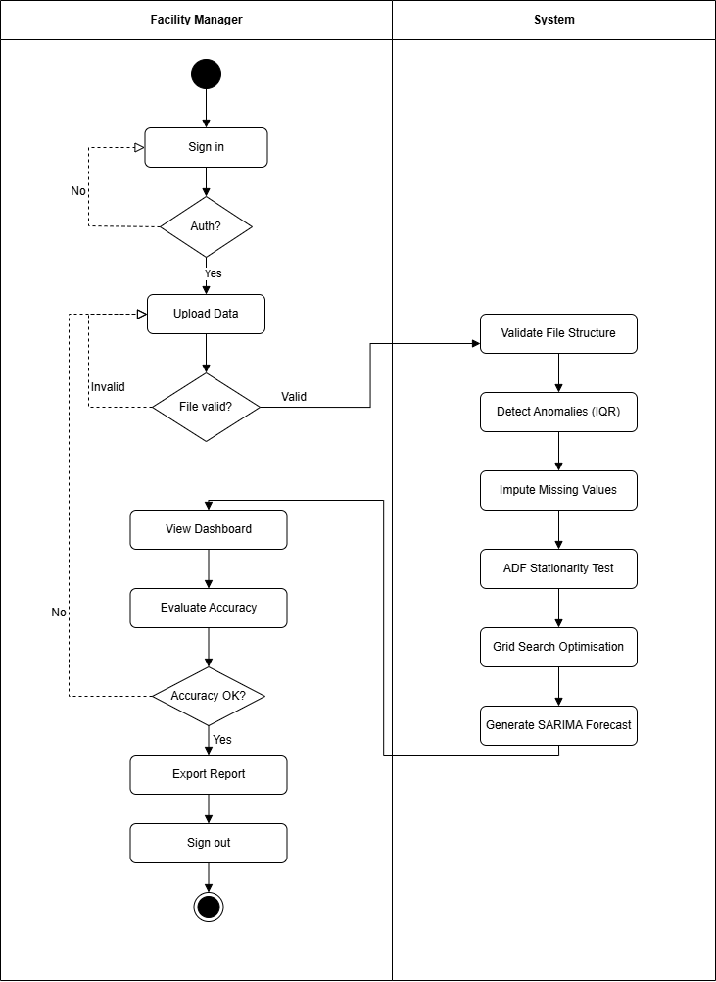
Figure 4.6.1: Activity Diagram — Overall workflow mechanism
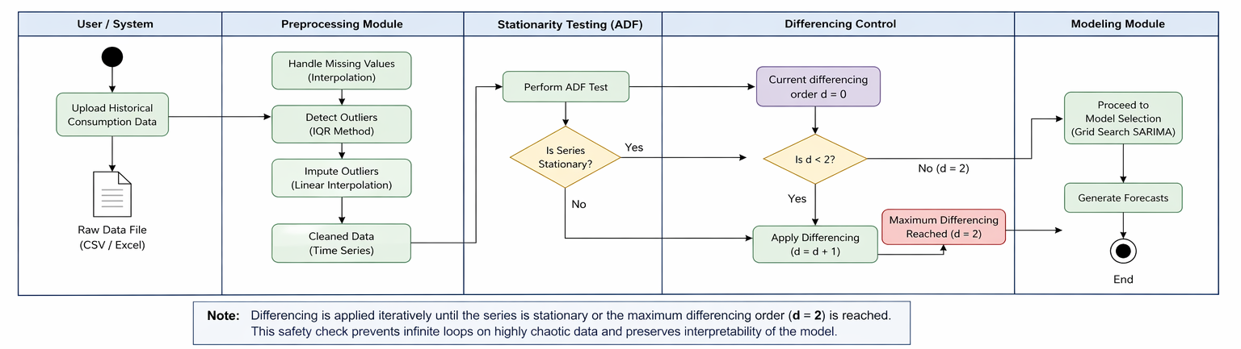
Figure 4.6.2: Activity Diagram — Preprocessing and Differencing for Stationarity

Data Flow Diagram

Figure 4.7 shows the Level 0 DFD, in which the entire system is treated as a single process. The Facility Manager is the sole external entity. Raw consumption data flows into the system from the Facility Manager; forecast visualisations and exported reports flow back out.

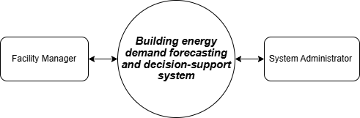
Figure 4.7: Level 0 DFD — Building energy demand forecasting and decision-support system

Figure 4.8 shows the Level 1 DFD, in which the system is decomposed into its five processing stages. Three data stores are used: DS1, the Raw Upload Store, holds the uploaded file temporarily after initial parsing; DS2, the Cleaned Data Store, holds the preprocessed in-memory time series after IQR imputation; and DS3, the Forecast Result Store, holds the ForecastResult object produced by the SARIMA model pending visualisation and export.
Process 1.0 (Data Input and Validation) reads the uploaded file from the Facility Manager and writes validated EnergyRecord objects to DS1. Process 2.0 (IQR Preprocessing) reads DS1, applies anomaly detection and imputation, and writes the cleaned series to DS2. Process 3.0 (SARIMA Forecasting) reads DS2, executes the ADF test and Grid Search, fits the model, and writes the ForecastResult to DS3. Process 4.0 (Visualisation) reads DS3 and renders the dashboard output for the Facility Manager. Process 5.0 (Report Export) reads DS3 and returns the exported file to the Facility Manager.
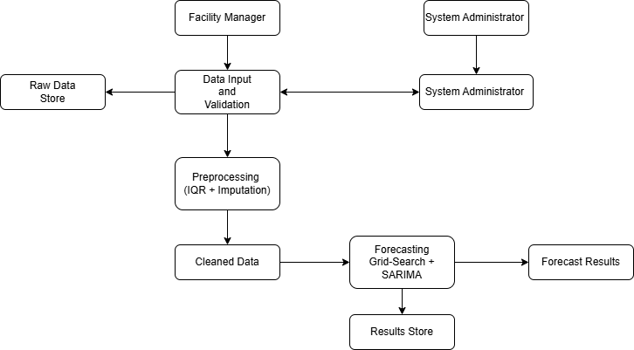
Figure 4.8: Level 1 DFD — Building energy demand forecasting and decision-support system

Algorithm Design: IQR Anomaly Detection
The IQR preprocessing algorithm was designed to be non-destructive and locally sensitive. Rather than replacing anomalous values with a global statistic such as the dataset mean, the algorithm uses a rolling neighbourhood of seven days on either side of each anomaly to compute a local median. This preserves seasonal patterns that a global replacement would obscure. The pseudocode is as follows:

PROCEDURE IQR_Preprocess(data: List<EnergyRecord>):
Q1 <- percentile(data.consumption, 25)
Q3 <- percentile(data.consumption, 75)
IQR <- Q3 - Q1
lower_bound <- Q1 - 1.5 * IQR
upper_bound <- Q3 + 1.5 * IQR
FOR EACH record IN data:
IF record.consumption < lower_bound OR
record.consumption > upper_bound:
window <- local_neighbourhood(record, radius=7)
record.consumption <- median(window.consumption)
record.isImputed <- TRUE
RETURN data
The implementation preserves the radius = 7 neighbourhood constraint during preprocessing to ensure local seasonal behaviour is maintained during anomaly correction and to prevent distortion of short-term consumption peaks.

Algorithm Design: Grid Search SARIMA Optimisation
The Grid Search algorithm was designed to systematically evaluate SARIMA parameter combinations within a bounded search space and select the configuration that minimises the Akaike Information Criterion (AIC). The seasonal period (s) is dynamically selected based on the dominant cycle detected in the uploaded dataset. For daily data, weekly seasonality may use s = 7, while monthly seasonality may use s = 30 or s = 12 depending on the observed temporal frequency.
PROCEDURE GridSearch_SARIMA(series: List<float>):
best_AIC <- +Infinity
best_params <- NULL
FOR p IN [0, 1, 2]:
FOR d IN [0, 1]:
FOR q IN [0, 1, 2]:
FOR P IN [0, 1]:
FOR D IN [0, 1]:
FOR Q IN [0, 1]:
TRY:
model <- SARIMA(series,(p,d,q),(P,D,Q,s))
result <- model.fit()
IF result.AIC < best_AIC:
best_AIC <- result.AIC
best_params <- (p,d,q,P,D,Q)
EXCEPT: CONTINUE
RETURN best_params

4.4.3 Physical Design
The physical design defines how the system operates at implementation level, covering database persistence, data validation rules, and runtime constraints applied during forecasting execution. It ensures traceability from raw input data through preprocessing, model execution, and evaluation output storage.

4.4.3.1 Database Design
The system uses a relational database composed of five normalized tables:
- Users
- UploadedFiles
- CleanedData
- ForecastResults
- EvaluationMetrics
These tables enforce separation of concerns across the forecasting pipeline. Each forecasting session is traceable end-to-end, from file ingestion to model output and evaluation metrics.
The following section provides a detailed textual expansion of the database schema, defining the structural attributes, data types, and relationships required for the system implementation.
Table 4.1: Users Table Definition
Stores system user accounts and authentication details.
Attribute | Type | Description
user_id | INT (PK) | Unique identifier for each user
full_name | VARCHAR(100) | User’s full name
email | VARCHAR(100) | Unique email address
password_hash | VARCHAR(255) | Encrypted password
Role | VARCHAR(50) | User role (e.g., Facility Manager, Admin)
created_at | DATETIME | Account creation timestamp

Table 4.2: UploadedFiles Table Definition
Stores metadata for raw datasets uploaded into the system.
Attribute | Type | Description
file_id | INT (PK) | Unique file identifier
user_id | INT (FK) | References Users
file_name | VARCHAR(255) | Original file name
file_path | VARCHAR(255) | Storage location
file_format | VARCHAR(20) | File type (CSV, Excel)
upload_date | DATETIME | Upload timestamp
total_records | INT | Number of records in file
created_at | DATETIME | Uploaded file timestamp

Table 4.3: CleanedFiles Table Definition
Stores metadata for preprocessed datasets generated after anomaly handling.
Attribute | Type | Description
clean_file_id | INT (PK) | Unique cleaned file identifier
file_id | INT (FK) | References UploadedFiles
file_name | VARCHAR(255) | Cleaned file name
file_path | VARCHAR(255) | Storage location
preprocessing_date | DATETIME | Timestamp of preprocessing
imputed_count | INT | Number of corrected data points
created_at | DATETIME | Cleaned file timestamp

Table 4.4: ForecastResults Table Definition
Stores forecasting outputs generated from cleaned datasets.
Attribute | Type | Description
forecast_id | INT (PK) | Unique forecast identifier
clean_file_id | INT (FK) | References CleanedFiles
forecast_date | DATETIME | Date forecast was generated
forecast_horizon | INT | Number of forecasted periods
model_order | VARCHAR(50) | SARIMA (p,d,q) parameters
seasonal_order | VARCHAR(50) | Seasonal (P,D,Q,s) parameters
forecast_values | TEXT | Predicted values
confidence_lower | TEXT | Lower confidence bounds
confidence_upper | TEXT | Upper confidence bounds
created_at | DATETIME | Forecast results file timestamp

Table 4.5: EvaluationMetrics Table Definition
Stores model performance evaluation results.
Attribute | Type | Description
metric_id | INT (PK) | Unique metric identifier
forecast_id | INT (FK) | References ForecastResults
rmse | FLOAT | Root Mean Square Error
mae | FLOAT | Mean Absolute Error
aic | FLOAT | Akaike Information Criterion
created_at | DATETIME | Evaluation matrix timestamp

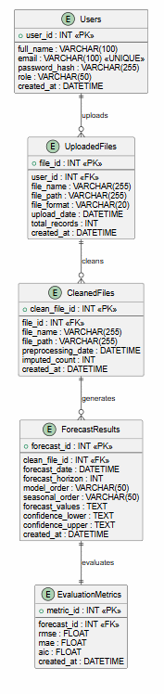
Figure 4.9: Entity Relationship Diagram (ERD) for the Building Energy Forecasting Database

4.4.3.2 Data Validation and Physical Constraints
At implementation level, the system enforces strict validation rules to maintain numerical stability and prevent invalid forecast outputs.
Key rule:
- Clip-to-Zero Constraint:
Any forecasted value or derived confidence interval lower bound that falls below zero is automatically clipped to zero.
This constraint is necessary because energy consumption values are non-negative in real-world systems. Negative predictions are physically meaningless and must be corrected at runtime.
Formally:
- If yt<0⇒yt=0y_t < 0 \Rightarrow y_t = 0yt​<0⇒yt​=0
This rule is applied after model inference and before persistence in the ForecastResults table.

4.4.3.3 Implementation-Level Forecasting Logic (Pseudocode Update)
The clipping rule must be explicitly embedded in the forecasting pipeline pseudocode, particularly within SARIMAForecaster or GridSearch_SARIMA.

Updated pseudocode segment:
SARIMAForecaster(input_data):
model ← train_SARIMA(input_data)
raw_forecast ← model.predict(steps = horizon)
FOR each value in raw_forecast DO
IF value < 0 THEN
value ← 0
END IF
END FOR
confidence_intervals ← model.conf_int()
FOR each bound in confidence_intervals DO
IF lower_bound < 0 THEN
lower_bound ← 0
END IF
END FOR
STORE raw_forecast INTO ForecastResults
STORE metrics INTO EvaluationMetrics
RETURN cleaned_forecast

4.4.3.4 Design Rationale
The clipping mechanism is a deterministic correction layer applied after statistical forecasting. It does not modify the underlying SARIMA model but enforces domain validity constraints required for energy systems.

4.4.3.5 User Interface

The system interface was designed as a web-based dashboard. The decision to use a web interface rather than a desktop application was made on usability grounds: facility managers are not expected to install or maintain local software, and a browser-based tool is accessible from any networked device within the building estate without additional configuration.
The interface is structured around four screens. The Upload Screen presents a file input control and, after submission, a preview table showing the first ten rows of the uploaded dataset alongside a validation status indicator. The Preprocessing Report Screen displays the IQR bounds computed from the data, the number of anomalies detected, the number of values imputed, and an overlaid line chart comparing the raw and cleaned series. The Forecast Dashboard Screen is the primary output screen: it shows a continuous line chart of the historical cleaned data extending into the 30-day forecast period, with the confidence band shaded between the upper and lower bounds. Peak demand periods are marked with distinct indicators on the x-axis. RMSE and MAE are displayed as metric cards beneath the chart. The Export Screen provides format selection between PDF and CSV and triggers the download. During preprocessing and forecasting execution, the dashboard displays a processing indicator showing the current workflow stage, including validation, anomaly detection, Grid Search optimisation, and forecast generation.

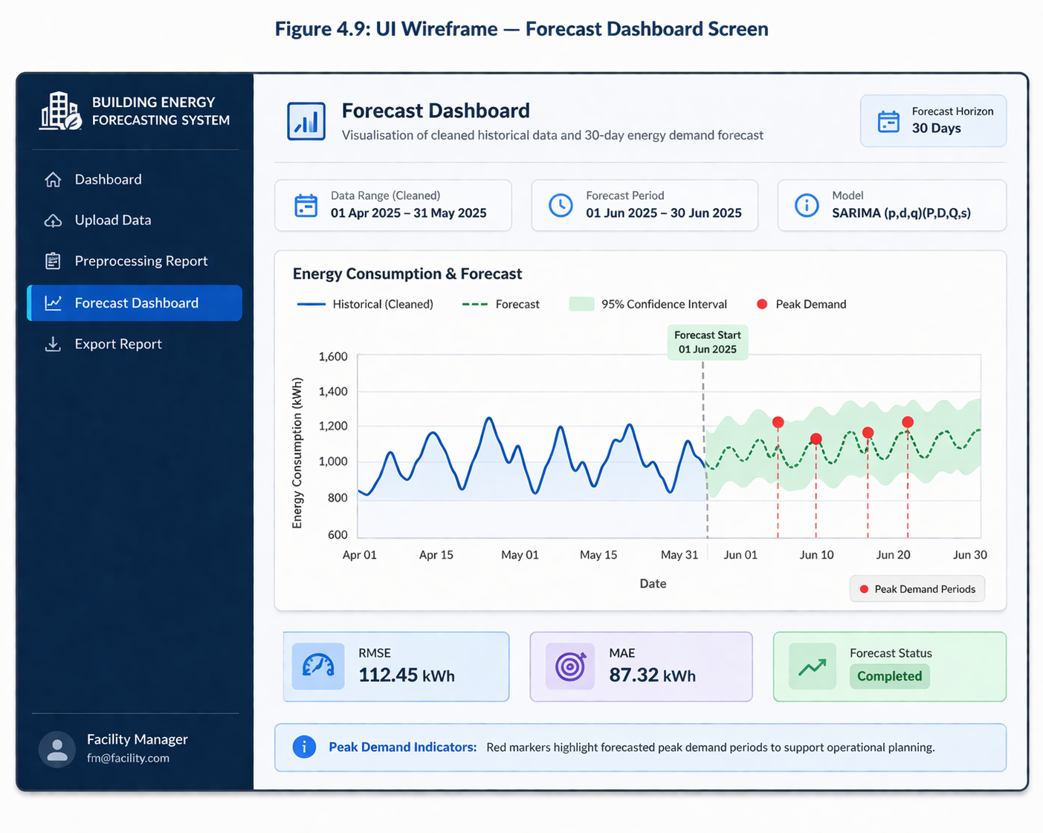
Figure 4.9: UI Wireframe — Forecast Dashboard Screen
The UI dashboard Figure 4.9 provides a centralized interface for Facility Managers to monitor and analyze building energy consumption. It presents key outputs such as energy usage trends, forecast results, and model accuracy metrics in a clear visual format. A data quality indicator highlights issues like outliers or missing values in uploaded datasets. It also enables dataset upload and triggers system processing workflows. Overall, it supports informed decision-making by converting raw data into actionable insights.

Figure 4.10: UI - User Authentication Interface
The Figure 4.10 UI authentication interface provides a secure entry point for system access through user login functionality. It ensures that only authorized users can access the platform by validating credentials against stored user records. The interface includes fields for email and password, along with error handling for invalid attempts. It enforces session control to maintain secure interactions throughout system usage. This component forms the foundation of system security and access control.
Validation and Processing Rules
Each module in the pipeline enforces its own input validation contract before accepting data from the preceding layer. This design decision was deliberate: by validating at each boundary rather than only at the point of entry, the system ensures that a fault introduced at one stage cannot reach a downstream module in a form that would cause a silent incorrect result.
The Data Input Layer rejects files that are not in CSV or Excel format and rejects individual records where the timestamp cannot be parsed to a recognised date format or where the consumption value is non-numeric or negative. The Preprocessing Layer requires a minimum of 48 records in the uploaded dataset before computing IQR bounds, as smaller datasets produce unreliable quartile estimates. The Forecasting Engine requires a minimum of 24 clean data points before fitting a SARIMA model; datasets shorter than this threshold are rejected with an explanatory message. Differencing is applied only when the ADF p-value exceeds 0.05. The Visualisation Layer clips confidence interval lower bounds to zero before rendering, preventing the display of negative consumption projections which have no physical interpretation.
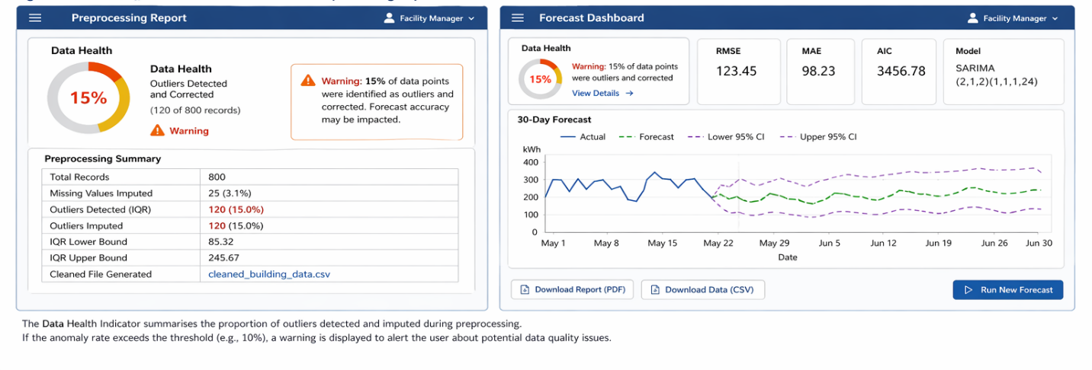
Figure 4.11 UI - Data Health Alerting Mechanism
The Figure 4.11 alerting logic monitors incoming datasets to detect quality issues such as missing values and statistical outliers. When anomalies exceed predefined thresholds, the system generates a data health warning visible on the dashboard. This ensures users are immediately informed about potential data reliability concerns before analysis. The mechanism improves trust in system outputs by preventing misleading forecasts from poor-quality inputs. It acts as a safeguard layer within the data preprocessing pipeline.

Data Storage
The system adopts a persistent relational database to support user management, file storage metadata, and long-term storage of generated forecasting results.
This design is necessary because the system is intended to maintain user accounts, preserve uploaded datasets, and retain generated forecast results for future comparison with newly generated forecasts.
Persistent storage is required for three main purposes.
First, the database stores user account information, including authentication credentials and access details, to ensure that only authorised users can access the system and their forecasting results, in accordance with the security requirement (NFR6).
Second, the system stores metadata and references for uploaded files. These uploaded CSV or Excel files are preserved so that the original dataset used for each forecasting session can be revisited when comparing current forecast outputs with previous results.
Third, the database stores generated forecast results together with associated evaluation metrics. This enables the system to compare present forecasting outputs with previously generated results and observe performance trends over time.

4.5 Conclusion
The system design addresses three core issues identified in the analysis phase: data quality degradation, lack of automated forecasting, and ineffective forecast communication. A layered pipeline architecture supported by a client-server deployment model was selected due to its alignment with the sequential forecasting process, modular structure, and compliance with non-functional requirements.
The design produced key artefacts including a class model of eight objects, a full use case model covering eleven functional requirements, and sequence, activity, and data flow diagrams describing the end-to-end workflow. The preprocessing stage applies IQR-based anomaly detection with median imputation, while the forecasting stage uses SARIMA with Grid Search optimisation guided by AIC.
The system is implemented as a web-based interface with structured modules and validation rules. A persistent database stores users, uploaded files, and generated forecast results, enabling session continuity and comparison of outputs over time.
Model performance is evaluated using RMSE and MAE stored in the EvaluationMetrics table. If errors exceed defined thresholds or worsen over time, the system flags model drift and prompts re-running of Grid Search SARIMA for recalibration.

