Power Plant Challenge Readme Document

1. Steps to build the application and publish files in a folder

* Open Solution folder PowerPlantChallenge in Visual Studio Environment and click on WebApplication1 to build solution as shown below

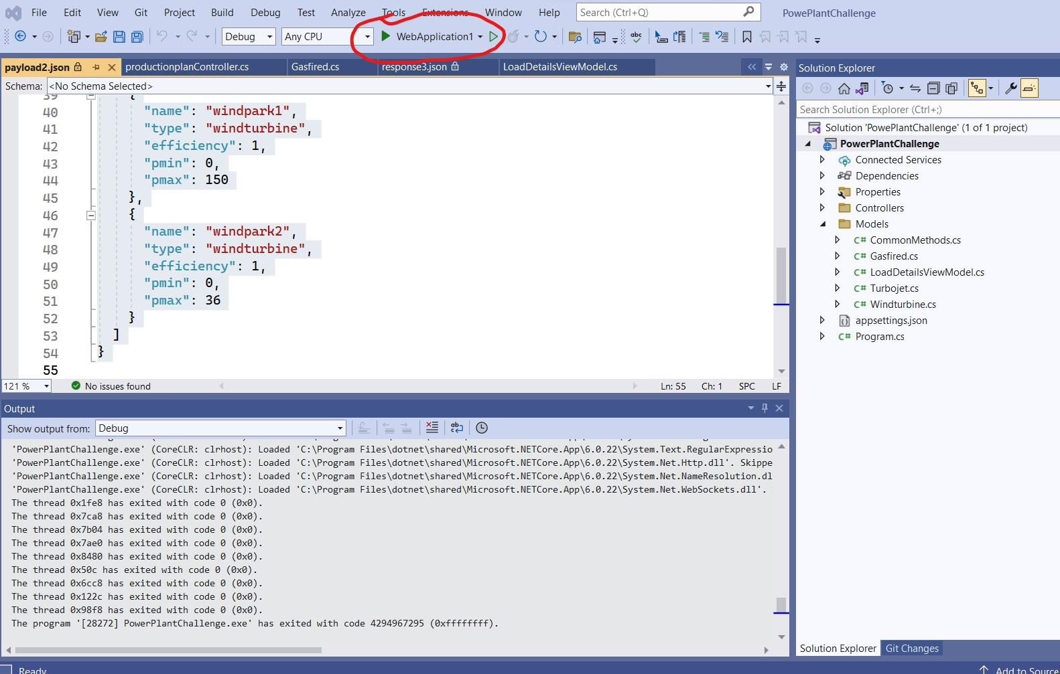

* Swagger UI will open to test Web API

2 To Publish the files in a folder

* To publish files ,right click on solution and click on Publish as shown in below image

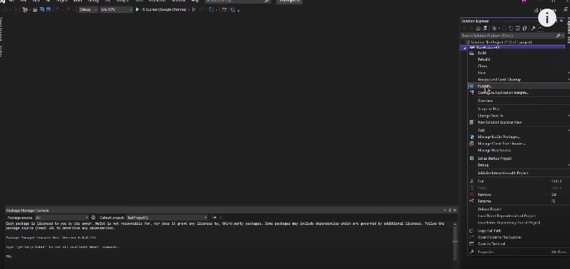

* Select folder and click on next as shown in below image

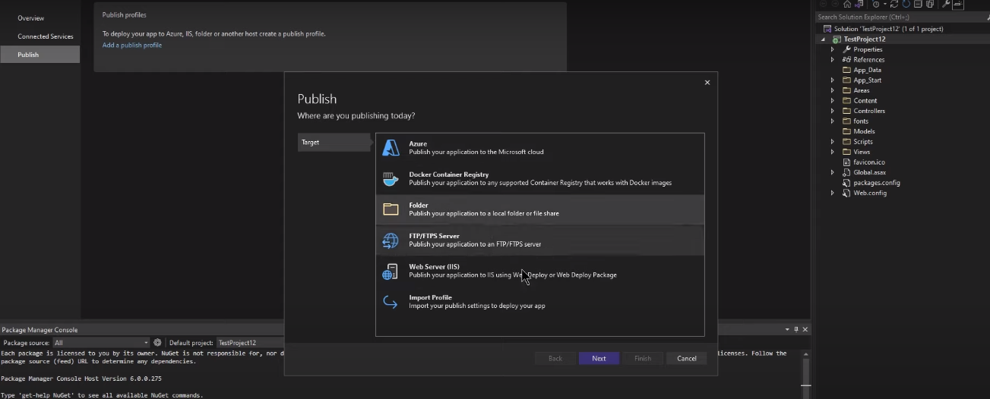

* Enter the folder path where files need to be published

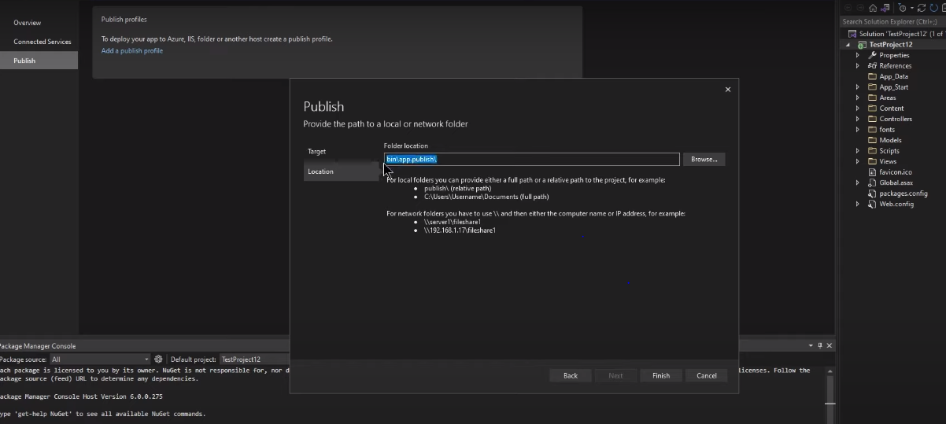

3 Steps to launch and expose API on port 8888

* Install IIS Manager in local system and open.
* Right click on Sites on left side and add a site

Enter field names as mentioned in below image

Site Name ex:Powerplant

* We need to paste our published files in Physical Path field (or)

Published file path in previous step can also be used in Physical Path field

* Enter the port filed as 8888 and rest of the fields as mentioned in below screen shot and click OK

* Install below files to access end point in Microsoft edge browser.

[Download ASP.NET Core 7.0 Runtime (v7.0.11) - Windows Hosting Bundle Installer (microsoft.com)](https://dotnet.microsoft.com/en-us/download/dotnet/thank-you/runtime-aspnetcore-7.0.11-windows-hosting-bundle-installer)

Install the .exe file as mentioned in below screen shot.

* You can test the web API by accessing Browse Website *8888 url on right side as mentioned in below screen shot

* Use the input same as mentioned in the example_payloads (json files ) ,

output will be json file.