SH-26 MAJOR PROJECT PROPOSAL SUBMISSION

Project Title: Stock Price Prediction System: AI-Powered Financial Analytics & Recommendation Platform
Project Domain: Artificial Intelligence & Machine Learning
Project Type: Software
Project Category: FinTech / Quantitative Finance
SDG Mapping & Justification:
- SDG 8 – Decent Work and Economic Growth
The Stock Price Prediction System democratizes algorithmic trading and quantitative finance for retail investors. By providing accessible, institutional-grade financial analytics, it promotes financial literacy and smarter investment decisions, thereby supporting economic growth and wealth generation.
Project Guide: [Name of the Project Guide]
Team Details:
SrNo. | Student ID | Student Name
1 | [ID 1] | [Name 1]
2 | [ID 2] | [Name 2]
3 | [ID 3] | [Name 3]
4 | [ID 4] | [Name 4]

Abstract:
The Stock Price Prediction System is an AI-powered, full-stack web application designed for real-time stock price analysis. Unlike traditional stock charting tools that require manual interpretation, this platform acts as an intelligent quantitative assistant. It forecasts future stock trends using a custom deep learning meta-ensemble (LSTM, GRU, and Conv1D) and provides actionable BUY/SELL/HOLD recommendations by combining technical indicators and NLP-based news sentiment analysis into a single unified platform.
Users can search for global or Indian (NSE/BSE) stocks, select timeframes, and instantly receive customized technical analysis, price forecasting, and market sentiment, enabling data-driven investment decisions.

Problem Statement
Retail investors often struggle to analyze massive amounts of market data, technical indicators, and financial news simultaneously. Existing platforms either focus solely on raw charting or offer overly complex, expensive institutional tools. There is a lack of accessible platforms that seamlessly integrate machine learning price forecasts, automated technical analysis, and real-time news sentiment. This creates a need for an intuitive, centralized intelligent platform that democratizes quantitative finance and simplifies the trading process.

Problem Solution
The Stock Price Prediction System is an AI-powered financial platform that generates real-time price predictions based on historical OHLCV data, macroeconomic indicators, and technical parameters. It combines a robust REST API backend with an interactive Streamlit frontend to deliver automated technical analysis, sentiment scoring, and AI-driven recommendations in a single, user-friendly dashboard.

Objectives
- To develop a decoupled full-stack AI-powered stock prediction platform.
- To implement a Meta-Ensemble Deep Learning model for accurate time-series price forecasting.
- To generate automated BUY/SELL/HOLD recommendations using a multi-factor scoring system.
- To integrate real-time NLP sentiment analysis from financial news.
- To calculate and visualize advanced technical indicators (MA, RSI, MACD, Bollinger Bands) instantly.

Scope of the Project
Features included
- AI Price Predictor utilizing a fused Deep Learning model (LSTM + Attention + GRU + Conv1D).
- Smart Recommendation Engine that aggregates Technicals, AI predictions, and Sentiment.
- Advanced Technical Analysis with interactive Plotly charting.
- Real-Time Data Fetching for both US and Indian stock markets.
- Live News Sentiment Analysis using FinBERT.
- Premium Dashboard featuring a dark-themed UI.
Features Excluded
- Live trade execution (Broker integration)
- High-Frequency Trading (HFT) capabilities
- Paper trading portfolio management
Future Scope
- Paper Trading Integration for tracking recommendation performance.
- Alternative Data integration (e.g., social media sentiment via Twitter/Reddit).
- Probabilistic forecasting using Bayesian Neural Networks.

Proposed System
Proposed Solution
The system employs a microservices architecture isolating the UI from the heavy machine learning workloads. It integrates live market data fetching, vectorized indicator calculation, NLP sentiment scoring, and deep learning inference into a single, cohesive workflow accessible via a REST API.
Architecture
- Frontend (Streamlit): Serves as the presentation layer.
- Backend (Flask): Acts as the REST API gateway.
- Services Layer: Contains StockService, IndicatorService, PredictionService, and RecommendationService.
- AI Engine: Deep Learning ensemble deployed locally, caching models for O(1) subsequent inference times.

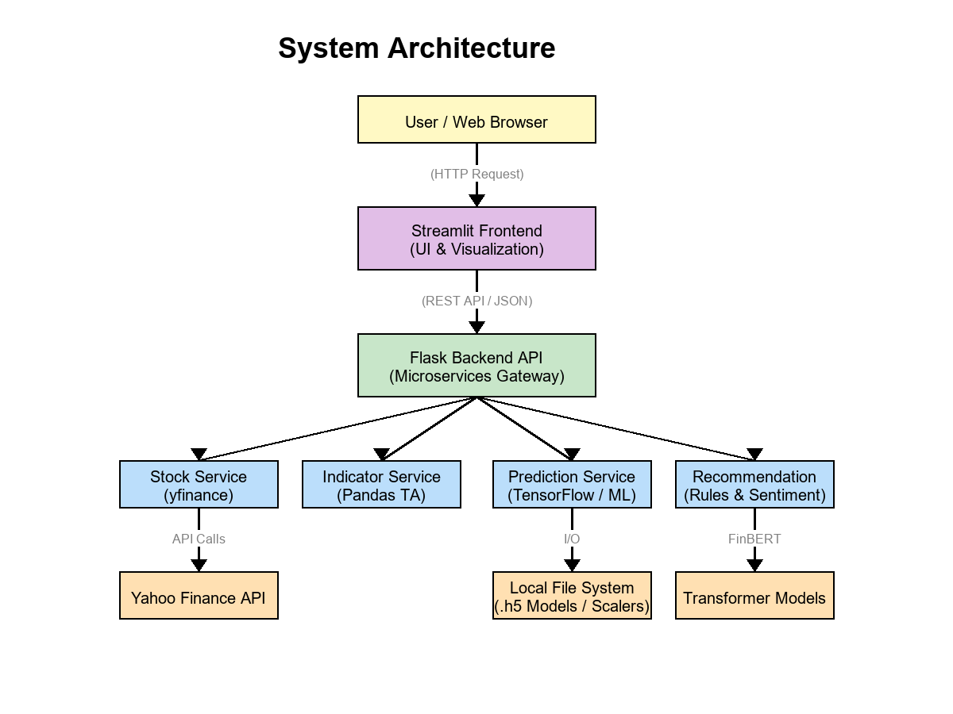
Advantages
- Accessible institutional-grade analytics.
- Highly accurate predictions through Meta-Ensemble deep learning.
- Real-time insights and live market fetching.
- Time-saving automated technical analysis.

Novelty / Innovation
What makes this project different?
Unlike standard charting applications, this system synthesizes multiple domains of quantitative finance—Deep Learning forecasting, traditional Technical Indicators, and Natural Language Processing (NLP) sentiment—into a single integer score for actionable trading.
What value does it add?
- Eliminates the need to switch between charting apps and news aggregators.
- Reduces emotional bias in trading by relying on mathematical models.
- Democratizes access to algorithmic trading techniques.
How does it improve existing solutions?
Existing Systems | Proposed System (Stock Price Prediction)
Manual Technical Analysis | Automated vectorized calculation of indicators
Basic LSTM forecasting | Meta-Ensemble (LSTM + Attention + GRU + Conv1D)
Isolated Price Data | Integrated FinBERT NLP News Sentiment
High-latency ML training | Local File System Cache Strategy for instant inference
Generic chart plotting | Interactive Plotly graphs with dual-axis handling

Technologies Used
- Frontend: Streamlit, Plotly, HTML/CSS
- Backend: Flask (Python), Flask-CORS
- Machine Learning / AI: TensorFlow, Keras, Scikit-learn
- Data Processing & Analytics: Pandas, NumPy
- NLP: FinBERT (Transformers)
- APIs: yfinance

Expected Outcome
The project aims to provide retail investors and traders with a comprehensive, adaptive, and highly accurate financial analysis platform. By fusing artificial intelligence with traditional market indicators, the platform will help users make smarter, data-driven investment decisions while reducing risk and enhancing their overall market understanding.

Team Members
[Name 1] ([ID 1]). _________________
[Name 2] ([ID 2]). _________________
[Name 3] ([ID 3]). _________________
[Name 4] ([ID 4]). _________________

Project Guide & Co-ordinator
[Name of Project Guide]. _________________

