ICDFA — International Cybersecurity and Digital Forensics Academy
ACICP302ICS — Network Security & Attacks
Module 1 Practical Laboratory — Final Report
Analyze, Test & Defend the Supplied Modbus/TCP OT Simulation
Course | ACICP302ICS — Network Security & Attacks
Practical title | Analyze, Test & Defend the Supplied Modbus/TCP OT Simulation
Learner | Mutahar Kamran Mughal
Registration number | C11/26/ACIS/17375
Submission date | 11 October 2026
Course source URL | https://github.com/icdfa/ACICP302ICS-Network-Security-and-Attacks
Course source commit used | 2a66f9bcf253eb3fe31c68ad52794cd535421da8
Assigned VM / snapshot | Claude isolated Ubuntu 24.04.5 LTS sandbox (instructor-approved VM substitute); clean state = fresh clone + source SHA-256 hashes
Authorized scope | Loopback 127.0.0.1 only
Learner evidence repository | https://github.com/MutaharKamranMughal/icdfa (private) — branch main — folder ACICP302-ICS-Network-Security-and-Attacks/Module1-Lab01/ — final commit ID as submitted on E-Campus

Academic integrity & authorized use
This practical uses the instructor-provided course simulation source under authorization; the source is attributed and is NOT presented as learner-authored code. All diagrams, captures, observations, analysis, risk assessment, test records and this report are the learner's own work, produced from the assigned isolated environment on loopback only. No real or external system was targeted.

Student Declaration
I declare that the analysis, evidence and conclusions in this report are my own work, gathered only in the assigned ICDFA isolated Ubuntu environment using the canonical student source on loopback (127.0.0.1). I have not targeted any real or external system, have not altered the supplied source or its safety parameters, and have attributed the course-provided code. I am able to explain all evidence and conclusions during the defence.
Learner name | Mutahar Kamran Mughal
Registration number | C11/26/ACIS/17375
Signature | Mutahar K Mughal
Date | 11th Oct 2026

1. Executive summary
This report documents a source-code-guided analysis of the instructor-provided Modbus/TCP OT simulation (commit 2a66f9b): a small loopback-only model of a hydrogen (H2) facility — electrolyzer, compressor, H2 tank and export — exposed over Modbus/TCP and fronted by an optional rule-based validation guard. Working on 127.0.0.1 only, I established the normal baseline, mapped the data model, captured and decoded normal traffic, inventoried the local services and their risks, analysed the supplied guard, and ran five instructor-approved bounded demonstrations one at a time on both the direct and guarded paths, verifying recovery after each.
Most important evidence-backed findings
1. The guard, when traffic passes through it (:5021), correctly blocks gross tampering — out-of-range holds and false-data injection were fully contained, with 97 structured BLOCKED events across those scenarios.
2. The guard protects only its own path. Port :5020 reaches the plant with no validation; every direct-path demonstration drove unsafe values into the process (0 guard events) and raised the HMI alarm.
3. A slow, in-range pressure ramp evaded the rolling-drift check: from a 32.9 bar baseline, steps 1–7 (up to 39.9 bar) were accepted through the guard; blocking began only at 40.9 bar via the absolute-range check.
4. A replayed valid write was accepted on both paths — Modbus/TCP and this guard provide no authentication or anti-replay.
5. Recovery was verified after every scenario; all lab ports were confirmed closed at shutdown.

2. Scope, safety and method
Canonical source path: labs/ot-security/student-lab-source/ at commit 2a66f9b. Authorized scope: loopback 127.0.0.1 only; no bridged networking or port forwarding. Preflight loopback checks passed — grep for 192.168.2.139 / 0.0.0.0 in plant_sim returned no matches, and 127.0.0.1 was present (13 occurrences). The sibling archive-original/ directory was read for comparison but never executed; it differs from the student source only by its unsafe defaults (192.168.2.139 targets, 0.0.0.0 binds) plus a dashboard subtitle and the Flask requirement.
Method: services were started in the guide order (plant → guard → direct dashboard → guarded dashboard); baseline and dashboards recorded; one authorized read captured on lo and decoded; five approved demonstrations run one at a time on :5020 then :5021 with supplied parameters unchanged; guard events, dashboards and script output recorded; recovery verified; services stopped and ports confirmed closed. Dependencies: pymodbus 3.6.9, Flask, in a project-local venv.

3. Supplied architecture and process model
The simulation comprises five supplied components, all bound to loopback. plant.py is the authoritative process and Modbus/TCP server on :5020; guard.py is a validating write-through proxy on :5021 that forwards accepted writes to the plant; dashboard.py (:8080) shows the plant directly; dashboard_guarded.py (:8081) shows the process through the guard and renders the guard event log. The demonstration clients connect to :5020 (direct) or :5021 (guarded).
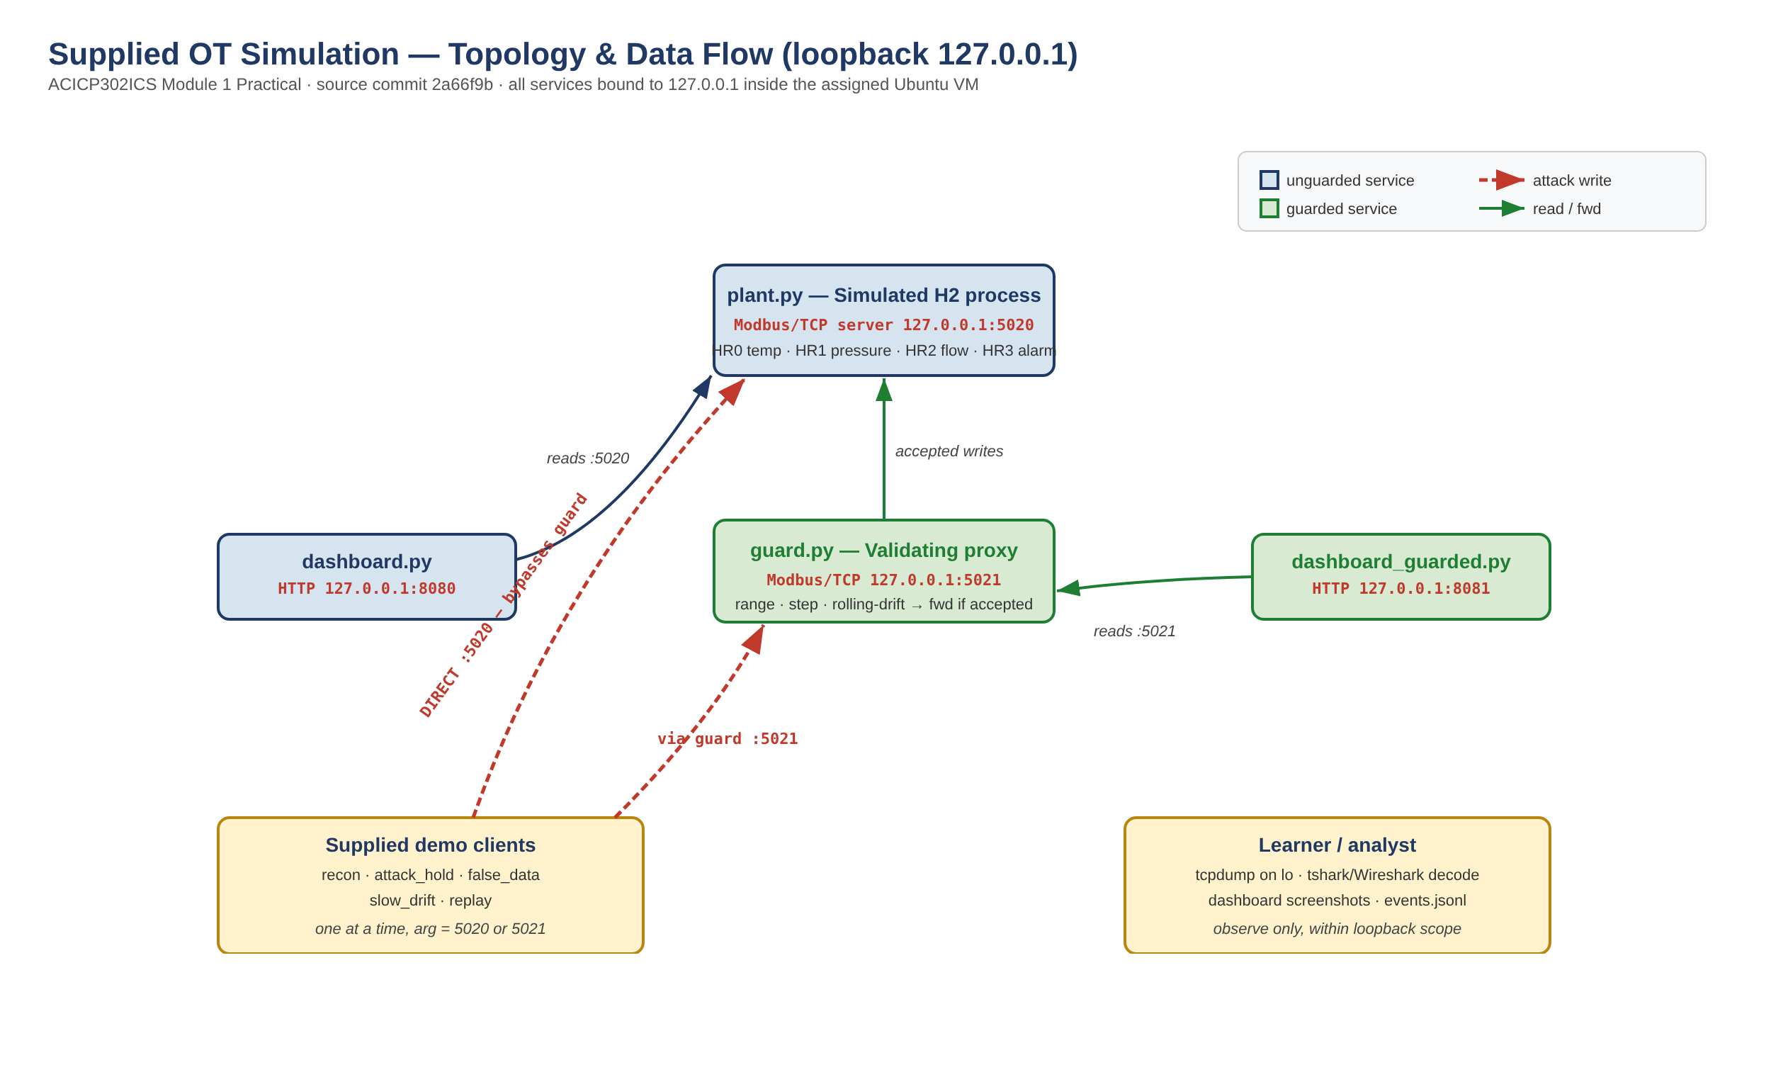
Figure 1 — Annotated topology and data flow (learner-produced; roles/ports from source and Student Lab Guide).

3.1 Verified Modbus/TCP data-point map
Process values are 16-bit holding registers in tenths of the engineering unit (integer ÷ 10), confirmed by the packet capture in §4.
Point | Reg | Scale | Unit | Normal range | Alarm / guard limits | Source
Temperature | HR0 | ÷10 | °C | 60.0–75.0 | step 3.0, drift 2.0/3 | plant.py TEMP_RANGE; guard.py
Pressure | HR1 | ÷10 | bar | 30.0–40.0 | alarm ≥39.5; step 5.0, drift 2.0/3 | plant.py PRESSURE_RANGE, line 79
Flow | HR2 | ÷10 | Nm³/h | 50.0–150.0 | step 10.0, drift 4.0/3 | plant.py FLOW_RANGE; guard.py
Alarm | HR3 | int | — | 0 normal | 1 when pressure ≥39.5 bar | plant.py line 79
HR4–HR99 | 4–99 | int | — | 0 (unused) | read back as 0 | plant.py initial_values

Finding — source/display mismatch (Activity 02)
The browser dashboards compute their own alarm thresholds that differ from the authoritative plant/guard ranges: the direct dashboard flags on pres>40 or <28, temp>76 or <57, flow>156 or <44; the guarded dashboard flags on pressure only. The dashboards also do not use HR3 for the banner. The authoritative process ranges are those defined in plant.py/guard.py (table above); the dashboard thresholds are a display artefact and should not be read as the process limits.

4. Normal operations and packet evidence
At baseline both dashboards agreed at approximately 67 °C, 33 bar and 90 Nm³/h, alarm clear, status normal (direct) / protected (guarded). Values drift slightly as the simulator runs its clamped random walk.
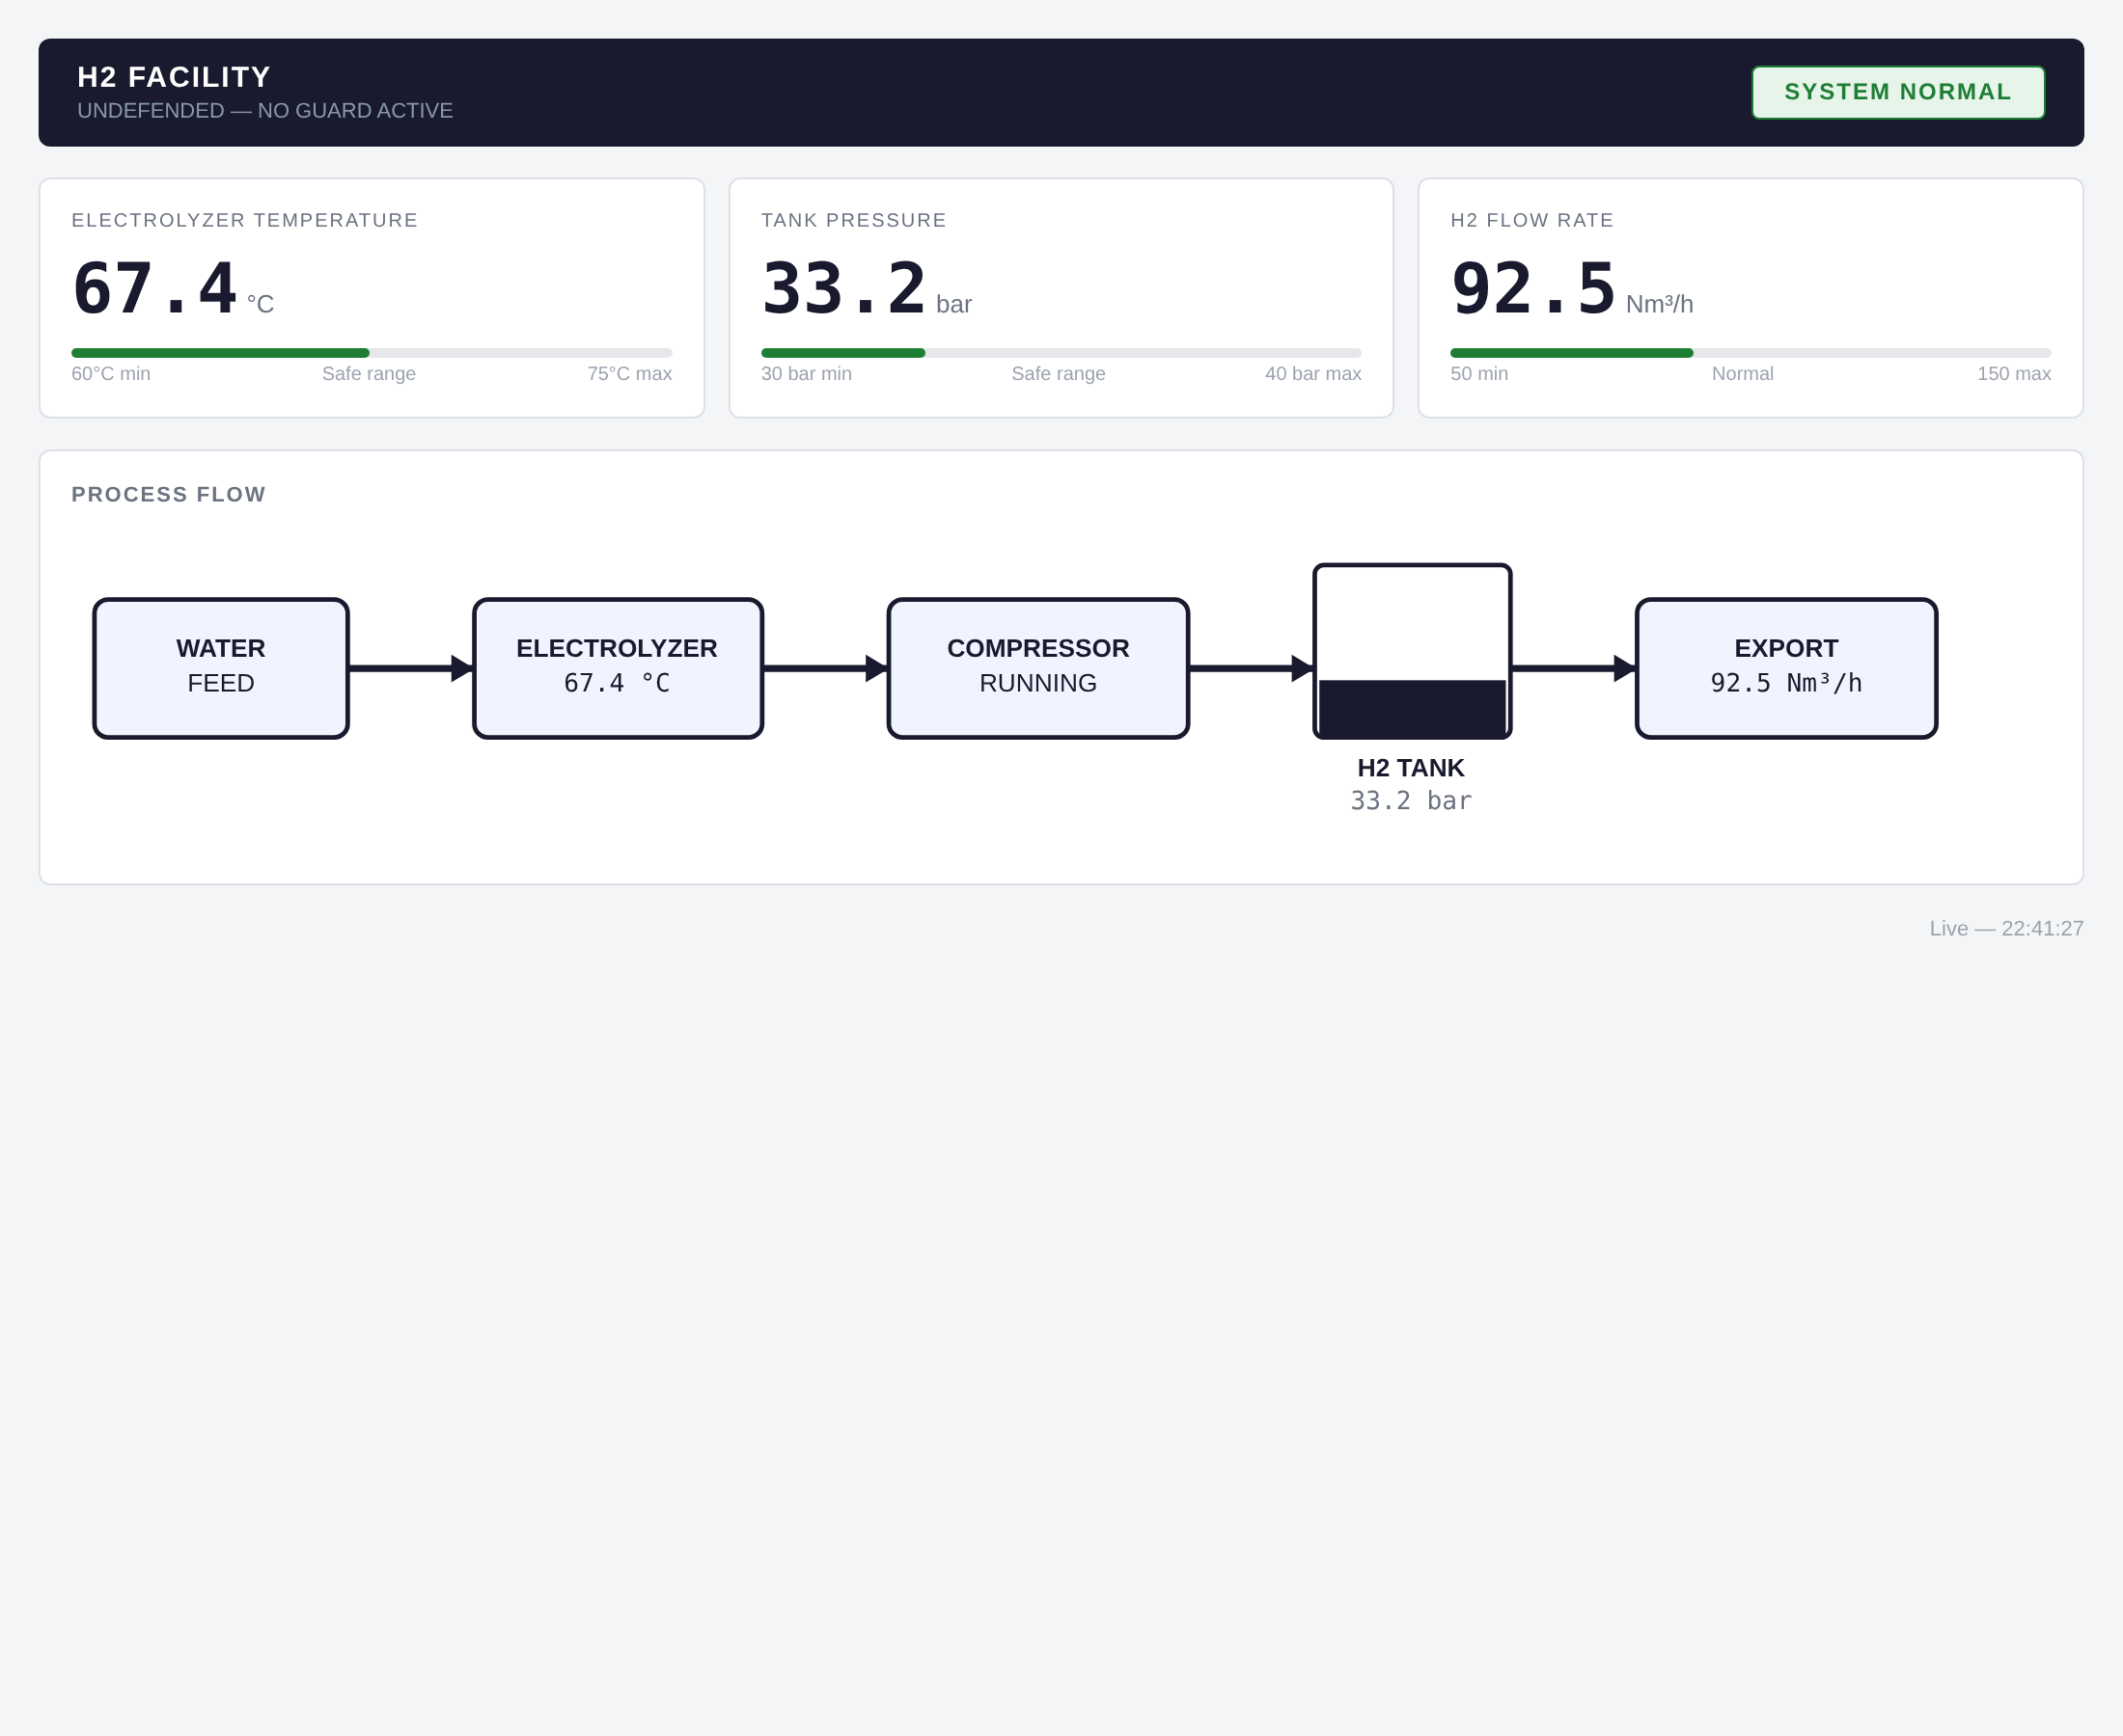
Figure 2 — Direct dashboard (:8080) at baseline — SYSTEM NORMAL.
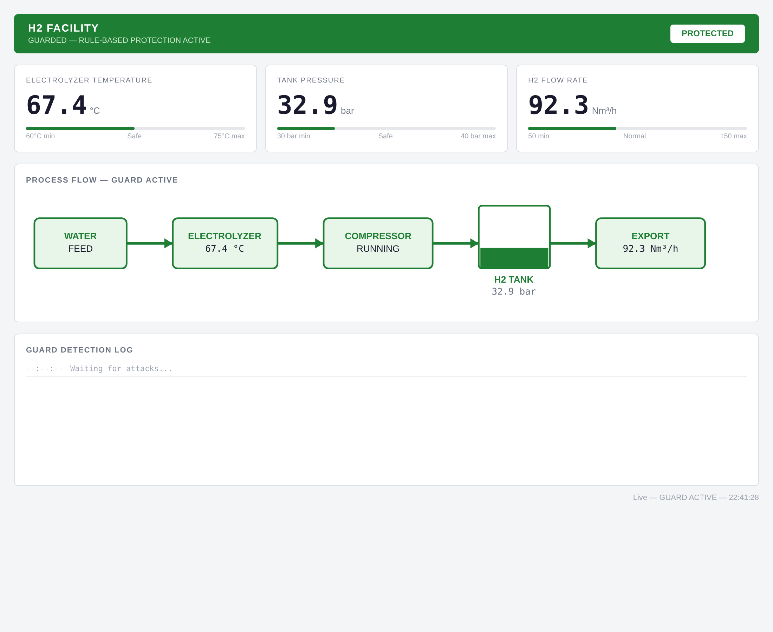
Figure 3 — Guarded dashboard (:8081) at baseline — PROTECTED, detection log idle.
A single authorized read of HR0–HR3 was captured on the loopback interface and decoded with the Modbus dissector. One matched transaction (Transaction ID 1): a function-code-3 read of 4 holding registers from address 0, returning [674, 326, 880, 0] = 67.4 °C, 32.6 bar, 88.0 Nm³/h, alarm clear — correlating exactly with the register map and the dashboard at capture time.
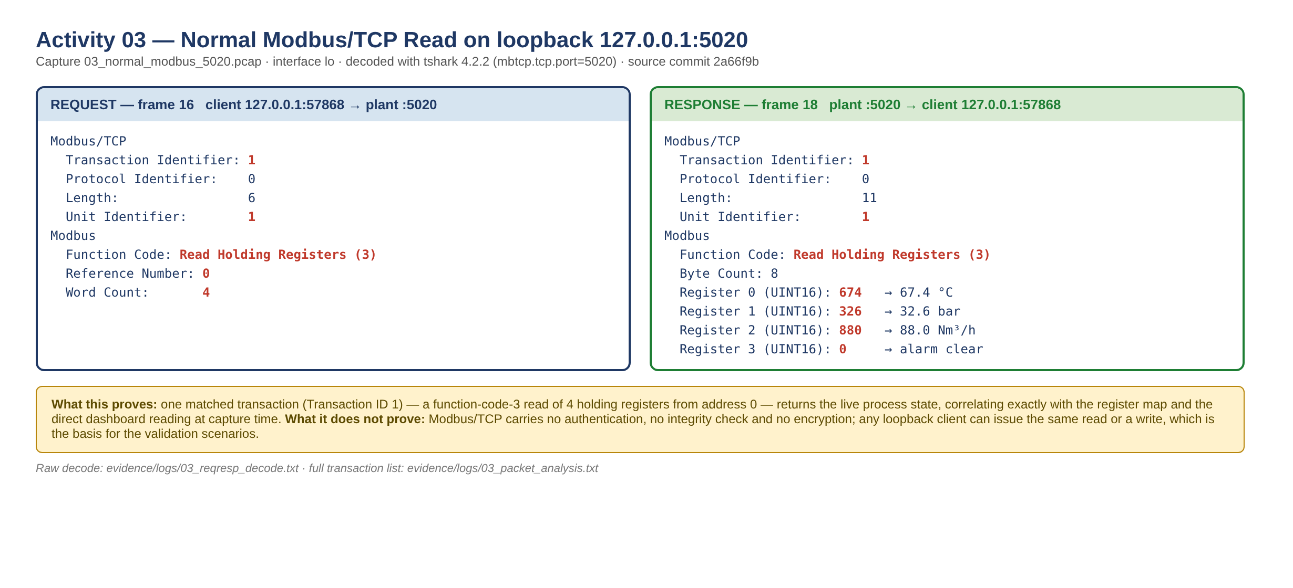
Figure 4 — Matched Modbus/TCP request (frame 16) and response (frame 18) from the learner PCAP on lo:5020.
What the capture proves / does not prove
Proves: the on-the-wire protocol, register addressing and scaling match the source and the live process state. Does not prove: any security property — Modbus/TCP carries no authentication, integrity or encryption, so any loopback client can issue the same read or a write. This is the basis for the validation scenarios in §7.

5. Local exposure and risk assessment
Discovery stayed within the documented loopback services; no non-loopback endpoint exists in the student source. Local service inventory:
Endpoint | Component | Protocol | Process significance | Consequence if misused
127.0.0.1:5020 | plant.py | Modbus/TCP | authoritative process + direct control | unvalidated writes → unsafe state
127.0.0.1:5021 | guard.py | Modbus/TCP | validated control path | partial protection only (§6)
127.0.0.1:8080 | dashboard.py | HTTP | direct monitoring | shows true (possibly attacked) state
127.0.0.1:8081 | dashboard_guarded.py | HTTP | guarded view + events | may show stale-but-safe mirror in a direct attack

Risk register (evidence-based; full CSV in docs/risk-register.csv):
ID | Source/exposure | Impact on process | Rating | Key control | Evidence
R-01 | Direct :5020 bypasses guard | unsafe write to plant | Critical | segment so only guard reaches plant | SV-02/03/04 direct
R-02 | Drift baseline re-seeded each 1 s | slow creep undetected | High | fixed/longer reference window | SV-04 guarded
R-03 | No auth / anti-replay | replay of valid command | High | signed commands / nonces | SV-05
R-04 | Unauthenticated reads | process recon | Medium | restrict/allowlist reads | SV-01
R-05 | Only values[0] validated; HR3+ passthrough | partial write validation | Medium | validate all registers | guard.py 117,135-143
R-06 | No rate limiting | availability (not tested) | Medium | connection/rate limits | dos_attack not run

6. Supplied guard analysis
guard.py validates each single-register write to HR0–HR2 with three checks and forwards only accepted writes to the plant; a rejected write is dropped entirely (no forward, no mirror update, not added to the drift baseline) and one JSON event is appended to events.jsonl. Reads are not validated; writes to HR3 and above are passed through unvalidated.
# | Check | Rejects when | Action | Source
1 | Absolute range | value outside the register's safe range | drop + log | guard.py 92–96
2 | Step size | |requested − current| > max step (3.0/5.0/10.0) | drop + log | guard.py 98–103
3 | Rolling drift | |requested − value 3 writes ago| > 2.0/2.0/4.0, once history full | drop + log | guard.py 105–112

Event evidence: 114 BLOCKED events were recorded across the run — 106 fired all three checks (gross tampering), 4 range-only and 4 range+drift (the slow ramp). The guarded dashboard renders these live:
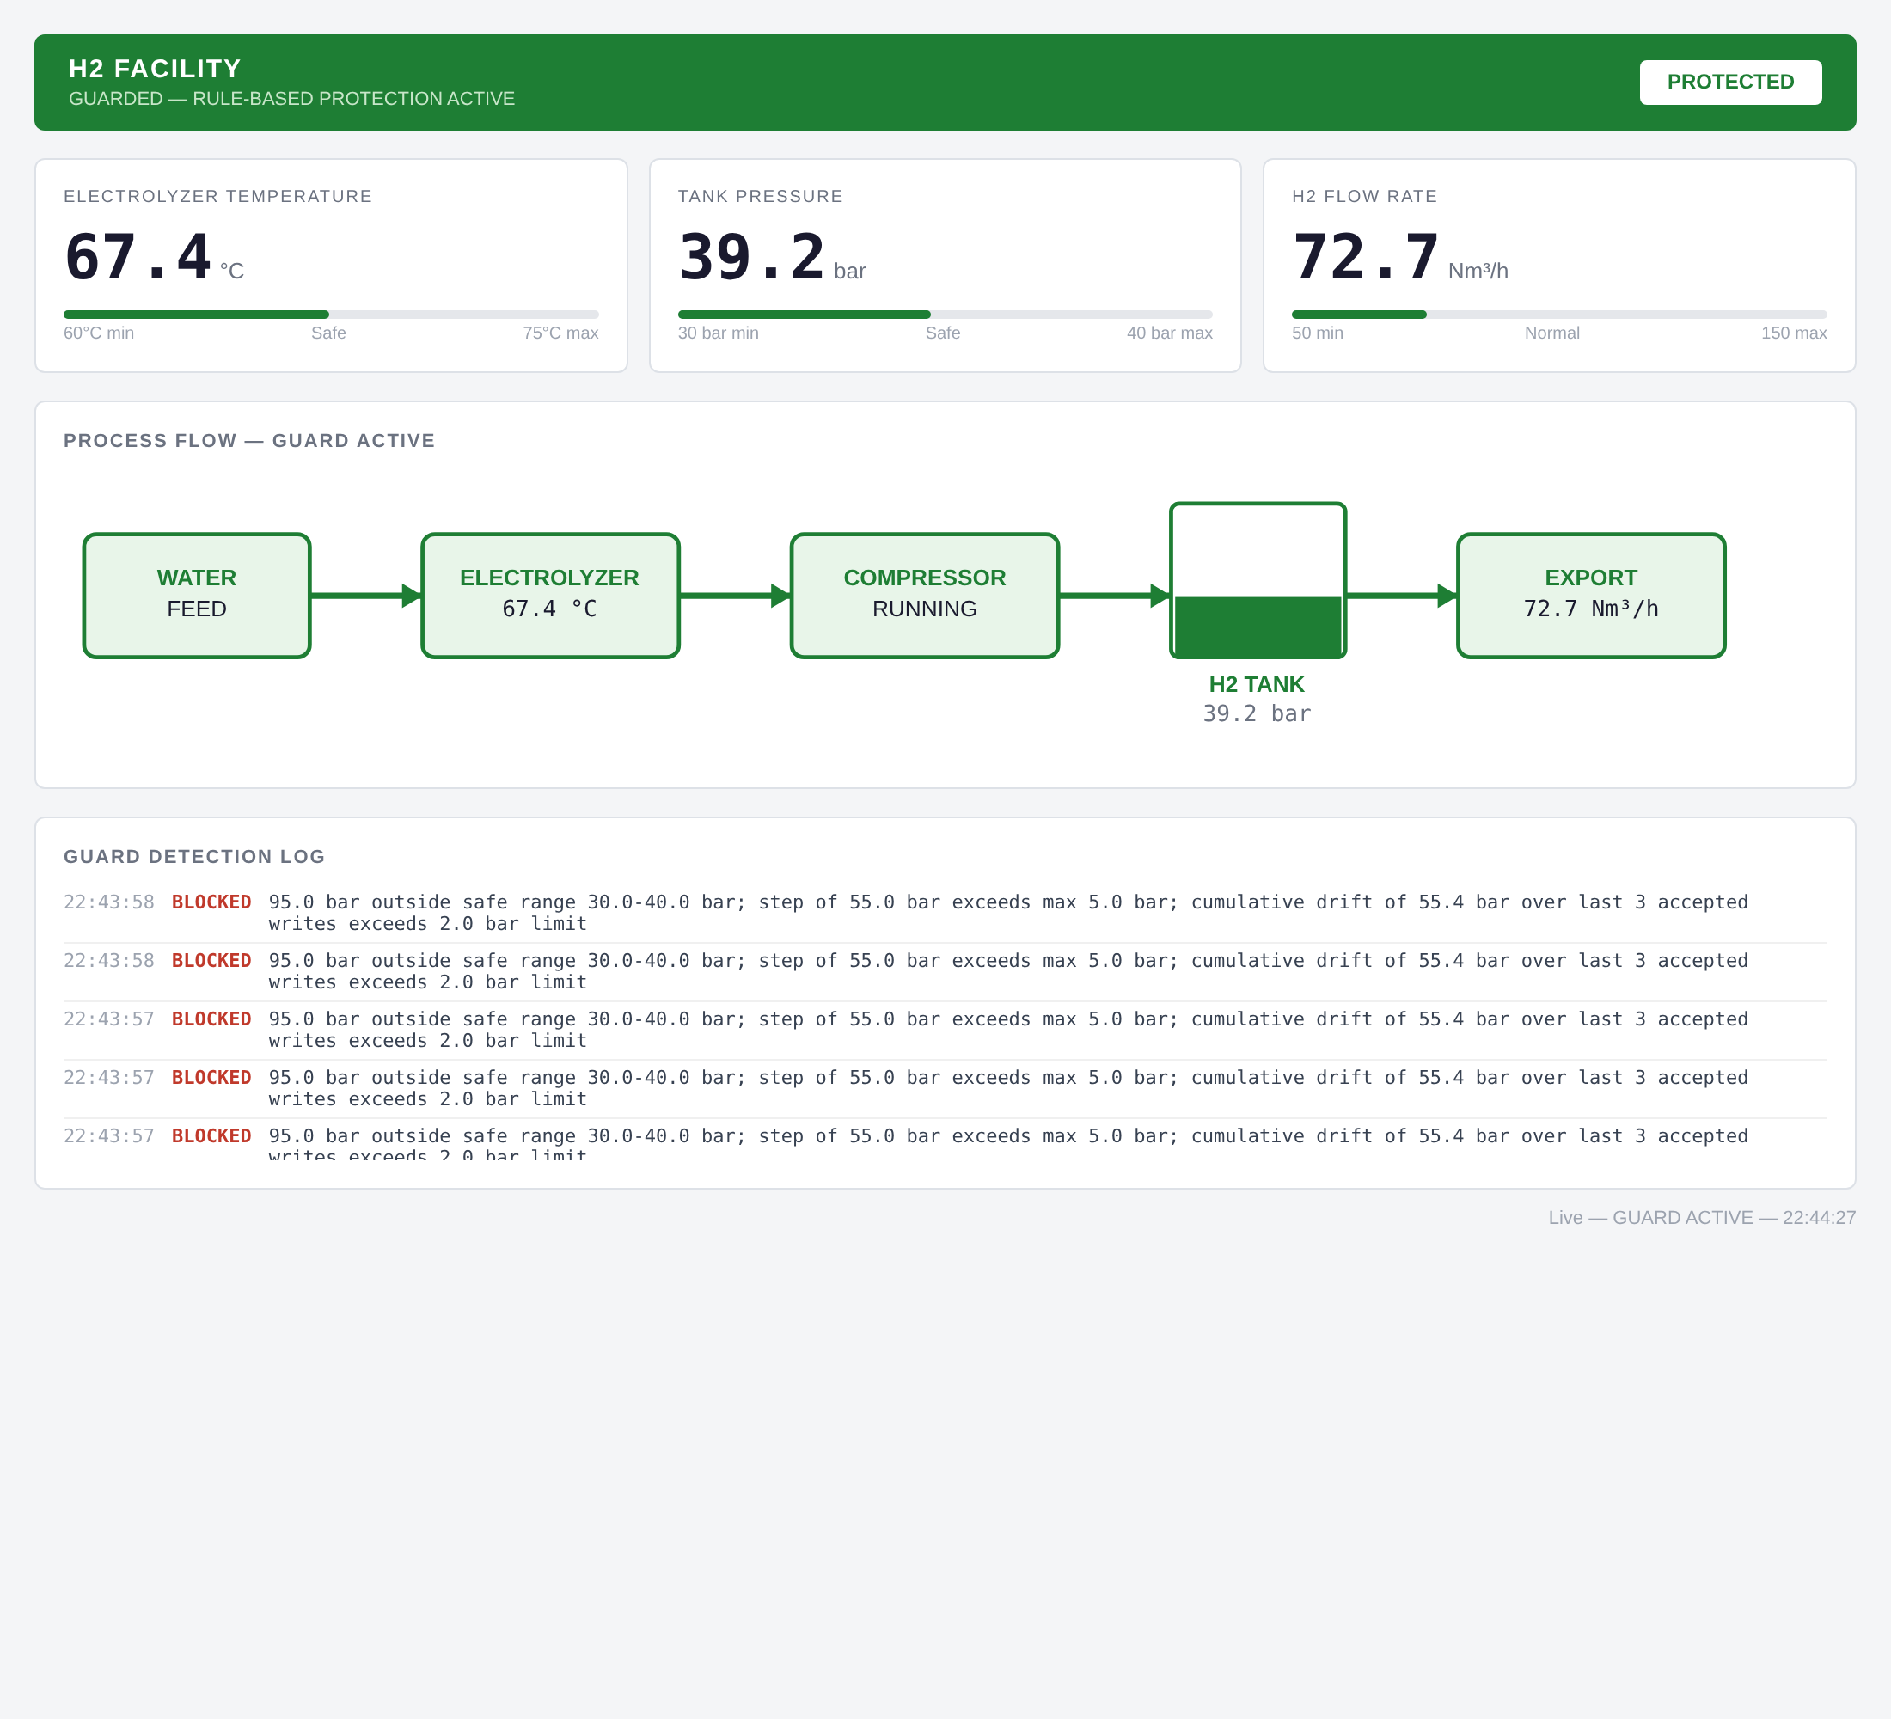
Figure 5 — Guarded dashboard during attack_hold: pressure held in safe range, detection log showing BLOCKED entries citing all three checks.
Guard limitations (demonstrated — do not overstate protection)
1. Direct-path bypass — the guard never sees :5020 traffic (R-01).
2. Reads unprotected — recon returns identical data through the guard (R-04).
3. Slow in-range drift evades the drift check — the sync_safe_reads thread re-seeds the accepted-value baseline from live plant reads every second (guard.py 192–194), so a ramp staying under ~2 bar per 3-sample window is not flagged; it was stopped only by the absolute-range ceiling at 40.9 bar (R-02, SV-04).
4. No authentication / anti-replay — a replayed valid write is accepted (R-03, SV-05).
5. Single-register validation only — only values[0] is checked; HR3+ passes through (R-05).
6. Availability not addressed — no rate limiting (R-06). This guard is an educational example, not a safety system.

7. Controlled validation and findings
Five instructor-approved scenarios were run one at a time, supplied parameters unchanged, on the direct path (:5020) then the guarded path (:5021). dos_attack.py was not run (requires explicit approval; availability demo out of scope). Each scenario is given a real-world parallel for context only — the lab evidence is the loopback result, kept separate from the parallel.
ID | Script | Real-world parallel
SV-01 | recon_scan | ICS reconnaissance (Havex/Dragonfly; PIPEDREAM Modbus module)
SV-02 | attack_hold | FrostyGoop 2024 — Modbus writes to heating controllers, Lviv
SV-03 | false_data_attack | Stuxnet-style false process values / grid false-data injection
SV-04 | slow_drift_attack | Low-and-slow setpoint manipulation (Stuxnet subtle changes)
SV-05 | replay_attack | Replay of a captured valid command (no Modbus auth/sequence)

Expected-versus-observed:
ID | Path | Observed | Events | Recovery
SV-01 | 5020 | regs 0–49 read; HR0–2 live, HR4–49 = 0 | 0 | unchanged
SV-01 | 5021 | identical read through guard | 0 | unchanged
SV-02 | 5020 | 79 writes, peak 95.0 bar, 100% unsafe — reached plant; HMI alarm | 0 | self-heal, alarm cleared
SV-02 | 5021 | peak 40.0 bar, 0% unsafe — fully contained | 79 | contained
SV-03 | 5020 | 110 °C / 55 bar / 200 Nm³/h, 6/6 unsafe each — reached plant | 0 | self-heal
SV-03 | 5021 | 0/6 unsafe on all three — fully contained | 18 | contained
SV-04 | 5020 | ramp accepted to ~40 bar ceiling; alarm | 0 | self-heal
SV-04 | 5021 | steps 1–7 (≤39.9 bar) ACCEPTED; blocked at 40.9 bar by range | 5 | contained at ceiling*
SV-05 | 5020 | replayed +0.5 bar ×3 accepted | 0 | normal
SV-05 | 5021 | replayed write ×3 accepted — not distinguished from valid | 0 | normal

* SV-04 is the key limitation result: the rolling-drift check did not catch the slow in-range climb; only the absolute-range check stopped it once the requested value crossed 40 bar. See §6 limitation 3.
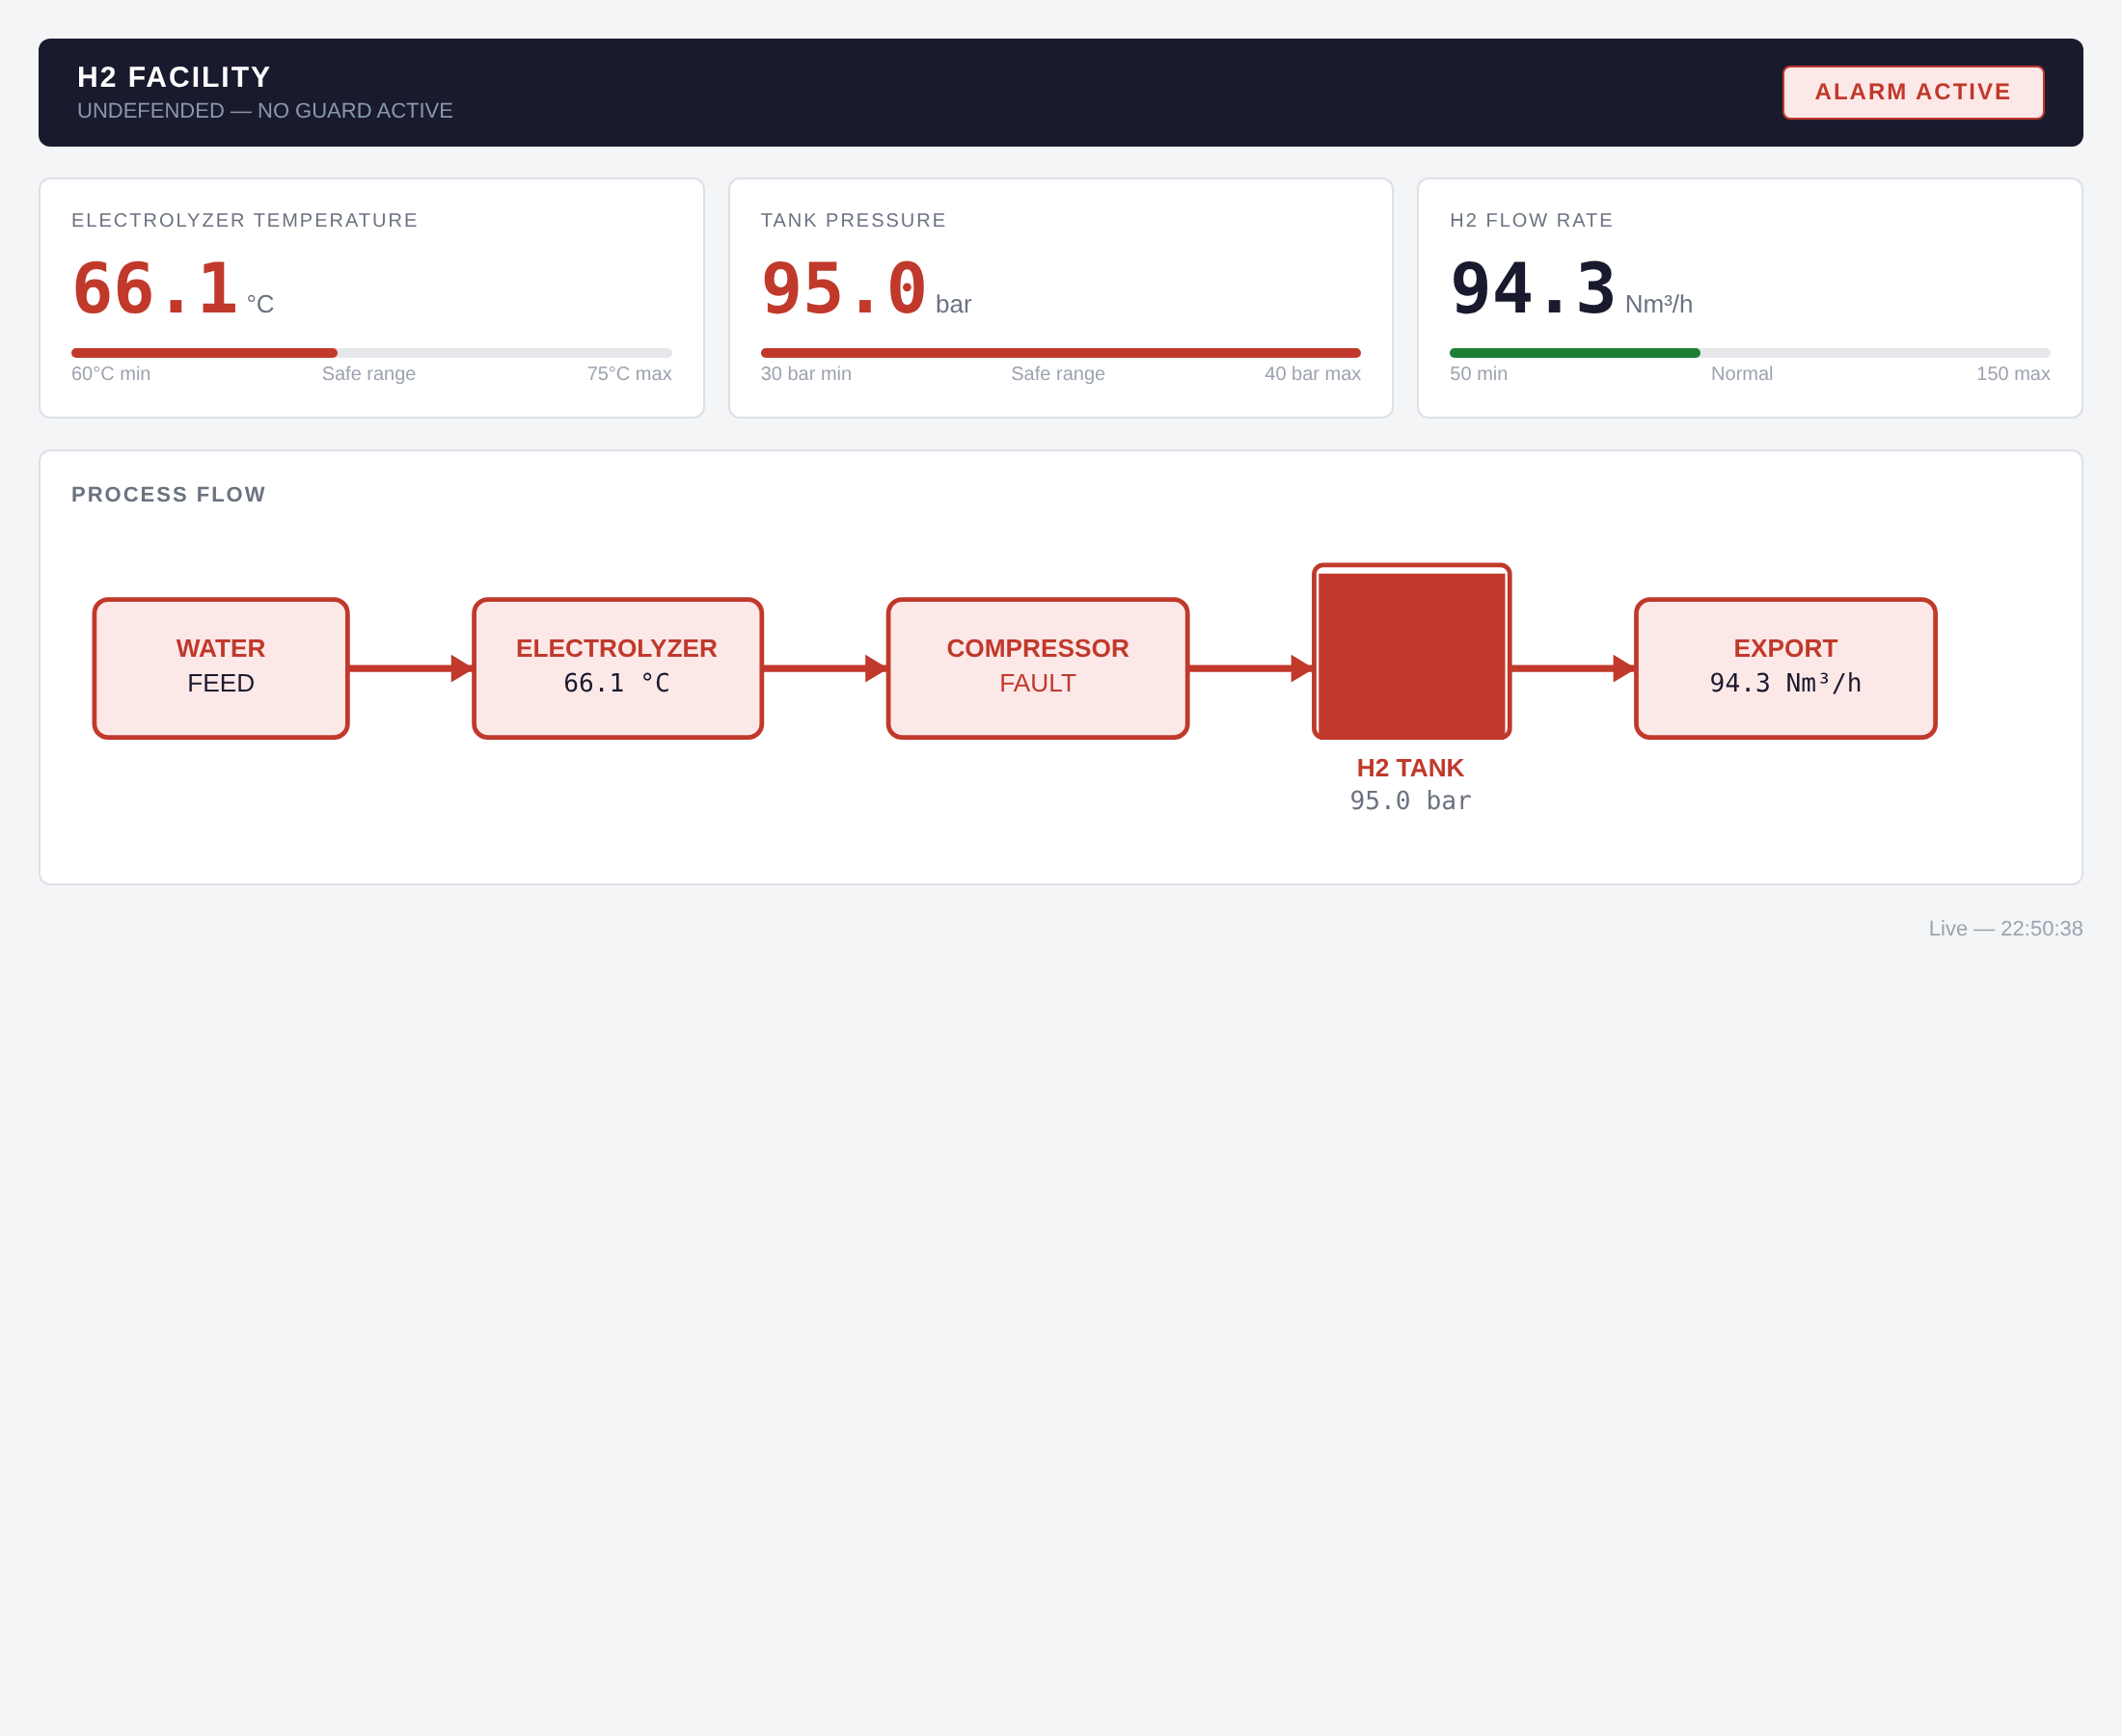
Figure 6 — Direct (undefended) dashboard during attack_hold on :5020 — ALARM ACTIVE at 95.0 bar, tank red, compressor FAULT: the attack reached the plant.

8. Recommendations
These are recommendations, not features already present in the source:
- Segment the process network so the plant (:5020) is reachable only through the guard; remove direct operator/client access to the unguarded port (addresses R-01).
- Strengthen drift detection with a fixed or longer reference window not continuously re-seeded from live reads, plus an absolute rate-of-change limit measured over minutes (addresses R-02).
- Add authentication and anti-replay at a gateway — mutual-auth or signed commands with per-session nonces — since Modbus/TCP provides none (addresses R-03).
- Restrict and monitor reads; alert on sequential register sweeps (addresses R-04).
- Validate every register in a write and validate HR3/alarm writes rather than passing them through (addresses R-05).
- Add connection/rate limiting and resource quotas for availability, and monitor connection rates (addresses R-06).
- Correlate related process values (temperature/pressure/flow) rather than validating each register in isolation.

9. Recovery and conclusion
Recovery was verified after every scenario: the plant self-heals through its clamped random walk, and services were restarted to the initial baseline between scenarios as a snapshot-restore substitute. At shutdown all four lab processes were stopped and ports 5020/5021/8080/8081 were confirmed closed with no residual listeners.
The lab demonstrates that the supplied guard meaningfully contains gross, fast tampering on the path it controls, but that its protection is bounded: it is bypassed by the direct port, does not authenticate or detect replay, validates only single registers, and — most subtly — can be walked past by a slow in-range drift because its baseline is continuously refreshed from live reads. These are the honest limits of an educational rule-based guard and are not claimed to make the process safe.

10. References and appendices
Course source: https://github.com/icdfa/ACICP302ICS-Network-Security-and-Attacks — commit 2a66f9bcf253eb3fe31c68ad52794cd535421da8. The provided code is course source, attributed, and not learner-authored. Source files inspected: plant.py, guard.py, dashboard.py, dashboard_guarded.py, and the five demonstration clients.
Appendices (in the learner evidence repository):
- docs/topology — Figure 1 source
- docs/register-map.md
- docs/guard-decision-table.md
- docs/scope-card.md
- docs/risk-register.csv
- docs/test-plan.md
- evidence-log.md (chronological log + safety declaration)
- report/evidence-index.md
- evidence/captures/*.pcap, evidence/logs/*, evidence/screenshots/*

