*REPORT*

***Mutahara Ghulam Rasool:***



***Submitted to:***

***DR JUNAID AKTHAR:***

**ACKNOLOGEMENT:**

I would like to thanks Dr, junaid Akhtar for making this remarkable assignment for us. Before I started this assignment I was having difficulty of understanding this assignment because for the very first time I do not know what is evolutionary algorithm is? And how the theory of evolution relate with the evolutionary algorithms. Now that I have finished it I understand all these things. This assignment helped me grow up.

I would also like to thanks Mr. Ali Raza Khan for help me out in this project.

**ABSTRACT:**

Image matching is an important topic in image processing, and it has broad application prospects in the field of computer vision. Image matching typically includes Template Matching (TM), Feature Matching, and Dynamic Pattern Matching, among which TM is the most commonly used matching approach. TM is employed to measure whether an image patch matches a small area of the source image by sliding the template through the source image, and then use the coordinates of the upper-left corner of the corresponding window in the two images to determine the matching position .So, here we have a larger and a smaller template image, here we takes the two images and solves the template matching problem that, i.e. finds the coordinates or location of the smaller image within the larger image by using the complete Evolutionary Algorithm.

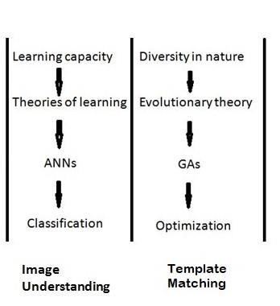

**PROBLEM STATEMENT:**

Given a larger and a smaller template image, you have to write a complete Evolutionary Algorithm that takes the two images and solves the template matching problem, i.e. finds the coordinates or location of the smaller image within the larger image.

**THEORY:**

➢ **THEORY OF EVLUATION**:

The theory of evolution makes statements about three different, though Related, issues:

1. **The fact of evolution—that is, that organisms are related by common descent;**
2. **Evolutionary history—the details of when lineages split from one another and of the changes that occurred in each lineage;**
3. **The mechanisms or processes by which evolutionary change occurs.**

An evolutionary algorithm is a search experimental which is inspired by Charles

Darwin’s theory of natural evolution. The process of natural selection reflects this algorithm, here we select the fittest individuals for reproduction in order to produce children of the next generation. The process of natural selection starts with the selection of fittest individuals from a population. They produce children which inherit the characteristics of the parents and will be added to the next generation. If parents have better fitness, their children will be better than parents and have a better chance at surviving. This process keeps on iterating and at the end, a generation with the fittest individuals will be found. This notion can be applied for a search problem. We consider a set of solutions for a problem and select the set of best ones out of them. Five phases are considered in a genetic algorithm.

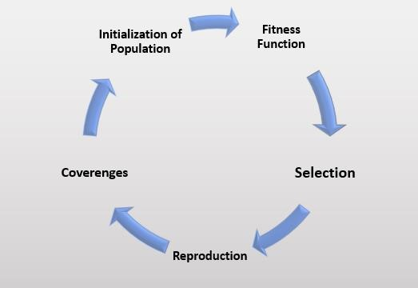

1. **Initial population**
2. **Fitness function**
3. **Selection**
4. **Crossover**
5. **Mutation**

* **Initial population:**

The process begins with a set of individuals which is called a Population. Each individual is a solution to the problem you want to solve. An individual is characterized by a set of parameters (variables) known as Genes. Genes are joined into a string to form a Chromosome (solution). In a genetic algorithm, the set of genes of an individual is represented using a string, in terms of an alphabet. Usually, binary values are used (string of 1s and 0s). We say that we encode the genes in a chromosome.

* **Fitness function:**

The fitness function determines how fit an individual is (the ability of an individual to compete with other individuals). It gives a fitness score to each individual. The probability that an individual will be selected for reproduction is based on its fitness score. Modern evolutionary theory defines fitness not by how long an organism lives, but by how successful it is at reproducing. If an organism lives half as long as others of its species, but has twice as many offspring surviving to adulthood, its genes become more common in the adult population of the next generation. Though natural selection acts on individuals, the effects of chance mean that fitness can only really be defined "on average" for the individuals within a population. The fitness of a particular genotype corresponds to the average effect on all individuals with that genotype. A distinction must be made between the concept of "survival of the fittest" and "improvement in fitness". "Survival of the fittest" does not give an "improvement in fitness", it only represents the removal of the less fit variants from a population.

* **Selection:**

The idea of selection phase is to select the fittest individuals and let them pass their genes to the next generation. Two pairs of individuals (parents) are selected based on their fitness scores. Individuals with high fitness have more chance to be selected for reproduction.

* **Crossover:**

Crossover is the most significant phase in a genetic algorithm. For each pair of parents to be mated, a crossover point is chosen at random from within the genes. For example, consider the crossover point to be 3. Children are created by exchanging the genes of parents among themselves until the crossover point is reached. The new children are added to the population.

* **Mutation:**

In certain new children formed, some of their genes can be subjected to a mutation with a low random probability. This implies that some of the bits in the bit string can be flipped. Mutation occurs to maintain diversity within the population and prevent premature convergence.

* + **COMCEPTUAL MODELING:**

In this code we have first initialize the population then selection function is used which determines that the best fit individual are selected for survivals. Crossover and mutation are also used foe populate a new generations. Using all these functions I have found the baby ki boothi form large image.

Basic pseudo code / Algorithm of our model is given below,

**START :**

**Initialize** population with randomly selected possible solutions.

**Find Fitness** of each candidate solution in population.

**REPEAT TILL** ( when **termination criteria** is satisfied ):

Parent Selection Stage

Cross over the parents pairs

Mutate them

Find their fitness

Selection of next generation

**LOOP ENDS**

**END**

* + **APPLICATIONS:**

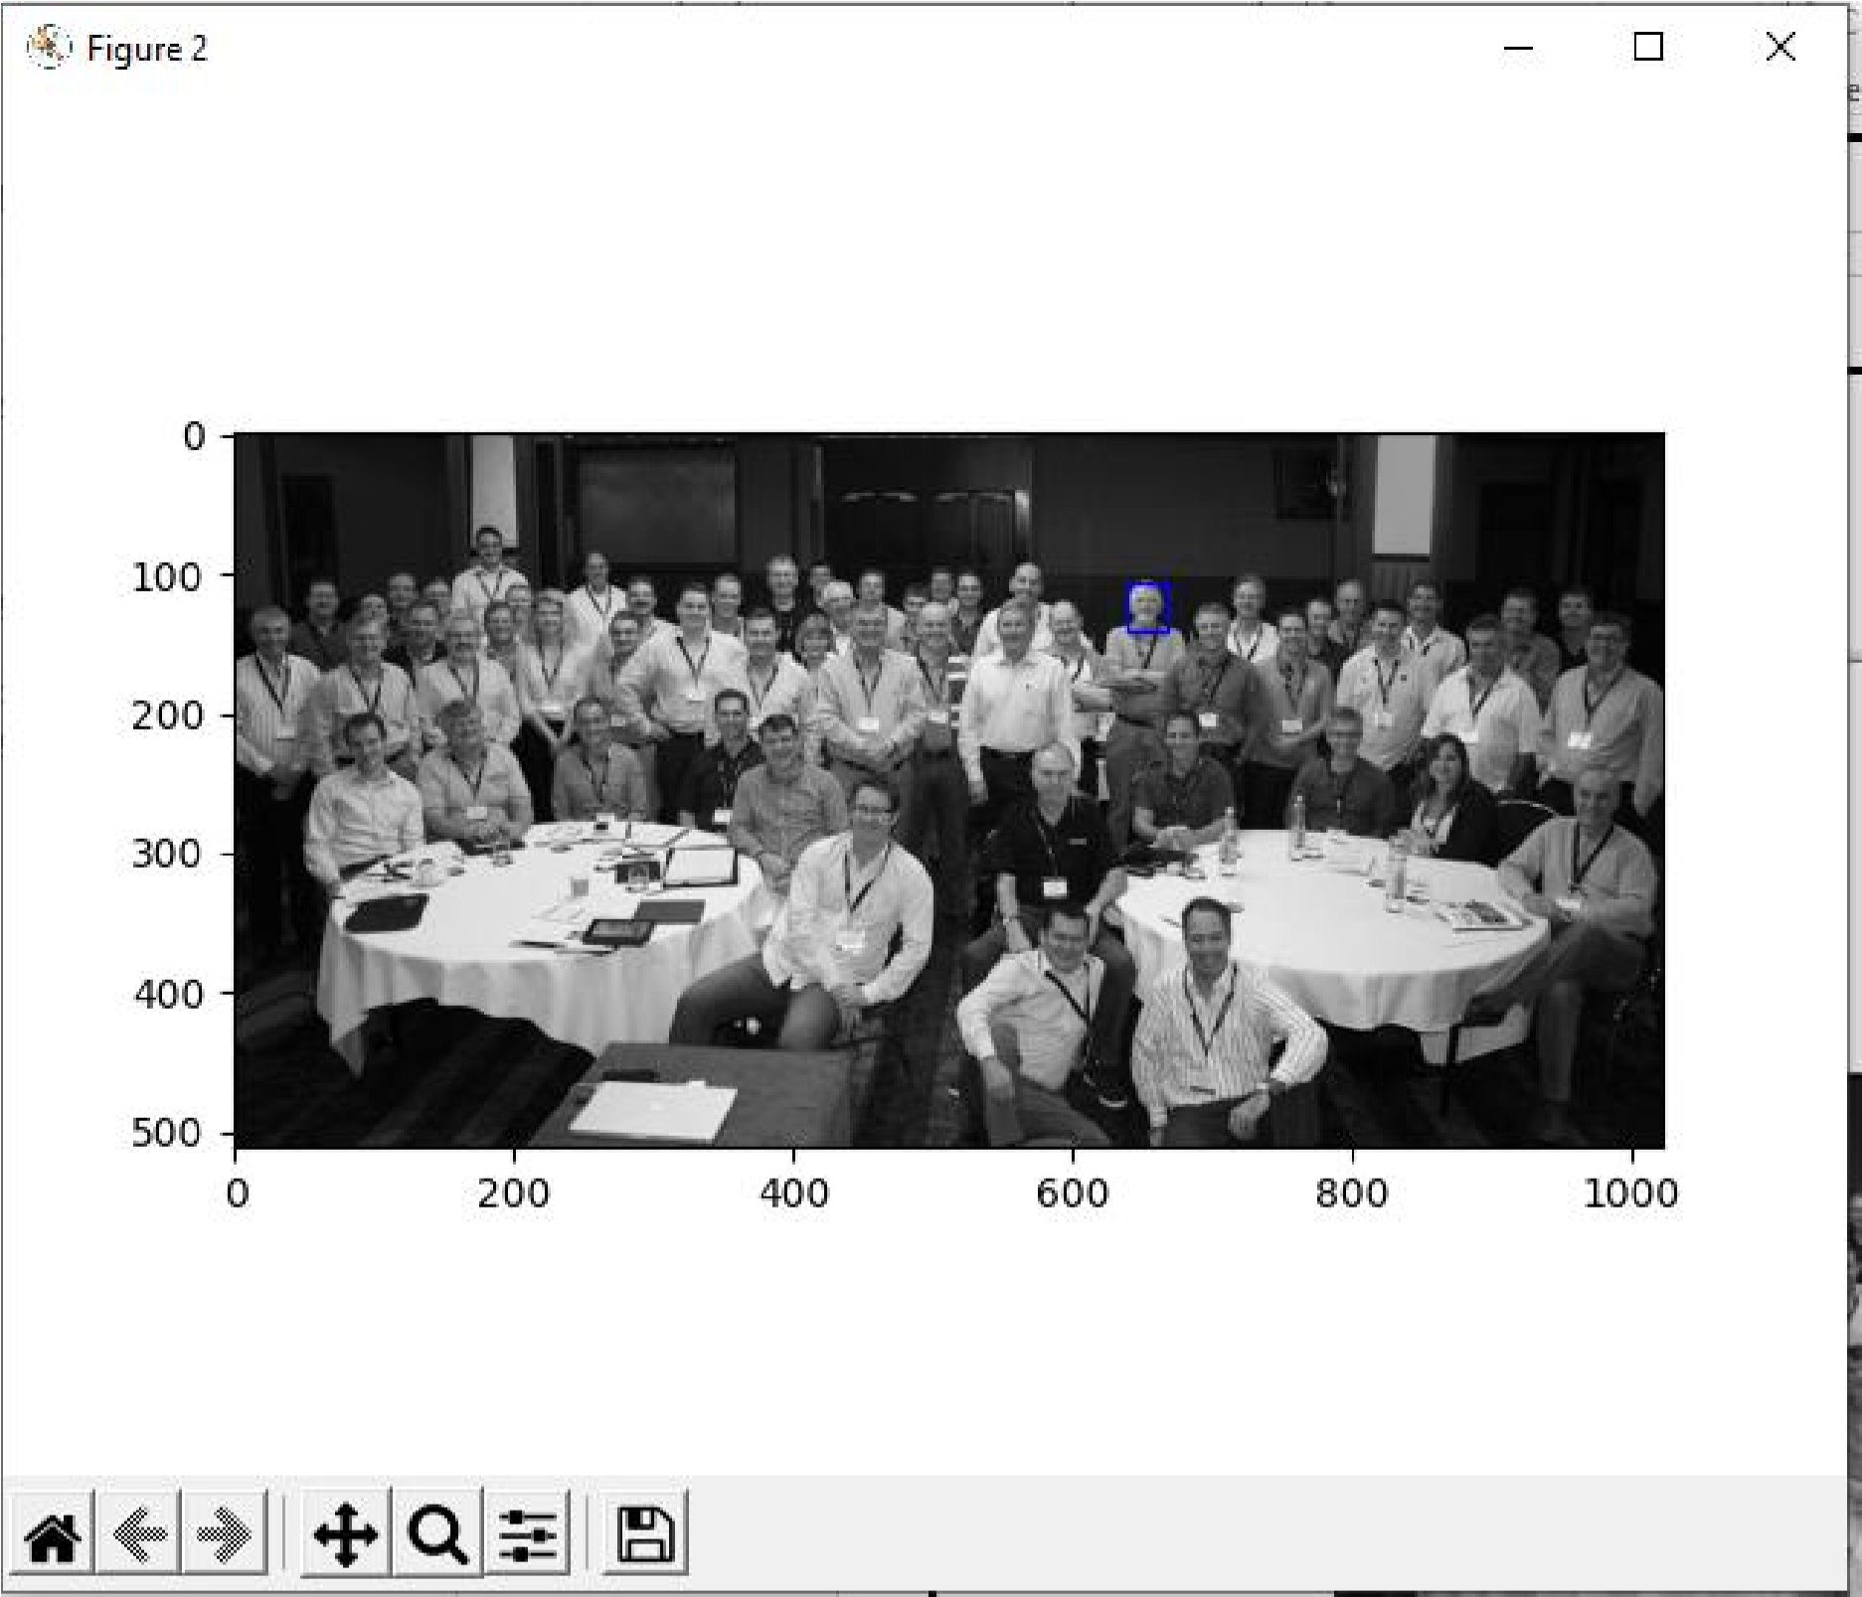

In my code sometimes they may find the baba ki boothi very quickly but sometimes they take a lot of time to show the baba ki boothi.