**1.1 Project Definition**

The [pharmaceutical industry](https://en.wikipedia.org/wiki/Pharmaceutical_industry) in [Bangladesh](https://en.wikipedia.org/wiki/Bangladesh) is one of the most developed sectors in Bangladesh. This sector provides 97% of the total medicinal requirement of the local market. In our country there are almost 800 medicine companies and nearly 1 million medicine shops. Every medicine shop orders medicines to the medical representatives of pharmaceutical companies mainly over phone. Payment is also collected by the representatives manually. Automation of a process is always a better solution than doing it manually. To automate this process we have introduced “e-pharma”. It will also helpful for the pharmaceutical companies to track of their sold and ordered medicine information.

“e-pharma” is a b2b e commerce web portal which will be used to order medicine online. This web portal will be used by medicine resellers and pharmaceutical companies. “e-pharma” can be used through both web and android app. Normal medicine resellers can download this app from app-store or can use the web portal.

Medicine retailors can order their medicine and pay through this application. Pharmaceutical companies will update the medicine catalogue. They will also get a statistics of everyday order, monthly and yearly sold medicines. Besides they will also get predictive analytics of the medicines.

**1.2 Domain Analysis**

**1.2.1 Target Market**

* The sector has grown from strength to strength over the last 40 years.
* The industry meets 97% of the demand for medication in the country.
* Pharmaceutical companies around 800.
* Around 1 million pharmacy retailor shops.
* Total market size around $1.6 billion.

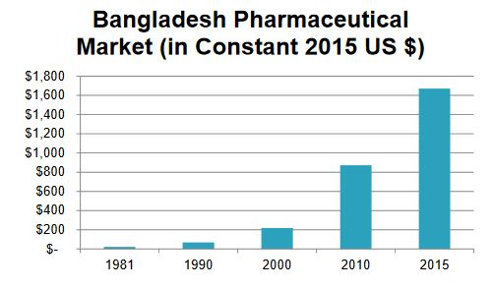

**1.2.2 Targeted User**

|  |  |  |
| --- | --- | --- |
| **Pharmaceutical companies** | **Target in each year** | **After 5 years** |
| 800 | 10 | 50 |

|  |  |  |
| --- | --- | --- |
| **Retail shops in all zilla cities(reg.)** | **Target in 1 year** | **After 3 years** |
| 50000 | 6000 | 20000 |

**1.3 Project Goal**

Our main goal is to bring thousands of Buyers (medicine shops) and Suppliers (pharmaceutical companies) together with the help of technology and promote their Business.

**1.4 Project Scope**

The objectives of the project are given below –

* Making profiles of different pharmaceutical companies and medicine shops.
* Making a medicine catalogue of different pharmaceutical companies.
* Medicine searching options based on different criteria.
* Medicine ordering and payment options.
* Providing predictive analytics to pharmaceutical companies.

**1.5 Key deliverables**

* Android app
* Web application
* Necessary documents

**1.6 Stakeholders**

The stakeholders of this project along with benefits of each stakeholder are given below:

* Pharmaceutical Companies
  + Selling medicine through this application.
  + Reaching to the target customers by advertising here.
  + Taking better business decisions based on predictive analytics.
* Medicine Retailors
  + Using this one stop sourcing platform, they can find wide range of genuine suppliers.
  + Buying medicine.
* Project Team Members
  + Benefited financially.

**1.7 Team Role**

We have formed our team with seven members for Software Project Management (SE 803) course.  
The team will be working on a real life project for approximately four months. To reach optimum  
goal, the whole activities within the project are divided into many tasks and the members are  
assigned to that specific task. Some of our members are assigned to multiple tasks but they have their own special role for the project. The following table contains name of the team members and project responsibilities that are assigned to that person.

|  |  |
| --- | --- |
| Team Member | Role |
| Md Rifat Arefin (BSSE0515) | Project Manager |
| Md Sharifur Rahman (BSSE0506) | Backend Development, Business Case Analysis |
| Muntaqim Labbaeik (BSSE0513) | App Development |
| Mutasim Fuad (BSSE0520) | Backend Development, System Designer |
| Abdul Mannan (BSSE0522) | Front-end Development |
| Jamal Hossain(BSSE0525) | Front-end Development |
| Tahmim Jeba (BSSE0533) | Quality Assurance, Documentation |

**1.8 Assumption, Constraints & Risks**

* Medicine resellers are familiar with mobile app and internet.
* Some requirements cannot derived from customer needs.
* Errors in estimations.
* Lack of budget.
* Time limitations.
* Inadequate planning.
* Lack of standards.
* Lack of co-operation among the members.
* Inexperience team members.