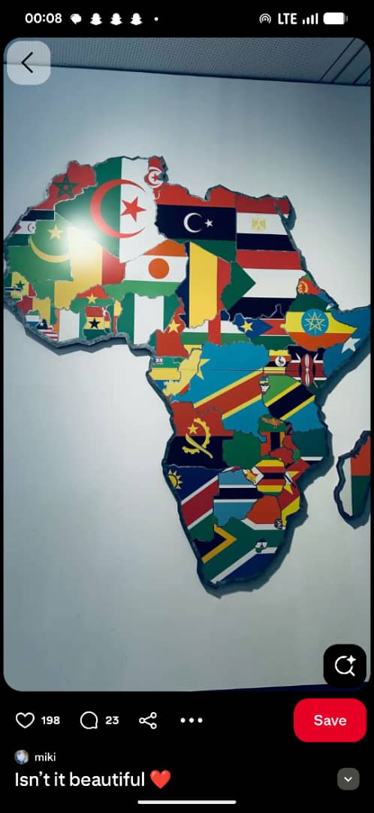

African Youth Summit 2026
15–17 September 2026 | Mombasa, Kenya
Theme: "Empowering African Youth as Catalysts for Crime, Drug and Substance Abuse Prevention and Sustainable Development"

DAY 1 – Tuesday, 15 September 2026

Time | Activity
08:00–09:00 | Registration and Networking
09:00–09:30 | Procession of Dignitaries and National Anthems
09:30–10:00 | Opening Ceremony and Welcome Address by Host Organization
10:20–10:40 | Remarks by African Union Youth Representative
10:40–11:00 | Remarks by UNODC / WHO / NACADA Representative
11:30–12:00 | Award Presentation, Group Photograph and Media Briefing
12:00–13:00 | Lunch Break
13:00–14:00 | Plenary Session I: The State of Crime, Drug and Substance Abuse Among African Youth
14:00–15:00 | Plenary Session II: Emerging Trends – Cybercrime, Online Drug Markets, Organized Crime and Youth Vulnerability
15:00–15:30 | Health Break
15:30–17:00 | Panel Discussion: Government, Civil Society, Academia and Youth Perspectives on Prevention
17:00–18:00 | Country Presentations (Selected African Delegations)
18:30–20:30 | Welcome Dinner & Cultural Night

DAY 2 – Wednesday, 16 September 2026

Time | Activity
08:30–09:00 | Recap of Day One
09:00–10:00 | Inspirational Keynote: Youth Leadership in Prevention and Community Safety
10:00–11:00 | High-Level Dialogue: Investing in Prevention Rather Than Punishment
11:00–11:30 | Health Break
11:30–13:00 | Parallel Technical Workshops  Workshop A: School-Based Drug Prevention Program  Workshop B: Community Policing and Crime Prevention  Workshop C: Mental Health, Resilience and Recovery  Workshop D: Digital Safety, Cybercrime and Online Protection
13:00–14:00 | Lunch
14:00–15:30 | Youth Innovation Challenge and Exhibition
15:30–16:00 | Health Break
16:00–17:30 | Breakout Groups: Developing National and Regional Youth Action Plans
17:30–18:30 | Networking Session and Partnership Marketplace
19:00–21:00 | Courtesy visit to the Governor/African Youth Awards on Prevention, Leadership and Community Service

DAY 3 – Thursday, 17 September 2026

Time | Activity
08:30–09:00 | Day Two Highlights
09:00–10:00 | Keynote Address: Building a Drug-Free and Crime-Free Africa
10:00–11:00 | Presentation of Workshop and Breakout Outcomes
11:00–11:30 | Health Break
11:30–12:30 | Adoption of the Mombasa Youth Declaration on Crime, Drug and Substance Abuse Prevention
12:30–13:30 | Launch of the African Youth Prevention Network (AYPN)
13:30–14:30 | Lunch
14:30–15:30 | Commitment Session: Governments, Youth Organizations and Development Partners
15:30–16:30 | Closing Ceremony & Communiqué
16:30–17:00 | Vote of Thanks
17:00 | Official Close of Summit

Prepared by: AYS

